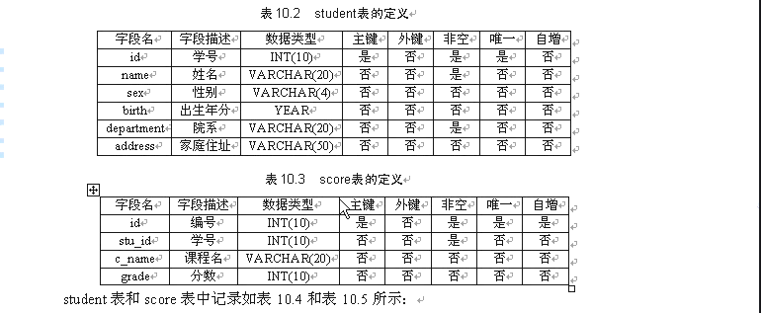
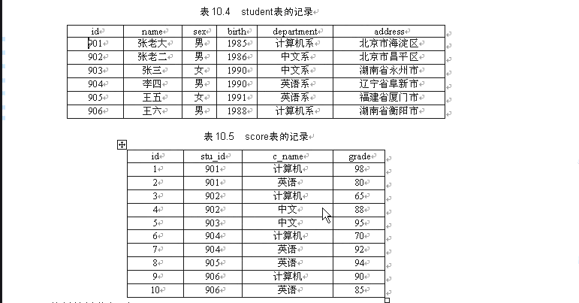
执行的操作如下：
- 在查询之前，创建表并添加记录
- 查询Student表的所有记录
- 查询student表的第二到第四条记录
- 查询student表中所有学生的id name院系 department
- 查询student表计算机系和英语系的学生信息
- 查询student表18-22的学生信息
- 查询student表每个院系有多少人
- 查询score表中每个科目的最高分
- 查询李四的考试科目c_name 和考试成绩grade
- 用连接查询的方式查询所有学生的信息和考试信息
- 计算每个学生的总成绩
- 计算每个考试科目的平均成绩
- 查询计算机系成绩低于95的学生信息
- 查询同时参加计算机和英语考试的学生信息
- 将计算机考试成绩按从高到低进行排序
- 从student表和score表中查询出学生的学号，然后合并查询结果
- 查询姓张和姓王的同学的姓名、院系、考试科目和成绩
- 查询都是湖南的同学的姓名 年龄 院系 考试科目和成绩

- 在查询之前，创建表并添加记录
Create table student
(id int(10) not null unique primary key,
Name varchar(20) not null,
Sex varchar(4) ,
Birth year,
Department varchar(20),
Address varchar(50)
);

Create table score
(id int(10) not null unique primary key auto_increment,
Stu_id int(10) not null,
C_name varchar(20),
Grade int(10)
);

Desc 表名； // 查询表结构 show create table 表名 \G

Insert into student values(901,’张老大’,’男’,’1985’,’计算机系’,’北京市海淀区’);
Insert into student(902,’张老二’,’男’,’1986’,’中文系’,’北京市昌平区’);
(903,’张三’,’男’,’1990’,’中文系’,’湖南省永州市’);
(904,’李四’,’女’,’1990’,’英文系’,’辽宁省阜新市’);
(905,’王五’,’男’,’1991’,’英文系’,’福建省厦门市’);
(906,’王六’,’女’,’1988’,’计算机系’,’湖南省恒南阳市’);

Insert into score values(null,901,’计算机’,98);
Insert into score values(null,901,’英语’,80);
Insert into score values(null,902,’计算机’,65);
Insert into score values(null,902,’中文’,88);
Insert into score values(null,903,’中文’,95);
Insert into score values(null,904,’计算机’,70);
Insert into score values(null,904,’英语’,92);
Insert into score values(null,905,’英语’,94);
Insert into score values(null,906,’计算机’,90);
Insert into score values(null,906,’英语’,85);

- 查询Student表的所有记录
Select * from student; //或者所有字段罗列查询

- 查询student表的第二到第四条记录
Select * from student limit 1,3;
- 查询student表中所有学生的id name院系 department
Select id,name,department from student;
- 查询student表计算机系和英语系的学生信息
Select * from student where department in (‘计算机系’,’英语系’);

Select * from student where department=‘计算机系’ or department=’英语系’;

- 查询student表18-22的学生信息
Select id,name,sex,2009-birth AS age, department,address from student
where 2009-birth between 18 and 22; //如上第二种查询

- 查询student表每个院系有多少人//先院系分组
Select department,count(id) AS sum_of_department from student group by department;

- 查询score表中每个科目的最高分
Select c_name,max(grade) from score group by c_name;

- 查询李四的考试科目c_name 和考试成绩(score有科目成绩，学号，无姓名)
Select c_name,grade from score where stu_id=(select id from student where name=’李四’);

- 用连接查询的方式查询所有学生的信息和考试信息
Select student_id,name,sex,birth,department,address,c_name,grade from student,score
Where student_id=score.stu_id;

Select s1_id,name,sex,birth,department,address,c_name,grade from student s1,score s2
Where s1_id=s2.stu_id;

- 计算每个学生的总成绩
Select stu_id,sum(grade) from score group by stu_id;

Select stu_id,name,sum(grade) from student, score
Where student.id=score.stu_id group by student.id;

- 计算每个考试科目的平均成绩
Select c_name,AVG(grade) from score group by c_name;

- 查询计算机系成绩低于95的学生信息
Select * from student id in(select stu_id from score where c_name=’计算机’ and grade<95);

- 查询同时参加计算机和英语考试的学生信息
Select * from student where id=any
(select stu_id from score where stu_id IN
(select stu_id from score where c_name=’计算机’ and c_name=’英语’));

- 将计算机考试成绩按从高到低进行排序
Select stu_id,grade from score where c_name=’计算机’ order by grade desc;
- 从student表和score表中查询出学生的学号，然后合并查询结果
Select id from student UNION select stu_id from score;

- 查询姓张和姓王的同学的姓名、院系、考试科目和成绩
Select s1.id,name,sex,birth,department,address,c_name,grade from student as s1,score
Where(name like ‘张%’ or name like ‘王%’) and s1.id=score.stu_id;

18.查询都是湖南的同学的姓名 年龄 院系 考试科目和成绩
Select s1.id,name,sex,birth,department,address,c_name,grade from student s1,score
Where address like ‘湖南%’ and s1.id=score.stu_id;

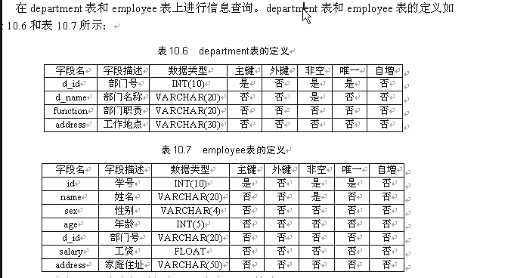
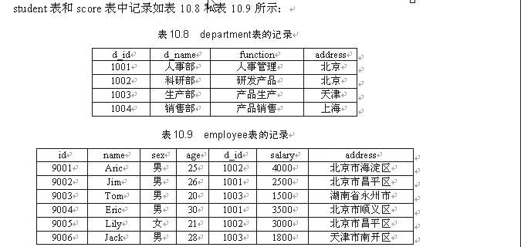
在department表和employee表查询记录。查询要求如下：
- 查employee中所有数据
- 查employee表第四条到第五题记录
- 从department表查询部门号（d_id），部门名称(d_name)和部门职能（function）
- 从employee表中查询人事部和科研部的员工信息
- 从employee表中查询年龄在25-30之间的员工信息
- 查询每个部门有多少员工
- 查询每个部门的最高工资
- 用左连接的方式查询department表和employee表
- 计算每个部门的总工资
- 查询employee表按照工资从高到底的顺序排列
- 从department表和employee表中查询出部门号 然后合并查询结果
- 查询家在北京市的员工的姓名、年龄、家庭住址
- 查询名字由四个字母组成，而且最后三个“ric”的员工信息
- 查询名字由四个字母组成，以“L”开头，字母“y”结尾的员工的信息

- 查employee中所有数据
Create table department(
d_id int(10) not null unique primary key,
d_name varchar(20) not null,
function varchar(20),
address varchar(30)
);

Create table employee(
id int(10) not null unique primary key,
name varchar(20) not null,
sex varchar(4),
age int(5),
d_id int(10),
salary float,
address varchar(50)
);

Insert into department values(1001,’人事部’,’人事管理’,’北京’);
Insert into department values(1002,’科研部’,’研发产品’,’北京’);
Insert into department values(10013,’生产部’,’产品生产’,’天津’);
Insert into department values(1004,’销售部’,’产品销售’,’上海’);

Insert into employee values(9001,’Aric’,’男’,25,1002,4000,’北京市海淀区’);
Insert into employee values(9002,’Jim’,’男’,25,1001,2500,’北京市昌平区’);
Insert into employee values(9003,’Tom’,’男’,20,1003,1500,’湖南省永州市’);
Insert into employee values(9004,’Eric’,’男’,30,1001,3500,’北京市顺义区’);
Insert into employee values(9005,’Lily’,’女’,21,1002,3000,’北京市昌平区’);
Insert into employee values(9006,’Jack’,’男’,28,1003,1800,’天津市南开区’);

Select * from employee;

- 查employe1e表第四条到第五题记录
Select * from employee limit 3,2;

- 从department表查询部门号（d_id），部门名称(d_name)和部门职能（function）
Select d_id,d_name,function from employee;

- 从employee表中查询人事部和科研部的员工信息
Select *from employee where d_id=ANY
(select d_id from department where d_name IN(‘人事部’,’科研部’));// 或者or关键字
- 从employee表中查询年龄在25-30之间的员工信息
Select * from employee where age between 25 and 30;

- 查询每个部门有多少员工
Select d_id,count(id) from employee group by d_id;

- 查询每个部门的最高工资
Select d_id,MAX(salary) from employee group by d_id;

- 用左连接的方式查询department表和employee表
Select d.d_id,d_name,function,d.address,id,name,age,sex,salary,e.address
From department as d LEFT JOIN employee as e ON ed_id=d.d_id;
- 计算每个部门的总工资
Select d_id,SUM(salary) from employee group by d_id;

- 查询employee表按照工资从高到底的顺序排列
Select d_id,SUM(salary) from employee order by salary DESC;

- 从department表和employee表中查询出部门号 然后合并查询结果
Select d_id from employee UNION select d_id from department;

- 查询家在北京市的员工的姓名、年龄、家庭住址
Select name,age,address from employee where address like ‘北京%’；

- 查询名字由四个字母组成，而且最后三个“ric”的员工信息
Select * from employee where name like ‘_ric’;

14.查询名字由四个字母组成，以“L”开头，字母“y”结尾的员工的信息
`` select * from employee where name regexp ‘^L..y$’;
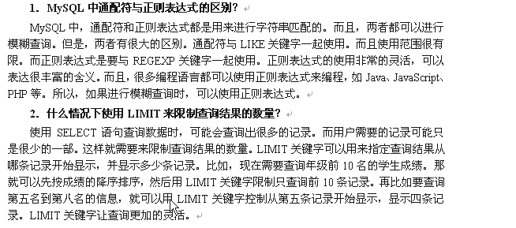
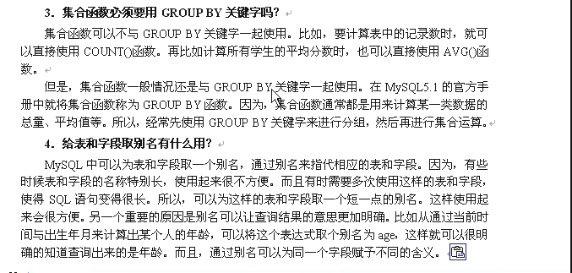
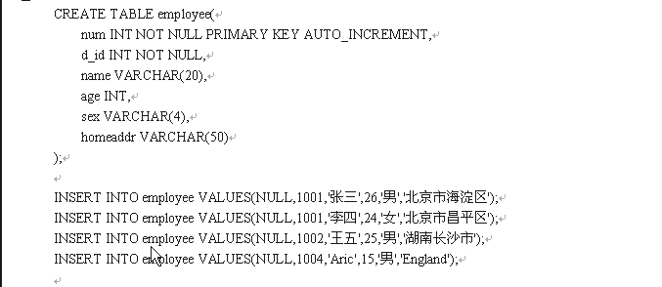
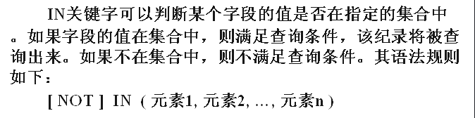
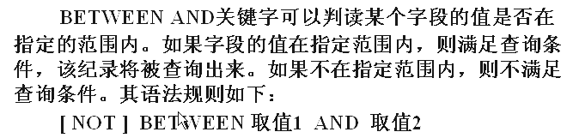

1.查询d_id小于1004，age<26,而且为男的记录。
Select * from employee where d_id<1004 and age<26 and sen=’男’;

- 用and关键字查询employee表中的记录。查询条件为num取值在（1，2，3）这个集合中，age从15-25这个范围，haddr的取值“北京市”
Select * from employee where num IN(1,2,3) and age between 15 and 25
And homeaddr like ‘%北京市%’;
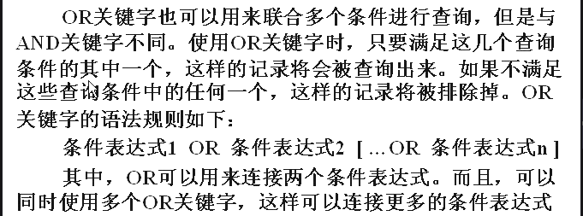
- 用and关键字查询employee表中的记录。查询条件为num取值在（1，2，3）这个集合中，或者age从15-25这个范围，或者haddr的取值“北京市”
Select * from employee where num IN(1,2,3) or age between 15 and 25
or homeaddr like ‘%北京市%’;
- 用and关键字查询employee表中的记录。查询条件为num取值在（1，2，3）这个集合中，age从25，或者sex为女
Select * from employee where num IN(1,2,3) and age = 25
or sex=’女’;
- 下面使用DISTINCT关键字来消除d_id字段中重复记录。
Select distinct d_id from employee;

- 按照d_id 升序 age字段进行降序
Select * from employee order by d_id ASC,age DESC;

- 将sex字段分组查询，每个分组的name字段显示出来
Select sex,group_concat(name) from employee group by sex;

- 将sex进行分组查询，值相同的为一组，然后对每一组使用count()进行计算，求出每一组的记录数。
Select sex,count(sex) from employee group by sex;

- 将sex进行分组查询，求出每一组的记录数大于等于3的分组。
Select sex,count(sex) from employee group by sex having count(sex)>=3;
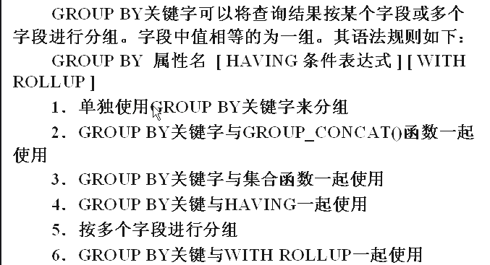
- 按照d_id 和 sex字段进行分组，前面的字段有相通的通过后面的来分组查询
Select *from employee group by d_id,sex;

- 按sex字段进行分组，使用count()函数来计算没组的记录数。并且加上with rollup.
Select sex,count(sex) from employee group by sex with rollup;

12.按sex 进行查询，使用gruot_concat()函数查看没组的name字段的值，并且加上withrollup.
Select sex,group_concat(name) from employee group by sex with rollup;

13.查询所有，以第二条开始，显示两条
Select * from employee limit 1,2;

- 统计employee表中的记录数
Select count(*) from employee;

- 统计employee表中的d_id不同的记录数
Select d_id,count(*) from employee group by d_id;

- sum()函数统计grade表中学号为的同学的总成绩
Select num,sum(score) from grade group by num=1001;

- 将grade表按照num字段进行分组，然后使用sum（）函数统计各组总成绩
Select num,sum(score) from grade group by num;

- 用AVG()函数计算grade表中不同科目的平均成绩
Select course,AVG(score) from grade group by course;

- 用max()函数查询grade表中不同科目的最高成绩
Select num,crouse,max(score) from grade group by course;

- 内连接方式查询employee和department，在执行内连接查询时先分别查量表中的记录
Select num,name,employee.d_id,age,sex,d_name,function from employee,department
Where employee.d_id=department.d_id;

- 用左连接的方式查两表通过d_id字段进行连接
Select num,name,employee.d_id,sex,age,d_name,function from employee
Left join department ON employee.id=department.d_id;

- 内连接方式查询employee和department，age大于24
Select num,name,employee.d_id,age,sex,d_name,function from employee,department
Where employee.d_id=department.d_id and age>24; //order by age ASC age升序排列

- 查e中的记录，这些记录的d_id字段的值必须在D表中出现过（未出现 not in）
Select * from employee where d_id IN(select d_id from department);
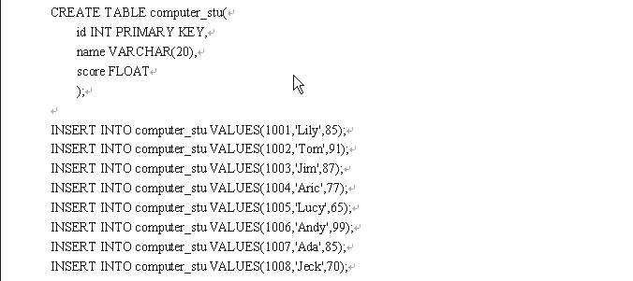
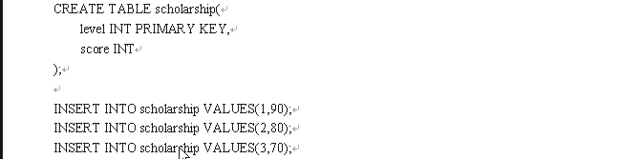
- 从computer_stu表中查询获得一等奖学金的学生的学号，姓名和分数。各个等级的奖学金的最低分存储在scholarship表中。
Select id,name,score from computer_stu where score>=
(select score from scholarship where level=1);

25.查d 表中查询哪个部门没与年龄为24的，员工年龄在e 表中
Select d_id,d_name from department where d_id!=
(select d_id from employee where age=24);
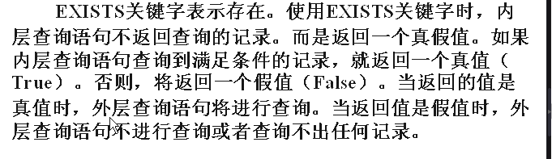
26.查d表中存在d_id为1003的记录，则查询e表的记录(子真则查外层，子假则不查)
Select * from employee where exists (select d_name from department where d_id=1003);

- 查d表中存在d_id为1003的记录，则查询e表中age>24的记录(不存在++not)
Select * from employee where age>24 and exists
(select d_name from department where d_id=1003);

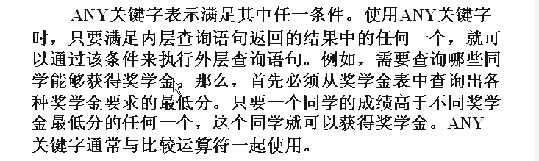
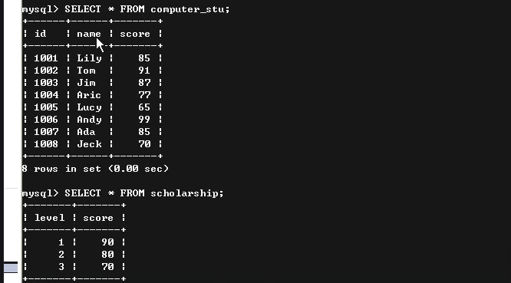
28.从computer_stu表中查出那些同学可以获得奖学金，奖学金的信息存储在scholarship中
Select *from computer_stu where score>=ANY
(select score from scholarship);
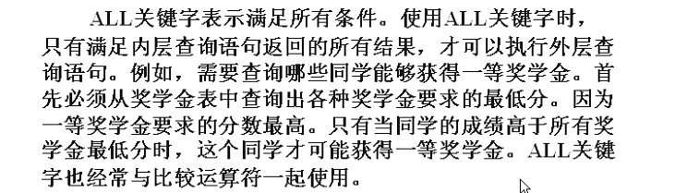29.查出那些同学可以获得一等奖（只要查出大于所有的分数就可以）
Select * from computer_stu where score>=all
(select score from scholarship);
- 从D和E表中查d_id字段的取值，并UNION合并在要一起(去掉重复的值)
Select d_id from department
UNION
Select d_id from employee;
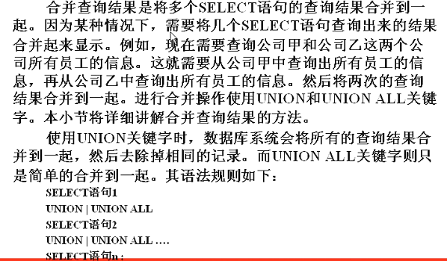

- 从D和E表中查d_id字段的取值，并UNION合并在要一起(包括重复的值)
Select d_id from department
UNION ALL
Select d_id from employee;
- 取别名 d.d_id ...from department as d;
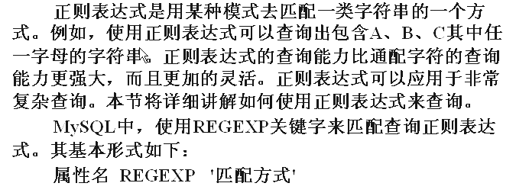
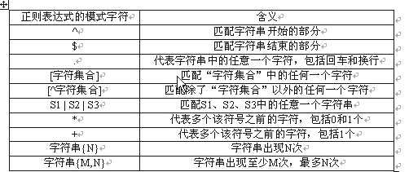
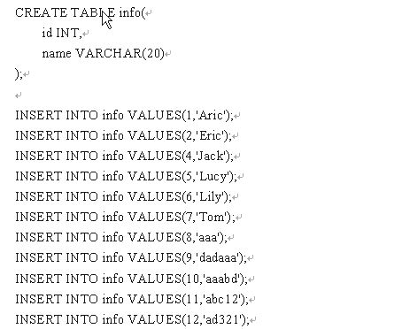
- 从info表中查询name字段L开头的记录
Select * from info where name regexp ‘^L’;

32.从info表中查询name字段 c结尾的记录
Select * from info where name regexp ‘c$’;

33.从info表中查询name字段 L开头y 结尾，中间有两个字符的记录（.一个代表一个字符）
Select * from info where name regexp ‘^L..c$’;
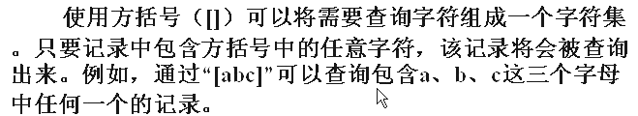
34.从info表中查询name字段包含 c e o 这三个字母中的任意一个的记录（[0-9a-c]）
Select * from info where name regexp ‘[c,e,o]’;

35.从info表中查询name字段包含a-w和数字以外的字符的记录。
Select * from info where name regexp ‘[^a-w0-9]’;

36.从info表中查询name字段包含ic uc ab 这三个任意一个的记录。
Select * from info where name regexp ‘ic|uc|ab’;
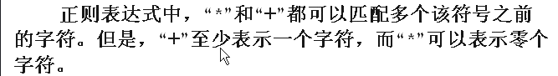
37.从info表中查询name字段中 c 之前出现过的 a 的字符的记录。
Select * from info where name regexp ‘a*c’; // jack 可以出现一次也可以不出现
Select * from info where name regexp ‘a+c’;
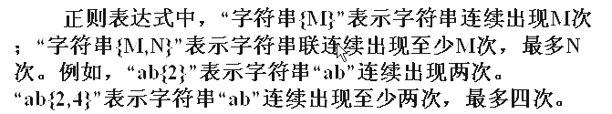
38.从info表中查询name字段中a出现过3次的记录。
Select * from info where name regexp ‘a{3}’;

39.从info表中查询name字段中a出现过最少一次，最多3次的记录。
Select * from info where name regexp ‘ab{1,3}’;

