System-Identification for Regular wave

Aoming Liang(1)(2), Second Author(2) and Third Author(3) (Full Name, 10pt Arial Font; separated by commas)  
(1 line spacing here leading (interline spacing) of 10pt and no spacing before and after)

(1) Zhejiang University, Hangzhou, China, (ACRONYMS IN INSTITUTION NAMES AND FULL ADDRESS ARE NOT RECOMMENDED)   
12263092@zju.edu.cn (Use “Arial” font, size 8pt)

(2) Westlake University, Hangzhou, China,   
 liangaoming@westlake.edu.cn (Use “Arial” font, size 8pt)

(2 lines spacing here)

Abstract [10pt Arial Font, Sentence case, bold]

(1 line spacing here)

In this paper, We study two types of Waves which include linear and non-linear Wave ' identification methods about Nonlinear auto-regressive model (NARM) and Hammerstein-Wiener model. We analyze and optimize parameters in multi-regressions. Under the nonlinear group regression model, we selected three common models, such as wavelet transform, decision tree model, and support vector machine model with Gaussian process. Finally, the Hammerstein-Wiener shows a great performance on identification processes. Specifically, we achieved a maximum accuracy of 88% on our validation set. We used the AIC index and NMSE to measure the superiority of the model, and finally optimized the H-W model using Newton's method.

(1 line spacing here)

**Keywords:** *system identification, Nonlinear auto-regressive model, wave predication, Hammerstein-Wiener model, optimization* [10pt Arial font, separated by; semi-colons, first letter of first word of each keyword capitalized, space between the keywords]

(2 lines spacing here)

1. INTRODUCTION [10PT ARIAL FONT, UPPERCASE, BOLD]

(1 line spacing here)

Wave forecasting is to predict or report the future wave conditions in advance according to the wind conditions and natural geographical conditions of a certain wind field in the ocean area. Accurately grasping the characteristics of wave models will be beneficial for wave prediction. There are so many researchers using economic methods to study the nonlinear interactions of waves and explain the evolution process of waves from a frequency dependent perspective(Hasselmann et al., 1985; Rogers et al., 2002). Additionally, more scholars are also focusing on the impact of waves on the environment and climate, especially on port construction and biological impacts(Silva et al., 2018).

However , results of semi-empirical and theoretical formula and numerical simulation are not practical in the ocean engineering. With the development of information science, more and more deep learning methods have been proposed. James et al., (2018) developed a machine learning framework Multi-layer perception and Support vector machine for  estimating ocean-wave conditions. Jing et al, (2022) proposed a convolution neural-network based regional wave prediction (CNN-RWP) to predict a regional wave under the conditions of wind speed field. System identification mainly uses the data-driven method to model the non-parametric model. We hope to use a small parameter space to fit or understand the law of wave changing with water depth. Huang (1989) use a trace theorem to estimate for time periodical operator. Dos Santos & Perdicoúlis (2021) successfully applied the methods of polynomial functions, orthogonal sinusoid and Gaussian regression to the state space equation. Based on Artificial Intelligence, a new system identification method is proposed, which combines linear and nonlinear theory and the physical form of simple string motion inherent in waves. The time series characteristic expression is added. We evaluate and optimize the performance of the two strong nonlinear models and propose our own evaluation matrices on our datasets. The goal is to generate a new model which is fit for non-linear wave forms, with integrating dynamic and non-linear theory.

(1 line spacing here)

1. Model Selection and Comparison
   1. **Nonlinear auto-regressive model (NARM) models selection**

In terms of mathematical relationship, we can consider the height of wave surface as an observable measurement . According to the prior physical knowledge, the wave evolution is a dynamic process aboutsuch as time, position and depth of the water, which is very similar to the NARM model. We model it by generate discrete-time as following in Eq. [1] ：

[1]

where,

is a non-linear operation function in this equation

The nonlinear model is collectively known as identified nonlinear models. These models represent nonlinear systems with coefficients that are identified using measured input and output data. In this study, the model is multi-input and single output system. For the NARM estimator, the Figure1 is to illustrate the structure and principle of the model. The regresses which could have chronology differential relationship with different input and output.

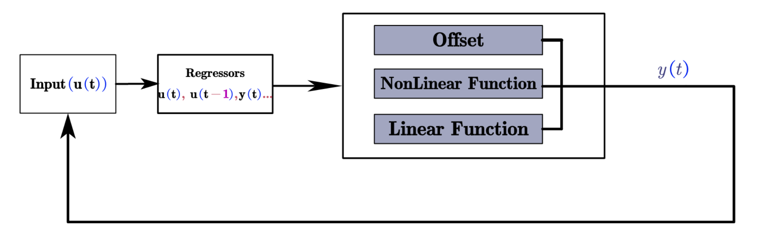

**Figure 1**. The NARM model's structure, for the wave identification the Input could be a multi-input variable, in this case, the input variables is three and the output is one.

Output is relevant to the static offset, nonlinear functions and linear functions. The mathematical expression is as follows in Eq. [2].

[2]

where,

is a vector about regresses and r is the mean of regresses . is a scalar offset that is added to this equation. is a projection matrix which the calculations could be well influenced. The Linear Function is and the nonlinear function is . Ideally, the parameters of model should minimize the mean square error (MSE), given systematic error and random error (Variance).

However, using MSE as a train loss function is nothing to do with the prior physical knowledge and the dynamic time term of the system and increase the in explicitly and high uncertainty burden. For our wave prediction problem, adding proper regularization is a good way to improve the fitting effect, as shown below in Eq. [3].

[3]

where,

t is the time variable, is the number of data samples, is the parameters and is the predicted error computed as the difference between the observed output and the predicted output of the model. represents the confidence in the prior knowledge of the unknown parameters. This implies that the larger the value, the higher the confidence. In the following experiments, we pick the as 1 by empirical experience.

* 1. **Characteristics and Model metrices in the following experiments**

For a Wave form, we select three inputs as a position depth of water , time and the position . The Output is Wave height. In this section, we choose regresses as four items in three inputs: ,, and , respectively. The non-linear function is about 4 order Fourier decomposition terms in this case. For example, for input we set the function to as a regressor item. such as , , , . For the train set, we choose the data-set which is produced by closed from equation.

In order to evaluate the final result, the normalized root mean square error (NMSE) is adopted in Eq. [4]. The value of NMSE close to 1, it shows that the model is correct. Additionally, Akaike information criterion (AIC) in Eq. [5] is a standard for the size of the parameter space in models, and the criteria are based on the concept of entropy. The smaller the AIC, the better the model. Usually, the model with the smallest AIC is selected.

[5]

where,

is equal to the number of parameters and is a likelihood function.

In this section, we selected the 4-order regresses and different non-linear functions in wavelet Networks, tree partitions and SVM combined Gaussian process named Model A, Model B, Model C.

For the wavelet Nonlinear function model (Qinghua Zhang, 1997), the basic mathematics principle is as follows in Eq. [6]:

[6]

where,

In this equation, is a m by 1 vector of regresses. is an offset. is m by p projection matrix,

m is the number of regresses and *p* is linear weights. is *p* by 1 vector of weights. and constitute wavelet network function. is a sum of dilated and translated functions. is a sum of a sum of dilated and translated wavelets.

For the model B, which is a tree-partition method, a non-linear function is shown as following in Eq. [7].

[7]

where,

belongs to the partition , The mapping is defined by a dyadic partition of the space, such that on each partition element , is a linear mapping. is a 1-by-m vector, is a 1-by-m+1 vector and is a value of the total nodes. In “tree” model, the AIC is None.

For the model C, which is the Support Vector Machine combined with gaussian process, the principle is as following.

[8]

Where,

is an m-by-1 vector of inputs, and is the number of support vectors in the trained model. is the nth support vector in the model. is the weight associated with each support vector. is the Gram matrix that results from the operation of the specified kernel function on and and is the offset of the trained model. Basically, we choose Gaussian kernel for computing the Gram matrix.

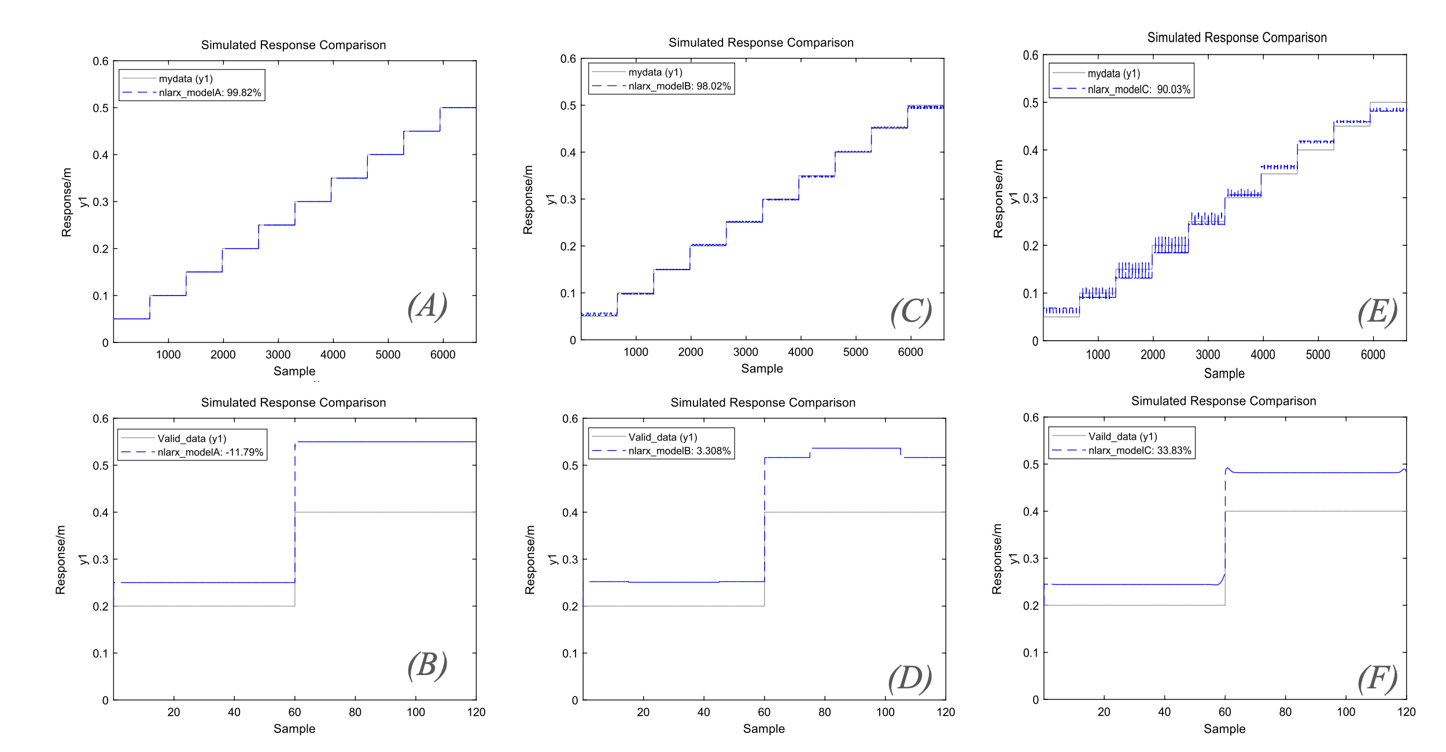

**Figure3**. The 4-order NARM model fitting result, figure(A), (C)and (E)show that the fitness in the train data set of model A, B and C. Figure (B), (D) and (F)show that the fitness in the valid data

From the Table1 that shows that although the Model A has the best fitting characterize in NMSE, the effect in the test set is not as good as model C. However, in terms of model size, the AIC index of model C is higher, which means that more variable space is required.

**Table 1**. NARM Performance in Training and valid set.

|  |  |  |  |  |
| --- | --- | --- | --- | --- |
|  | **MSE** | **NMSE in**  **Test** | **AIC** | **NMSE in Valid** |
|  |  |  |  |  |
| **modela** | 6.8e-8 | 98.82 | -4.5e+6 | -11.79 |
| **modelB** | 7.24e-6 | 98.02 | None | 3.308 |
| **modelC** | 2.09e-4 | 90.10% | -1.86e+6 | 33.83 |
|  |  |  |  |  |

[1 line spacing here]

1. Hammerstein-Wiener Model Selection and experiments of Regular Waves
   1. **Hammerstein-Wiener Model Selection**

The Hammerstein-Wiener models is a model to describe a dynamic model by using three parts which includes Linear transform and Non-Linear transform (BROURI et al., 2022; Kumar et al., 2022; Xie et al., 2021) . The basic structure is as following in Figure 4.

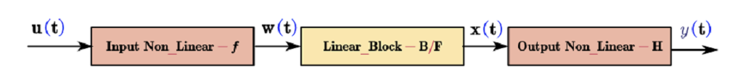

**Figure4.** The structure of the Hammerstein-Wiener Model

It is worth noting that the middle linear layer is a discrete and dynamic combination of . Relatively speaking, the middle linear layer represents a dynamic layer. acts on the input port of the linear block, this function is called the input non-linearity. Similarly, because acts on the output port of the linear block, this function is called the output non-linearity.

where,

is a nonlinear function that transforms input data as . The Linear block is a linear transfer function that transforms as . represents discreteness, determining the order of dynamics of the system. is a nonlinear function that maps the output of the linear block to the system outputas.

* 1. **Result of HW model in identification**

In this experiment, we utilized linear transformation. When selecting the intervals of the linear transformation, we evenly divided them into 10 and 100 intervals as Model D and Model E, and selected the second-order linear dynamic layer in the middle. The final results are shown in the Figure 5.

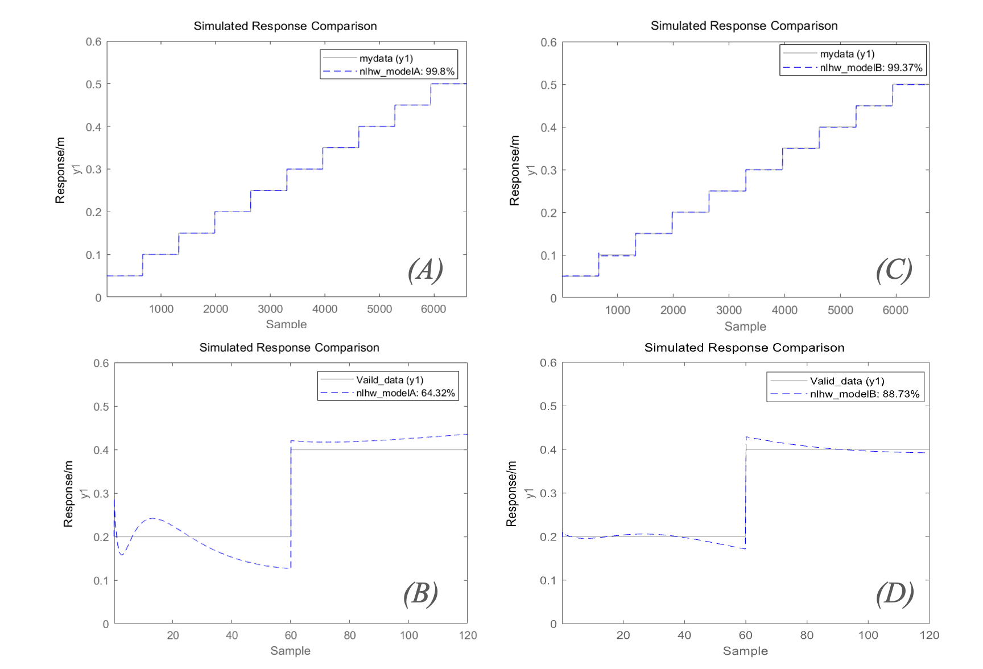

**Figure5**. (A) and (B) is the HW model fitting result, figure(A) and (C)show that the fitness in the train dataset. (C)and (D) shows that fitness in the valid dataset

As is shown in Figure 5，The more the number of segmented linear intervals, the easier it is to achieve identification results, and the verification of the latter is 88.73%.

In the table 2 below, in order to compare the effect of linear interval segmentation between these two quantity sets, we did not choose a large linear interval in this comparison because the calculation time of the response will increase exponentially according to the AIC.

**Table 2**. HW Performance in Training and valid set.

|  |  |  |  |  |
| --- | --- | --- | --- | --- |
|  | **MSE** | **NMSE in**  **Test** | **AIC** | **NMSE in Valid** |
|  |  |  |  |  |
| **modelD** | 8.315e-8 | 98.8 | -4.45e+6 | 64.32% |
| **modelE** | 3.165e-6 | 98.7 | -3.24e+6 | 88.73% |
|  |  |  |  |  |

1. CONCLUSIONS

In this paper, we compare the system identification of the regular wave signal of the two models with different dynamic function terms. The results show that the HW model has very superior properties. Of course, the optimization of the former model has not been carried out, because the identification time increases with the increase of power items, but has reached 88% of the effect, which shows the application of system identification in waves. All the results of this paper, including data and code, are linked on GitHub. https://github.com/liangaomng/paper.git.

1. ACKNOWLEDGEMENTS [10pt ARIAL FONT, UPPERCASE, BOLD]

The author thanks the collaborators for their help and the Future Industry Center of West Lake University for their support.

1. REFERENCES [10pt ARIAL FONT, UPPERCASE, BOLD]

BROURI, A., OUANNOU, A., GIRI, F., OUBOUADDI, H., & CHAOUI, F. (2022). Identification of Parallel Wiener-Hammerstein Systems. *14th IFAC Workshop on Adaptive and Learning Control Systems ALCOS 2022*, *55*(12), 25–30.

dos Santos, P. L., & Perdicoúlis, T.-P. A. (2021). A Non-Parametric LPV Approach to the Indentification of Linear Periodic Systems⁎⁎This work is financed by National Funds through the Portuguese funding agency, FCT - Fundação para a Ciência e a Tecnologia within project: UID/EEA/50014/2019. *4th IFAC Workshop on Linear Parameter Varying Systems LPVS 2021*, *54*(8), 13–19.

Hasselmann, S., Hasselmann, K., Allender, J. H., & Barnett, T. P. (1985). Computations and parameterizations of the nonlinear energy transfer in a gravity-wave spectrum. Part II: parameterizations of the nonlinear energy transfer for application in wave models. *J. PHYS. OCEANOGR.*, *15*(11, Nov. 1985), 1378–1391.

Huang, M.-J. (1989). A trace theorem for time-periodic Hamiltonian operators. *Journal of Mathematical Analysis and Applications*, *143*(1), 224–234.

James, S. C., Zhang, Y., & O’Donncha, F. (2018). A machine learning framework to forecast wave conditions. *Coastal Engineering*, *137*, 1–10.

Jing, Y., Zhang, L., Hao, W., & Huang, L. (2022). Numerical study of a CNN-based model for regional wave prediction. *Ocean Engineering*, *255*, 111400.

Kumar, K., Patwardhan, S. C., & Noronha, S. (2022). Development of adaptive dual predictive control schemes based on Wiener–Hammerstein models. *Journal of Process Control*, *119*, 68–85.

Qinghua Zhang. (1997). Using wavelet network in nonparametric estimation. *IEEE Transactions on Neural Networks*, *8*(2), 227–236.

Rogers, W. E., Kaihatu, J. M., Petit, H. A. H., Booij, N., & Holthuijsen, L. H. (2002). Diffusion reduction in an arbitrary scale third generation wind wave model. *Ocean Engineering*, *29*(11), 1357–1390.

Silva, D., Rusu, E., & Soares, C. G. (2018). The effect of a wave energy farm protecting an aquaculture installation. *Energies*, *11*(8).

Xie, C., Rajan, D., & Chai, Q. (2021). An interpretable Neural Fuzzy Hammerstein-Wiener network for stock price prediction. *Information Sciences*, *577*, 324–335.