Technical Proposal

1. System Infrastructure:
A Linux server on intranet.
Unlimitied netwrok traffic within intranet.
Intranet is safe.

Terminals: Chrome browser

2. System architecture:

Client -> Web server -> Database

Browser -----intranet----> Linux server(Web server) ------intranet-------> Linux Server (Database Server)

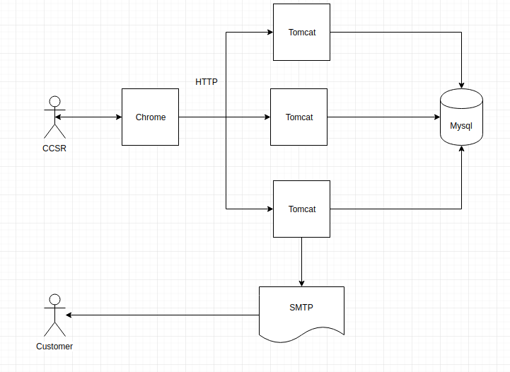
3. Technology stack:
Spring Boot, MySql, Jquery

4. Soluton:

