Technical Proposal

1. System Infrastructure:

A Linux server on intranet.

Unlimitied netwrok traffic within intranet.

Intranet is safe.

Terminals: Chrome browser

2. System architecture:

Client -> Web server -> Database

Browser -----intranet----> Linux server(Web server) ------intranet-------> Linux Server (Database Server)

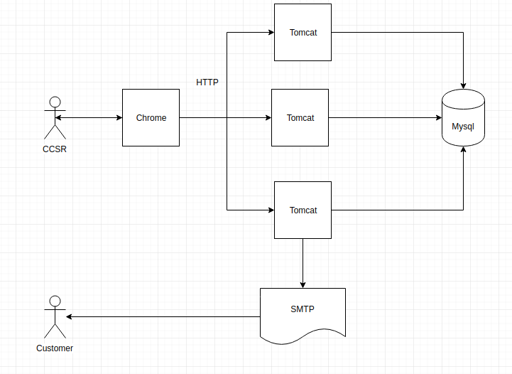

3. Technology stack:

Spring Boot, MySql, Jquery

4. Soluton: