MovingKML Instruction Guide

- Introduction
MovingKML (http://www.sirrs.org/MoveKml/en/MoveKml.html) is a webpage developed with the Google Earth web browser plug-in and its JavaScript API. The purpose of this webpage is to test the effectiveness of our proposed framework for the moving transformation of KML geometry elements within Google Earth. Any computer, which already has the Google Earth web plug-in installed, can freely visit this webpage on a decent broadband connection. After loading a hosted KML/KMZ file from a specified URL, users of this webpage can move multiple KML geometry elements arbitrarily.
As shown in Fig.1, the user interface of MovingKML is composed of three parts:
(1) The input area, which is designed for importing the URL of a hosted KML/KMZ file, is located in the top of the webpage.
(2) The Google Earth container, also incorporating three screen-overlay-based custom sliders, is located in the left side of the screen.
(3) The slider control area, containing three general-purpose slider controls, is located in the right side of the screen.

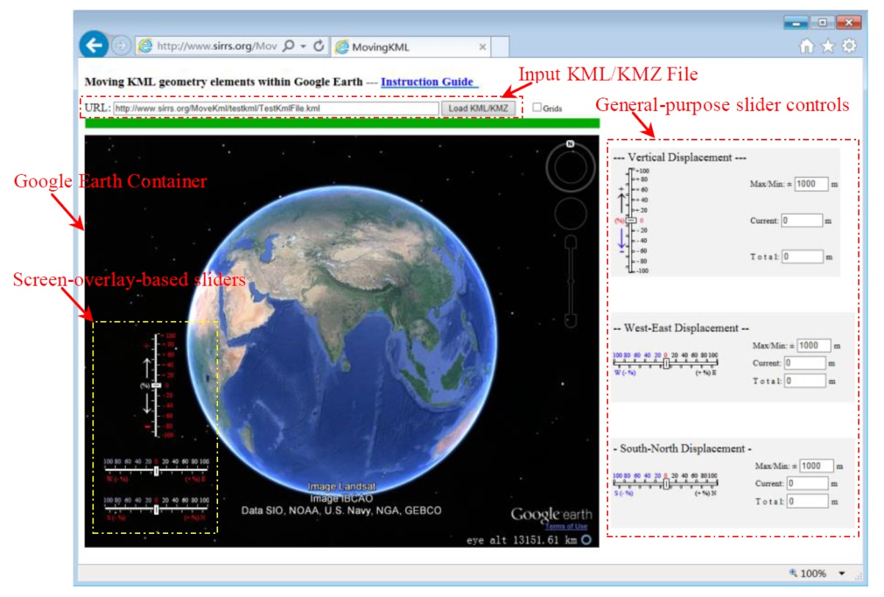
Fig.1. User interface of MovingKML

- Move KML geometry elements using MovingKML
- For moving KML geometry elements on the Internet, you can download the zipped MovingKML.zip onto your computer and unzip, you will see a HTML file: MoveKml.html. Open your web browser and you can access this HTML file.
Or:
Visit the website at http://www.sirrs.org/MoveKml/en/MoveKml.html on a decent broadband connection.
- Input the URL of any hosted KML/KMZ file (default: http://www.sirrs.org/MoveKml/testkml/TestKmlFile.kml), and click the “Load KML/KMZ” button. The KML geometry elements stored in the KML/KMZ file immediately appear in the Google Earth container.
- Using the general-purpose slider controls, which are located on the webpage beside the Google Earth container, you can manually set the movement distance along a specified direction. Alternatively, the screen-overlay-based custom sliders, which are embedded in the Google Earth container, also can be used to control the movement distances.
- In the slider control area, you also can set the maximum/minimum range (default: 1000 m) of the displacement along a specified direction.
- Using the mouse, you can drag the draggable piece (thumb) along the track in the sliders. In the slider control area, the current displacement and the total displacement along a specified direction, corresponding to the sliders, are displayed and changed synchronously. Once you release the mouse button, MovingKML automatically adjusts the geographic coordinates of the KML geometry elements according to the predefined movement distance, and displays the transformed KML geometry elements on the Google Earth container quasi-instantly. And finally, the draggable piece (thumb) is reset to zero to wait for the next moving transformation.

- Appendix A. Supporting information
Computer code of MovingKML is available at the URL below: http://www.sirrs.org/MoveKml/code/MovingKML.zip.
For moving KML geometry elements on the Internet, we refer the reader to the website at http://www.sirrs.org/MoveKml/en/MoveKml.html. Any computer that has the Google Earth plug-in installed can freely access this webpage.

