VisualCrust Instruction Guide

- Introduction
VisualCrust (http://www.visualearth.org/globalcrust10/crust10web/visualcrust10.html) is a web application developed with the Google Earth web browser plug-in and its JavaScript API. The purpose of this web application is to disseminate and visualize the KML-formatted global crustal structure (from the CRUST 1.0 model) on the Google Earth virtual globe over the Internet. Any computer, which already has the Google Earth web plug-in installed, can freely visit this webpage on a decent broadband connection.
As shown in Fig. 1, the user interface of VisualCrust is composed of two parts:
- The view control area, which is designed for controlling the appearance and behavior of the Google Earth plug-in, is located at the top of the webpage.
- The Google Earth container, incorporating two screen-overlay-based custom controls (one is a group of button-styled legends, and the other is a vertical slider), is located at the bottom of the screen. The button-styled legends can be used as interactive map keys to control the visibility of individual sublayers within crustal cells. The vertical slider is designed to control the uplifted height value for elevating the vertical position of the crust.

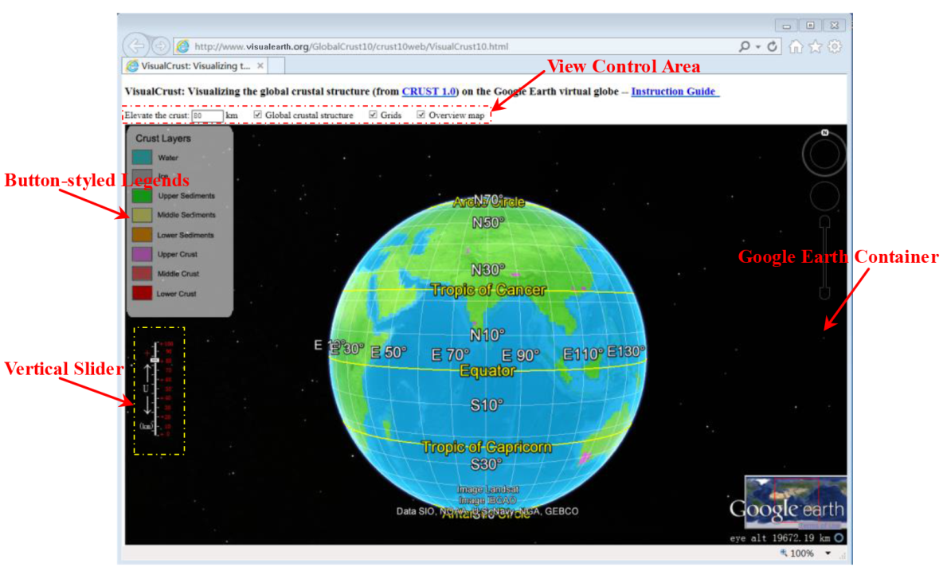
Fig.1. User interface of VisualCrust

- Demo
A demo of the use of VisualCrust is available at the URL below: http://www.visualearth.org/globalcrust10/crust10web/help/visualcrustdemo.rar. Download the compressed VisualCrustDemo.rar onto your computer and unzip, you will see the demo file: VisualCrustDemo.avi. Open the file you can see how VisualCrust works.

- Use of VisualCrust
- When you access the VisualCrust webpage (http://www.visualearth.org/globalcrust10/crust10web/visualcrust10.html), the global crust in LOD0 (the coarsest level), represented by a raster image draped over the solid Earth terrain model, first appears in the Google Earth container (Fig. 1).
- As the view moves closer, the crust in LOD1 is loaded automatically, and polygon placemarks representing top surfaces of crustal cells come into view. Choosing a polygon placemark, the property information about this cell pops up from the descriptive balloon.
- As the view moves even closer, the crust in LOD2 (the most detailed level) is activated, and 3D solid models representing sublayers within crustal cells appear on the screen. By default, the vertical positions of the interior sublayers are elevated by 80 km in order to make them visible above the Earth’s terrain surface. With advanced visualization tools embedded in Google Earth, you can freely explore those 3D models with a vivid appearance in a variety of ways. When you click a sublayer, the property information associated with this sublayer is displayed in a descriptive balloon (Fig. 2).

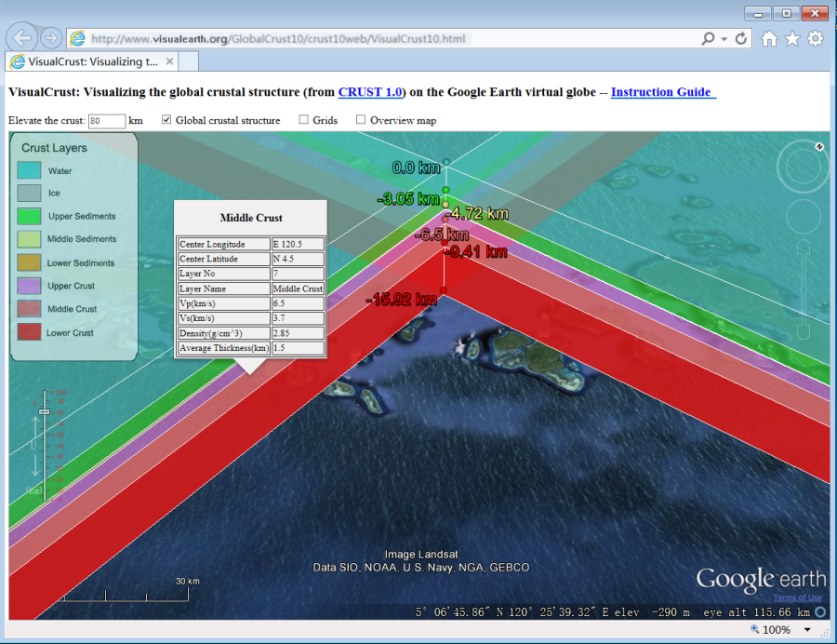

Fig. 2. Displaying the property information associated with an interior sublayer within a crustal cell

- By clicking the button-styled legends, it is possible to show and hide individual sublayers within crustal cells (Fig. 3).
- Using the vertical slider control, you can manually set the uplifted height for elevating the vertical position of the 3D solid models (Fig. 3). Using the mouse, you can drag the draggable piece (thumb) along the track in the vertical slider control. Once you release the mouse button, VisualCrust automatically adjusts the vertical position of the 3D solid models according to the predefined uplifted height, and displays the elevated crustal models on the Google Earth container quasi-instantly.

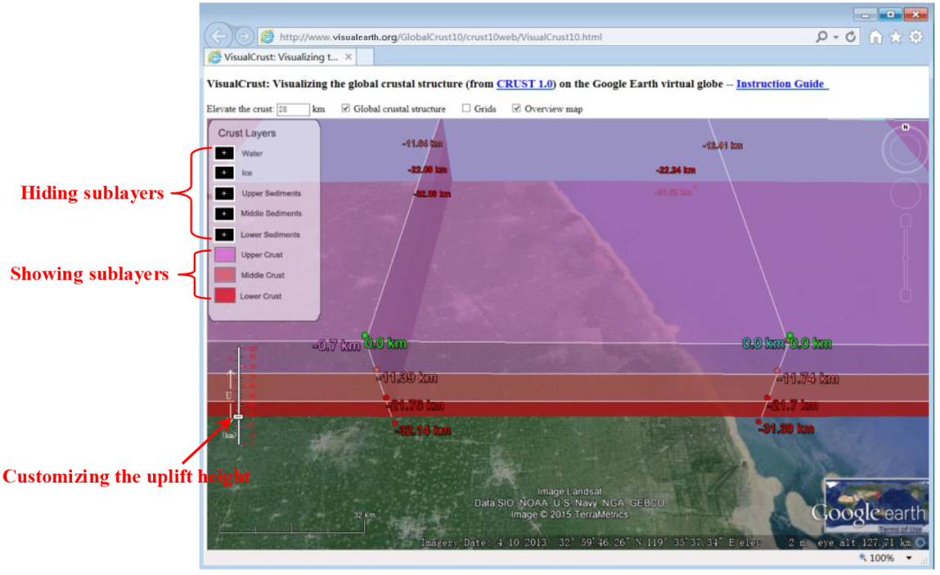

Fig. 3. Controlling the visibility of individual sublayers, and setting the uplifted height to elevate the vertical position of 3D solid models. In this figure, the top five sublayers (from water to lower sediments) have been unchecked in the legend; consequently they disappear from the view. In addition, the uplifted height is set to 28 km, which is different from the default value (80 km).

