**Some notes about Embedding layer & LSTM**

**About Embedding layer:**

- indexes -> vectors of fixed size

- input shape: (batch_size, seq_length)

- output shape: (batch_size, seq_length, output_dim)

- input dim: vocab_size

- input length: seq_length

**Single LSTM cell:**

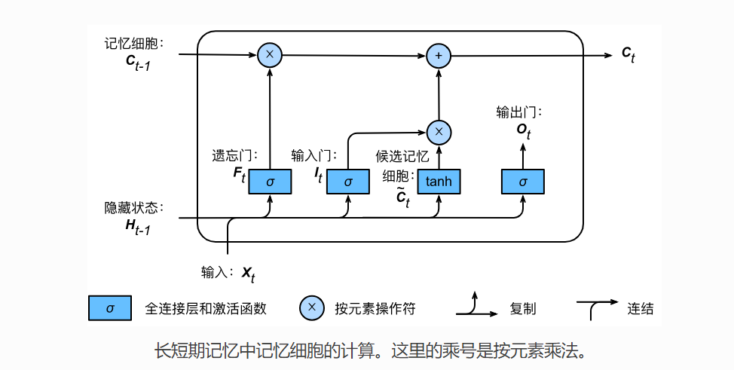

**Stacked-LSTM:**

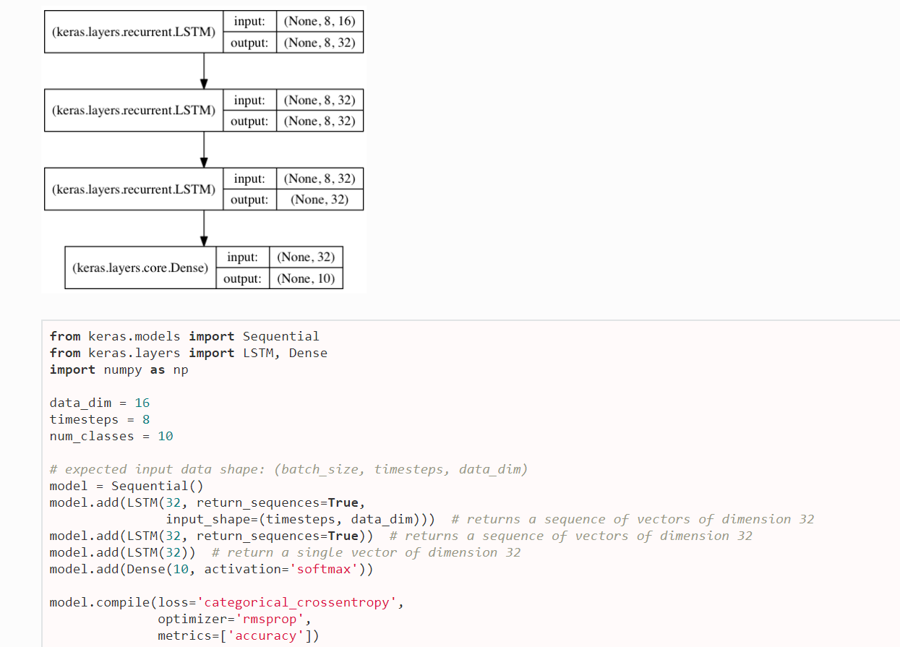

**About return_sequences=True:**

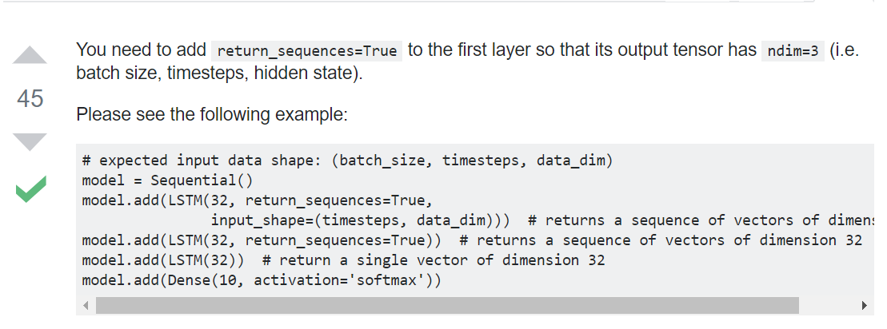

**Note: timesteps is seq_length**

**Detailes of Stacked-LSTM:**

