# subversion 简介

Subversion是一个自由开源的版本控制系统。在Subversion管理下，文件和目录可以超越时空。   
Subversion将文件存放在中心版本库里，这个版本库很像一个普通的文件服务器，不同的是，它可以记录每一次文件和目录的修改情况，这样就可以借此将数据恢复到以前的版本，并可以查看数据的更改细节。正因为如此，许多人将版本控制系统当作一种神奇的“时间机器”。

subversion 官网：[http://subversion.apache.org/](http://subversion.apache.org/" \t "http://blog.csdn.net/wh211212/article/details/_blank)

# subversion 安装

安装subversion

[root@linuxprobe~]# yum -y install subversion

创建源仓库，以“/var/svn/repos/project”为例

[root@linuxprobe ~]# mkdir -p /var/svn/repos/project

[root@linuxprobe ~]# svnadmin create /var/svn/repos/project # 创建源仓库

[root@linuxprobe ~]# svn mkdir file:///var/svn/repos/project/trunk -m "create"

Committed revision 1.

[root@linuxprobe ~]# svn mkdir file:///var/svn/repos/project/branches -m "create" # 创建分支

Committed revision 2.

[root@linuxprobe ~]# svn mkdir file:///var/svn/repos/project/tags -m "create" # 创建标签

Committed revision 3.

导入已存在的代码文件到SVN仓库，导入/home/project目录的文件

[root@linuxprobe ~]# ll /home/project/

total 0

-rw-r--r-- 1 root root 0 Nov 1 11:57 index.go

-rw-r--r-- 1 root root 0 Nov 1 11:57 index.html

-rw-r--r-- 1 root root 0 Nov 1 11:57 index.php

-rw-r--r-- 1 root root 0 Nov 1 11:58 index.py

-rw-r--r-- 1 root root 0 Nov 1 11:58 info.php

[root@linuxprobe ~]# svn import /home/project file:///var/svn/repos/project/trunk -m "initial import"

Adding /home/project/index.html

Adding /home/project/index.go

Adding /home/project/index.php

Adding /home/project/index.py

Adding /home/project/info.php

Committed revision 4.# 确认

[root@linuxprobe ~]# svn list file:///var/svn/repos/project/trunk index.go

index.html

index.php

index.py

info.php

启动svnserver，svnserve监听TCP 3690，防火墙开启端口通信

# svn server 端

[root@linuxprobe ~]# systemctl start svnserve# svn client 端

[root@vdevops ~]# yum -y install svn

[root@vdevops ~]# svn list svn://linuxprobe.org/repos/project

branches/

tags/

trunk/# 导出代码到本地

[root@vdevops ~]# svn checkout svn://linuxprobe.org/repos/project

A project/tags

A project/trunk

A project/trunk/info.php

A project/trunk/index.html

A project/trunk/index.go

A project/trunk/index.php

A project/trunk/index.py

A project/branches

Checked out revision 4.

如果没有启动svnserve，通过端口无法连接到svn server，可以通过ssh的方式连接到svn server

# svn server 端

[root@linuxprobe ~]# systemctl stop svnserve# svn client端

[root@vdevops ~]# svn list svn+ssh://root@linuxprobe.org/var/svn/repos/project

root@linuxprobe.org's password:

branches/

tags/

trunk/

# subversion 访问控制

设置访问控制“/var/svn/repos/project”

[root@linuxprobe ~]# vi /var/svn/repos/project/conf/svnserve.conf# line 9: add (prohibit anonymous access)

[general]

anon-access = none# line 28: uncomment

password-db = passwd# line 35: uncomment

authz-db = authz

[root@linuxprobe ~]# vi /var/svn/repos/project/conf/passwd# define username and password for this repository

[users]

shaon= password

wang = password

devops = password

[root@linuxprobe ~]# vi /var/svn/repos/project/conf/authz# define groups and users

[groups]

developer = devops,wang# allow read/write on document root for developer group

[/]

@developer = rw# allow read on trunk folder for fedora user

[/trunk]

shaon = r

svn client 客户端测试

[root@vdevops trunk]# svn --username shaon list svn://linuxprobe.org/repos/project/trunk

Authentication realm: <svn://linuxprobe.org:3690> LinuxProbe Repository

Password for 'shaon':

-----------------------------------------------------------------------

ATTENTION! Your password for authentication realm:

<svn://linuxprobe.org:3690> LinuxProbe Repository # 仓库名称

can only be stored to disk unencrypted! You are advised to configure

your system so that Subversion can store passwords encrypted, if

possible. See the documentation for details.

You can avoid future appearances of this warning by setting the valueof the 'store-plaintext-passwords' option to either 'yes' or 'no' in'/root/.subversion/servers'.

-----------------------------------------------------------------------

Store password unencrypted (yes/no)? yes #记住密码index.goindex.htmlindex.phpindex.py

info.php

# Subversion : Windows 客户端

在window10下安装TortoiseSVN ，TortoiseSVN 下载地址：[http://tortoisesvn.net/downloads.html](http://tortoisesvn.net/downloads.html" \t "http://blog.csdn.net/wh211212/article/details/_blank)

安装TortoiseSVN后，移动到一个工作文件夹，点击右键，选择“SVN Checkout”，指定存储库的URL，然后单击“确定”   
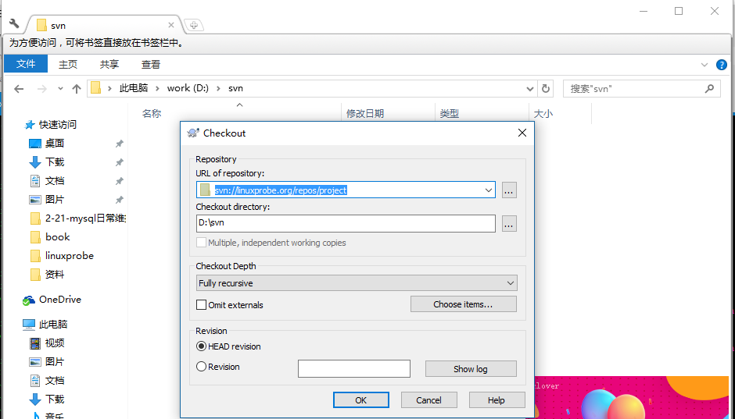  
如果在存储库上设置访问控制，则需要进行身份验证，如下所示，继续使用有效的用户和密码。   
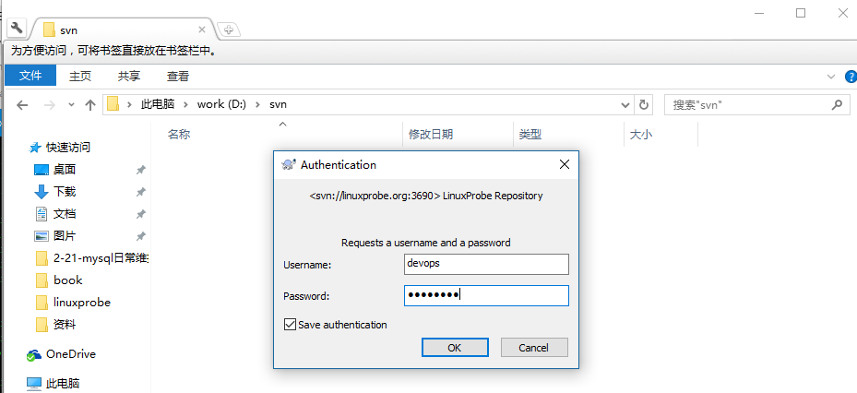  
完成结帐后，单击确定按钮   
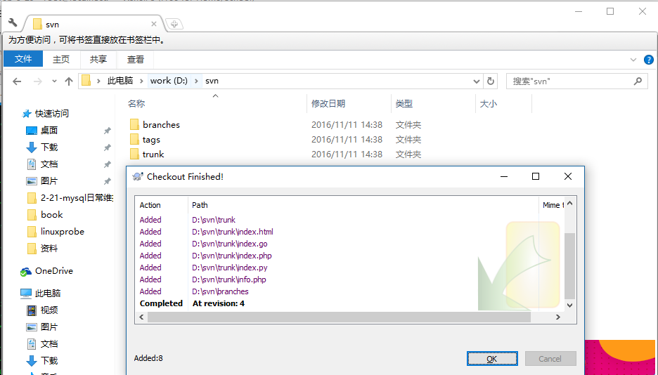  
只是完成从存储库检出。它可以从这个应用程序操作存储库

# Subversion HTTP Access

安装httpd参考：[http://blog.csdn.net/wh211212/article/details/52982917](http://blog.csdn.net/wh211212/article/details/52982917" \t "http://blog.csdn.net/wh211212/article/details/_blank)

安装依赖包

[root@linuxprobe~]# yum -y install mod_dav_svn

为HTTP访问配置Subversion，例如，为存储库“/var/svn/repos/project”

[root@linuxprobe run]# vi /etc/httpd/conf.d/subversion.conf# create new

<Location /project>

DAV svn

AuthType Basic

AuthName "DAV SVN"

AuthUserFile /var/svn/.svnpasswd

Require valid-user

SVNPath /var/svn/repos/project

</Location>

[root@linuxprobe run]# htpasswd -c /var/svn/.svnpasswd wang

New password:

Re-type new password:

Adding password for user wang

[root@linuxprobe run]# chown -R apache. /var/svn/repos

[root@linuxprobe run]# systemctl restart httpd

[root@linuxprobe run]# systemctl status httpd

配置访问控制

[root@linuxprobe ~]# vi /var/svn/repos/project/conf/authzsvn.conf # define group

[groups]

developer = wang,devops

operator = shaon# everyone can Read access

[/]

* = r# only developer group can Read/Write under the trunk

[project:/trunk]@developer = rw# only operator can Read/Write under the branches

[project:/branches]@operator = rw# only operator can Read/Write under the tags

[project:/tags]@operator = rw

[root@linuxprobe~]# vi /etc/httpd/conf.d/subversion.conf

<Location /project>

DAV svn

AuthType Basic

AuthName "DAV SVN"

AuthUserFile /var/svn/.svnpasswd

Require valid-user

SVNPath /var/svn/repos/project

AuthzSVNAccessFile /var/svn/repos/project/conf/authzsvn.conf

</Location>

[root@linuxprobe ~]# systemctl restart httpd

从客户端访问如下

[root@vdevops ~]# svn --username wang list http://linuxprobe.org/project

Authentication realm: <http://linuxprobe.org:80> DAV SVN

Password for 'wang':

-----------------------------------------------------------------------

ATTENTION! Your password for authentication realm:

<http://linuxprobe.org:80> DAV SVN

can only be stored to disk unencrypted! You are advised to configure

your system so that Subversion can store passwords encrypted, if

possible. See the documentation for details.

You can avoid future appearances of this warning by setting the valueof the 'store-plaintext-passwords' option to either 'yes' or 'no' in'/root/.subversion/servers'.

-----------------------------------------------------------------------

Store password unencrypted (yes/no)? no

branches/

tags/

trunk/

可以使用Web浏览读取访问   
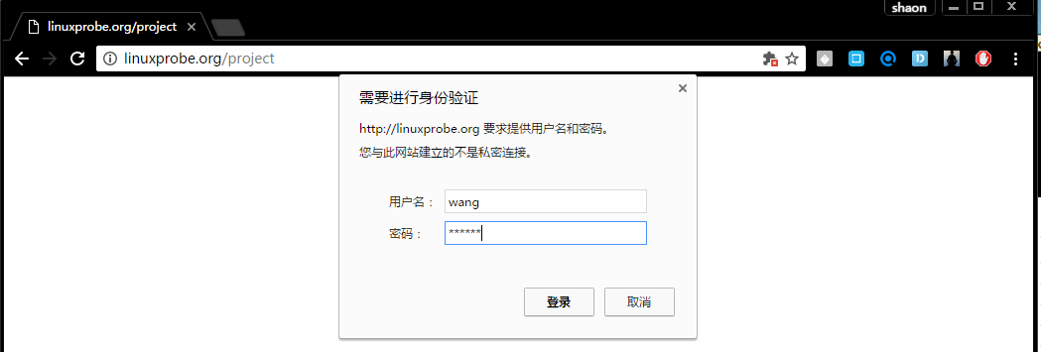  
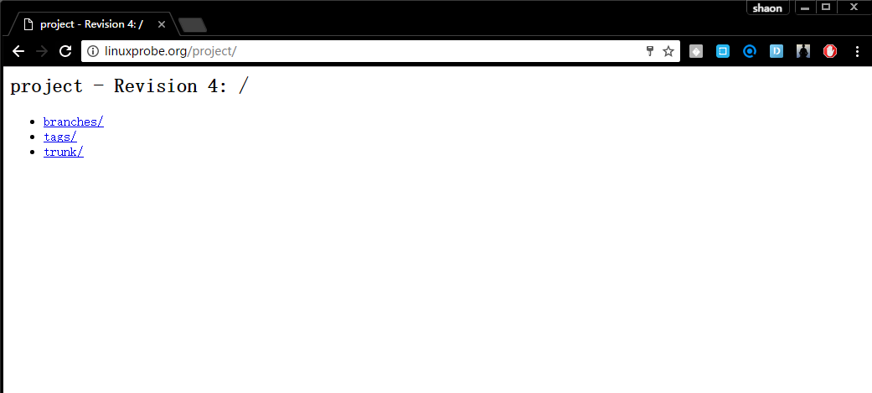

可以使用TortoiseSVN客户端指定我们设置的URL，如下所示   
