# 

**BookBiz Management System**

Course：420-942-VA APPLICATION DEVELOPMENT 1 (DESKTOP)sect. 05899

StudentID：2201546

StudentName：Jianquan Liang

目录

BookBiz Management System 1

1. Project Description 3

2. Permissions and functions 3

3. User class Design 4

4. Class Design 5

5. Database Design 5

6. Interface Design 7

Login page 7

MIS Manager Main Page 8

Add User/Employee Information 9

Update User/Employee Information 9

Sales Manager Main Page 10

Add Client Information 11

Update Client 11

Inventory Controller Main page 12

Add Book Information 13

Update Book Information 13

Add Publisher 14

Add Author 14

Order Clerks Main Page 15

Add Order Information 16

Incomplete Orders information 17

Complete Orders information 18

7. Code Design 18

8. Implementation 18

9. Conclusion 19

10. Specify clearly what you have learned from this project. 19

### Project Description

Book distribution management system. The system design has the following parts: book inventory management, personnel and user information management, order management, and so on. Realize the different contents of the personnel authority management system of different departments.

### **Permissions and functions**

* 1. Permissions are assigned to the following people：

MIS Manager,Sales Manager ,Sales Manager ,Order Clerks.In the system design, the authority management of the following personnel is realized, and different personnel displays different contents.

* 1. MIS Manager:
* Add user information
* Search/List user information
* Add employee information
* Search/list employee information
  1. Sales Manager:
* Add client information
* Search/List client information
  1. Inventory Controller
* Add/search/list book information and related information
  1. Order Clerks
* Add/Cancel clients’ orders
* Search/List clients’ orders

### **User class Design**

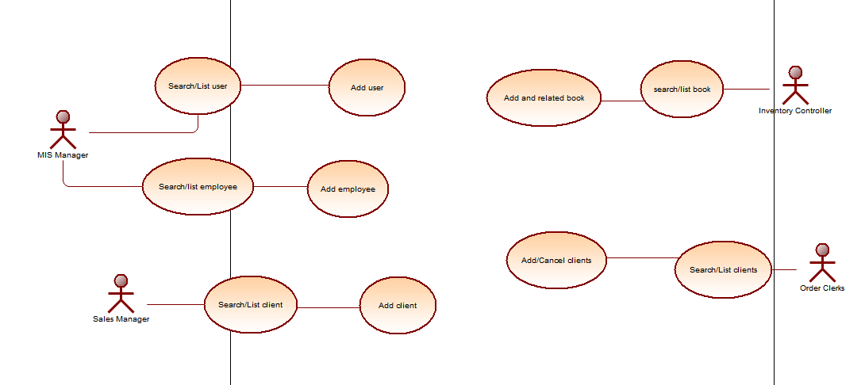

### **Class Design**

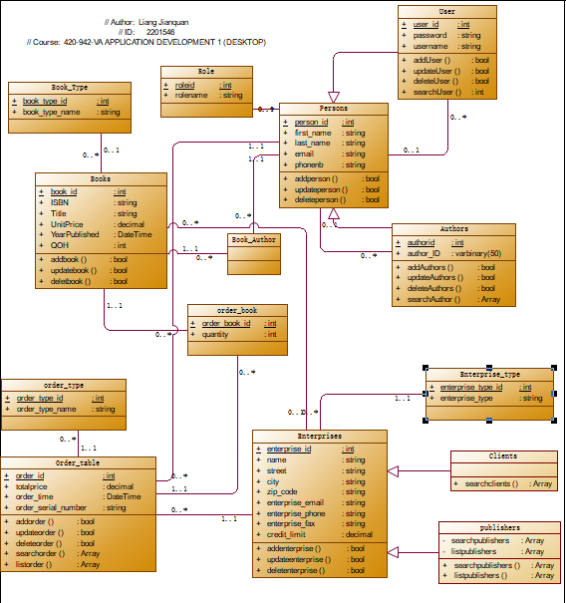

### **Database Design**

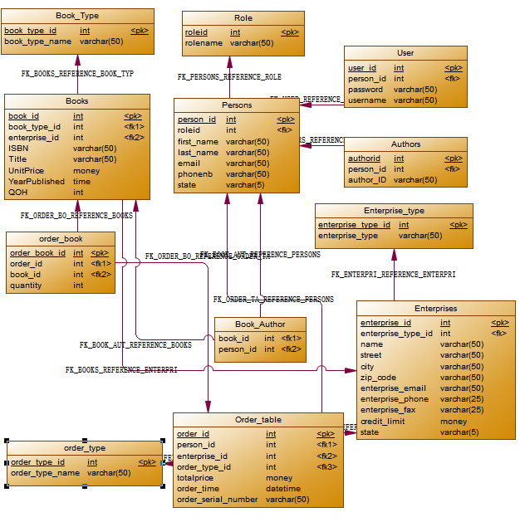

### **Interface Design**

## Login page

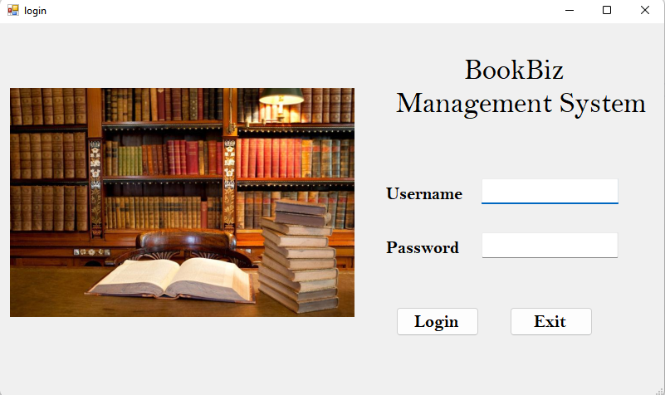

## MIS Manager Main Page

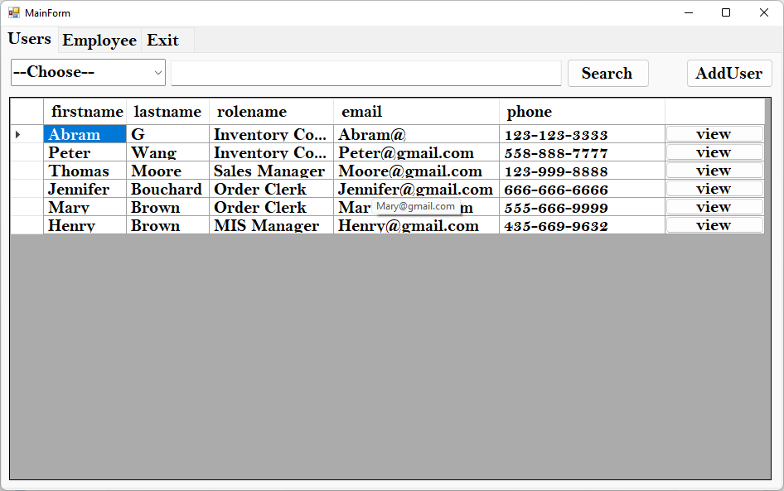

## Add User/Employee Information

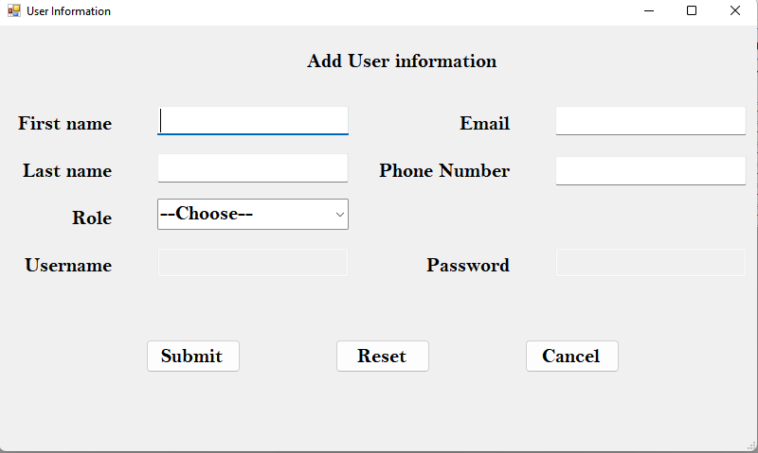

## Update User/Employee Information

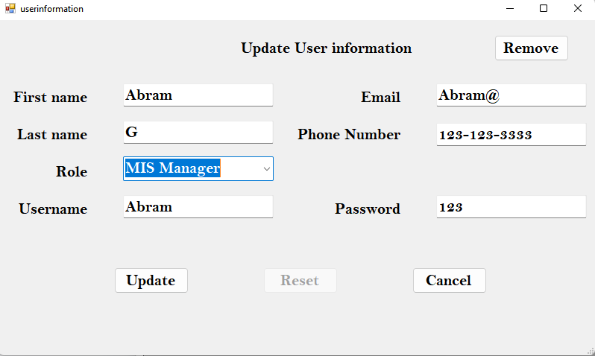

## Sales Manager Main Page

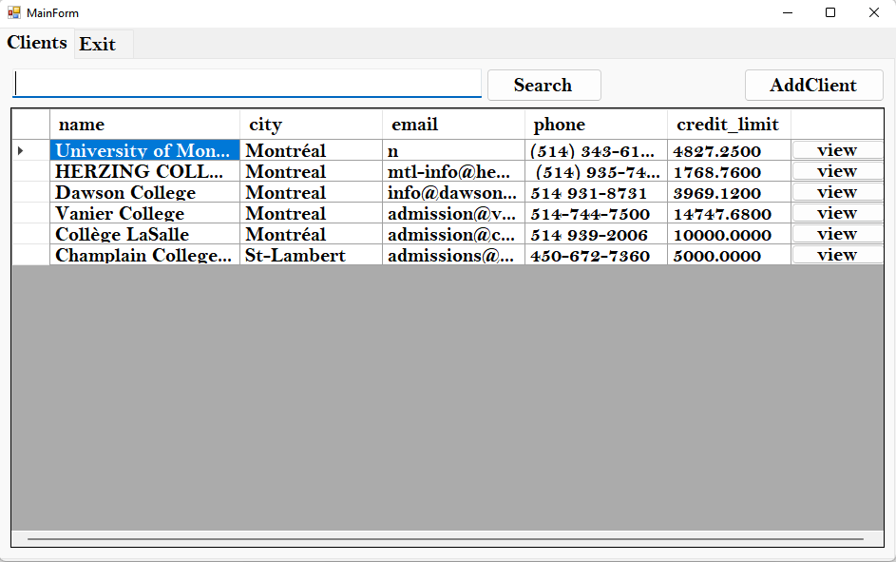

## Add Client Information

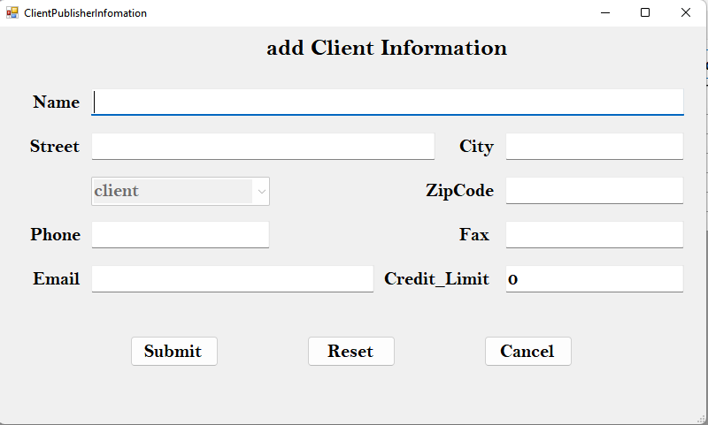

## Update Client

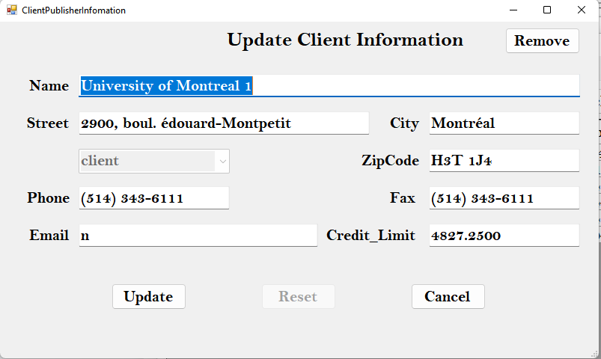

## Inventory Controller Main page

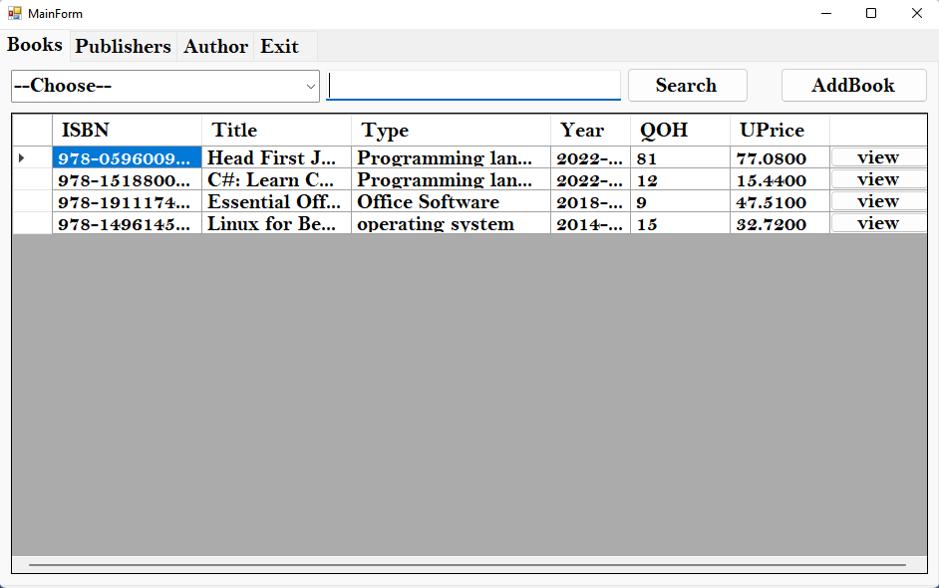

## Add Book Information

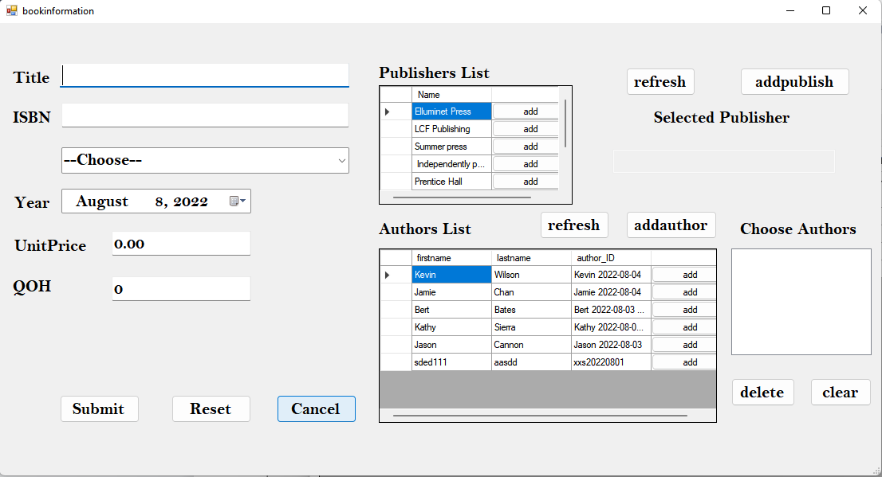

## Update Book Information

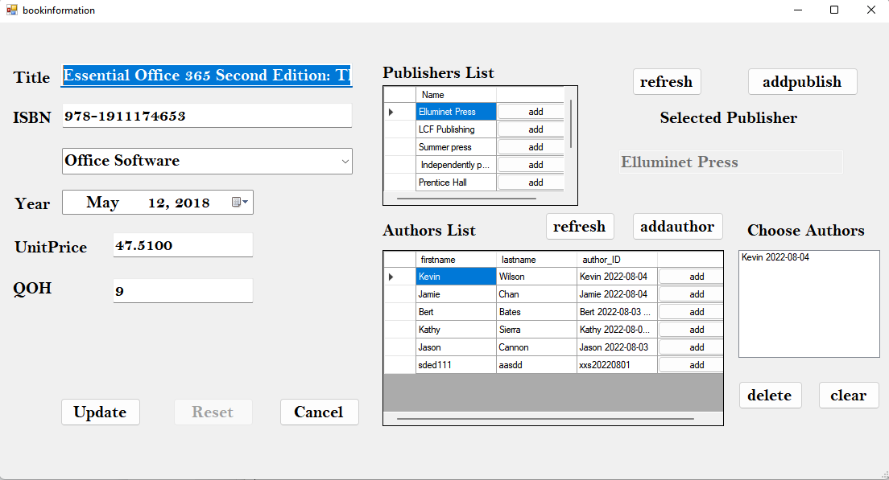

## Add Publisher

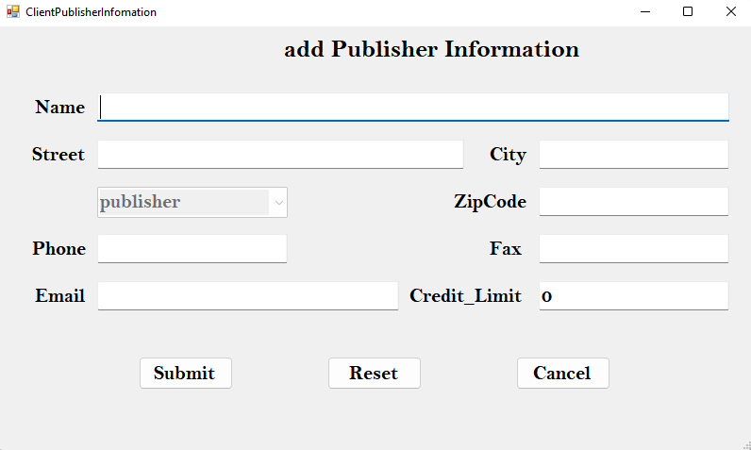

## Add Author

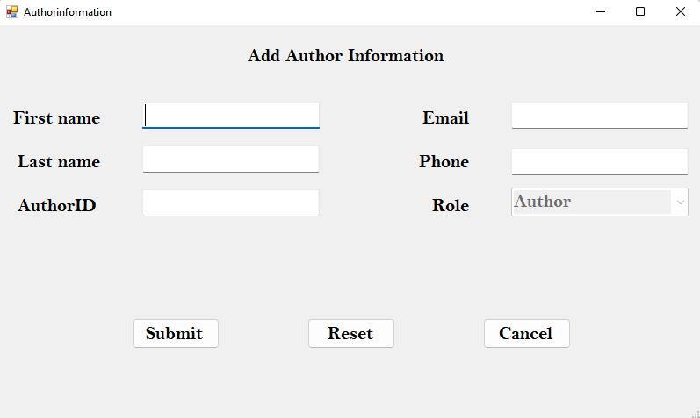

## Order Clerks Main Page

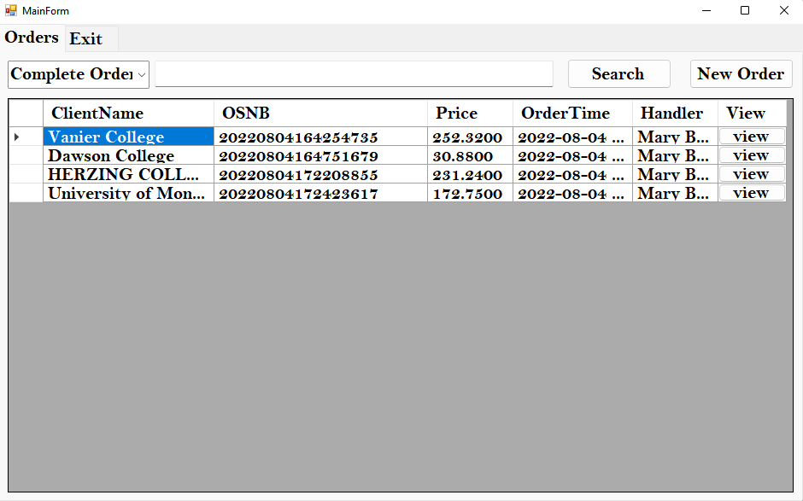

## Add Order Information

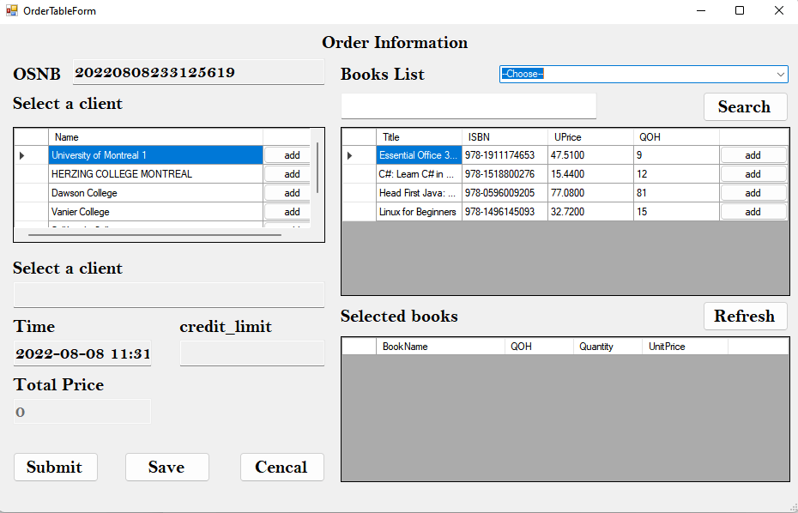

## Incomplete Orders information

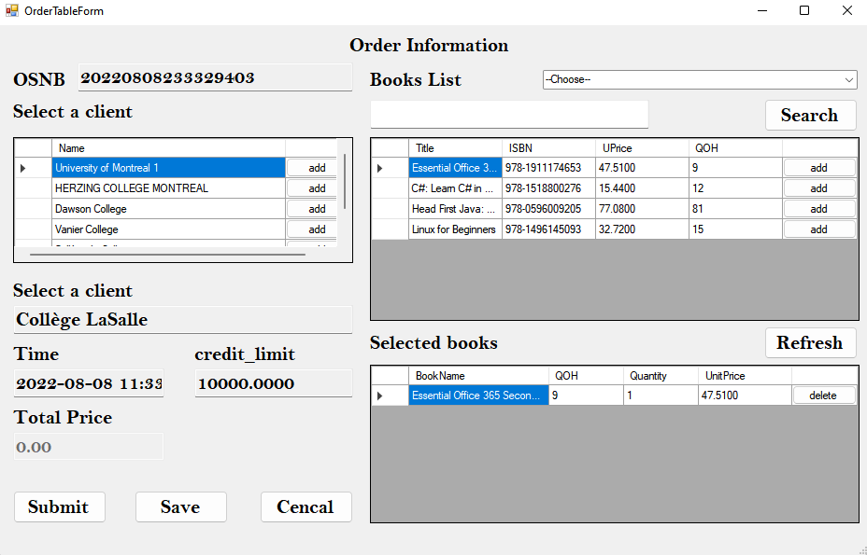

## Complete Orders information

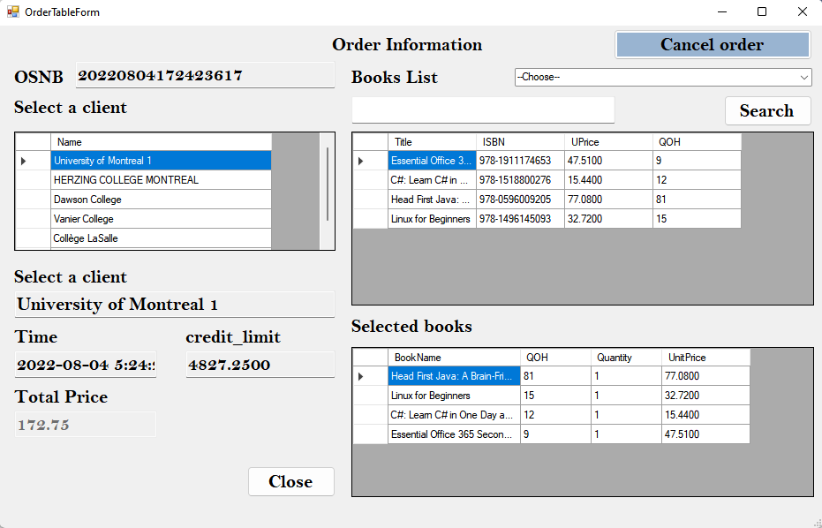

### **Code Design**

The code uses an object-oriented model, and the windows form interface code mainly involves interface operations. Classes are entities and methods. I am using the MS SQL 2019 database. The database link string is in the App.config file. The internal class Sqlconnect implements the incoming string to execute the database statement and returns the required type.

MSSQL2019 database backup file (BookBizDB.bak)

MSSQL2019 database execution statement file, including table creation statement, and some basic data that need to be pre-inserted in some tables (bookbizdb_tableanddata.sql).

### **Implementation**

Display the corresponding page according to the user type. For example, MIS Manager displays users and employees. Sales manager showing customers. The inventory controller displays books, publishers, and authors. The order clerk shows the order.

Complete the addition, modification, and deletion of users and employees. The client adds, modifies, and deletes. Book additions, modifications, deletions, and association of publishers and authors. Publisher and Author add, modify, and delete. When an order is saved as an incomplete order, the incomplete order can be modified and submitted. Orders are saved as completed orders, completed orders cannot be modified, but completed orders can be canceled.

### **Conclusion**

Complete the actions required by the project. Functions that implement user needs.

### **Specify** clearly what you have learned from this project.

Use OOM canonical code. Use power design software to design database diagrams and class diagrams. In-depth understanding of the control and operation code writing of windows froms. Familiar with linking databases and writing database statements in c#.