**LeStorage网站配色方案**

**作者：JIanquan Liang&Demi**

目录

配色方案一： 3

配色方案二： 4

配色方案三： 5

配色方案四： 7

总结： 9

收集图标： 10

# 配色方案一：

网站效果截图：网站主色调 蓝色和橙色

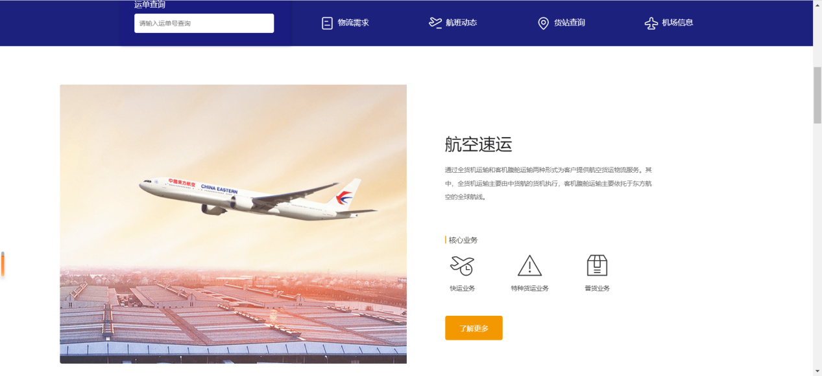

色卡：

|  |  |
| --- | --- |
| [#FFFFFF Color Image](https://www.colorcombos.com/colors/FFFFFF) | **Hex:** [#FFFFFF](https://www.colorcombos.com/colors/FFFFFF)  **RGB:** 255, 255, 255  **CMYK:** 0, 0, 0, 0  **HSV:** 0, 0, 100 |
| [#C0C0C0 Color Image](https://www.colorcombos.com/colors/C0C0C0) | **Hex:** [#](https://www.colorcombos.com/colors/C0C0C0)[C0C0C0](https://www.colorcombos.com/colors/C0C0C0)  **RGB:** 192, 192, 192  **CMYK:** 0, 0, 0, 24.7  **HSV:** 0, 0, 75 |
| [#FF9900 Color Image](https://www.colorcombos.com/colors/FF9900) | **Hex:** [#FF9900](https://www.colorcombos.com/colors/FF9900)  **RGB:** 255, 153, 0  **CMYK:** 0, 40, 100, 0  **HSV:** 36, 100, 100 |
| [#000099 Color Image](https://www.colorcombos.com/colors/000099) | **Hex:** [#000099](https://www.colorcombos.com/colors/000099)  **RGB:** 0, 0, 153  **CMYK:** 100, 100, 0, 40  **HSV:** 240, 100, 60 |
|  | **Hex:**#252835 |

图标颜色：



# 配色方案二：

网站效果截图：主色调黄色，黑色，红色

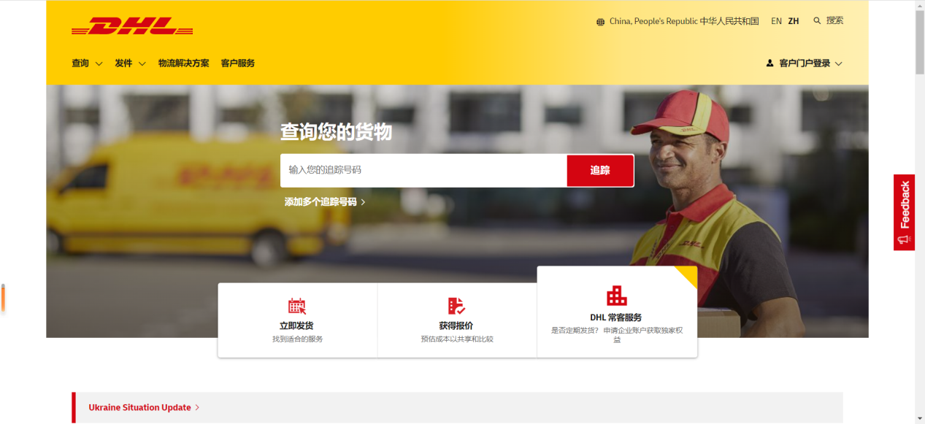

色卡

|  |  |
| --- | --- |
| [#FFCC00 Color Image](https://www.colorcombos.com/colors/FFCC00) | **Hex:** [#FFCC00](https://www.colorcombos.com/colors/FFCC00)  **RGB:** 255, 204, 0  **CMYK:** 0, 20, 100, 0  **HSV:** 48, 100, 100 |
| [#000000 Color Image](https://www.colorcombos.com/colors/000000) | **Hex:** [#000000](https://www.colorcombos.com/colors/000000)  **RGB:** 0, 0, 0  **CMYK:** NAN, NAN, NAN, 100  **HSV:** 0, 0, 0 |
| [#CC0000 Color Image](https://www.colorcombos.com/colors/CC0000) | **Hex:** [#CC0000](https://www.colorcombos.com/colors/CC0000)  **RGB:** 204, 0, 0  **CMYK:** 0, 100, 100, 20  **HSV:** 0, 100, 80 |
| [#FFFFFF Color Image](https://www.colorcombos.com/colors/FFFFFF) | **Hex:** [#FFFFFF](https://www.colorcombos.com/colors/FFFFFF)  **RGB:** 255, 255, 255  **CMYK:** 0, 0, 0, 0  **HSV:** 0, 0, 100 |

图标颜色：



# 配色方案三：

网站效果截图：主色调紫蓝色，绿色

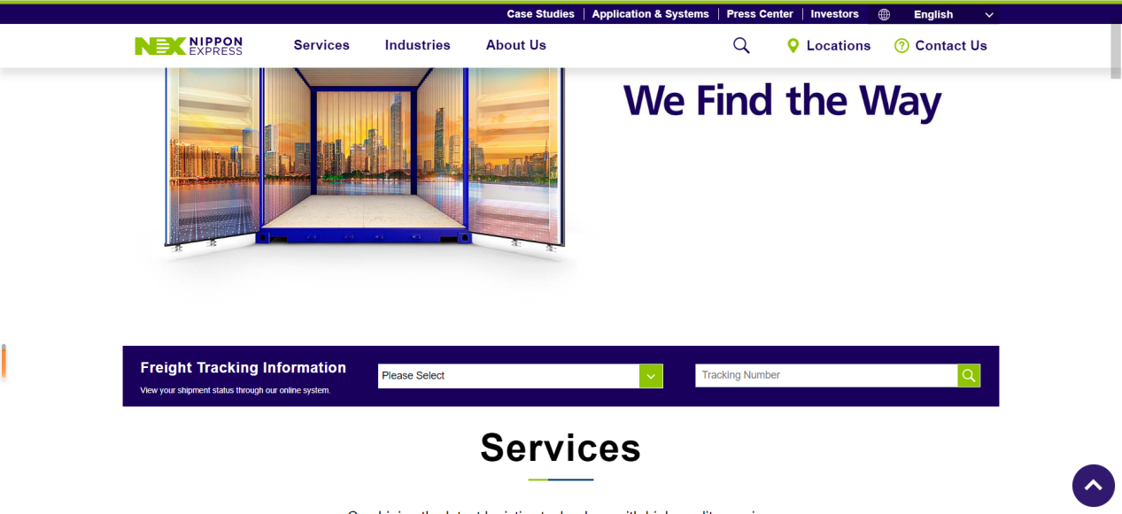

色卡

|  |  |
| --- | --- |
| [#443266 Color Image](https://www.colorcombos.com/colors/443266) | **Hex:** [#443266](https://www.colorcombos.com/colors/443266)  **RGB:** 68, 50, 102  **CMYK:** 33.3, 51, 0, 60  **HSV:** 261, 51, 40 |
| [#F1F0FF Color Image](https://www.colorcombos.com/colors/F1F0FF) | **Hex:** [#F1F0FF](https://www.colorcombos.com/colors/F1F0FF)  **RGB:** 241, 240, 255  **CMYK:** 5.5, 5.9, 0, 0  **HSV:** 244, 6, 100 |
| [#8C489F Color Image](https://www.colorcombos.com/colors/8C489F) | **Hex:** [#8C489F](https://www.colorcombos.com/colors/8C489F)  **RGB:** 140, 72, 159  **CMYK:** 11.9, 54.7, 0, 37.6  **HSV:** 287, 55, 62 |
| [#000000 Color Image](https://www.colorcombos.com/colors/000000) | **Hex:** [#000000](https://www.colorcombos.com/colors/000000)  **RGB:** 0, 0, 0  **CMYK:** NAN, NAN, NAN, 100  **HSV:** 0, 0, 0 |
| [#92CD00 Color Image](https://www.colorcombos.com/colors/92CD00) | **Hex:** [#92CD00](https://www.colorcombos.com/colors/92CD00)  **RGB:** 146, 205, 0  **CMYK:** 28.8, 0, 100, 19.6  **HSV:** 77, 100, 80 |
| [#FFFFFF Color Image](https://www.colorcombos.com/colors/FFFFFF) | **Hex:** [#FFFFFF](https://www.colorcombos.com/colors/FFFFFF)  **RGB:** 255, 255, 255  **CMYK:** 0, 0, 0, 0  **HSV:** 0, 0, 100 |

图标颜色：



# 配色方案四：

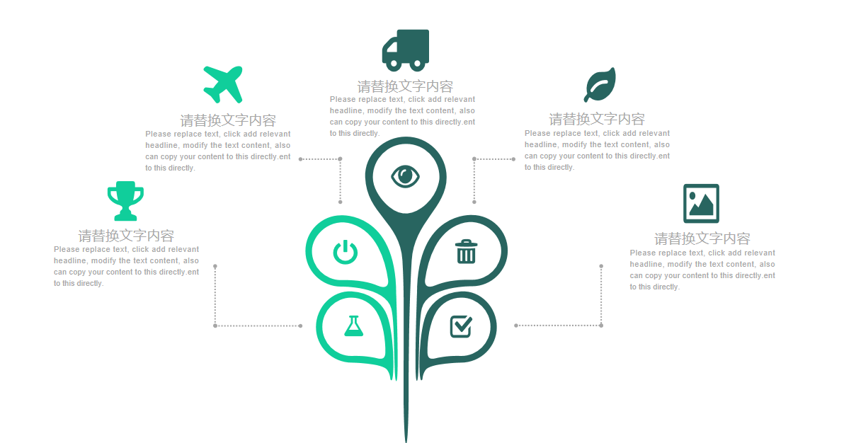：

色卡

|  |  |  |
| --- | --- | --- |
| [#41924B Color Image](https://www.colorcombos.com/colors/41924B) | **Hex:** [#41924B](https://www.colorcombos.com/colors/41924B)  **RGB:** 65, 146, 75  **CMYK:** 55.5, 0, 48.6, 42.7  **HSV:** 127, 55, 57 | |
| [#AFEAAA Color Image](https://www.colorcombos.com/colors/AFEAAA) | **Hex:** [#AFEAAA](https://www.colorcombos.com/colors/AFEAAA)  **RGB:** 175, 234, 170  **CMYK:** 25.2, 0, 27.4, 8.2  **HSV:** 115, 27, 92 | |
| [#87E293 Color Image](https://www.colorcombos.com/colors/87E293) | **Hex:** [#87E293](https://www.colorcombos.com/colors/87E293)  **RGB:** 135, 226, 147  **CMYK:** 40.3, 0, 35, 11.4  **HSV:** 128, 40, 89 | |
| [#000000 Color Image](https://www.colorcombos.com/colors/000000) | **Hex:** [#000000](https://www.colorcombos.com/colors/000000)  **RGB:** 0, 0, 0  **CMYK:** NAN, NAN, NAN, 100  **HSV:** 0, 0, 0 | |
| [#FFFFFF Color Image](https://www.colorcombos.com/colors/FFFFFF) | | **Hex:** [#FFFFFF](https://www.colorcombos.com/colors/FFFFFF)  **RGB:** 255, 255, 255  **CMYK:** 0, 0, 0, 0  **HSV:** 0, 0, 100 |

图标颜色：



# 总结：

这里有四种配色方案，可以根据现在LeStorage公司制服颜色选择，因为如果上传公司宣传图片，近似色系会增加网站美观。如果没有跟公司图片或者Logo颜色相近的，请发图片给我，我会根据颜色重新选择色卡。

# 收集图标：





