1.给出职工中所有男性的所有信息（empid,empname,age,sex,edpid）

SELECT empid, empname, age, sex, depid

FROM employee

WHERE sex = '男';

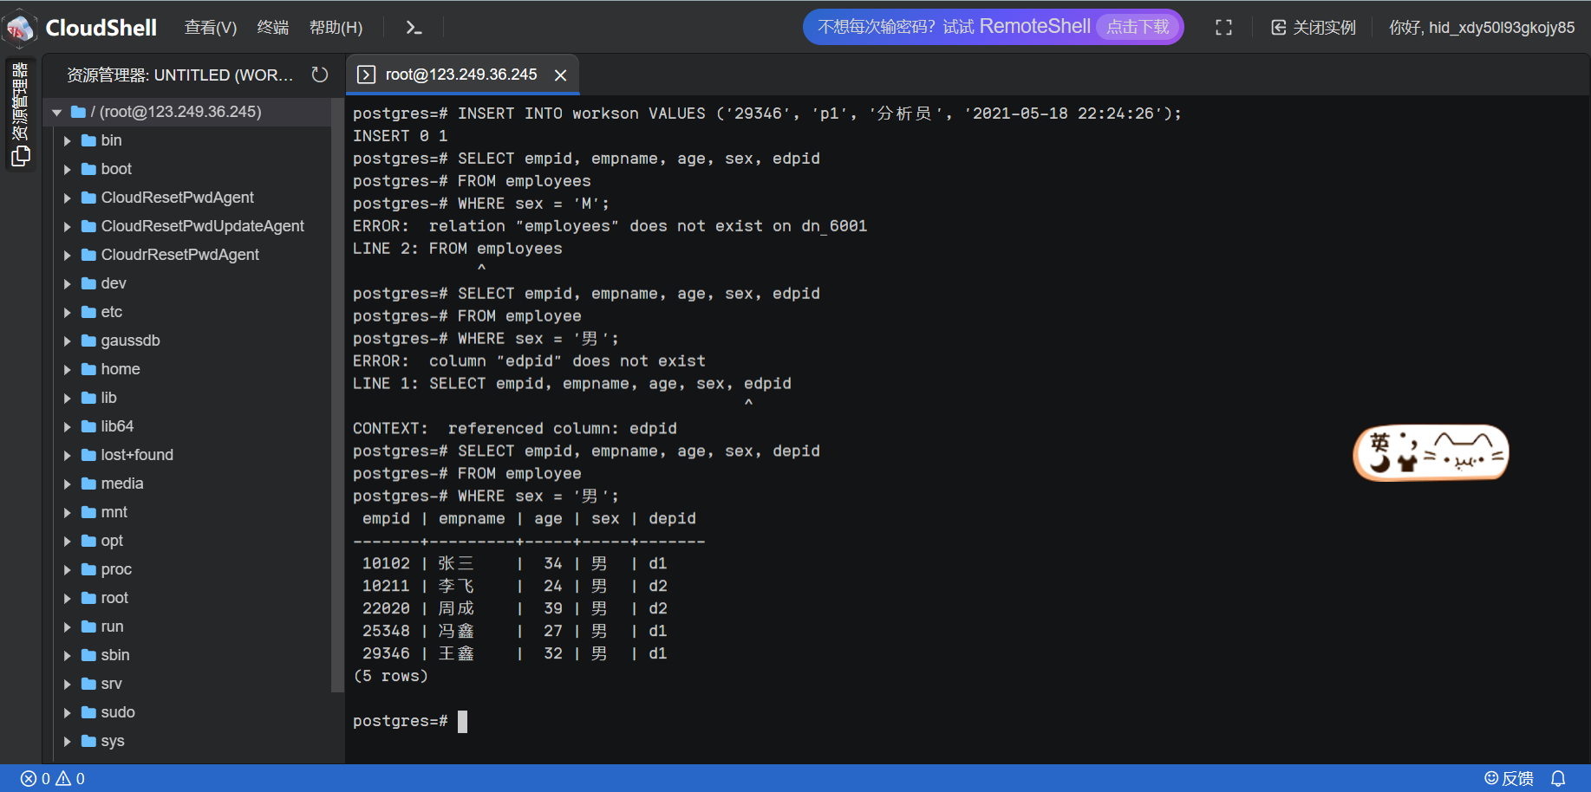

1. 统计“李”性职工信息，按年龄降序排序。（empid,empname,age,location）

SELECT employee.empid, employee.empname, employee.age, department.location

FROM employee INNER JOIN department ON employee.depid = department.depid

WHERE employee.empname LIKE '李%'

ORDER BY employee.age DESC;

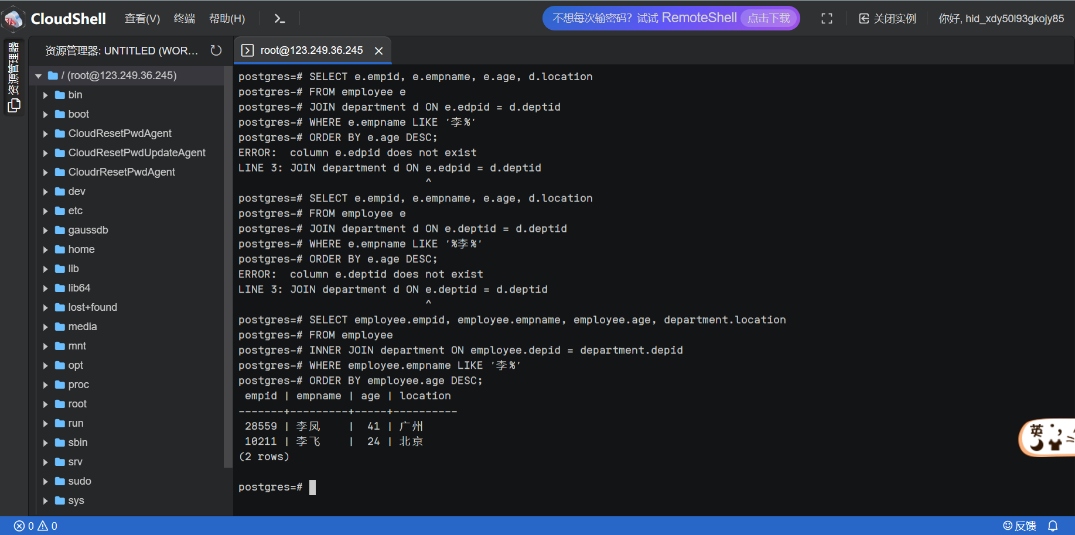

1. 给出每位职员参与项目的最高预算和最低预算（empname，highestbudget，lowestbudget）

SELECT e.empname,

MAX(p.budget) AS highestbudget,

MIN(p.budget) AS lowestbudget

FROM employee e

INNER JOIN workson w ON e.empid = w.empid

INNER JOIN project p ON w.proid = p.proid

GROUP BY e.empname;

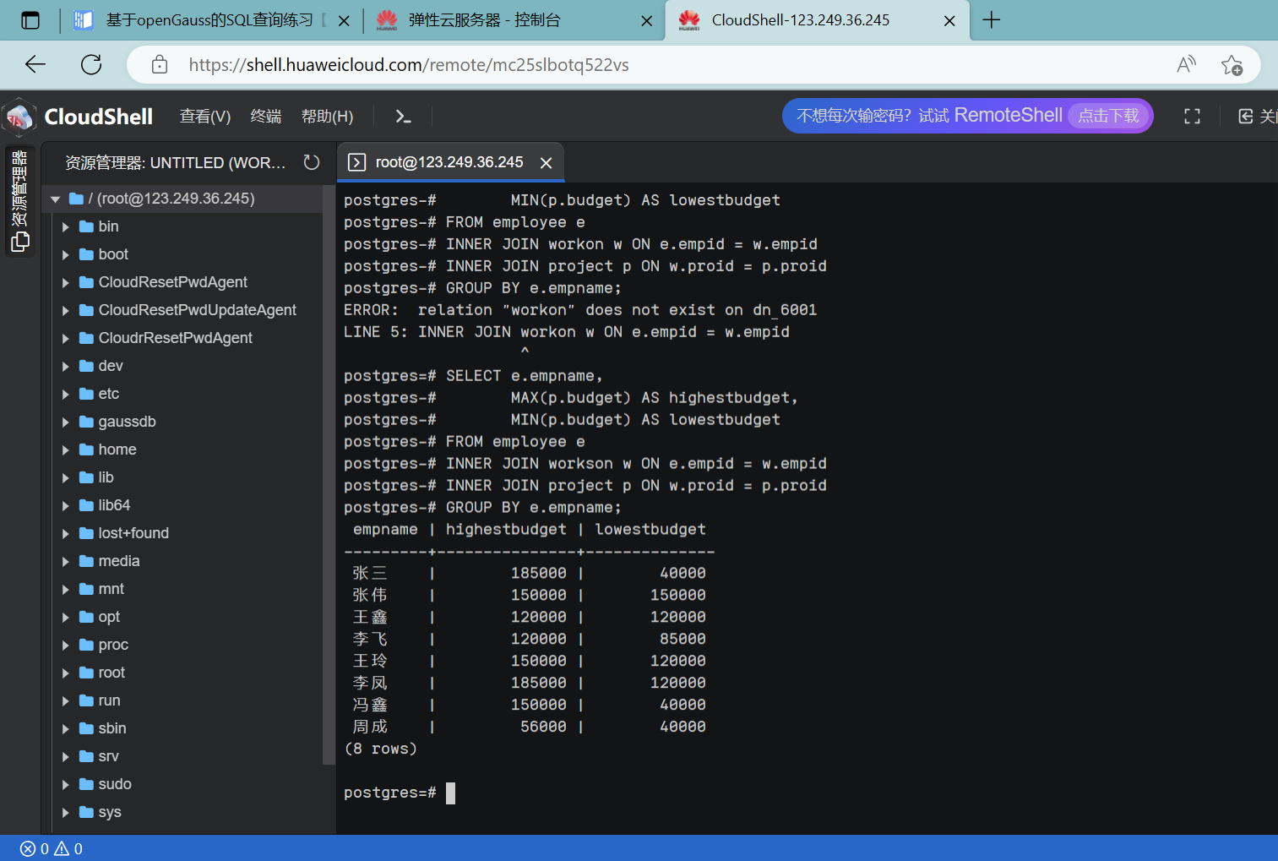

1. 给出所有项目超过一个的员工的id和参加的项目个数（empid, num）

SELECT empid, COUNT(\*) AS num

FROM workson

GROUP BY empid

HAVING COUNT(\*) > 1;

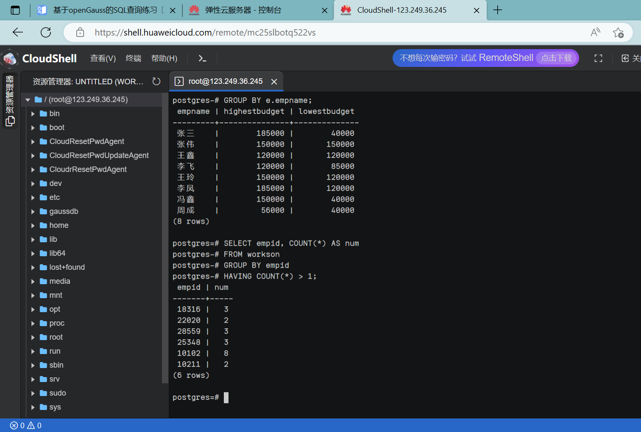

1. 给出项目种类号为“c2”且预算最多的项目。（proid，projectname，budget）

SELECT proid, projectname, budget

FROM project

WHERE catid = 'c2'

ORDER BY budget DESC

LIMIT 1;

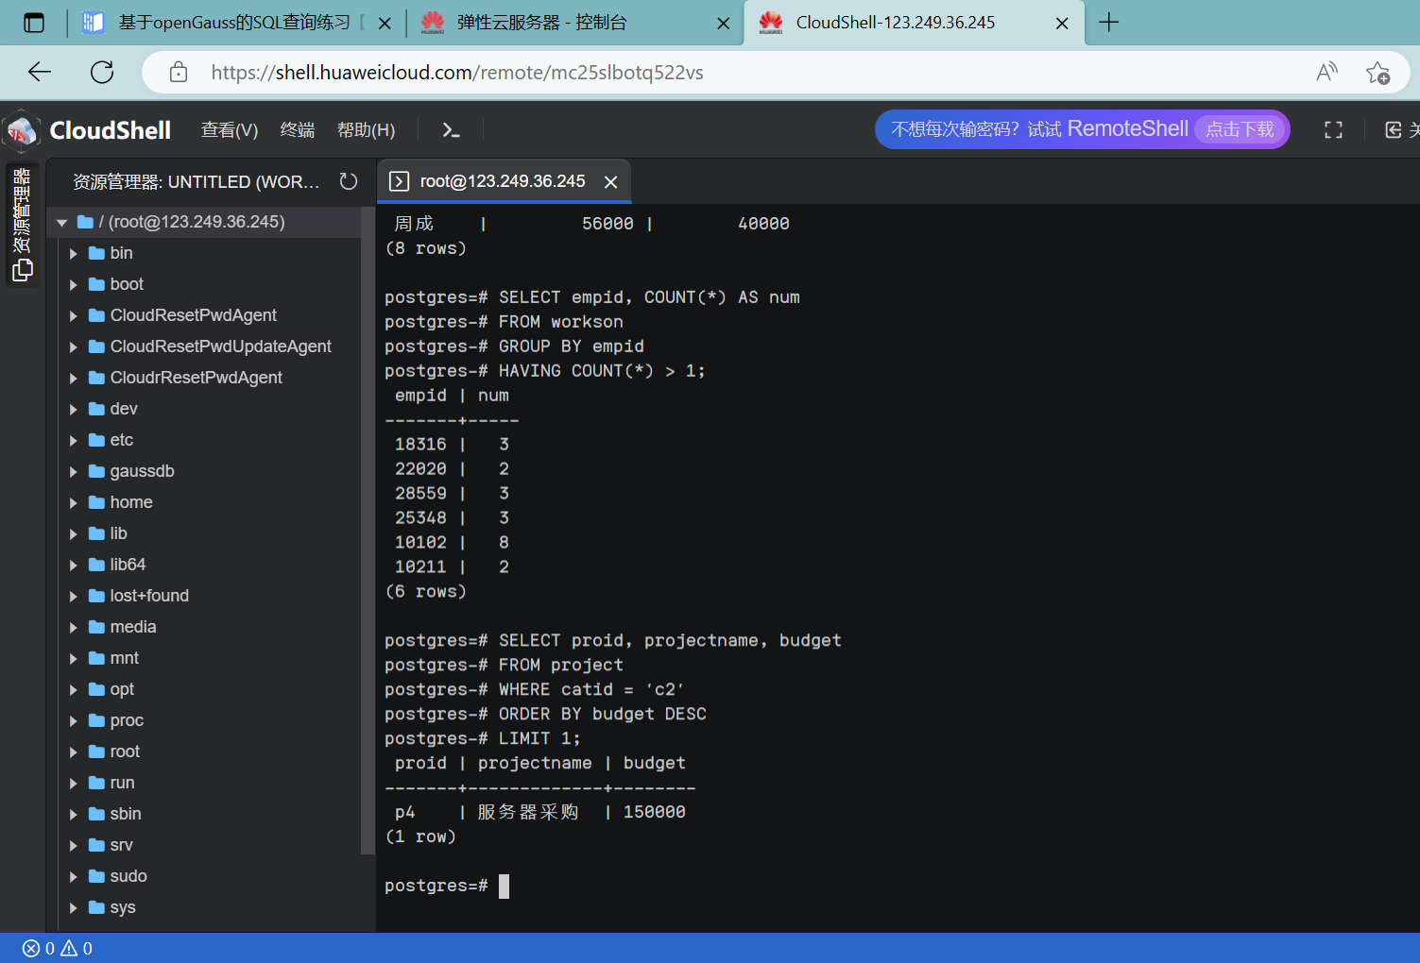

1. 给出参加“产品推广”项目，但不担任职位的员工的信息，（empid,empname，age,sex.depid）

SELECT e.empid, e.empname, e.age, e.sex, e.depid

FROM employee e

JOIN workson w ON e.empid = w.empid

JOIN project p ON w.proid = p.proid

WHERE p.projectname = '产品推广' AND w.job IS NULL;

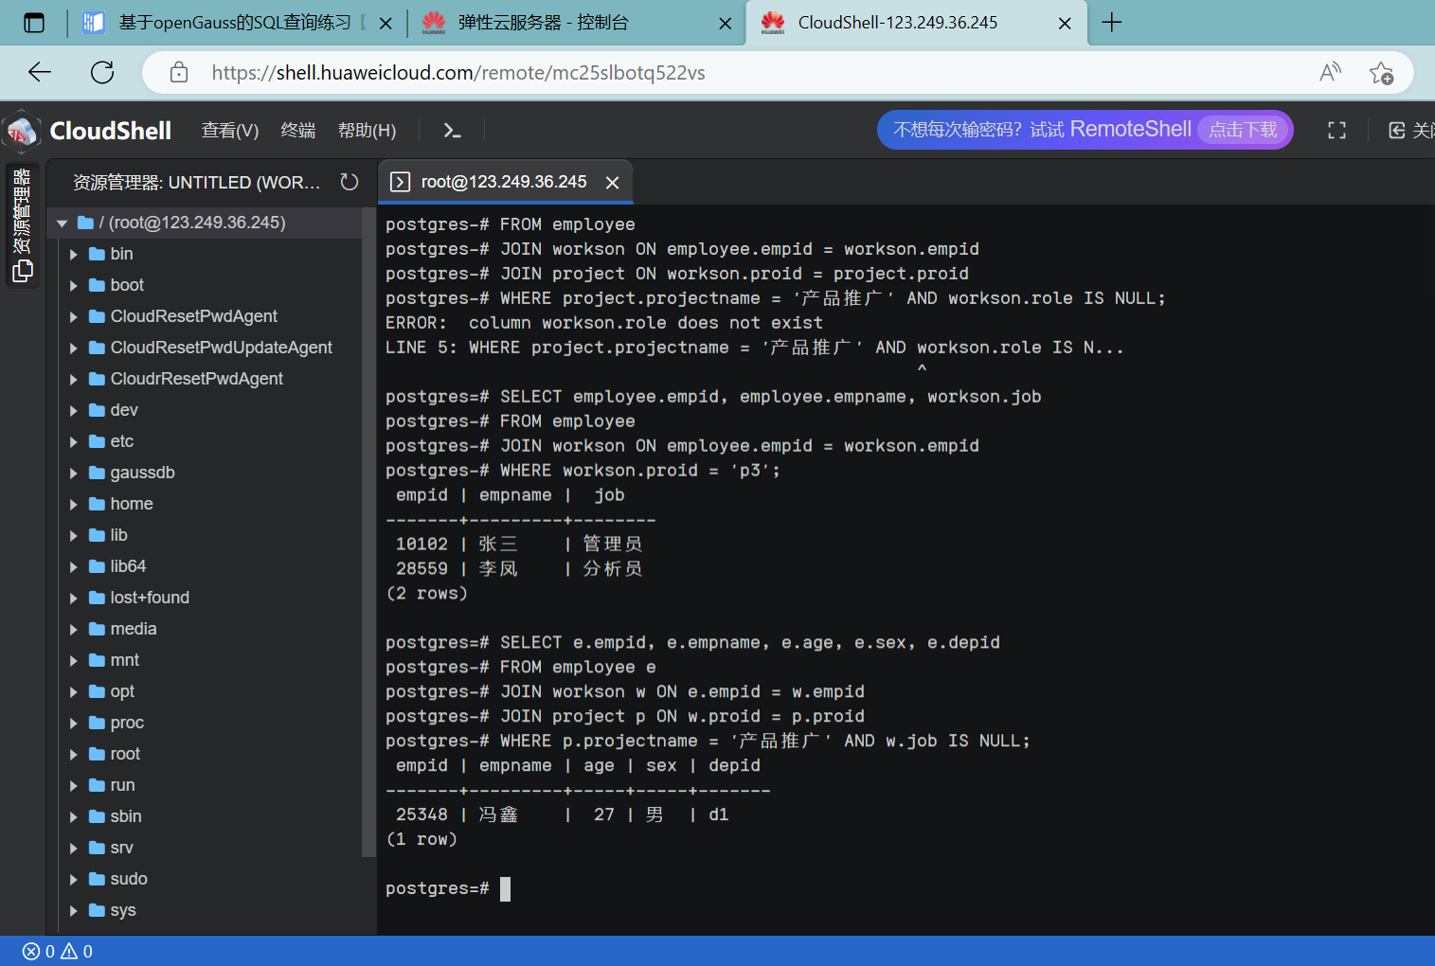

1. 给出工号为“10102”的员工每类项目的参加总数，若没有参加过某类项目，则参加项目总数显示为0（catid，proNum）

SELECT c.catid, COUNT(w.proid) AS proNum

FROM category c LEFT JOIN project p ON c.catid = p.catid

LEFT JOIN workson w ON p.proid = w.proid AND w.empid = '10102'

GROUP BY c.catid;

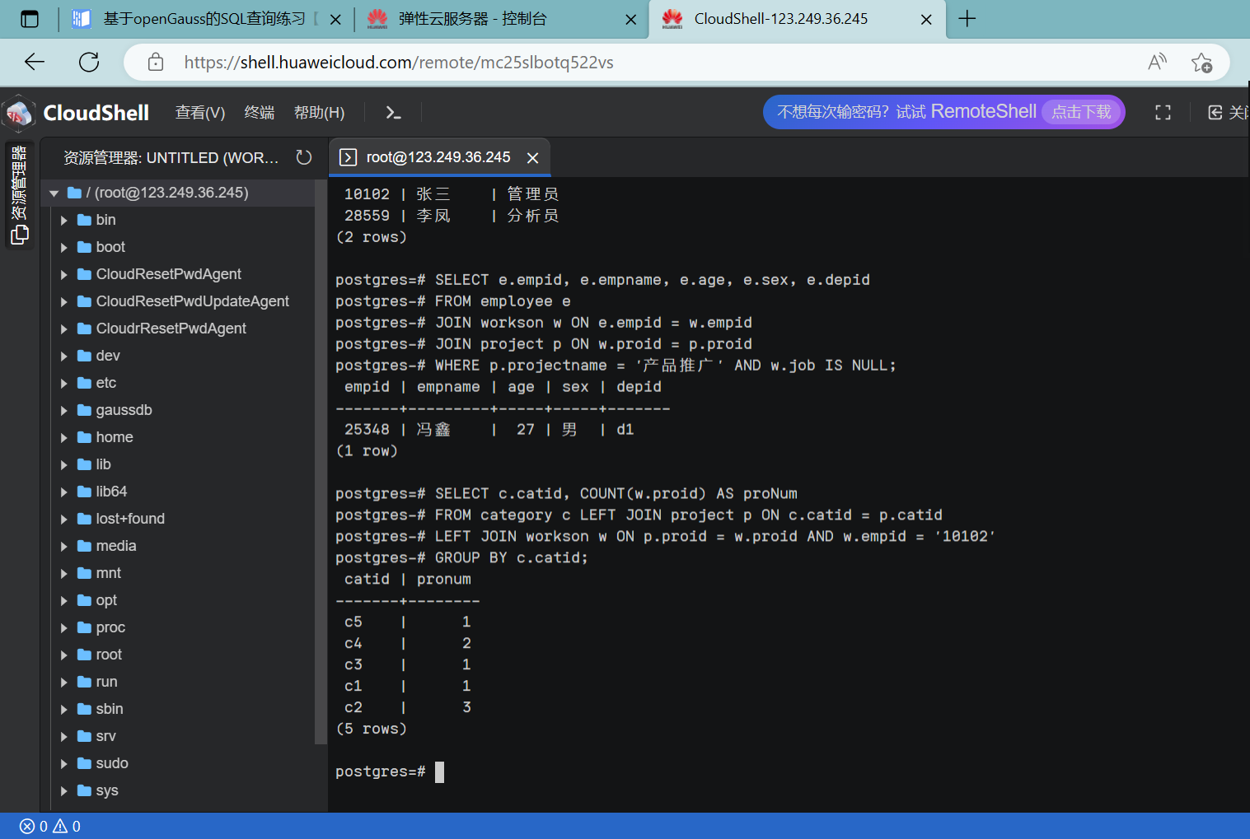

1. 给出没有参与“软件类”项目女性职工的信息（empid,empname, age,sex,depid)

SELECT e.empid, e.empname, e.age, e.sex, e.depid

FROM employee e

WHERE e.sex = '女' AND e.empid NOT IN (

SELECT w.empid

FROM workson w JOIN project p ON w.proid = p.proid

WHERE p.catid = 'c4'

);

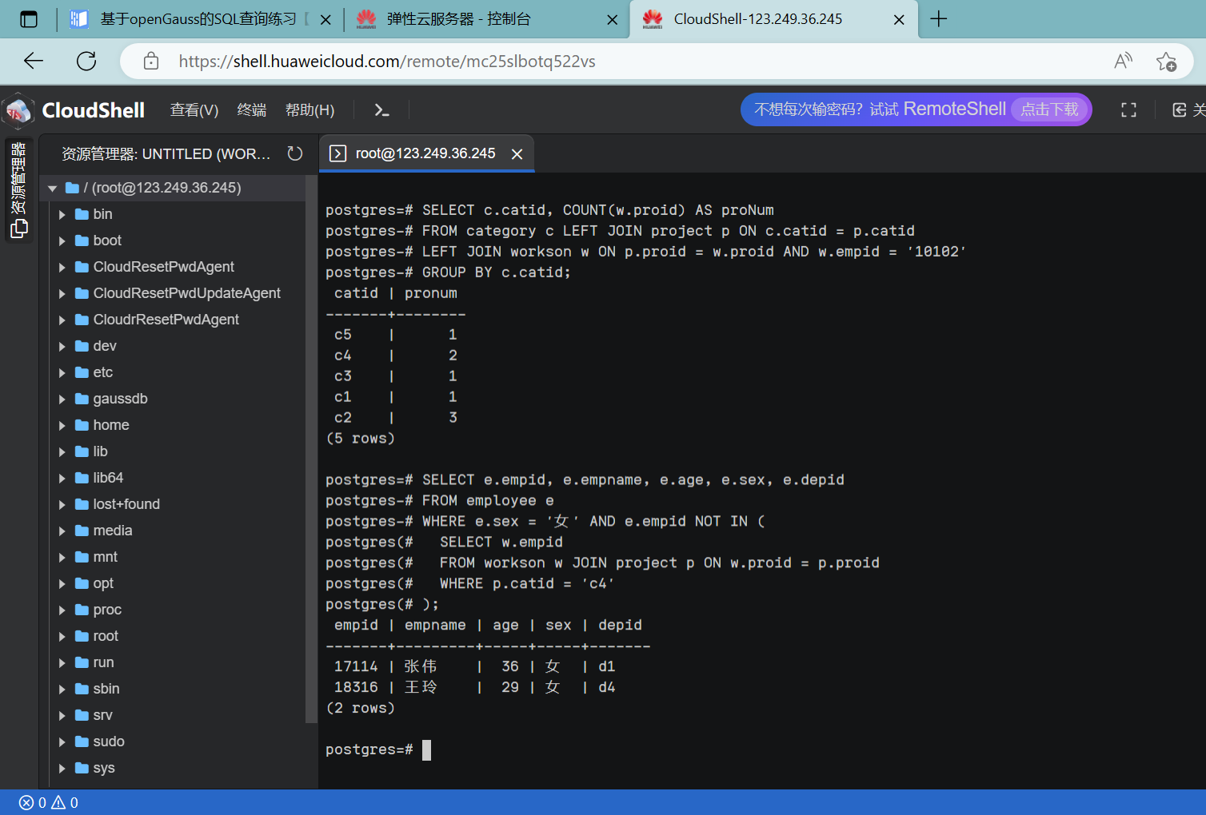

9.给出有30岁以上男性员工的地点名称和该地男员工最大年龄，结果按最大年龄升序排序

（location，maxage）

SELECT d.location, MAX(e.age) AS maxage

FROM employee e

INNER JOIN department d ON e.depid = d.depid

WHERE e.age > 30 AND e.sex = '男'

GROUP BY d.location

ORDER BY maxage ASC;

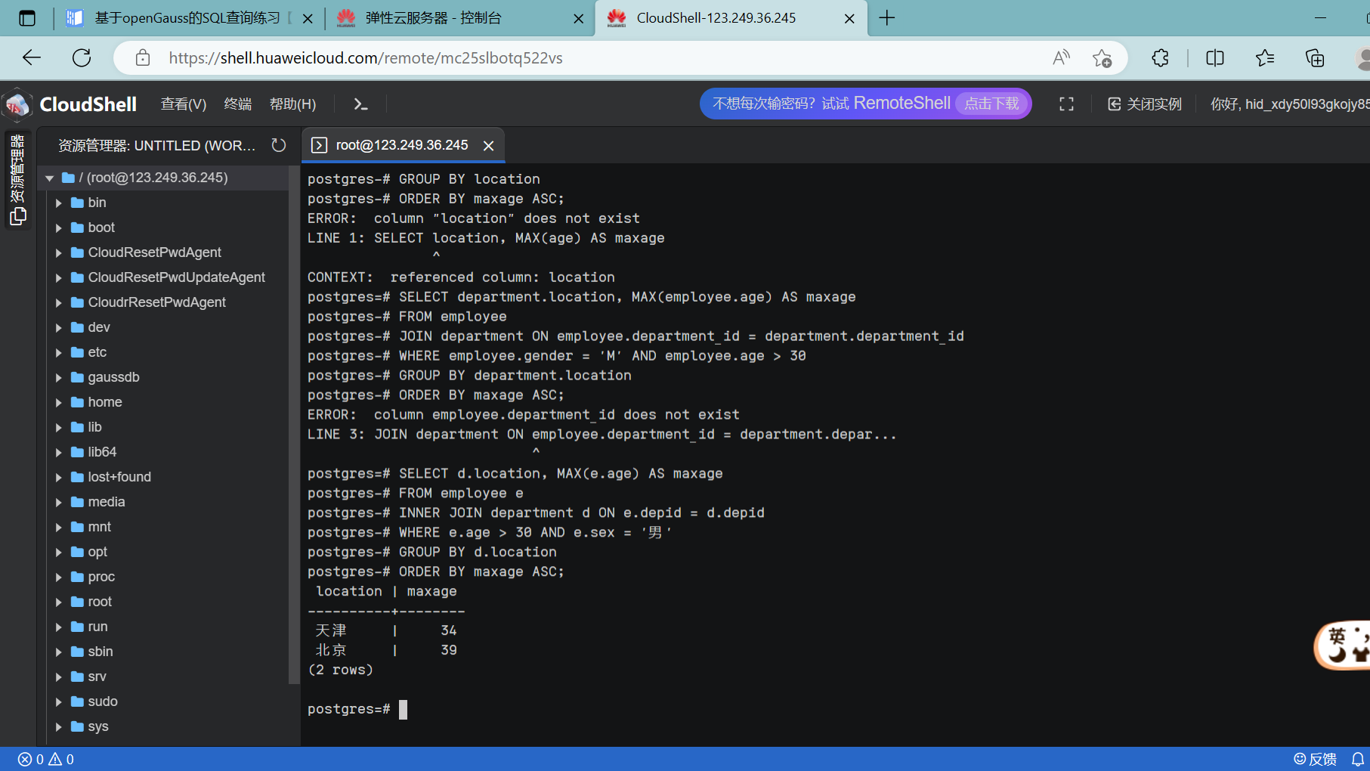

10.给出在广州工作的、参加“'产品推广'”项目的职员id、姓名及他们参加的项目个数（empid, empname, procnt）

SELECT e.empid, e.empname, COUNT(w.proid) AS procnt

FROM employee e

JOIN department d ON e.depid = d.depid

JOIN workson w ON e.empid = w.empid

JOIN project p ON w.proid = p.proid

WHERE d.location = '广州' AND p.projectname = '产品推广'

GROUP BY e.empid, e.empname;

