Description of the SPLINE library

Contents

1. General routines

1.1. Table of routine
1.2. Underline definitions
1.2.1. Definition of splines
1.2.2. Band matrices
1.3. General modules
1.4. Additional comments

2. Atomic orbital-related routines

2.1. Table of routines
2.2. Underline theory
2.2.1. Evaluation of two-electron integrals by direct differential. equation. method
2.2.2. Evaluation of two-electron integrals in B-spline basis
2.2.3. Cell algorithm for evaluation of two-electron integrals
2.3. Program realization
2.3.1. Specific modules
2.3.2. Direct integration of the Breit-Pauli Integrals: RKy, NKy, VKy, TKy.
2.3.3. Evaluation of two-electron integrals in B-spline basis: RK, NK, VK, TK.
2.3.4. Evaluation of two-electron integrals by cell algorithm: RK1, NK1, VK1, TK1.
2.4. Additional comments

3. Test program

1. General routines

1.1 Table of routines

name | short description
bvalu2 | calculates at given x the value and derivatives of function given in the B-spline representation
bvmv | returns matrix element <x|A|y>, where x,y are vectors, A is band array in symmetric, non-symmetric or almost symmetric form
bxv | computes y = B v, where B is symmetric band matrix, y,v are vectors
define_grid | gets input data for the grid and sets up the knots for spline
define_spline | initializes the values of the spline and its derivatives and evaluates the spline basic arrays (elementary operators in spline basis)
dinty | computes the array elements <B_{i}| y(r)|B_{j}> or <B_{i}|y(r)|B'_{j}> in non-symmetric column storage mode for function y(r) given at the gaussian points of each interval, weighted by the gaussian weights
gauss | gives up the values of gaussian coordinates and guassian weights over the interval [0, 1]
minty | computes the array elements <B_{i}| y(r)|B_{j}> in symmetric column storage mode for function y(r) given at the gaussian points of each interval, weighted by the gaussian weights
mrm | Computes the matrix representation of the operator r^{m} in the B-spline basis
spline_param | module - contains the main spline parameters
spline_grid | module - defines the values of splines and their some general functions at the gaussian points needed for integrations on the grid
spline_galerkin | module - contains common arrays used in the application of splines and the Galerkin method.
vbsplvd | calculates the values of the B-splines and their derivatives for one point per each interval
vinty | computes the vector elements <B_{i}|y(r)> where function y(r) is given at the gaussian points of each interval, weighted by the gaussian weight
yval | computes the values of r^{m} f(r), f'(r) or f''(r) at the gaussian points of each interval where f(r) is defined by the spline expansion vector

1.2. Underline definitions

1.2.1. Definition of splines

Consider interval [0,R] divided into segments. The endpoints of these segments are given by the knot sequence [t_{i}], i = 1,2,...,n + k. The B-splines of order k, B_{i,k}(r), on this knot sequence are defined recursively by the relations
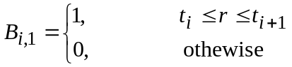 (1.1)
and
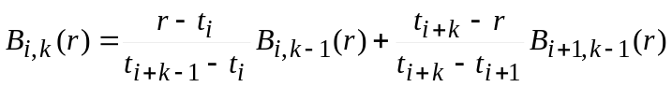 (1.2)
The function B_{i,k}(r) is a piecewise polynomial of degree k -1 inside the interval t_{i} ≤ r < t_{i+k} which vanish outside this interval. The sum at any point of all of the B-splines that do not vanish at the point is unity. The set of B-splines of ordre k on the knot sequence [t_{i}] forms a complete basis for piecewise polynomials of order k-1 on the interval spanned by the knot sequence, i.e.
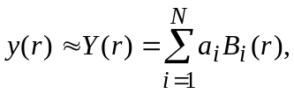 with a_{i} = < y(r)|B(r) > (1.3)
The knot defining our grid have k-fold multiplicity at the endpoints 0 and R; i.e. t₁ = t₂ = ... = t_{k} = 0 and t_{n+1} = t_{n+2} = ... = t_{n+k} = R. For k > 1, the B-splines generally vanish at their endpoints: however, at r = 0 the first B-spline is equal to 1 (with all others vanishing) and at r = R the last B-spline has the same behavior, which fact we will use below in implementing boundary conditions.

k+1 n
k • • • • • • • • • • • n+1
. • ml me • n+2
. • • .
2 • • .
1 • • n+k

number of intervals: nv = n+1-k
Each B_{i}-spline begins in knot i and ends in knot i+k+1, so, only B-splines with |i-j| ≤ k overlap.
Each interval iv is covered only by k B-splines: i = iv+ith-1 with ith=1,k

Semi-logarithmic scale:

1. ivt = 1, ml - equal step with h=1/ml (t(k+ml)=1.0)
2. ivt = ml+1,ml+me - logarithmic scale with incriment (1+h)
3. ivt = ml+me+1, n+1-k - equal step with h = h_{max}

    - Band matrices

Symmetric lower-column storage mode:

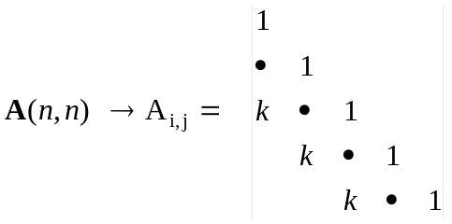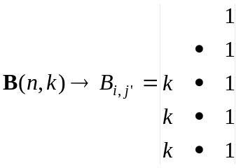

A(i,j) = B(i,j') j =j'+i-k
The summation over elements: Do j' = 1, k
Do i = k+1-j', n

Symmetric upper-column storage mode:

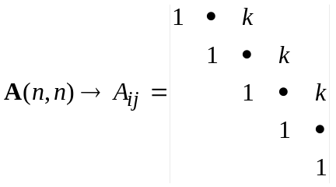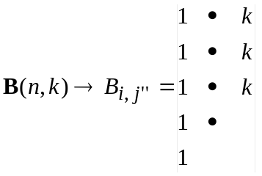

A(i,j) = B (i,j'') at j =j''+i-1
The summation over elements: Do j'' = 1, k
Do i = 1, n-j''+1

Non-symmetric column storage mode:

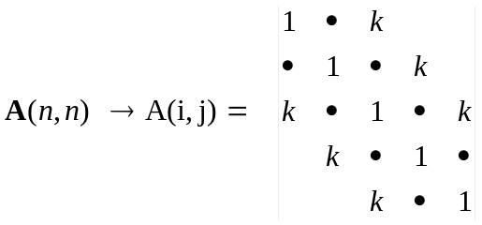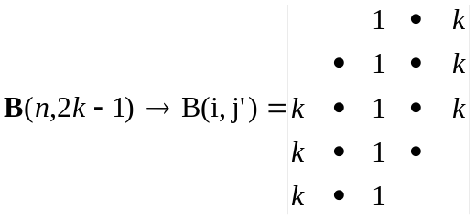

A(i,j) = B(i,j') at j =j'+i-k
The summation over elements: Do j' = 1, 2*k-1
imin = max(1,1+k-j')
imax = min(n,n+k-j')
Do i = imin,imax

'Almost' symmetric lower-column storage mode:
There is only one non-symmetric element: A(n,n-1) ≠ A(n-1,n), the latter is saved in B(1,1).

1.3. General modules

MODULE spline_param

Variables:
ks - order of B-splines
ns - number of splines
nv - number of intervals (= ns- ks + 1)
ml - the number of distinct points from 0 to 1 ( = 1/h)
me - number of points in the "exponential" region
h - initial step in knot sequence

MODULE spline_grid
Variables:
t(1:ns+ks) - knot sequence
bsp(1:nv+1,1:ks,1:ks) - bsp(i,m,ith) contains value of the i+ith-1 B-spline in interval i at gaussian point m
bspd(1:nv+1,1:ks,1:ks,1|2) - corresponding values of first and second
derivatives
bsp(nv+1,1,.) and bspd(nv+1,1,.,.) - corresponding values at last knot point,
i.e. at r_{max}
gr(1:nv,1:ks) - gr(i,m) contains Gaussian point m in interval i, equal to
(t(i+ks)-t(i+ks-1))*gx(m)+t(i+ks-1),
grm(1:nv,1:ks) - reciprocals of the values of gr
grw(1:nv,1:ks) - Gaussian weights at corresponding points,
(i,m) -> (t(i+ks)-t(i+ks-1))*gw(m)

Internal routines:
Allocate_grid - allocates space of the arrays bsp, bspd, gr, grm, and grw
according to parameters from module spline_param

Module spline_galerkin
Variables:
sb(1:ns,1:ks) - sb(i,j) --> <B_{i}|B_{i+j-k}>
r1(1:ns,1:ks) - r1(i,j) --> <B_{i}|r|B_{i+j-k}>
rm1(1:ns,1:ks) - rm1(i,j) --> <B_{i}|(1/r)|B_{i+j-k}>
rm2(1:ns,1:ks) - rm2(i,j) --> <B_{i}|(1/r²)|B_{i+j-k}>
db1(1:ns,1:ks) - db1(i,j) --> <B_{i}|B'_{i+j-k}>
db2(1:ns,1:ks) - db2(i,j) --> <B_{i}|B''_{i+j-k}>
bs(1:ks,:ns) - factorization of array sb

Arrays are given in the symmetric lower-column storage mode, with corrections:
db2 - 'almost' symmetric array;
db1 - antisymmetric array.

Internal routines:
Allocate_galerkin - allocates space of the arrays sb, r1, rm1, rm2, db1, db2, and bs according to parameters from module spline_param

1.4. Additional comments

Hereafter, in diagrams of the calling hierarchy
| means that the called subprogram and the calling subprogram are separate
subroutines.
|| means that the called subprogram is contained in the calling subprogram.

SUBROUTINE define_grid (z)

Calling sequence define_grid
|
-----------------
// || \\
getinput mkgrid print_grid
/ \ |
terminal or knot.dat knot.dat

Internal routines:

getinput - gets basic data to define the grid (z, h, hmax, rmax, ks )
from file 'knot.dat', if it exists, otherwise asks them from
terminal
mkgrid - sets up the knots for spline (see section 1.2.1.)
print_grid - outputs the knot data in file 'knot.dat'

SUBROUTINE define_splines

Calling sequence:
define_spline
|
-------------------------
/ | || \\
/ | initvb initas
/ | | // \ \\
gauss | vbsplvd mdb1 mrm facsb
| mdb2 |
allocate_grid dpbfa (Linpack)
allocate_galerkin

Internal routines:

initvb - sets the arrays gr, grm, grw, bsp, bspd (see module spline_grid)
initas - sets the array sb, r1, rm1, rm2, db1,db2, bs (see module
spline_galerkin) in symmetric lower-column storage mode.
mdb1, mdb2 - calculate the arrays db1, db2
facsb - factorizes the array sb, by using the LINPACK routine dpbfa

Remarks:
1. Most general routine were slightly modified in comparison to early
versions, but the names and formal parameters are saved except the routines
VINTY and YVAL.
2. VINTY - the array bsp is obtained from spline_grid but not as formal
parameter
3. YVAL - combines the early YVAL and YVALW, i.e. weights the functions
according the formal parmeter iw. Besides, the first parameter id
indicates now the option to use f'(r) or f''(r) instead of f(r).

2. Atomic orbital routines

2.1. Table of routines

name | short description
bhl | evaluates matrix element <P_{i} |L |P_{j}> for atomic orbitals i,j
bhwf | computes the spline expansion coefficients for hydrogenic radial functions
bzk | computes the spline solution for the the Z^{k}(P_{i},P_{j}) function (see eq. ...)
ecore | computes the energy of the common closed shells
facdyk | sets up and factorizes the matrix of Y^{k} operator: d²/dr² -k(k+1)/r²
facdzk | sets up and factorizes the matrix of Z^{k} operator: d/dr + k/r
grad | gives matrix element <P_{i} | d/dr + l/r |P_{j}> for atomic orbitals i,j
hlc | computes matrix element <P_{i} |L |P_{j}> modified by interaction with closed shells
hlm | sets up the matrix of L operator in the B-splines basis
mnk | sets up the matrix of N^{k} integral in the B-splines basis (the diff. eq. method)
mnk1 | sets up the matrix of N^{k} integral in the B-splines basis (the cell algorithm)
moment | evaluates the moments defining as <B_{i}|r^{k}|B_{j}> over an interval
momentd | evaluates the moments defining as <B_{i}|r^{k}|B'_{j}> over an interval
mrk | sets up the matrix of R^{k} integral in the B-splines basis (diff. eq. method)
mrk1 | sets up the matrix of R^{k} integral in the B-splines basis (cell algorithm)
mrk2 | mrk1 but with incorporation of symmetry according to i and j variable
mrk3 | mrk1 but with alternattive diagonal-cell intrgration
mtk | sets up the matrix of T^{k} integral in the B-splines basis (diff. eq. method)
mtk1 | sets up the matrix of T^{k} integral in the B-splines basis (cell algorithm)
mvk | sets up the matrix of V^{k} integral in the B-splines basis (diff. eq. method)
mvk1 | sets up the matrix of V^{k} integral in the B-splines basis (cell algorithm)
nk | evaluates N^{k} integral by assembling the B-spline integrals (diff. eq. method)
nk1 | evaluates N^{k} integral by assembling the B-spline integrals (cell algorithm)
nky | evaluates N^{k} integral by direct diff. eq. method
quadr | evaluates matrix element <P_{i} |r^{k}|P_{j}> for atomic orbitals i,j
rk | evaluates R^{k} integral by assembling the B-spline integrals (diff. eq. method)
rk1 | evaluates R^{k} integral by assembling the B-spline integrals (cell algorithm)
rk2 | evaluates R^{k} integral by assembling the B-spline integrals (from mrk2 routine)
rk3 | evaluates R^{k} integral by assembling the B-spline integrals (from mrk3 routine)
rky | evaluates R^{k} integral by direct diff. eq. method
spline_atomic | module - contains the main atomic parameters
spline_hl | module - contains the L matrix and routines for evaluation of rel. shift
spline_integrals | module - contains arrays for B-splines representation of two-electron integrals
spline_orbital | module - contains the description of atomic orbitals
spline_slater | module - contains common arrays used in evaluation of integrals by direct diff. eq. method
tk | evaluates T^{k} integral by assembling the B-spline integrals (diff. eq. method)
tk1 | evaluates T^{k} integral by assembling the B-spline integrals (cell algorithm)
tky | evaluates T^{k} integral by direct diff. eq. method
vk | evaluates V^{k} integral by assembling the B-spline integrals (diff. eq. method)
vk1 | evaluates V^{k} integral by assembling the B-spline integrals (cell algorithm)
vky | evaluates V^{k} integral by direct diff. eq. method
ykf | computes the spline solution for the the Y^{k}(P_{i},P_{j}) function (see eq. ...)
zcb | compute the 3j-symbols needed for evaluation the interaction with core
zeta | evaluates the Z(P_{i},P_{j}) integrals using the rky, nky, and vky routines for estimation the interaction with closed shells

2.2. Underline theory

2.2.1. Evaluation of two-electron integrals by direct differential equation method

The two-electron radial integrals in atomic structure calculations are of the form
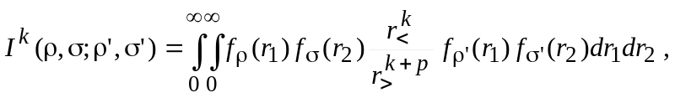 (2.1)
where r< and r> are the smaller and larger of the two coordinates r₁ and r₂ . The f(r) functions are linked to the radial orbitals, p is the positive integer and k can assume a range of different integer values. If we define a function Y^{k}(σ,σ';r) so that
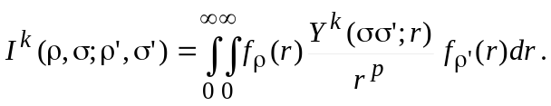 (2.2)
from which it follows that
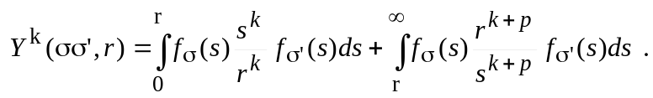 (2.3)
It is easy to show that this function satisfies a differential equation of the form
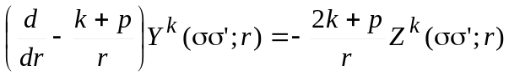 (2.4)
(2.5)
In the above, we have introduced a second function
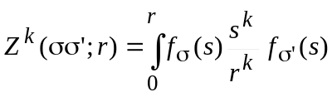 (2.6)
which satisfies the differential equation
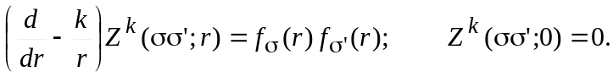 (2.7)
The form of the Z^{k} function is quit general, when defined in this way, since it is independent of p.
In the Breit-Pauli calculations all two-electron integrals can be reduced to fore different types: R^{k}, N^{k}, V^{k} and T^{k} integrals.
R^{k} Integrals
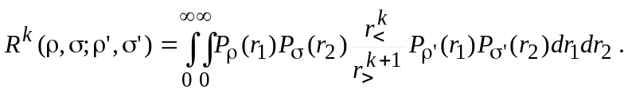 (2.7)
It is the special case of equation (1) with p=1, and f functions are simply the radial orbitals. The R^{k} integrals are highly symmetric
(2.8)
that is, they are unchanged as long as the ρ and ρ' orbitals, and thereby the σ and σ', are linked together with one coordinate.
The two-step procedure described above can be avoided, since the differential equation for the Y^{k} functions is
(2.9)
In the special case of p=1, the coefficient of the Z^{k} function disappears, and we are left with one single, but second-order, differential equation for Y^{k}
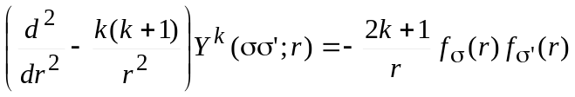 (2.10)
with boundary conditions
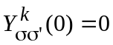 (2.11)
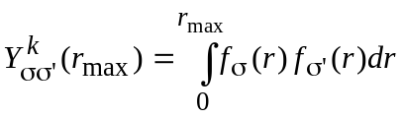 if k=0 (2.12)
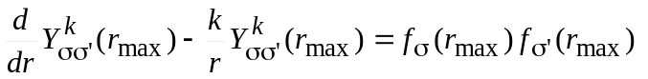 if k >0 (2.13)
The boundary condition at r_{max} can be obtained from (2.3), assuming that orbitals disappear at r > r_{max}.
In our study, we used the second approach which leads to more simple problem in comparison with two-step procedure.

N^{k} integrals
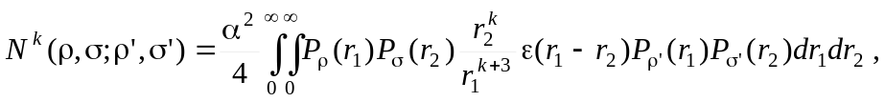 (2.14)
where k≥-1 and ε(x)=0 for x≤0, ε(x)=1 for x>0. The ε(x) step function reduce the Y^{k} function to the Z^{k}, and N^{k} integral is the special case of equation (1) with p=3, Y^{k}=Z^{k} and f functions are simply the radial orbitals. So, in this case we need to solve only one first-order differential equation (2.7). But additional complication occurs when dealing with the case N⁻¹, i.e. k < 0. In this case the homogeneous solution to equation (2.7) is
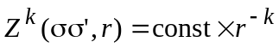 (2.15)
which leads to an ambiguous result when r → 0, since k > 0. This is solved by imposing a stronger boundary condition
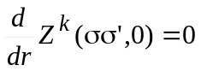 if k < 0. (2.16)
The N^{k} integrals is not so symmetric as R^{k} integrals:
(2.17)
V^{k} integrals
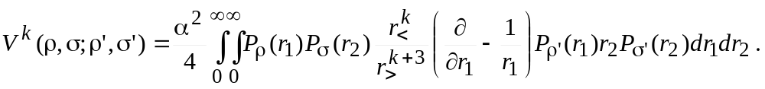 (2.18)
This is the special case of equation (1) with p=3 and
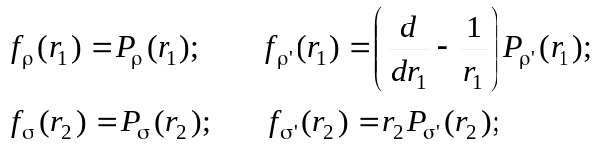 (2.19)
The V^{k} integral allows only to use the two-step procedure (2.4)-(2.7), and has most restricted symmetrical relations:
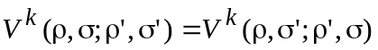 (2.20)
T^{k} integrals
(2.21)
with p=1 and
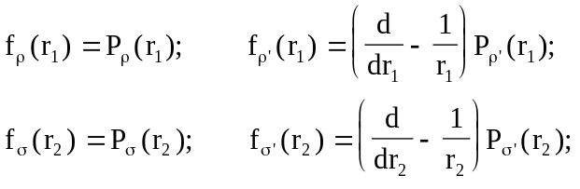 (2.22)
Here we can use the same procedure as for R^{k} integrals but the symmetric relations are more strict:
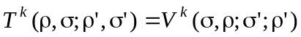 (2.23)

2.2.2. Evaluation of two-electron integrals in B-spline basis

Under the B-spline representation of radial functions of atomic orbitals (1.3), the two-electron integrals (2.1) becomes
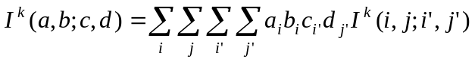 (2.24)
where the matrix elements I^{k}(i,j;i',j') are
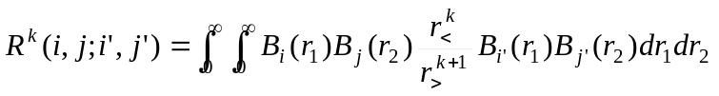, (2.25)
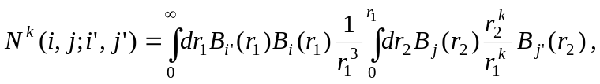 (2.26)
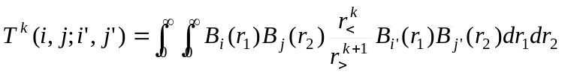, (2.27)
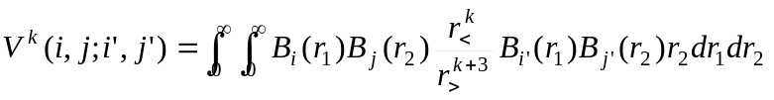, (2.28)
where 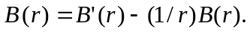 These matrix elements can be obtained by using the same procedures described above but with replacing f(x) functions on the corresponding B-splines.
So, the two-electron integral is given as a fourfold summation, but considerable simplification is possible. Note that,
(2.29)
Besides, the integrals may be symmetric relative to (i,i') or (and) (j,j') indexes. In result, the B-spline integrals can be stored as matrix with band character relative to (i,i') or (j,j') indexes, namely:

R^{k}(ns,ns,ks,ks), (2.30)
N^{k}(ns,ns,ks,ks), (2.31)
V^{k}(ns,ns,2*ks-1,ks), (2.32)
T^{k}(ns,ns,2*ks-1,2*ks-1). (2.33)

In particular, array element R^{k}(i,j;ip,jp) referred to the matrix element in which i' = i + ip -1 and j' = j + jp -1, where ip,jp=1,..,k_{s} (the symmetric upper-column mode, see 1.2.2). However, array element T^{k}(i,j;ip,jp) referred to the matrix element in which i' = i + ip - ks and j' = j + jp - ks, where ip,jp=1,..,2+ks-1 (the non-symmetric column mode, see 1.2.2).

Thus, it is convenient to regroup the summation as follows:
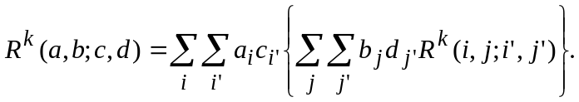 (2.33)
Let us consider the innermost double summation. Only the matrix elements with j' ≥ j are stored but the summation in Eq.(4.12) is over all values. However. the summation may be written as
(2.34)
Let us define a direct "density matrix":
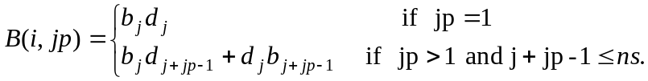 (2.35)
With a similar definition for the direct density matrix:
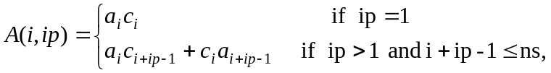 (2.36)
the Slater integral is then defined as
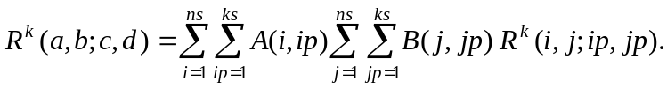 (2.37)
Similarly, we can obtain
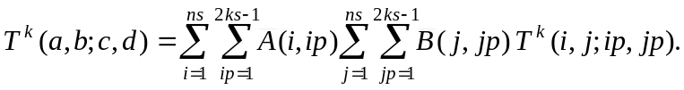 (2.38)
where
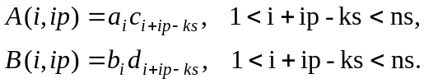 (2.39)
The N^{k} integrals are also define through the 'symmetric' summation (2.37), whereas the V^{k} integrals are in mixed case:
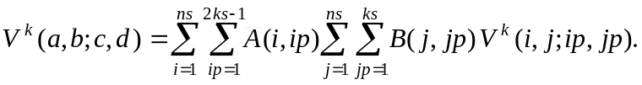 (2.40)
Note, that the R^{k} and T^{k} integrals are symmetric relative to the i and j indexes, and we can further reduce the corresponding matrices (2.30), (2.33.) to

R^{k}(ns(ns+1)/2, ks, ks), (2.41)

T^{k}(ns(ns+1)/2, 2*ks-1, 2*ks-1). (2.42)

where first index is i(i-1)/2+j and i > j .

2.2.3. Cell algorithm for evaluation of two-electron integrals

In this algorithm, the two dimensional region (r₁,r₂) is divided into a number of rectangular cells according the chosen grid and the direct two-dimensional integration over each individual cell using Gaussian quadrature is implemented for evaluation of integrals in limits of given cell. Over the off-diagonal cells, the integration are separable so that each two-dimensional cell integral is reduced to a product of two one-dimensional integrals. Furthermore, the scaling invariance of the B-splines in the logarithmic region of the chosen grid is fully exploited such that only some of the sell integrations need to be performed. The values of given integrals are the can obtained by assembling the cell integrals. This algorithm significantly improves the efficiency and accuracy of the traditional method that relies on the solution of differential equations.

Integration over the off-diagonal cells

In this case the integrand in the matrix elements is separable and the two-dimensional integrals are reduced to a product of two one-dimensional integrals. Consider, for example, Slater integral, and assume iv < jv, then,

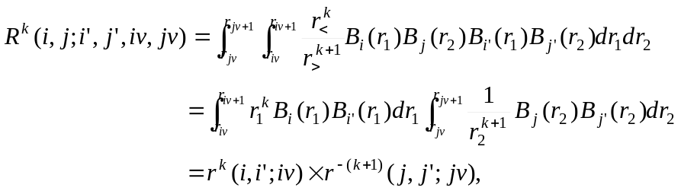 (2.43)
where
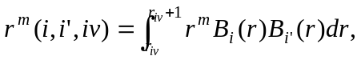 (2.44)
We see, although there are nv(nv-1) off-diagonal cells, we only need to be calculated and store the nv one-dimensional moment arrays r^{m}(i,i';iv). The needed moment integrals can be evaluated effectively using Gaussian quadrature with ks Gaussian points. Note, that each B-spline is a positive polynomial over a finite range. For given order ks, the spline B_{i} is non trivial only in the range from knot i to knot i+ks, i.e. for given cell iv, i and j indexes run only ks values: iv, ..., iv+ks-1. So, the moment arrays r^{m}(i,i';iv) has dimension (1:ks;1:ks,1:nv). Besides, because the r^{m}(i,i';iv) is symmetrical relative to indexes i,i', only r^{m}(i,i';iv) with i≤i' need to be evaluated. Moreover, the evaluation can be further reduced by using their scaling properties in the logarithmic grid region. Suppose, the spline discussed lie entirely within the exponential region. Let the left-most knot defining B_{i}(r) be t_{i} and let r = t_{i}+s, then,

B_{i}(t_{i}+s) = B_{i+1}((1+h)( t_{i}+s)) = B_{i+1}(( t_{i+1} + s(1+h)). (2.45)

Based on this displacement invariance, it can be shown the following scaling low for moment integrals

r^{m}(i+1,i'+1;iv+1) = (1+h)^{1+m} r^{m}(i,i';iv). (2.46)

Similar to (2.43) expressions can be easy written also for N^{k}, V^{k}, and T^{k} integrals:

(2.47)
(2.48)
(2.49)
(2.50)
(2.51)
where we introduce moment integrals d^{m}(i,i',iv) containing derivatives:
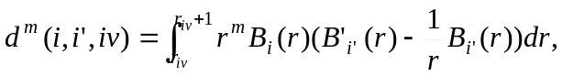 (2.52)

Integration over the diagonal cells

Over the diagonal cells the two coordinates in the integrand of the two-electron integrals are coupled. Moreover, the integrand as not continuous across the cell diagonal where r₁ = r₂. We separate the rectangular cell into two triangles so that the integrand inside each triangle is continues. For example of Slater integrals, the integration over the rectangular cell is then a summation of integrations over the two triangles, which are symmetric with respect to index exchange, i.e.
, (2.53)
where
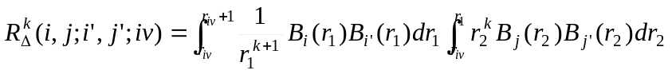. (2.54)
We use Gaussian quadrature again to do the integration over the triangular cell in Eq.(23). To minimized the new B-spline values needed to perform two-dimensional integration, we apply the original Gaussian points used in the evaluation of one-dimensional integrals to the integration with respect to to coordinate r₁. In the integration regarding to coordinate r₂, we also use the ks Gaussian points for each interval (r_{iv},r₁) dynamically calculated the needed B-spline values. With this two-dimensional grid, the difficulty of the cell integrals near the origin because of the singularity of the integrand is minimized and uniformly accurate results for all Slater integrals can be obtained. The full storage of the 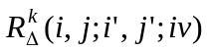takes n_{v}×k_{s}⁴ locations ignoring symmetry other indexes. The evaluation of these integrals can be also reduced by using the scaling law in the logarithmic grid region:

(2.55)

For N^{k} integrals we have
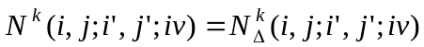, (2.56)
where
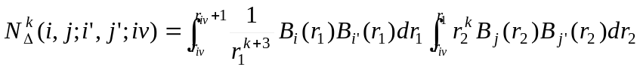. (2.57)
T^{k} integrals:
, (2.58)
where
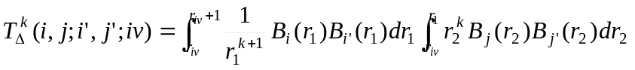. (2.59)

V^{k} integrals:
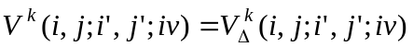, (2.60)
where
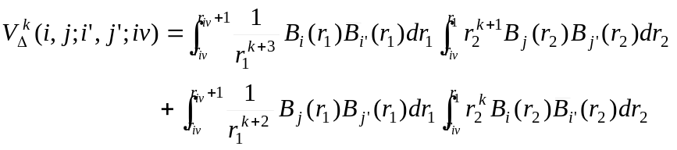. (2.61)
For all relativistic integrals scaling law is the same (but different from R^{k} case) form

(2.62)

  - Program realization

2.3.1. Specific modules

MODULE spline_orbitals
Variables:
nwf - number of atomic orbitals
n(1:nwf) - principal quantum numbers
l(1:nwf) - orbital momentums of orbitals
kn(1:nwf) - set indexes of orbitals
el(1:nwf) - spectroscopic label for orbital
mx(1:nwf) - length of the B-spline expansions
p(1:ns,1:nwf) - B-splines expansion coefficients for atomic orbitals

Internal routines:
Allocate_orbitals - allocates space of the array n, l, kn, el, mx, p
for goven value nwf
Number_nl - defines the orbital index for given n,l,kn

MODULE spline_slater
Variables:
fc1, fc2, fy1, fy2 (1:nv,1:ks) - serve for storing the gauss-point representation of the radial orbitals.
fyk(1:nv,1:ks) and yk(1:ns) - these arrays are the gauss-point and the B-spline represantation of the Yk or Zk functions.
dyk(3*ks-2,ns), ipvtd(ns) - serve for storing the factorization of the Yk operator: Yk --> d^2/dr^2 - k(k+1)/r^2.
dzk(3*ks-2,ns), ipvtz(ns) - serve for storing the factorization of the Zk operator: Zk --> d/dr + k/r.
fc(1:nv,1:ks) - work array.

ic1,ic2,iy1,iy2,ky,kz - These integers serve to check the repeated calculations for arrays fc1,fc2,fy1,fy2, dyk and ipvtd, dzk and ipvtz, respectively.
ktx - 3*ks-2

Internal routines:
Allocate_slater - allocates space of all above arrays
according to parameters from module spline_param

MODULE spline_integral
Variables:
rkb(1:ns,1:ns,1:2*ks-1,1:2*ks-1) - store the B-spline representation of the given two-electron integral
krk - multipole index for integral storing in the array rkb at the moment
itype - character (rk, rk1, tk, vk, ...) which indicates the type of integral storing in array rkb at the moment

rk2(ns(ns+1)/2,ks,ks) - store the B-spline representation of the integrals
in the symmetric mode
krk2 - multipole index for integral storing in the array rk2 at the moment
ityp2 - character (rk, rk1, tk, vk, ...) which indicates the type of integral storing in array rk2 at the moment

Internal routines:
Allocate_integrals - allocates space of for the rkb array
according to parameters from module spline_param
Allocate_integral2 - allocates space of for the rk2 array
according to parameters from module spline_param

MODULE spline_hl
Variables:
hl(1:ns,1:ks) - matrix of L operator in the B-spline basis
(in almost symmetric lower-column mode)
lh - the corresponding value of the orbital momentum
vc(1:ns,1:ks) - matrix of mass-velocity correction in the B-spline basis

Internal routines:
Allocate_hl - allocates space of for the hl and vc array
according to parameters from module spline_param
mvc - calculates the matrix of mass-velocity correction
azl - value of the B_{l+2}/r^{l+1} needed for evaluation of the one-body Darwin correction

MODULE spline_atomic
Variables:
z - charge of nucleus
nclosd - number of closed shell
rel - indicates on the relativistic calculations
fine - fine-structure constant
ioo - if ioo > 0, the RKy integrals are redefined to include the part of orbit-orbit interaction
EC - energy of core

Remarks:

- Module spline_integrals contains only one array for all type of integrals.
If requirements to memory is not very strict, it is possible to introduce the specific arrays
(with different shape) for each integral. In this case variable itype is not necessary.
- Module spline_atomic can replaced on the more general atomic_param which may be common
for many atomic programs

2.3.2. Direct integration of the Breit-Pauli Integrals: RKy, NKy, VKy, TKy.

Calling sequence:

RKy
-----------------
/ | | \
YKF YVAL (TKy, NKy if ioo>0)
\
-------------------------
| | | | \
FACDYK YVAL VINTY QUADR dgbsl
|
dgbfa

NKy
----------
/ \
BZK YVAL
|
-------------
/ | \
FACDZK YVAL dgbsl
|
dgbfa

TKy
----------
// | \
YTK YVAL YDAL
|
--------------------------
| | | | \
FACDYK YVAL VINTY QUADR dgbsl
|
dgbfa

VKy
------------
// | \
YVK YVAL YDAL
|
-------------------------
| | | | \
BZK YVAL VINTY FACDZK dgbsl
| |
-------------- dgbfa
| | \
FACDZK YVAL dgbsl
|
dgbfa

The Y^{k} and T^{k} integrals are defined through solution of the second-order differential equations. The N^{k} integral needs only the Z^{k} solution of the first order equation. V^{k} integral is evaluated by sequential solution of two first-order differential equations.

The basic arrays are placed in module 'spline_slater'. The all routines differ only by way of calculations the corresponding Y^{k} functions: the routines YKF, BZK, YTK and YVK. The specific routines YTK and YVK are incorporated in the calling routines.

YKF routine include the relativistic shift modification of the YK function when parameter REL = 'TRUE'' . If parameter ioo > 0, the RKy integral inludes also the modification due to orbit-orbit interaction.

The QUADR routine is used for determination of the right boundary conditions when k=0. It is important for non-orthogonal orbitals.

These routine is very quick but not so accurate as the sell integration.

2.3.3. Evaluation of two-electron integrals in B-spline basis: RK, NK, VK, TK.

RK, NK, VK, TK routines only assemble the matrix elements in the B-spline basis with corresponding orbital expansion coefficients (see Eq.2.33-2.40). The calculations of matrix elements are performed by routines MRK, MNK, MVK, MTK, which first check the parameters krk and itype, and only if these parameters are not appropriate, the calculations of corresponding rkb array are performed.

Calling sequence:

rk nk
| |
mrk mnk
| |
----------------- -----------------
/ || | \ / || | \
facdyk bspyk yval minty facdzk bspzk yval minty
| | | |
dgbfa dgbsl dgbfa dgbsl

tk vk
| |
mtk mvk
| |
----------------- -----------------
/ || | \ / || | \
facdyk bsptyk yval dinty facdzk bspvyk yval dinty
| | | |
dgbfa dgbsl dgbfa ----------
/ | \
yval vinty dgbsl

The above routines differ mainly by way of calculations of the corresponding Y^{k} functions: bspyk, bspzk, bsptyk and bspvyk routines, respectively. These specific routines are incorporated in the calling routines MRK, MNK, MVK, MTK.

2.3.4. Evaluation of two-electron integrals by cell algorithm: RK1, NK1, VK1, TK1.

rk1 nk1
| |
mrk1 mnk1
| |
---- ----
/ \\ / \\
moment rk_pdiag moment nk_pdiag
|| ||
rk_triang nk_triang
/ \ / \
gauss vbsplvb gauss vbsplvb

rk1 nk1
| |
mtk1 mvk1
| |
--------- -------------------
/ \\ / | \\
momentd tk_pdiag moment momentd vk_pdiag
|| ||
tk_triang vk_triang
/ \ / \
gauss vbsplvd gauss vbsplvd

Al the above routines have the same structure, and differ mainly by calculation of the diagonal cell contribution (routines ??_triang). The ??_pdiag routines control the scaling properties.

Remarks:

1. rk2 (mrk2) use the same algorithm as in rk1 (mrk1), but use the symmetric representation for the matrix elements - see the description rk2 array in module spline_integrals.

2. rk3 (mrk3) also use the same algorithm as in rk1 (mrk1) except the calculation of integrals in the diagonal cells. Here is implemented the alternative algorithm where is used the coordinate rotation x = (r₁+r₂)/√2, y=(r₁-r₂)/ √2 and the integrand is reduce to form with zero value at r₁=r₂. But it turned that this algorithm has no benefits in comparison with straightforward integration described above.

3. Note again, that though the mrk1, mnk1, nvk1 and mtk1 routines are called at each enter to RK1, NK1, TK1 and VK1, the real calculations of the matrix elements are carried out only when the data in the array rkb is not appropriate.

- All rk routines has option to include the relativistic shift if the parameter rel = .TRUE. So this need only one additional loop of operations, we have not introduced the special subroutine as it can be done in early versions.

3.3. Additional comments

BHL routine

This routine gives the matrix elements <P_{i}|L|P_{j}> through the construction of L(.,.) matrix in routine HLM. The relativistic shift is introduced direct to the matrix L(.,.) matrix rather then to calculate it separately as this was done in the early versions. It allows to introduce easy the relativistic shift in the total interaction matrix, for example, in the close-coupling calculations.

BHWF routine

Computes the spline expansion coefficients for hydrogenic radial function for quantum numbers (n,l) and effective nuclear charge z.

Calling sequence:

bhwf
-----------------
// | | \
vhwf vinty zfacsb dpbsl
|| | / \
hnorm dpbfa daxpy ddot

Contains the internal procedure vhwf which returns the vector of values of a normalized hydrogenic function with nuclear charge z and quantum numbers (n,l) at given values of the radius..
It was also found that slightly more accurate values can be obtained when first (l+1) B-splines coefficients are exactly to be zero. It needs to modify the procedure facsb (see routine difine_spline) and introduce additionally new similar procedure zfacsb.

ZCB routine

Computes the 3j-symbols (j1,j2,j3,0,0,0) and is used for evaluation of angular coefficients for interaction with core in routines HLC and ZETA_y (instead to use the tables for this coefficients)

dpbfa, dpbsl, dgbfa, dgbsl (+ daxpy, ddot, idamax)

LINPACK (+ BLAS) routines for solving liniar band systems.

Allocate_??? routines.

These routines called automatically at first calling the routine there the relevant arrays are used.

3. Test program

This program is designed for testing the accuracy of integral and some other routines, as well as system time needed for different algorithms.

Calling sequence:
test_bs SPLINE.LIB MATH.LIB
| ↓ ↓
-------------------------------------------------------------------------------------------------------
| | | | | |
define_grid define_spline define_orbitals test_integrals test_quadr test_hl
↑↓ ↑ ↓ ↓ ↓
knot.dat int_inp int_out quadr_out hl_out
-------------------------------
| | | | |
RRTC LA AL ELF4 EL4_nlk

SPLINE.LIB must contains all B-spline routines described in sections 1 and 2.

MATH.LIB must contain at least the dpbfa, dpbsl, dgbfa, dgbsl (+ daxpy, ddot) routines from
LINPACK (+ BLAS) libraries for solving linear band systems.

Routine define_grid defines the knot sequence according the parameters, reading from file knot.dat.
If file knot.dat does not exist, the parameters are asked from terminal.

Routine define_spline defines main B-spline arrays (see section 1.4)

Routine define_orbitals generates the 15 hydrogenic radial orbitals for n=1-5, l=1-4.

Routine test_integrals reads data from file 'inp_inp' and writes the results in file 'int_out'.

There three types of data in 'int_inp':
- Indication of two-electron integral under consideration and its exact value as ratio s1/s2.
Example: R 0( 1s, 1s; 1s, 1s)= 5 8
Such data are used for investigation of accuracy of different algorithms.
In this case file 'int_out' contains the exact value for given integral in comparison with values obtained from all programmed algorithms.
- Indication of calculation procedure for given integral.
Example: #MRK1
Such data are used for timing of the given algorithm.
In this case file 'int_out' contains the time for calculation of matrix elements in B-spline basis and
time needed for assembling these matrix elements to obtain the specific integral
- '*' - indication of the end of work.

Routine RRTC is used to define current time (by using system function DATE_AND_TIME)

Routines AL, LA, ELF4, ELF4_nlk are used for work with spectroscopic notation for orbitals.

Routine test_quadr tests the routines QUADR and GRAD for a set of one-electron integrals.
The exact values for comparison are generated by subroutine HVA.
The results are placed in file 'quadr_out'

Routine test_hl tests the routines BHL, HLM for all possible matrix elements for given set of radial functions. The results are placed in file 'hl_out'

files rk-res, nk-res, tk_res and vk_res contain the testing results obtained on
PC Pentium II (350 MHz, 128MB)

