Remarks on B-splines.

Contents:

1. Introduction
2. Definition of basis splines
3. The Grid
4. The radial equations
5. Determination of frozen core Hartree-Fock basis sets
6. Slater Integrals
7. Continuum

8. Using B-spline method for solution of close-coupling equations
9. Asymmetrical values on the border:

1. Introduction

The term spline has its origin from a tool used by draftsmen called a draftsman's spline. This is a thin flexible strip used for drawing irregular curves. It is pinned down at certain points, which are referred to as knot points, and automatically interpolates a cubic polynomial between the points. It is, however, very straightforward to generate higher-order splines. The first use of splines in atomic physics was made by Shore (1974), who used cubic splines. They have been used with increasing frequency in the last 10 years (...).
There are a wide variety of finite basis sets in present use in computational atomic and molecular physics, with perhaps the most frequently used being those based on Gaussian and Slater functions. However, B-splines have a number of desirable properties that make them particularly useful. One advantage is the banded nature of the matrices one has to diagonalize. This allows the generation of very large basis sets with now complications from linear dependence. In the bound state calculations, it is standard to work with 40 basis functions, but in case of continuum states it has to increase this number to ~100. A second advantage of B-splines is the flexibility afforded by the freedom to choose the radial grid points between which the B-splines are defined. If it is desired to accurately describe continuum states, a set of points can be evenly placed at large distances from the atom, and if the finite size of the nucleus is important, extra points can be placed at very small distances. The code involved is relatively simple, and the integrals involved, comprising as they only polynomials, can be evaluated to machine accuracy with Gaussian integration, making B-splines an accurate and easily set up basis set of wide utility.
It has recently been found that it is possible to take the influence of a whole Rydberg series into account, explicitly, i.e. without introducing a cut-off, in atomic structure calculations for bound or quasi-bound states. In this procedure advantage is taken of the properties of B-splines, polynomials recently introduced in atomic structure calculations by several groups (...).

2. Definition of basis splines

The basis we will use in the following is chosen to be a set of n B-splines of order k. Following deBoor [1] we divided the interval [0,R] into segments. The endpoints of these segments are given by the knot sequence [t_{i}], i = 1,2,...,n + k. The B-splines of order k, B_{i,k}(r), on this knot sequence are defined recursively by the relations
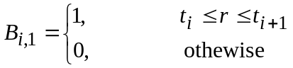 (2.1)
and
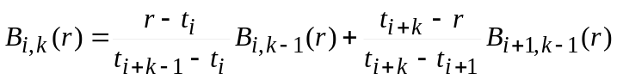 (2.2)
The function B_{i,k}(r) is a piecewise polynomial of degree k -1 inside the interval t_{i} ≤ r < t_{i+k} which vanish outside this interval. Efficient FORTRAN codes to evaluate it and its derivatives exist in many numerical libraries, and are also explicitly listed in [1].
The sum at any point of all of the B-splines that do not vanish at the point is unity. The set of B-splines of ordre k on the knot sequence [t_{i}] forms a complete basis for piecewise polynomials of order k-1 on the interval spanned by the knot sequence. The knot defining our grid have k-fold multiplicity at the endpoints 0 and R; i.e. t₁ = t₂ = ... = t_{k} = 0 and t_{n+1} = t_{n+2} = ... = t_{n+k} = R. When multiple knots are encountered, limiting forms of the above recursive definition of the B-splines must be used. For k > 1, the B-splines generally vanish at their endpoints: however, at r = 0 the first B-spline is equal to 1 (with all others vanishing) and at r = R the last B-spline has the same behavior, which fact we will use below in implementing boundary conditions.
In general, each knotpoint can be given a multiplicity larger than one which is necessary at the endpoints in order to ensure a continuous derivative of order k - 2 over the whole interval [A,B] of the functions we are approximating. Usually, in atomic calculations the first and the last knotpoints are given multiplicity k in order to accomplish this, while all other knotpoints have multiplicity one. Algorithms tp produce splines of any order have been published.
The set of B-splines provides a basis for piecewise-polynomial functions with certain continuity properties on [A,B]. This property makes the B-splines interesting as basis functions for atomic structure calculations since wavefunctions are smooth functions which lend themselves very well to representation by piecewise polynomials. This is particularly so because the number of splines is finite.
It is important to emphasize that the restriction to a box [A,B] is not equivalent to a usual cut-off of Rydberg seies. This is due to the effective completeness of the B-spline basis set. This means that it is necessary only to ensure that the box is chosen large enough to allow a good description of the energy range for the wavefunctions we are interested in. The numerical accuracy will of course depend on the number of splines but if the knot points are chosen carefully, a rather small number of splines will suffice in the sense that the numerical accuracy will improve only very slowly with the addition of further splines. On the other hand, if we want to describe a large number of states at the same time, the number of splines must be increased in proportion. An important advantage of the B-spline basis is the ease with which the knot sequence can be chosen to suit the properties of the functions to be approximated.
There is different ways for implementation of splines, with slightly different emphasis. Ones are interested in accurate obtaining wavefunctions for one or a few particular states while we are interested in obtaining a basis set which subsequently can be used in further calculations.

Grid:
n - number of B-splines
k - order of B-splines
t(n+k) - total set of knots (t = z×r)
t(1)=t(2)=...=t(k) = 0
t(n+1)=t(n+2)=...t(n+k)=t_{max}

k+1 n
k • • • • • • • • • • • n+1
. • ml me • n+2
. • • .
2 • • .
1 • • n+k

number of intervals: nint = n+1-k

Each B_{i}-spline begins in knot i and ends in knot i+k+1

So, only B-splines with |i-j| ≤ k overlap

Each interval int is covered only by k B-splines: i = int+ith-1 with ith=1,k

Semi-logarithmic scale:

1. int = 1, ml - equal step with h=1/ml (t(k+ml)=1.0)
2. int = ml+1,ml+me - logarithmic scale with incriment (1+h)
3. int = ml+me+1, n+1-k - equal step with h = h_{max}

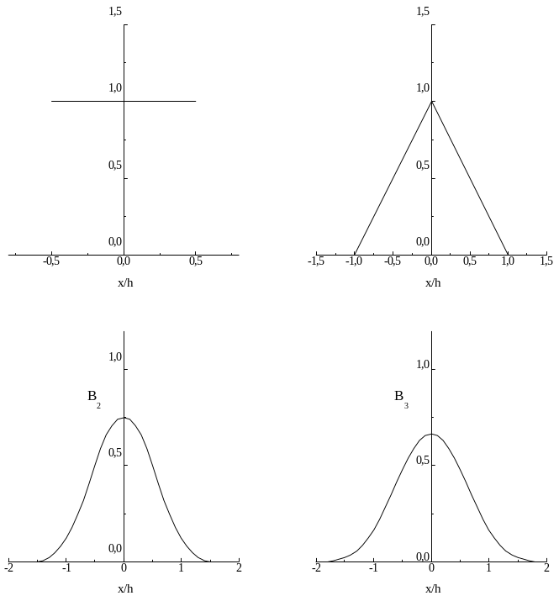
3. The Grid

An important decision in the design of computational procedures for atomic structure calculations is the selection of the grid. Let Z be the nuclear charge of atom. With splines, we can create any composite grid if needed. Experiments have been performed with a grid that is linear at the origin for Zr ≤ 1 and exponential thereafter (following the exponential behavior of the atomic wavefunctions), namely:

Zr_{i} = ih, i = 0,...,h⁻¹, and r_{i+1} = r_{i} (1 + h), i > h⁻¹.

With this grid, when B-splines are entirely in the outer region, relations such as the following,
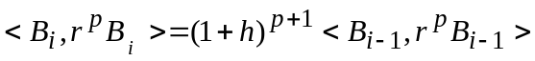
can be shown to hold. Thus, only a few integrals need to be evaluated, and for others, a scaling law applies. Similar rules can be derived for Slater integrals (?) commonly occurring in atomic structure calculations.
Another grid parameter defines the maximum range or extent of the solution. Since the of a 1s orbitals is much less than, say a 10s, the software may automatically adjust the range for each orbital, but in a general purpose software, sufficient range is needed to allow orbitals to attain their full extent for the desired accuracy.
The grid together with the order of the spline, k, determines the accuracy of approximation.

4. The radial equations

Consider a differential equation of the form

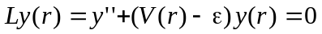 (3.1)

In our applications, boundary conditions will always specify y(0) = 0, but the boundary conditions as r → ∞ will vary: in the case of bound state systems, where ε > 0, the latter condition will require that y(r) → 0, but for continuum states the condition is in term of amplitude. Of course, since the equation is homogeneous, this is similar to a normalization condition.
An approximation solution is sought which, in the case of the spline -Galerkin method, is expressed as a liniar combination of B-splines over an interval [0,r_{max}], say {B_{i}(r), i=1...N}. Then
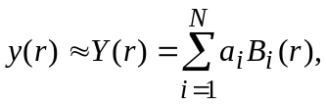 (3.2)
Usually the approximate (or trial) functions satisfy the boundary conditions. When the B-spline basis is generated using a grid with multiple knots at the ends of the interval, this leads to the condition a₁ = 0. We shall refer to the column vector a = (a_{i}) as a spline expansion vector of Y(r).
The Galerkin method is a member of a larger class of methods known as the methods of weighted residuals. The latter require that the residual of the differential equation, LY(r), be orthogonal to each of a set of test functions, one for each remaining coefficient, {τ_{i}, i =2,N}, say. Introducing an inner product notation,
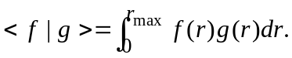 (3.3)
the conditions become
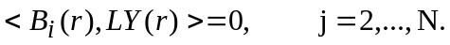 (3.4)
In collocation methods, the test functions are τ_{i}(r)=δ(r - r_{i}), where δ is the Dirac delta function, a choice which avoids the necessity of evaluating an inner product. In the Galerkin method, the test functions are selected from the same family as the trial functions. The Eq.(3.4) leads to the Galerkin system of equations
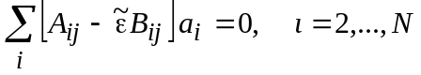 (3.5)
where
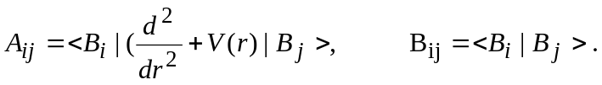 (3.6)
and 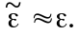 Fletcher (1984) provides a subjective comparison of different methods of weighted residuals; the collocation method rates very good on ease of formulation and moderate on accuracy whereas Galerkin rates very high on accuracy with moderate ease of formulation. Collocation method have been used extensively for time-dependence problems as described by Umar et al (1991). In MCHF wave function expansions, a given accuracy with a minimum basis set is highly desirable since the memory requirements increase rapidly with N. Fast vector algorithms can be used for the evaluation of inner products and other vector operations.
When the trial function also is zero at r = r_{max}, then Eq.(3.5) is a symmetric, generalized eigenvalue problem for which an eigenvector defines the expansion of the approximate solution associated with the corresponding eigenvalue and standard eigenvalue techniques may be used. Because the product of B_{i}(r) and B_{j}(r) fails to vanish only when i and j differ by k or less, the matrices A and B are sparse, diagonally dominant banded matrices. The solutions to the eigenvalue problem for such matrices is numerically stable even when the matrices are very large. Gaussian integration of order 2k allows the evaluation of the matrix elements of A and B to machine accuracy in the case of analytically given potentials. For numerical potentials an interpolation must be used to calculate part of A, but the associated errors is insignificant.
In the continuum case, the matrix H is not symmetric. If we define A=H-εB, then the desired eigenvector is the one corresponding to the zero (or near zero) eigenvalue of A, and inverse iteration is applied to the almost symmetric matrix A.
Solving the generalized eigenvalue problem, Av = εBv, one obtains n-2 (or n-1) real eigenvalues ε^{λ} and n-2 (or n-1) eigenvectors v^{λ}. The eigenvectors satisfy the orthogonality relations
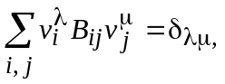 (3.7)
which leads to the orthogonality relations
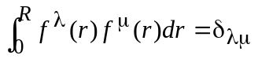 (3.8)
for the corresponding radial wavefunctions.
The first few eigenvalues and eigenvectors in the cavity agree precisely with the first few bound-state eigenvalues and eigenvectors obtained by numerically integrating the radial Schrödinger equations, but as the principal quantum number increases, the cavity spectrum departs more from the real spectrum, and forms the so-called 'pseudospectrum' which can be used instead the real spectrum in different physical problems. For example, the second-order energy correction in the framework of the Rayleigh-Schrodinger perturbation theory
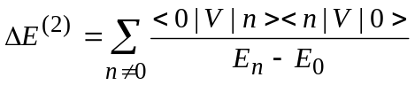 (3.9)
requires the direct evaluation of the sum in terms of an infinite sum over the bound states and an integration over the continuum. In differential equation method, this summation can be evaluated by replacing the sum over n with the solution of a differential equation [..]. In the B-spline pseudospectrum, only some first states are bound, and the remaining states are unbound, and the infinite sum (3.9) is reduced to the finite sum. With small number of B-splines in many cases this sum very accurate reproduces the infinite sum (3.9), i.e. the B-spline basis is effectively complete in this sense. The calculations of E⁽³⁾ involves multiple sums over intermediate states, as does the evaluation of the second-order energy correction in the many-body case. When dealing with a double summation, one can again carry out the sums by solving a partial differential equation, which, however, is considerably more difficult to solve. When a basis set is used, the only complication is that the evaluation takes more computer time, since there are N² rather than N terms to be evaluated for the basis set size N.
Briefly, the algorithm is as follows. Given a grid and an order k, the B-spline basis is determined. Each basis element is non-zero over a set of (k) adjacent intervals defined by the grid and, within each interval, the basis function is a polynomial of degree k-1. Furthermore, in going from one interval to next, the spline and its first k-2 derivatives are continuous. Discontinuities occur in the k-1 derivative, and the size of this discontinuity can be used to confirm the appropriateness of the grid. Algorithms for generation of B-splines have been published by de Boor (1985).

The result is a banded, generalized eigenvalue problem that can be solved using LAPACK routines (ftp://www.netlib.org), though it should be remembered that only a few eigenvalues and eigenvectors are required in atomic calculations.

5. Determination of frozen core Hartree-Fock basis sets (without orthogonal constrains)

Consider determination of the nl basis for (core)nl series where core is frozen. Generally the expression 'frozen core' is taken to mean that the core orbitals have been determined from some other state than the one under consideration so that the effect of the additional electron on the core is not included. (Often, one includes some part of the effect of the outer electron on the core by taking the core orbitals from a HF calculations for the lowest member of the nl series but it is not always justified.) The numerical orbitals are expanded in the B-spline basis or interpolated to the Gaussian points needed for the calculation of the two-body integrals.
In the HF equation for the nl orbital we substitute an expansion of P_{l}(r) as a liniar combination of B-splines from the basis set with the expansion coefficients as unknowns:
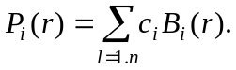 (5.1)
Here and in following the index k is omitted. This substitution transform the differential equation into a matrix equation of the type
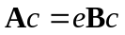 (5.2)
where ε is the energy eigenvalue and c is the vector of eigenvector components to be determined. The first and the last spline do not fulfil the boundary conditions P_{l}(0)=P_{l}(R)=0 and are discarded, so that the size of the matrix is n_{s}-2. The symmetric matrix A and B are defined in the following way:
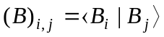 (5.3)
where the B-splines are non-orthogonal so the B matrix is not the unit matrix, and
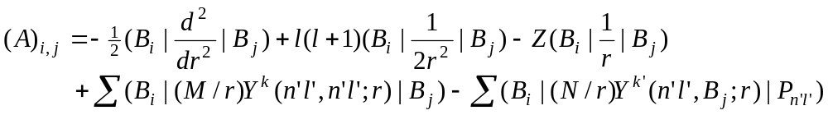 (5.4)
where M and N are constants and the summations are over all core orbitals n'l' and all allowed k and k' values. The Y^{k}(n'l',n'l';r) function represents the direct electrostatic interaction between n'l' and nl and Y^{k}(n'l',nl(B_{j});r) between the two electrons. All the terms in equation (5.4) are liniar in the B_{j}, which is necessary in order to solve the problem as an eigenvalue problem. It is also possible to use an effective potential taken from a HF calculations for a suitable state. In this way we have only the first three terms in (5.4) to calculate, with 1/r in the therd term replaced by the effective potential. The advantage of this is that the calculation of A is considerably simplified. Due to definition of B-splines we find also in this case that (A)_{i,j} = 0 unless |i-j| < k, which means that also the A matrix is banded and that therefore the diagonalization of matrix is simplified. This property is not changed if the direct part of the interation is calculated (the fourth term in (5.4)) but the fifth term (the exchange term) in this equation does not have the same structure and leads to a non-banded matrix.
Despite this disadvantage it is still advantageous to use (5.4) instead of an effective potential. This is primary because of the difficulties in extracting an effective potential from an exchange term. In general we must divide the contribution from the G^{k}(nl,n'l') exchange integrals with the n'l' wavefunction in order to obtain the effective potential for the nl electron and if this orbital has nodes, the effective potential has a singularity which must be smoothed out in some artificial way. This problem is avoided if equation (5.4) is used. However, it is clear that the two last terms in this equation are more difficult to calculate than the others since for each matrix elements (A)_{i,j} one or more two-dimensional integrals must be calculated numerically. This integration can be carried out accurately and efficiently using Gaussian quadrature, but the calculations of matrix elements is nevertheless more time consuming than the actual diagonalization.
Equation (5.2) is a generalized eigenvalue equation that can be solved by standard techniques. We have used the routines from the LAPACK library (httm:\\.www.netlib.org). A set of n_{s}-2 eigenvalues and eigenvectors is obtained (the latter with respect to the B-spline basis) that represent the energies and eigenvectors of the physical problem. The lowest eigenvalues of the matrix resemble the numerical frozen-core Hartree-Fock eigenvalues and eigenfunctions very well. Later the resemblance becomes worse and the eigenfunctions represent average over a number of bound states. At the top of the spectrum the eigenvalues become positive, but in the present calculations it is not possible to identify the eigenvectors belonging to this positive energies with real physical continuum orbitals in particular because of our choice of knot sequence(or boundary conditions ???), which, being optimized for bound states, does not allow us to reproduce the oscillations of a continuum wavefunctions at large distances. Nevertheless, these orbitals are important for the description of the interaction between a series and. for example, a single bound state. The normal procedure in such a calculation is to sum over a finite number of bound states and to approximate the interaction with the continuum by a numerical integration procedure. With the B-spline basis the integration is replaced by a summation over the finite basis set and effective completeness of the basis set is the important feature that means that the summation is independent of box size and number of splines if these two quantities are chosen large enough.
In result, with the complete set of B-spline wavefunctions we can tackle the problem of a perturber interacting with a series in a simple way. We simply use the eigenfunctions of equation (5.2) as an effective but complete set of L² functions.

6. Slater Integrals

Critical to the success of the spline is an accurate and efficient procedure for evaluating Slater integrals in a spline basis, namely
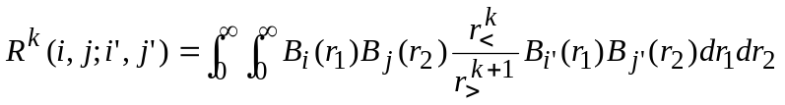 (4.1)
where r<, r> are max(r₁,r₂) and min(r₁,r₂), respectively. Note that,
(4.2)

The above may be rewritten as
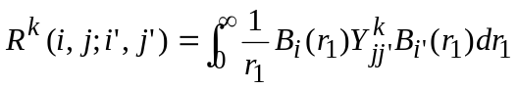 (4.3)
where
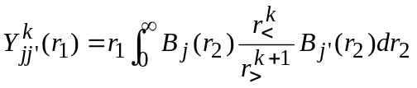 (4.4)
This reduce the problem to one of computing Y_{jj'}^{k}(r) accurately and efficiently.
There are basically two ways in which Y_{jj'}^{k} can be computed. One is to calculate Y_{jj'}^{k} by the following integration:
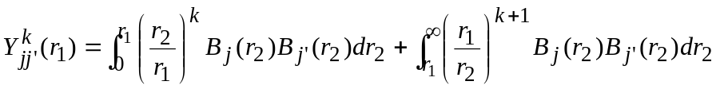 (4.5)
Another approach is to solve Y_{jj'}^{k} from the following differential equations and boundary conditions:
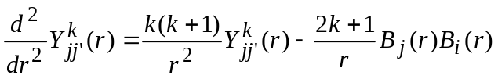 (4.6)
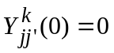 (4.7)
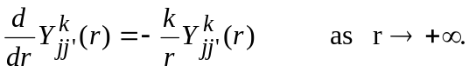 (4.8)
In our study, we used the second approach which again leads to a simple problem. The differential equation for Y_{jj'}^{k}(r) is solved by the Galerkin method and B-spline basis functions.

If the radial function for orbital a is approximated by
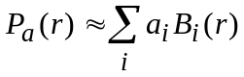 (4.9)
then the Slater integral,
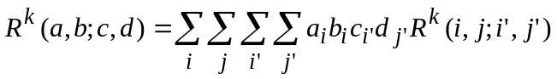 (4.10)
So the Slater integral is given as a fourfold summation, but considerable simplification is possible.
The Slater matrix elements in the spline basis have certain symmetry properties. In particular,
(4.11)
Furthermore, if |i-i'| ≥ k_{s} or |j-j'| ≥ k_{s}, then the Slater matrix element is zero. For this reason, our initial implementation stores these elements in an (Nk_{s})² array in which i' ≥ i and j' ≥ j. In particular, the array element R^{k}(i,j;ip,jp) refered to the matrix element in which i' = i + ip -1 and j' = j + jp -1, where ip,jp=1,..,k_{s}. Thus, it is convenient to regroup the summation as follows:
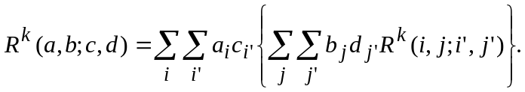 (4.12)
Let us consider the innermost double summation. Only the matrix elements with j' ≥ j are stored but the summation in Eq.(4.12) is over all values. However. the summation may be written as
(4.13)
Let us define a direct "density matrix":
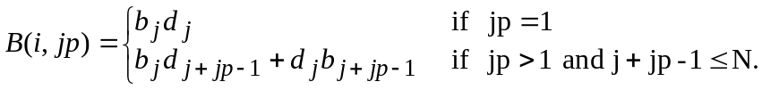 (4.14)
With a similar definition for the direct density matrix:
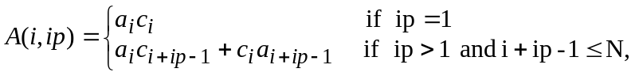 (4.15)
the Slater integral is then defined as
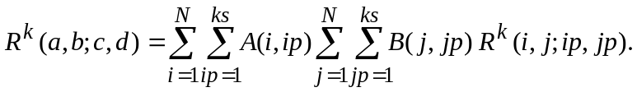 (4.16)
Calculations can be arranged so that the number of floating point multiplies is (Nk_{s})² + O(Nk_{s}). The fourfold summations can be arranged so that the innermost loop is a vector operation (?).

Program realization: MRK - calculation of array R^{k} for B-splines
RK - calculation of Rk between orbitals

Usually, two type of wavefunctions are used in the calculations. The first type is the analytic B-spline functions (see above) which are regular polynomials. Integral over such functions can be carried out to machine accuracy using Gaussian points if the integration is over a closed intervals. If N Gaussian points are used, polynomials of degree 2N-1 or less can be integrated exactly. The Gaussian points are zeros of Legendre polynomials which can be obtained from mathematical tables or from library routines. We have used B-splines of order 8 (degree 7), while the integrals characteristically involves two B-splines and a low power of the integration variable. Then the power of integral function is 2k_{s}-2+m, and for m≤1 the results must be exact. Hansen use the k_{s}=7 and 8 Gaussian points so the exact results must be for m≤3. He checked numerically that the inclusion of further points did not lead to a significant improvements.
Wavefunctions of the second type are not analytical but can , for example, be obtained from the MCHF code. These functions are defined numerically on an exponential grid but can be interpolated to an appropriate set of Gaussian points or expanded directly in the B-spline basis. These functions are smooth ones and therefore the interpolation can be carried out accurately. In practice therefore the Gaussian integration of these functions is very accurate although for ultimate accuracy it would be an advantage to determine also these functions directly in terms of B-splines.
The knot sequence {t_{i}} defines how the integration region [0,R] is partitioned into sub-intervals. The total integral of a function is obtained by adding the contributions corresponding to each sub-intervals. The length of the sun-intervals [t_{i},t_{i+}] depends on i. Consequently, for each sub-interval the Gaussian points are different and they are obtained via a linear transformation of the Gaussian points in the interval [-1,1].
Consider, for example, the evaluation numerical dipole integrals in the length and velocity forms. For the length form this is a straightforward integration using Gaussian quadrature. For the velocity form, advantage is taken of the fact that the B-spline basis functions can be differentiated analytically.
The integration of the one-dimensional functions is straightforward with this approach. However, most atomic structure calculations involved the two-body electrostatic interaction. This leads to two-dimensional integrals, which, due to their structure, can be calculated by performing two subsequent one-dimensional integration using the expressions (4.3) and (4.5). The Y^{k} function is calculated at the Gaussian points needed for the integration of equation (4.3). The latter integration is straightforward and the only difficulty lies in the calculation of the Y^{k} function, equation (4.5), due to cusp at the point r₁ in the definition of this function. An accurate determination of the contribution to the Y^{k} function from this sub-interval is essential since the weighting function r<^{k}/r>^{k+1} has its maximum here. Assume that r₁ lies in the sub-interval [T_{i},T_{i+1}]. In his interval two different functions must be integrated, one between t_{i} and r₁ and another between r₁ and t_{i+1}. For each of these parts a set of Gaussian points is defined and the integration of each function over its own region is carried out. That the existence of the cusp does not lead to an inaccuracy in the integration procedure is because only the function values in the Gaussian points are needed and not the function values in the cusp itself. (But additional division of intervals ???!!!)

7. Continuum

Treatment of the continuum states is much more difficult than the corresponding bound-state problem, a general approach which is also amenable to a computational implementation able to deal with complex systems, remains a difficult challenge. In a basis-set approach the well known Rayleigh-Ritz principle for bound states is not directly applicable for continuum due to different boundary conditions. Special requirements are also necessary on the basis functions which must be able to describe the strongly oscillating behavior of the continuum states and satisfy unwieldy boundary conditions, or include non-L² asymptotic solutions. A promising new approach, notable for its simplicity, has been proposed by Froese Fischer and Indrees (1989). The method determines the required solution within a finite boundary, with no assumed boundary conditions. This is not a limitation, provided that the asymptotic region is reached, so that the solutions can be matched with linear combination of true asymptotic solutions. The solutions within the boundary are expanded into a set of suitable basis functions which are chosen as B-splines due to their excellent numerical approximation properties. The aproach has been further generalized to the multi-electron bound-state case [3,4] and to the single- and multi-channel continuum case, with applications to He and H⁻ [...].

Froese Fischer and Indrees (1989) first have shown that, without applying a boundary condition at large r but by using inverse interaction, accurate solution can be obtained for the continuum problem using a B-spline basis. In the continuum problem, the Schrodinger equation may be written in matrix form as

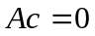 (..)

where definition of A depends on energy of the system ε which is here known. Because the given ε is not exact eigenvalue of the Galerkin system of equations, the desire vector c is the one that corresponds to the smallest eigenvalue of A.

The algorithm that converges to a relative error of 10⁻¹² in three to four iterations is the following.

1. Perform an LU decomposition of the matrix A.

2. Set c_{i}⁽⁰⁾ = 1, i = 1, ... , N.

3. Until the maximum absolute change in c_{i} < 10⁻¹²,

3.1 Solve Ly = c^{(m)} for y,

3.2 Solve Ux = y for x,
  - Set c^{(m+1)} = x/||x|| and determine maximum absolute change, |c_{i}^{(m+1)} - c_{i}^{(m)}|, i = 1, ... , N.

Whenever a high accurate approximation is defined, the matrix A may be singular leading a zero on the diagonal of the matrix U. To avoid division by zero, this zero must be replaced by a small number.

It is important to note that the matrix is not quite symmetric as is the case when the boundary condition y(b) = 0 is applied, but the lack of symmetry is restricted to the last row and column. No advantage was taken of this special property, except to assume that the eigenvalues and eigenvectors are real.

8. Using B-spline method for solution of close-coupling equations

In rigorous treatment of the scattering problem, we first must to derive the close-coupling equations for the radial functions of the continuum orbital, then expending the radial functions F(r) in the B-spline basis and using the Galerkin method, we obtained the final system of algebraic equations for the expansion coefficients. Formally, the derivation of the radial equations can be avoided and we may start from the B-spline representation of total wave function as ϕ×B(r) and then apply the Galerkin method directly to the Schrodinger equation, but at consideration of the matrix elements we have to assume that the orthogonal conditions between all bound orbital and B-splines, <P|B>, are the same as with the continuum radial orbital, <P|F>.

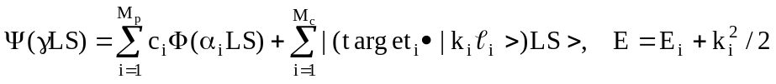 (1)

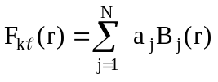 , 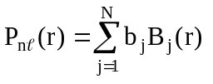

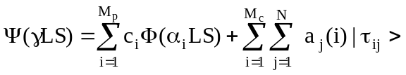 (2)

where 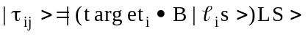 - B-spline basis function.

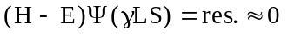 (3)

Galerkin method - the res. should be orthogonal to the solution space: <τ_{i}|res>=0.

(H-ES)c=0 , Ac=0 (4)

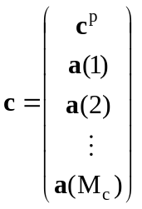 (5)

where c^{p} is the column vector of bound channel coefficients c^{p}=[c(1), c(2), ..., c(M_{p})]^{t}
and each a(i) is a column vector of B-spline coefficients a(i)=[a(i)₁, a(i)₂, ..., a(i)_{N}]^{t}
S is the overlap matrix consisting of diagonal blocks B B_{kl} =<B_{k}|B_{l} >
The interaction matrix (H-ES) has the following form:
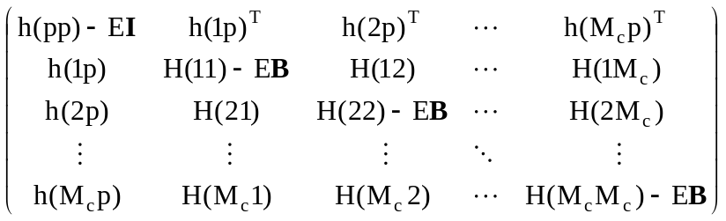

where h(pp) is an M_{p}×M_{p} matrix and comes from the bound-bound interaction, the h(ip) are the N×M_{p} matrices, represented the interaction between the i-th channel and bound states, H(ij) are the N×N matrices for channel-channel interaction.
Orthogonality requirements: <kl|nl>=0 → 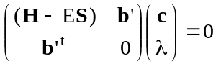,
where λ - Lagrangian multiplier, b' is a vector, it is zero evrywhere except at the rows that correspond to the channel k, where b' = Bb, and b' is the spline expansion coefficients of the P_{nl}.

9. Asymmetrical values on the border:

According integration in part
(1)
so the operator
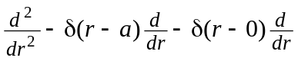 (2)
is symmetrical.

For B-splines only B_{n} is not equal zero on the outer border:
(3)
or
. (3.a)
This relation we can use in R-matrix theory to define the matrix elements of Bloch operator instead the explicit relations (Hart 1997):
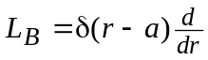 (4)
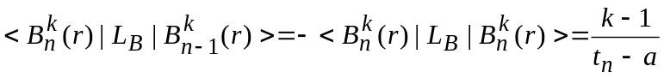 (5)
where border a = t_{n+1} - last knot point.

We need <H-L_{B}>. So the H(n-1,n) is not changed, H(n,n-1) => H(n-1,n),
H(n,n) => H(n,n) - <n|L_{B}|n> = H(n,n) + (H(n,n-1)-H(n-1,n))

References

[1] de Boor C 1978 A practical Guide Splines (New York: Springer)
[2] Shore B W 1974 J.Phys.B: At.Mol.Phys. 7 2502

