The one-channel continuum wave-function in LS-coupling.

Structure of equations

Let us assume that Ψ(N;γ_{t}L_{t}S_{t}) is a target wave function for an N-electron target state
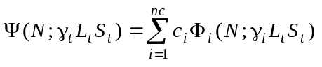, (1)
where Ф_{i} are the basis configuration state functions. Then the wave-function for one-channel continuum state with E = E_{target} + k²/2 and total term LS is
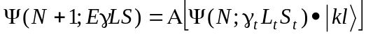, (2)
where • represent the coupling of the orbital of the continuum electron with orbital quantum number l and radial factor F(kl;r). In this definition, it is assumed that the target wave function Ψ_{t} is 7normalized and is known. The task then reduce to find the continuum orbital F(kl;r).
The equation for P(kl;r) can be obtained according to Galorkin principle:
(3)
It is more convenient to obtain the coefficients before different potential from expressions for matrix element:
(4)
This matrix element is transformed to the form
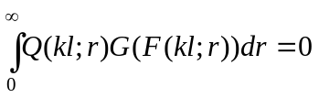 (5)
Then equation has the form
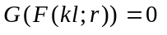 (6)
Consider different terms in matrix element (4) and their contribution in functional G. We assume that target functions are orthonormalized, but the continuum orbitals may be not orthogonal to bound orbital P(nl;r) of target. The bound orbitals also can be non-orthogonal, except the orbital which enter in one CFS, for example 1s₁² and 1s₂2s₂, and so on. Then the possible matrix terms and corresponding components in equation (6) have following schematic form.
Consider first the diferential operator.
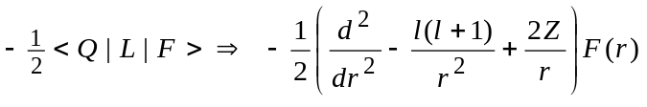 (7)
Due to normalization of the target function, the coefficient here must be always only -1/2, and to obtain the ordinary form of equation (6) as L|F>, we have to multiply all other terms on factor of -2.
Consider now the diagonal matrix elements.
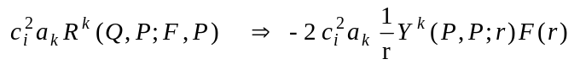 (8)
Hereafter the c_{i} denote the target expansion coefficients, and a_{i} stand for corresponding angular coefficients. The above terms responsible for the direct potentials, or screening of Coulomb field of nucleus Z/r, and these terms correspond to the F^{k} integrals in INT.LST.
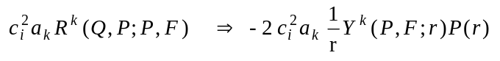 (9)
These terms lead to exchange potential and correspond to the G^{k} integrals in INT.LST. Due to orthogonality of bound orbitals belonging to one configuration, the potential (8) and (9) have no overlap factors.
(10)
(11)
Due to symmetry of problem, such terms have to enter in INT.LST only together, with Q ↔ F. In program, at generation of potentials, it is convenient to consider only the integrals, without specification whether or not it belong to diagonal matrix elements. Besides, the INT.LST does not differ Q and F functions. Then we have to consider both Q and F as variations, that leads to double results. It can be taken into account by deleting factor of 2 from terms (10) and (11). The above concerns also the one-electron interaction:
(12)
(13)
Finally,
(14)
Consider now the non-diagonal matrix elements in respect to target CSFs.
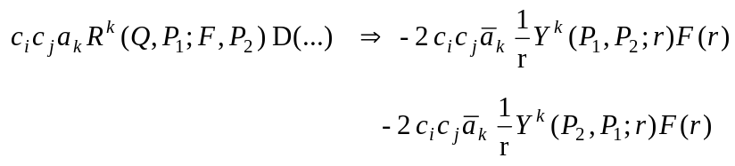 (15)
Such terms are also possible even for P₁≠P₂ because the one-electron orbitals may be non-orthogonal for different basis states that reflect the presents overlap factor D(...). This overlap factors depend only on the given bound orbitals, and to avoid their recalculation it is effective that they will be included in re-defined angular coefficients a_{k}. The second term appears because the INT.LST contains only the half of interaction matrix and the Q and F functions must enter symmetrically. In case of direct interaction (15), these terms are identical, but it is convenient to consider them separately, as variation of both Q and F (besides, INT.LST does not differ F and Q). Similarly, in case of exchange interaction we have
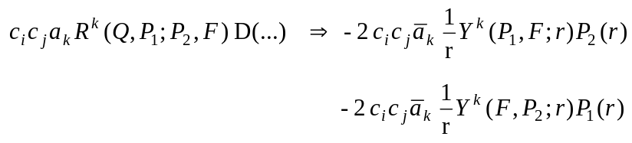 (15)
Other possible terms can be considered in the same manner.
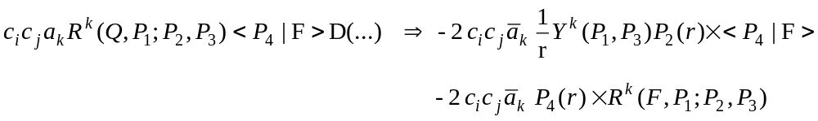 (16)
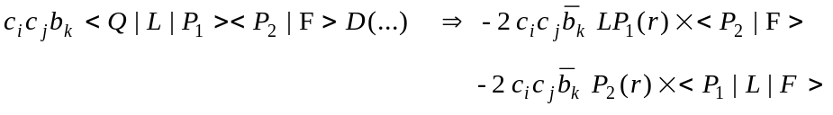 (17)
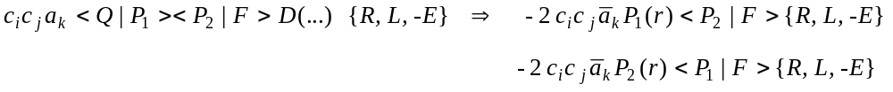
So, the general rule for obtaining the potentials from the INT.LST matrix elements is as follows:
- Re-define all coefficients by multiplying them on the bound-orbital overlap factors.
- Ignore all <F|F> and <F|L|F>.
- Each product c_{i}c_{j} for i≠j multiply on factor 2.
- Consider variation for each enter of F function in integrals.
- Interaction with core is included through the re-definition of L (L→L_{c}).
- Interaction within core is ignored, with re-definition of E→ (E-E_{core}), i.e. the reference point for
total energy is the core energy.
Then the general equation can be written as
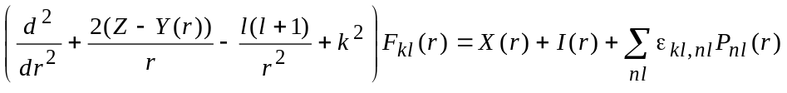 (18)
where direct potential Y(r) is defined by terms (8), exchange potential X(r) - by terms (9), interaction function I(r) - by all others terms, and last terms arise due to additional orthogonality constrains if needed.

Example
As example, consider the s-wave elastic scattering of electrons by hydrogen atoms: 1sks ^{1,3}S. The INT.LST (or ZINT.LST) gives the following matrix elements:
According the above rule, the following potentials can be obtained:
Make simplifications due to properties of hydrogen atom: E = E_{target} + k²/2 = -1/2 + k²/2, LP_{1s}(r)=P_{1s}(r), then
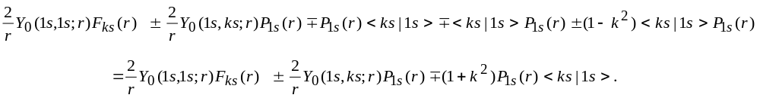So, finally we have equation
This equation can be compare with CFF(1977,p260) and with ''Methods in computational physics", 1971, p.22.

Consider the structure of the equation (18) in the case of logarithmic and semi-logarithmic scale.

Logarithmic scale: r=e^{ρ}, ρ=ln(r).

To avoid first derivites, re-define all radial functions: P(r)→ r^{1/2} P(ρ), F(r)→ r^{1/2} F(ρ), then equation (18) will be
(19)

1.3 Semi-logarithmic scale: ρ = αr + β ln(r)

In this case, re-define radial functions: P(r)→ [r/(αr+β)]^{1/2} P(ρ), F(r)→ [r/(αr+β)]^{1/2} F(ρ), then equation (18) will be
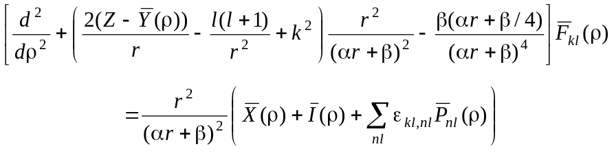 (20)

Note, that this equation have to reduce to equation (20) at β→1 and α→0.
Both (19) and (20) has the similar form
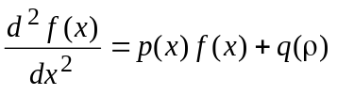 (21)
Consider its numerical solution on some grid x_{j}, j=0,1,..,M,M+1 with equal step h=x_{j+1}-x_{j,} and let f_{j}=f(x_{j}). By definition, the central difference operator is given by
(22)
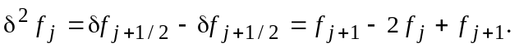 (23)
Many numerical procedures for equation (21) rely on an approximation to the second central differences
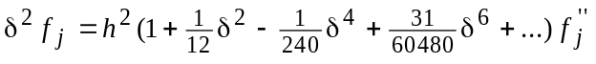 (24)
and use the differential equation to eliminate f''_{j}. The familiar Numerov method based on the first two terms of the discretization (24)
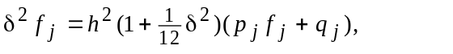 (24)
that leads to the system of linear equations
(25)
where
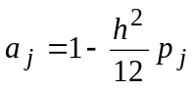
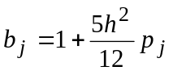
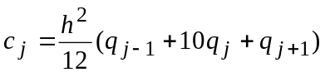.
These M equations involve M+2 unknowns; two additional equations must be obtained from the boundary conditions. According to (20), function p(ρ) at r → 0 approach to 1/β²[l(l+1)+1/4], so Y₀(0)=0. At r→∞ , the p(ρ) is defined by the term -k²r². Define the two intervals, [0,jj], where p_{j}>0, and [jj+1,M+1], where p_{j}<0. In the first interval, function has the exponential behaviour, whereas in the second interval, the function oscillates. In the first interval it is more stable to use so-called 'chaser' method, specific case of Gauss method. It can be shown that values f_{j} are related as
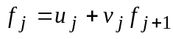 (26)
where
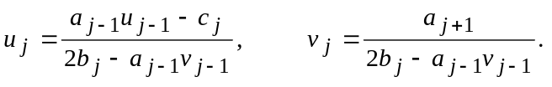 (27)
First, we define the coefficients u_{j} and v_{j} from (27), beginning with u₀=v₀=0, that corresponds f₀ = 0 (???). Then, if f_{jj} is known, values f_{j} for j=0,...,jj-1 can be found from relation (26). As the equation (20) is linear in respect to f(ρ), the normalization of solution may be arbitrary, and we choose f_{jj}=1. In interval [jj+1,M+1] solution is obtained directly from (25):
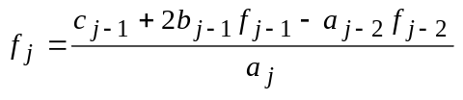 . (28)

