1. Symmetric column storage mode - each column is the diagonal, from down to central.
Lower part:
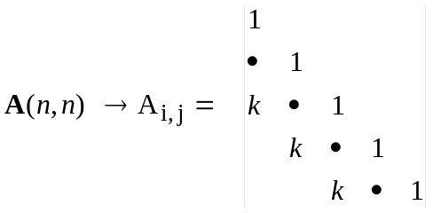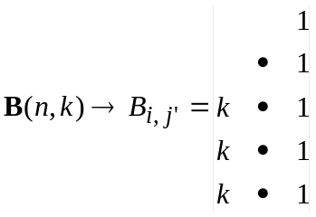

j' numerate the diagonal in A and a column in B
Relation: i=i', i-j=k-j' → j =j'+i-k, j' =j-i+k. A(i,j) = B(i,j')
The summation over elements: Do j' = 1, k
Do i = k+1-j', n

v = Ay → for low part: 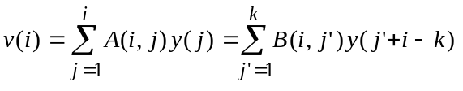 with all possible i
so A(i,j)=A(j,i), the same is valid for upper part with interchange of indexes in v(.) and y(.)

Upper part:
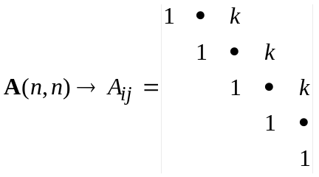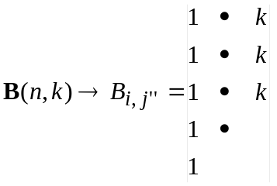

Relation: i=i'', j-i=j''-1 → j =j''+i-1, j'' =j-i+1. A(i,j) = B (i,j'')

The summation over elements: Do j'' = 1, k
Do i = 1, n-j''+1
Used for R^{k} (rmk array)

- Non-symmetric column storage mode - each column is the diagonal, from down to central.

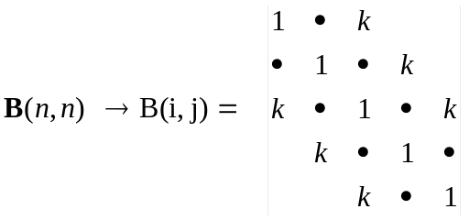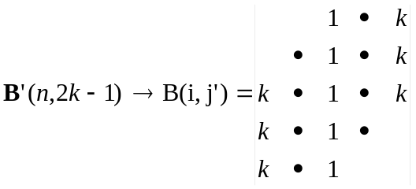

Relation: i=i', i-j=k-j' → j =j'+i-k, j' =j-i+k. A(i,j) = B(i,j')
The summation over elements: Do j' = 1, 2*k-1
imin = max(1,1+k-j')
imax = min(n,n+k-j')
Do i = imin,imax

- 'Almost' symmetric column storage mode - then we have only one non-symmetric element:
B(n,n-1) ≠ B(n-1,n)
Lower part:

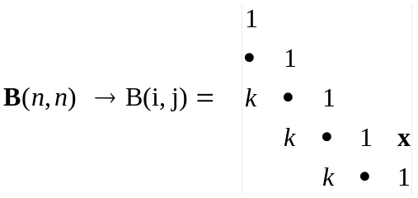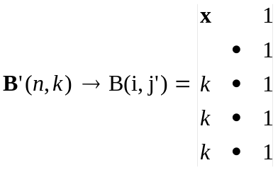

The B(n-1,n) element is saved in B'(1,1)

