TEM610 · INFORMATION ENGINEERING
The Architecture of Intelligence
From Mathematical Foundations to Agentic AI Systems

A Comprehensive Companion Report
Reviewing and Extending the Course Lecture Deck on Foundations of Artificial Intelligence
Prepared for the TEM610 Information Engineering course
September 2026

Contents

Preface
Why a forty-two-slide lecture deserves a full report.
The accompanying course slides move at the pace lectures must move: a definition here, a diagram there, a table of numbers flashed for ninety seconds before the next idea arrives. That pace is well suited to a live classroom, where a professor's voice fills the gaps between bullet points. It is poorly suited to review, to exam preparation, or to the kind of slow, connected understanding that turns disconnected facts about perceptrons, attention, and GPUs into a coherent mental model of how modern artificial intelligence actually works. This report exists to close that gap.
What follows is not a transcription of the slide deck. It is a full academic treatment of the same material — the same neuron diagrams, the same Bayes' theorem question, the same RLHF pipeline, the same GPU-pod arithmetic — expanded with the mathematical detail, the historical context, and the connective explanation that a fast-moving slide cannot carry. Every major claim in the original deck is preserved and cited to its place in the course material; every claim is then deepened with additional grounding drawn from the broader, well-established literature on machine learning, deep learning, and systems engineering.
The report is organized into seven parts that trace a single, deliberate arc: from the disciplinary foundations of AI, through the mathematics of learning, into the specialized architectures that gave rise to modern deep learning, through the generative AI systems built on top of those architectures, down into the physical silicon and data-center infrastructure that makes large-scale training possible, and finally up into the emerging paradigm of agentic AI — systems that do not merely answer questions but plan, act, and revise their own behavior. This arc mirrors the logic of the course itself: AI is not one technology but a layered stack, and each layer only makes sense in light of the one beneath it.
Readers are encouraged to treat this as a working document: a reference to return to before an exam, a companion to reread alongside the slides, and — in the discussion questions that close each major part — a prompt for the kind of critical thinking that separates a student who can recite the RLHF pipeline from one who can explain why it exists.
PART I · FOUNDATIONS — REASONING, MATHEMATICS, AND INFORMATION

1 What Is Artificial Intelligence? Defining the Field and Its Roots
Slide reference: “What is AI?” — the opening frame of the course.
Artificial intelligence is most usefully defined not as a single algorithm but as a property of a system: the capacity to simulate human-like intelligence through algorithms, data, and computational power, in order to learn, reason, make decisions, and adapt dynamically to new environments. This definition, drawn directly from the course's opening slide, is deliberately broad, and that breadth is the point. AI is not synonymous with any one method — not with neural networks, not with large language models, not with any single decade's dominant paradigm. It is the broader project of building machines that exhibit behavior we would call intelligent if a human exhibited it: recognizing a face, translating a sentence, diagnosing an X-ray, or planning a multi-step research task.
That project did not emerge from computer science alone. The course deck identifies five disciplines that converge to produce modern AI, and it is worth dwelling on why each one is indispensable rather than incidental.

The Five Disciplinary Pillars
- Mathematics — linear algebra, probability, and optimization. Neural networks are, at bottom, chains of matrix multiplications; training them is an optimization problem in a space with millions or billions of dimensions. Without linear algebra there is no way to even represent a network's weights; without optimization theory there is no way to improve them.
- Statistics and Data Science — the foundation for modeling and predicting patterns. Every trained model is, in a real sense, a compressed statistical summary of its training data. Concepts such as bias–variance tradeoff, overfitting, and generalization are statistical concepts before they are machine-learning concepts.
- Algorithms and Programming — the discipline of implementing efficient rules for learning and logic. An elegant mathematical idea (say, gradient descent) is useless at scale without an efficient algorithmic implementation (say, stochastic mini-batch gradient descent with adaptive learning rates) and the software engineering to run it reliably on real hardware.
- Neuroscience — the biological inspiration behind neural networks and deep learning. The artificial “neuron” borrows its name, and a loose structural analogy, from biological neurons that fire based on weighted inputs from other neurons. The analogy is imperfect — biological neurons are vastly more complex than any perceptron — but it was historically the spark that led McCulloch, Pitts, and later Rosenblatt to propose the perceptron model discussed in Part II.
- Philosophy and Ethics — ensuring responsible, transparent, and safe AI design. As systems move from narrow prediction tools toward autonomous agents (Part VI of this report), questions about accountability, alignment, and oversight move from academic curiosities to engineering requirements.
The lesson for an information-engineering student is not to master all five disciplines equally, but to recognize that a defensible AI system requires literacy across all of them. A brilliant model architecture built on statistically unsound data, or deployed without ethical review, is not a successful engineering outcome — it is a liability waiting to surface.

2 Three Logics of Reasoning: First Principles, Induction, and Analogy
Slide reference: “Three Logics and Methods.”
Before any algorithm is written, an engineer or scientist must choose a reasoning strategy — a logic by which conclusions are justified. The course deck distills this choice into three archetypes, summarized in Table 1. Understanding them is essential because different branches of AI lean on different logics, often without saying so explicitly.
Type | Direction | Core Idea | Typical Methods
First Principles | Top-down | Derive truth from fundamental laws | Physics / theoretical reasoning
Induction | Bottom-up | Infer general patterns from data | Experiments and statistical regression
Analogy | Side-to-side | Transfer understanding between similar systems | Reasoning by similarity

First-principles reasoning works top-down: it starts from axioms or fundamental laws and derives conclusions deductively, the way a physicist derives the trajectory of a projectile from Newton's laws without ever needing to observe the projectile in flight. Inductive reasoning works bottom-up: it starts from observed data and infers a general pattern, the way a regression model infers a relationship between advertising spend and sales from historical records without any a-priori theory of consumer psychology. Almost all of contemporary machine learning is fundamentally inductive — a model is only as good as the patterns latent in the data it was shown.
Reasoning by analogy sits between the two: it transfers understanding from one well-understood system to a less-understood one on the basis of structural similarity. This is more than a rhetorical device in AI — it is a genuine engineering method. Transfer learning, for example, is analogy formalized: a model trained on one large dataset (say, general internet text) is reasoned to be applicable, with modest fine-tuning, to a related but distinct task (say, legal-document summarization), because the two domains share enough structure that knowledge transfers. Recognizing which logic underlies a given technique — is this method deriving from theory, inferring from data, or transferring from a related domain? — is one of the fastest ways to build intuition for why a technique works, and where it is likely to fail.

3 The Mathematics of Prediction: Regression Analysis
Slide reference: “Regression Analysis: the Human Perspective.” Source cited in the deck: CLOSER (2020), Regression Analysis [video], YouTube.
Long before “machine learning” was a common phrase, regression analysis was already doing the job that headline AI systems do today: forecasting outcomes, identifying trends, and modeling relationships in time-dependent data. It remains the most interpretable entry point into predictive modeling, and it is not an exaggeration to say that a neural network is, in a structural sense, a deeply nested generalization of regression — a point made explicit later in this report (Part II).

Key Methodologies Introduced in the Course
- Linear Regression — models a single output as a weighted sum of input features plus an error term. It is the simplest possible predictive model, and its coefficients are directly interpretable: each weight tells you exactly how much the predicted output changes per unit change in that input.
- Multiple Linear Regression (MLR) — extends linear regression to several predictor variables simultaneously, allowing the model to separate the effect of, say, price from the effect of advertising spend on sales, rather than confounding them.
- Polynomial Regression — fits curved relationships by adding higher-order terms (x², x³, …) of the input. It captures non-linearity while remaining, technically, a linear model in its coefficients.
- Autoregressive (AR) Models — predict a value in a time series from its own previous values, capturing the intuition that “what happens next depends on what just happened.” This same intuition, scaled up enormously, is precisely what powers the “predict the next token” objective behind modern generative language models (Part IV).
- ARIMA Models — combine AutoRegressive terms, an Integrated (differencing) component for handling trends, and a Moving Average component for handling noise, making them a workhorse for classical time-series forecasting in economics, operations, and finance.
Why this matters for AI engineers
Regression is not a historical curiosity that deep learning made obsolete. It remains the correct tool whenever interpretability matters more than raw predictive power, whenever the dataset is small, or whenever a fast, auditable baseline is needed before investing in a neural architecture. A competent AI engineer reaches for the simplest model that solves the problem — and that is very often a regression model.

4 Probabilistic Reasoning: Bayes' Theorem and Updating Beliefs
Slide reference: “Bayes' Theorem — The Two-Event Case.” Source cited in the deck: Ace Tutors (2023), Bayes' Theorem Explained with Examples [video], YouTube.
If regression analysis answers the question “what value do I expect?”, Bayes' theorem answers a different and arguably more fundamental question: “how should I update what I believe once new evidence arrives?” This is the mathematical heart of probabilistic reasoning, and it underlies far more of modern AI than its modest classroom presentation suggests.
The course frames the theorem through its classic two-event case. Given two mutually exclusive events A₁ and A₂, together with the prior probabilities P(A₁) and P(A₂) — our initial belief about how likely each event is before seeing any evidence — and the conditional probabilities (likelihoods) P(B∣A₁) and P(B∣A₂) — how probable the observed evidence B is under each hypothesis — Bayes' theorem lets us compute the posterior probability P(Aᵢ∣B): the updated probability of each hypothesis after the evidence B has actually been observed.
Formally, for i = 1, 2:
P(Aᵢ ∣ B) = [ P(B ∣ Aᵢ) · P(Aᵢ) ] ⁄ Σⱼ P(B ∣ Aⱼ) · P(Aⱼ)
In plain language: the posterior is proportional to the likelihood of the evidence times the prior belief, normalized so that all posteriors sum to one. This single equation is the formal engine behind every spam filter that updates the probability an email is junk after seeing a suspicious word, every medical diagnostic model that updates disease probability after seeing a test result, and every Bayesian A/B-testing framework that updates belief about which product variant is better as new user data arrives.

Why Bayesian Thinking Matters Beyond the Formula
The deeper pedagogical value of Bayes' theorem is not the arithmetic — it is the discipline of separating three distinct quantities that students (and, frequently, practicing engineers) tend to conflate: what we believed before the evidence, how likely the evidence is under each hypothesis, and what we should believe after. Much of the discourse around AI “hallucination,” model confidence, and uncertainty quantification is, at root, a question of whether a system is doing anything resembling principled Bayesian updating, or whether it is simply reporting a raw, uncalibrated score that only looks like a probability.

5 Information Theory: The Hidden Mathematics of Learning
Slide reference: “The Foundational Role of Information Theory in Artificial Intelligence.”
Of all the mathematical foundations surveyed in the course, information theory is the least visible in day-to-day AI conversation and arguably the most structurally important. Information theory is a branch of applied mathematics and electrical engineering — originating with Claude Shannon's 1948 work at Bell Labs — that studies how information is quantified, stored, and communicated. Its central insight, that information can be measured in bits as a function of probability, turns out to be exactly the right lens for describing what a machine-learning model is doing when it “learns.”
The course deck highlights four information-theoretic quantities that appear constantly in AI system design, summarized here with their practical role.
Metric | Use in AI
Entropy (H) | Measures the uncertainty of predictions or inputs — a high-entropy prediction is one the model is genuinely unsure about.
KL Divergence | Compares a predicted distribution against a true (or reference) distribution — used inside variational autoencoders and in policy-update steps of reinforcement learning.
Cross-Entropy Loss | The single most common loss function for classification tasks, including the “predict the next token” objective used to train large language models.
Mutual Information | Evaluates how much knowing one variable tells you about another — used to assess correlation between learned features or representations.

The through-line connecting all four metrics is this: training a model is, almost without exception, the act of minimizing some information-theoretic quantity — usually cross-entropy — between the model's predicted probability distribution and the true distribution observed in the data. When a chatbot is trained to “predict the next token,” what is actually happening, mechanically, is that cross-entropy loss is being minimized across billions of next-token predictions. Entropy and cross-entropy are therefore not a footnote to deep learning; they are its objective function, hiding in plain sight behind the phrase “loss.”
This is also why information theory belongs in a course titled Information Engineering specifically. Every layer of the AI stack this report covers — from a single perceptron to a trillion-parameter transformer — is, from an information-theoretic point of view, a system for compressing, transmitting, and reconstructing information under uncertainty. That framing unifies what might otherwise look like a disconnected list of algorithms.

Part I — Checkpoint and Discussion
Before moving from foundations into the mechanics of neural networks, it is worth pausing to connect the four foundational tools introduced so far — first-principles/inductive/analogical reasoning, regression, Bayesian inference, and information theory — because every architecture discussed in the remainder of this report is, underneath its specific engineering, a combination of these same ideas.

Discussion Questions
- A perceptron's activation function converts a weighted sum into an output. Is training a perceptron better described as first-principles reasoning, induction, or analogy — and does your answer change once the network has many hidden layers?
- Explain, in your own words, why minimizing cross-entropy loss during language-model pre-training is mathematically equivalent to making the model's predicted next-token distribution match the true distribution of language as closely as possible.
- A spam filter has a prior belief that 1% of incoming email is spam. It then observes the word “free” in a message, which appears in 40% of spam but only 2% of legitimate email. Using Bayes' theorem, is this message more likely to be spam or not? What does this exercise illustrate about the danger of trusting “gut feeling” priors in a high-stakes classification system?
PART II · NEURAL NETWORKS — THE COMPUTATIONAL SUBSTRATE

6 Perception AI and the Biological Inspiration for Neural Networks
Slide reference: “Perception AI: A Glimpse into AI's Beginnings.”
Before a machine can reason about the world, it must first be able to perceive it. The course deck defines Perception AI as artificial intelligence systems designed to interpret and understand sensory data from the environment — images, sounds, and physical interactions — and identifies three key capabilities that recur across every perceptual system built since: object recognition (identifying and classifying visual or auditory elements), pattern detection (discerning meaning and structure from raw input), and human mimicry (enabling machines to respond to stimuli in a naturalistic way).
Historically, perception was where the modern deep-learning era began in earnest. Long before generative chatbots captured public attention, the breakthroughs that proved neural networks could work at scale were perceptual: recognizing handwritten digits, then photographs, then speech. This ordering is not an accident. Perception tasks provide dense, well-labeled data (a photograph is unambiguously “a cat” or “a dog”) and a clear, measurable notion of success, which makes them an ideal proving ground for new architectures before those same architectures are pointed at harder, less well-defined problems such as language generation or autonomous decision-making.
Section 15 of this report (Part III) returns to Perception AI in more technical depth once the reader has the vocabulary of neural computation in hand.

7 The Perceptron: Anatomy of an Artificial Neuron
Slide reference: “Fundamental Neural Network Modeling — The Perceptron.”
The perceptron is the atomic unit of every neural network discussed in this report, from the simplest classifier to the largest transformer. The course deck's diagram (reproduced as Figure 1) shows the canonical structure: two inputs, x₁ and x₂, feeding into a single output neuron, node 3, whose output is ŷ.
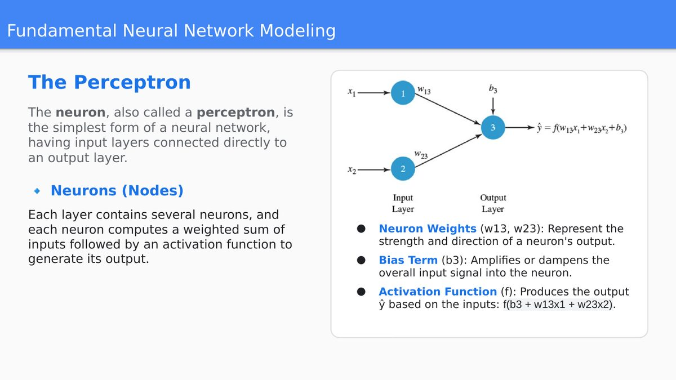
Figure 1. The perceptron: two inputs, weighted connections, a bias term, and an activation function producing the output ŷ.

Each connection in the diagram carries a weight — w₁₃ and w₂₃ — representing the strength and direction of that input's influence on the neuron's output. The neuron also receives a bias term, b₃, which shifts the neuron's decision boundary independently of the inputs, in the same way the intercept term shifts a regression line up or down the y-axis. The neuron computes a weighted sum of its inputs and bias, then passes that sum through an activation function f to produce its output:
ŷ = f(w₁₃x₁ + w₂₃x₂ + b₃)
Three components deserve emphasis because they recur, unchanged in principle, at every scale of neural-network engineering discussed later in this report:
- Neuron weights encode what the network has learned. Training a neural network is, mechanically, nothing more than searching for the set of weight values that make the network's outputs match the desired outputs as closely as possible.
- The bias term amplifies or dampens the overall input signal into the neuron, giving the model the flexibility to fit data that does not naturally pass through the origin.
- The activation function is what makes a neural network more than a glorified regression equation — without it, stacking multiple layers would collapse mathematically into a single linear transformation, no matter how many layers were stacked. Non-linearity is what allows deep networks to model the curved, complex decision boundaries that real-world data actually requires.

8 From One Neuron to Deep Networks: Mathematical Representation
Slide reference: “Mathematical Representation for one Signal Neuron or a signal Hidden Layer” and the associated full-network formulation.
A single perceptron can only separate data that is linearly separable — it can draw a single straight line (or hyperplane) through the data and nothing more. Real-world classification and regression problems are rarely so obliging, which is why practical systems stack neurons into layers, and layers into networks.

A Single Hidden Layer
For a network with one hidden layer, the course deck presents the relationship in matrix form:
h = σ(W₁x + b₁) ŷ = W₂h + b₂
Here x is the input vector, W₁ and W₂ are weight matrices, b₁ and b₂ are bias vectors, h is the hidden layer's output, and σ(·) is a non-linear activation function. Substituting the popular ReLU activation, defined as σ(x) = max(0, x), makes the computation completely explicit:
h = max(0, W₁x + b₁) ŷ = W₂h + b₂

Generalizing to L Layers
Extending this pattern to a network of L layers yields the general form used throughout the deep-learning literature:
ŷ = f(x) = Wₗσ(Wₗ₋₁σ(…σ(W₁x + b₁)…) + bₗ₋₁) + bₗ
This nested structure — a linear transformation, followed by a non-linearity, repeated L times — is the entire mathematical definition of a deep neural network. Everything else discussed in this report (convolutional layers, recurrent connections, attention mechanisms) is a specialized way of structuring the weight matrices Wᵢ to encode useful assumptions about the data, not a departure from this fundamental recipe.

Choosing an Activation Function
The course deck distinguishes two activation-function regimes that every practitioner must know:
- ReLU (Rectified Linear Unit) — the default choice for hidden layers. Its simplicity (zero for negative inputs, identity for positive inputs) makes it computationally cheap and, crucially, largely avoids the “vanishing gradient” problem that plagued earlier activation functions such as sigmoid in deep networks.
- Sigmoid or Softmax — reserved for the output layer in classification tasks. Sigmoid squashes a single output into the range (0, 1), suited to binary classification (“is this spam, yes or no”); softmax generalizes this to multiple classes, producing a full probability distribution over all possible labels that sums to exactly one — which is precisely the mechanism a language model uses to choose its next word from a vocabulary of tens of thousands of tokens.

The Building Blocks, Restated
The course summarizes the architecture of a basic neural network as three components, and it is worth restating them here as a checklist: the input layer accepts the raw features of the dataset; one or more hidden layers perform the actual computation, activating neurons based on learned weights and biases; and the output layer converts the network's internal representation into a final prediction, whether a class label or a continuous value.

9 How Networks Learn: Forward Propagation, Loss, Backpropagation, and Gradient Descent
Slide reference: “Neural Network Learning Paradigms for Computational Modeling” (two-part sequence).
Knowing the architecture of a neural network only explains how it computes an output; it says nothing about how the network's weights come to have useful values in the first place. That is the job of training, and the course deck lays it out as a five-step cycle. This is, without exaggeration, the single most important algorithmic sequence in modern AI — every large language model, every image classifier, and every game-playing agent discussed later in this report is trained through some variant of exactly these five steps.

Step 1 — Forward Propagation (Prediction Phase)
Input data is passed through the network layer by layer. At each layer, every neuron computes a weighted sum of its inputs, applies its activation function, and passes the result forward to the next layer. The final layer produces the network's output — a classification label, a numeric prediction, or (in a language model) a probability distribution over the next token.

Step 2 — Loss Calculation (Error Measurement)
The model's output is compared against the true target value using a loss function chosen for the task: Mean Squared Error (MSE) for regression problems, where the penalty grows with the square of the numeric error, or Cross-Entropy Loss for classification problems, where the penalty grows as the model's predicted probability for the correct class drops further from 1.0. As established in Section 5, cross-entropy is itself an information-theoretic quantity — loss calculation is where information theory and neural-network training meet directly.

Step 3 — Backpropagation (Error Correction)
The measured error is propagated backward through the network, layer by layer, to determine how much each individual weight contributed to that error. This is accomplished using the chain rule of calculus: because the network's output is a nested composition of functions (exactly the nested structure shown in Section 8), the chain rule allows the gradient of the loss with respect to any weight, however deep in the network, to be computed efficiently by working backward from the output.

Step 4 — Gradient Descent (Weight Optimization)
Once every weight's gradient is known, the weights are updated to reduce the loss, using the update rule:
Wₙₑᴡ = Wₒₗᴅ − η · (∂L ⁄ ∂W)
where Wₙₑᴡ is the updated weight, Wₒₗᴅ is the previous weight, ∂L⁄∂W is the gradient of the loss function with respect to that weight, and η (eta) is the learning rate — a hyperparameter that controls the step size of each update. This single hyperparameter is deceptively consequential: a learning rate set too high can cause training to diverge or oscillate; one set too low can make training prohibitively slow or trap the model in a poor local solution. Much of the “craft” of training large models lies in scheduling this rate carefully over the course of training.

Step 5 — Iteration (Epochs)
Steps 1 through 4 repeat across the entire training dataset, and the whole cycle repeats over multiple passes (epochs), until the loss converges — that is, until further updates no longer meaningfully reduce the error. In production-scale training this loop can run for weeks across thousands of GPUs (a point this report returns to in Part V), but the underlying algorithmic cycle is exactly the same five steps a student can trace by hand on a two-neuron toy example.
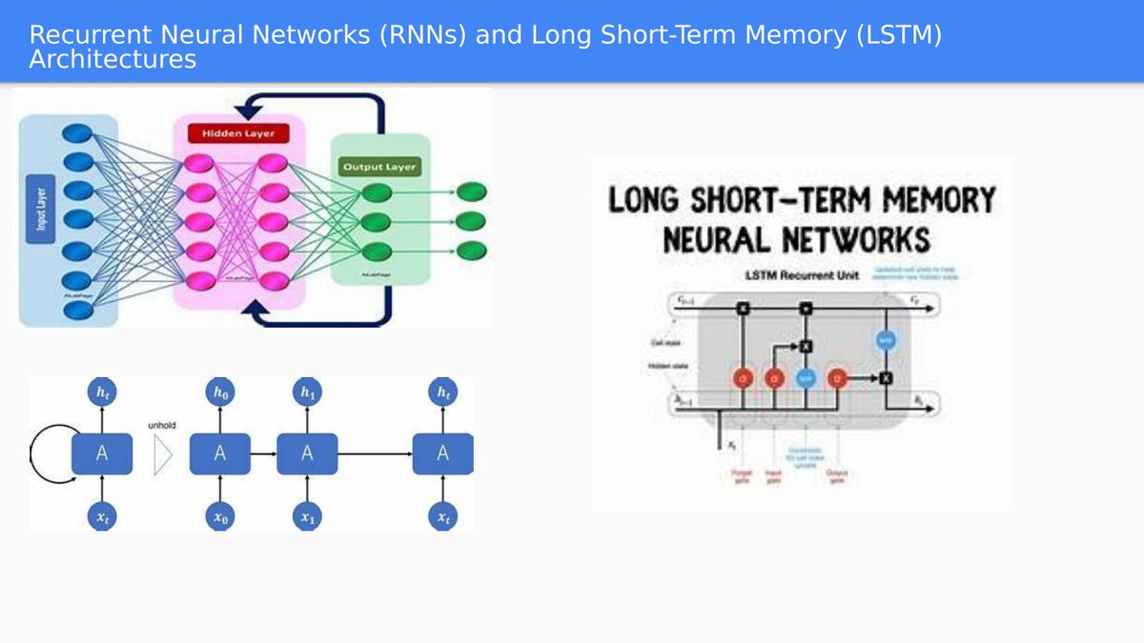
Figure 2. Sequential architectures extend this same training cycle across a chain of connected states — the subject of Part III.

Part II — Checkpoint and Discussion

Discussion Questions
- Explain why removing the activation function from every hidden layer of a deep network — leaving only the linear transformations Wᵢx + bᵢ — would make the entire network mathematically equivalent to a single-layer linear model, no matter how many layers remained.
- The learning rate η controls the size of each gradient-descent step. Sketch, in words, what you would expect to observe in the training loss curve if η were set far too high, and separately if it were set far too low.
- Why is cross-entropy loss the natural choice for classification tasks (including next-token prediction in language models) while Mean Squared Error is the natural choice for regression tasks? Connect your answer back to the information-theoretic definitions in Section 5.
PART III · SPECIALIZED ARCHITECTURES — MEMORY, REWARD, AND ATTENTION

10 Sequential Memory: RNNs and LSTMs
Slide reference: “Recurrent Neural Networks (RNNs) and Long Short-Term Memory (LSTM) Architectures”; “Key Theoretical Frameworks and Computational Learning Algorithms.”
The feed-forward network described in Part II has a structural blind spot: it has no memory. Each prediction is computed fresh from its inputs, with no awareness of what came before. That is a fatal limitation for any data that unfolds over time or in sequence — a sentence, a stock price series, a sensor stream — where the meaning of the current element depends on what preceded it. Recurrent Neural Networks (RNNs) and their more capable successor, Long Short-Term Memory networks (LSTMs), were built specifically to solve this problem.
Figure 3. Left: a feed-forward network unrolled with recurrent connections feeding hidden state forward through time. Right: the internal gating structure of an LSTM cell, which regulates what to forget, what to add, and what to output at each time step.

The Recurrent Idea
An RNN processes a sequence one element at a time, and at each step it combines the new input with a hidden state carried over from the previous step. That hidden state acts as the network's short-term memory of everything it has processed so far in the sequence. As the diagram's “unfold” view shows, an RNN is best understood not as a single exotic architecture but as the same neuron, A, applied repeatedly across time steps x₀, x₁, …, xₜ, each time reading in both the current input and its own previous hidden state h.

Why LSTM Was Necessary
Plain RNNs suffer badly from the vanishing-gradient problem introduced in Section 9: when backpropagation is unrolled across many time steps, gradients from distant past inputs shrink exponentially, so the network effectively “forgets” anything more than a few steps back. LSTM networks solve this with an explicit gating mechanism — a forget gate, an input gate, and an output gate — that gives the network fine-grained, learned control over what information to discard, what new information to store, and what to expose to the next layer at each time step. This gating structure is what allows an LSTM to maintain a coherent “cell state” across dozens or hundreds of time steps, something a plain RNN cannot reliably do.
The course deck identifies the primary use cases for this family of architectures: sequential-data problems in prediction, natural language processing, and time-series analysis. Historically, RNNs and LSTMs were the dominant architecture for machine translation, speech recognition, and text generation — right up until the attention mechanism, covered in Section 12, displaced them as the state of the art for almost all of these tasks.

11 Reinforcement Learning: Learning Through Interaction
Slide reference: “Reinforcement Learning: The Developmental Trajectory of Adult Learning Processes”; case study “Playing Games.”
Everything covered so far in this report — regression, classification, sequence modeling — falls under supervised learning: the model is shown correct answers and learns to reproduce them. Reinforcement Learning (RL) is a fundamentally different paradigm. There are no labeled correct answers. Instead, an agent learns to make decisions by interacting with an environment and receiving a reward signal, refining its behavior through trial and error in a manner the course deck explicitly likens to how humans and animals learn.

The RL Loop
The course reduces this to a simplified five-step loop that is worth committing to memory, because it recurs — barely modified — as the backbone of the agentic-AI loop in Part VI:
- Observe — the agent observes the current state of its environment.
- Decide — the agent selects an action according to its current policy (its learned strategy).
- Respond — the environment transitions to a new state and returns a reward signal.
- Learn — the agent updates its policy based on the outcome, reinforcing actions that led to reward and discouraging those that did not.
- Repeat — the loop continues, often for millions of iterations, until performance is optimized.

Case Study: The Rise of Game-Playing Agents
The course deck's case study on RL — game-playing systems — is one of the clearest illustrations available of how quickly a research paradigm can mature once the right algorithmic ingredients are in place, and it is reproduced in Figure 4.
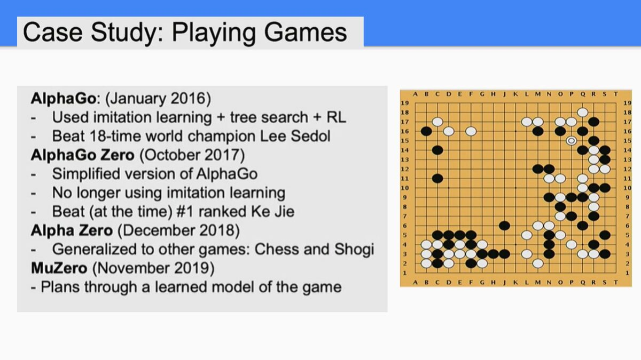
Figure 4. The trajectory of DeepMind's game-playing agents, from AlphaGo's narrow, human-imitation-assisted victory over Lee Sedol to MuZero's fully general, model-based planning — all built on the same observe–decide–respond–learn loop.

- AlphaGo (January 2016) combined imitation learning (studying human expert games), tree search, and reinforcement learning to defeat Lee Sedol, an 18-time world Go champion — a result many researchers had not expected for another decade, given Go's astronomically large search space.
- AlphaGo Zero (October 2017) simplified the recipe by removing imitation learning entirely, learning to play Go purely through self-play reinforcement learning, and went on to defeat the top-ranked human player, Ke Jie, without ever having studied a single human game.
- AlphaZero (December 2018) generalized the same algorithm beyond Go to chess and shogi, demonstrating that the self-play RL recipe was not a Go-specific trick but a general method for mastering any perfect-information board game.
- MuZero (November 2019) removed the final piece of built-in domain knowledge: rather than being given the rules of the game, MuZero learns its own internal model of the environment and plans through that learned model — a capability directly relevant to the model-based planning discussed for autonomous agents in Part VI.
This progression — from a system that needed human demonstrations, to one that needed only game rules, to one that needed neither — is a template that recurs throughout AI history: each generation of a technique strips away one more human-provided scaffold, replacing it with something the system learns for itself.

12 The Attention Revolution and the Transformer Architecture
Slide reference: “Attention Concept”; “Attention is All You Need”; “Transformer Model.” Primary source cited in the deck: Vaswani, A. et al. (2017), “Attention Is All You Need,” Advances in Neural Information Processing Systems, 30.
Attention is arguably the single most consequential idea in the modern era of AI, and the course deck rightly gives it sustained treatment across four slides. Its core definition, as stated in the deck, is deceptively simple: attention allows AI models to dynamically focus on the most relevant parts of the input, rather than treating all elements equally, by assigning different importance scores that help the model make better predictions.

An Intuitive Example
The course deck's linguistic example is worth restating in full because it is the clearest possible intuition-builder. Consider the sentence: “The cat sat on the mat because it was tired.” To correctly resolve what the pronoun “it” refers to, a model — like a human reader — must “attend” far more strongly to the word “cat” than to the word “mat,” even though “mat” is closer in the sentence. Attention formalizes exactly this intuition: it assigns higher weights to elements with stronger contextual relationships, regardless of their raw distance in the sequence.
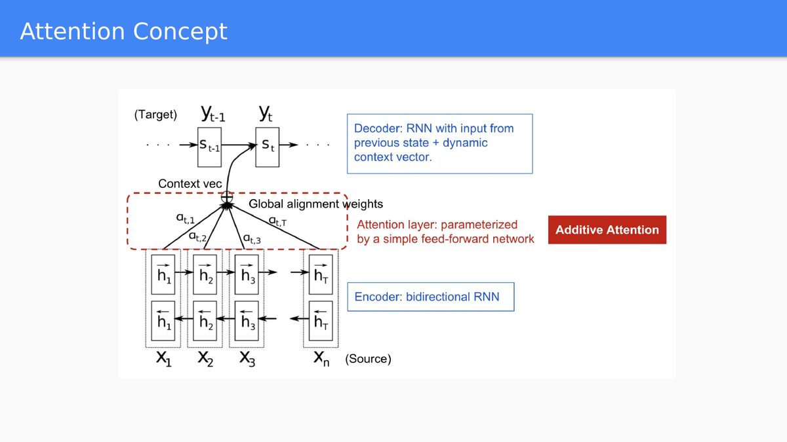
Figure 5. The attention mechanism as originally formulated for sequence-to-sequence translation: a bidirectional RNN encoder produces hidden states for each source word; an additive-attention layer computes alignment weights α; and the decoder RNN uses the resulting weighted context vector to generate each target word.

From an RNN Add-On to a Standalone Paradigm
As the diagram in Figure 5 shows, attention was originally introduced as an enhancement bolted onto RNN-based encoder–decoder translation systems, addressing exactly the long-range dependency weakness that plain RNNs struggle with (Section 10). The 2017 paper “Attention Is All You Need,” by Vaswani and colleagues, made a far bolder claim: that the recurrent connections could be discarded entirely, and attention alone — applied as self-attention, where every position in a sequence attends to every other position — was sufficient to build a state-of-the-art sequence model. This architecture became known as the Transformer, and its arrival marks the clearest single inflection point in the AI course's chronology.
The course deck identifies three key variants of the attention mechanism that recur throughout transformer-based systems:
- Self-Attention — each token in a sequence computes attention scores against every other token in the same sequence, allowing the model to build context-aware representations of every word simultaneously rather than one at a time.
- Cross-Attention — one sequence (for example, a decoder generating output) attends to a separate sequence (for example, an encoder's representation of the input), which is essential whenever a model must condition its generation on external content.
- Multi-Head Attention — several attention computations run in parallel, each free to learn a different kind of relationship (say, one “head” specializing in syntactic dependency, another in coreference), and their outputs are combined, giving the model a richer and more robust representation than any single attention computation could provide alone.

Why the Transformer Won
The course deck's summary of the Transformer's impact is worth quoting directly: it is “a neural network architecture that learns context and meaning by tracking relationships in sequential data,” first described by Google researchers in 2017, using self-attention to detect subtle, long-range dependencies between distant data elements. Its practical advantage over RNNs and LSTMs is not merely accuracy but parallelizability: because self-attention computes relationships across an entire sequence simultaneously rather than one time step at a time, transformer training can be massively parallelized across GPUs (Part V) in a way sequential RNN computation fundamentally cannot. This is not a minor engineering detail — it is the single architectural fact that made training on internet-scale datasets computationally feasible, and it is therefore the direct technical ancestor of every large language model discussed in Part IV.

Part III — Checkpoint and Discussion

Discussion Questions
- AlphaGo Zero and MuZero both use the same observe–decide–respond–learn loop described in Section 11, yet each removes a different piece of prior human knowledge. Compare what each system had to learn on its own, and connect this progression to the four “pillars” of agent architecture introduced later, in Section 18.
- An LSTM's forget gate, input gate, and output gate all exist to combat one specific training problem. Name the problem and explain, at a mechanical level, why gating helps solve it.
- The “Attention Is All You Need” paper removed recurrence from sequence modeling entirely. Explain why that removal — not just the addition of attention — was necessary to unlock large-scale parallel training on GPUs.
PART IV · GENERATIVE AI AND THE MODERN AI STACK

13 Generative AI at Scale: Scaling Laws and Frontier Models
Slide reference: “Generative Artificial Intelligence: The Progression Toward Human-Equivalent Cognition.”
Generative AI is defined in the course deck as a class of artificial intelligence models that can create new content — text, images, music, video, code, and more — by learning patterns from existing data and generating new outputs that resemble that training data. What distinguishes the current generation of generative models from earlier generative approaches (such as the GANs and VAEs introduced in Section 5's framework table) is scale: these models are built primarily on the Transformer architecture from Section 12, trained according to empirically observed scaling laws, on datasets of a size that has no real historical precedent.
The course deck illustrates this with estimated scale figures for a frontier-class model, reproduced in Table 3. These figures are presented in the source material as estimates, and they should be read as illustrative of the order of magnitude involved rather than as precise, verified specifications.
Component | Estimated Size / Scale
Token count | ~18 trillion tokens
Data diversity | 45% text, 25% code, 30% video / audio / math
Storage weight | ~8 petabytes (uncompressed)
Compute complexity | Estimated 10²⁶ to 10²⁷ FLOPs

To make those units concrete, the course deck supplies three conversions worth memorizing: one petabyte (PB) is roughly 1,000,000 gigabytes; a FLOP is a single floating-point operation (one addition or multiplication of decimal numbers); and, as a rough rule of thumb for English text, 100 tokens correspond to approximately 75 words. Applying that last conversion, 18 trillion tokens corresponds to on the order of 13–14 trillion words — several orders of magnitude beyond what any human could read in a lifetime.

What a Scaling Law Actually Claims
The term “scaling law,” used more fully in Part V, refers to empirical formulas describing how a model's performance improves as three variables increase together: compute power (C), dataset size (D), and model size (N, the number of trainable parameters). The practical significance for an information engineer is this: within the regimes studied so far, improvements in model capability have been remarkably predictable functions of these three inputs, which is precisely why frontier AI labs have been willing to commit the enormous capital expenditures on data-center infrastructure discussed in Part V — the relationship between spend and capability gain has, historically, held up as investment scaled.

14 From Model to Chatbot: Architecture, Pre-training, and Alignment (RLHF)
Slide reference: “Generative AI: Evolution into Chatbot Applications” (two-part sequence).
A raw, freshly trained language model is not a chatbot — it is closer to an extraordinarily well-read autocomplete engine. The course deck is precise and pedagogically valuable on this point, describing the transformation from “a mathematical model into a conversational partner” as a sophisticated multi-stage process resting on three core pillars: Architecture, Pre-training, and Alignment.

Pillar 1 — The Architecture: The Transformer
The Transformer, introduced in Section 12, supplies the “brain” of the system through its self-attention mechanism, which lets the model look at every word in a sentence simultaneously and determine which words are most relevant to each other. Before any of that computation can occur, raw text must be converted into a form the model can process mathematically: this is done through tokenization, which breaks text into tokens (chunks of characters or words), and vectorization, which converts each token into a vector — a long list of numbers — so that the model's matrix operations (Section 8) can be applied to it.

Pillar 2 — Pre-training: Learning the World
Once the architecture is built, the (still untrained) model undergoes unsupervised learning, ingesting massive amounts of text scraped from the internet, books, and articles — precisely the scale of data quantified in Table 3. Its training objective throughout this phase is deceptively narrow: predict the next token in a sequence, repeated millions of times per second across the training corpus, exactly the autoregressive prediction task described for classical AR models in Section 3, but generalized from numeric time series to language itself. The course deck's phrase for what emerges from this process is apt: the model becomes a “statistical mirror of knowledge.” By learning to predict what word comes next with high fidelity, the model is forced, as a side effect, to internalize grammar, facts about the world, coding logic, and fluency across multiple languages — none of which it was ever explicitly taught as a separate lesson.

Pillar 3 — Alignment: Learning to Chat
A pre-trained model predicts plausible continuations of text; it has no built-in notion of being helpful, honest, or safe to interact with. Converting it into a usable assistant requires a further stage the course deck names explicitly: Reinforcement Learning from Human Feedback (RLHF), which proceeds in three steps.
- Supervised Fine-Tuning — human annotators write out “perfect” example conversations (question-and-answer pairs) that demonstrate how a helpful assistant should behave, and the model is fine-tuned to imitate this style directly.
- Reward Modeling — human raters compare multiple candidate responses from the model and rank them from best to worst, and this ranking data is used to train a separate reward model that can score any given response for quality.
- Optimization — a reinforcement-learning algorithm (structurally the same observe–decide–respond–learn loop from Section 11, with the reward model standing in for the environment's reward signal) trains the chatbot to prioritize the kinds of answers humans ranked highly, shaping the model to be more polite, accurate, and concise.
The course deck offers a memorable “academic library” analogy for the full pipeline, connecting every technical stage to something a student can picture directly. It is reproduced in full in Table 4, because it is one of the most effective single teaching devices in the entire lecture deck.
Component | Function | The “Academic” Analogy
Transformer | The structural design of the neural network. | The blueprint of a library.
Pre-training | Processing trillions of words to learn patterns. | Reading every book in the library.
Fine-Tuning | Adjusting the model for specific tasks, like chatting. | Training a librarian to answer questions.
RAG (Retrieval) | Connecting the AI to real-time data or specific files. | Giving the librarian a search engine.

That final row — Retrieval-Augmented Generation, or RAG — deserves a brief technical note because the course deck introduces it only through the analogy. RAG addresses a structural limitation of pre-training: a model's factual knowledge is frozen at the moment its training data was collected, and it has no native access to private documents, live data, or events after its training cutoff. RAG solves this not by retraining the model, but by retrieving relevant external documents at query time and inserting them into the model's context window, so that its next-token prediction (Pillar 2) is conditioned on fresh, specific, and often proprietary information rather than relying solely on what it memorized during pre-training.

Part IV — Checkpoint and Discussion

Discussion Questions
- A pre-trained (but not yet aligned) language model and a fully RLHF-aligned chatbot may share the exact same underlying Transformer weights at the start of alignment. What, precisely, does RLHF change, and what does it leave untouched?
- Using the library analogy in Table 4, explain in your own words why Retrieval-Augmented Generation (RAG) is a fundamentally different solution to “the model doesn't know something” than further pre-training would be, and identify one scenario where RAG is clearly the better engineering choice.
- Scaling laws relate compute (C), dataset size (D), and model size (N) to performance. Why might an organization choose to hold model size fixed and instead scale dataset size and compute — and what does this decision have to do with the data-center economics discussed in Part V?
PART V · THE PHYSICAL INFRASTRUCTURE OF AI

15 GPUs: The Engine of the AI Revolution
Slide reference: “GPU: The Technology that Revolutionized AI Computing”; “Key Features of a Modern GPU”; “Inside a GPU: NVIDIA H100.” Additional context cited in the deck: NVIDIA GTC March 2025 Keynote [video], YouTube.
Every mathematical operation described in Parts II through IV — matrix multiplications inside a perceptron, gradient computations during backpropagation, the parallel attention computations inside a Transformer — must ultimately run on physical hardware. The course deck identifies the Graphics Processing Unit (GPU) as the single piece of hardware most responsible for making today's AI systems computationally feasible, and the reason is architectural, not incidental.
A GPU is defined in the course material as a specialized electronic circuit designed to rapidly process and manipulate memory in order to accelerate image rendering, animation, and — critically for this course — general-purpose numerical computation. Physically, a GPU is mounted on a GPU card, an expansion board that plugs into a computer's motherboard and is dedicated to graphical rendering and complex computation.

Why GPUs, Specifically, and Not Faster CPUs
The fundamental architectural difference the course deck draws out is this: a GPU prioritizes parallelism and high memory bandwidth over the raw sequential processing speed a CPU is optimized for. Concretely, this comes down to two features:
- Massively parallel core architecture — a GPU chip contains hundreds to thousands of smaller, simpler processing units (Streaming Processors on NVIDIA hardware, Compute Units on AMD hardware) that execute tasks simultaneously, rather than the handful of large, complex cores a CPU relies on.
- Dedicated high-bandwidth memory — GPUs use their own on-board memory, VRAM (Video Random-Access Memory), built to standards such as GDDR6 or HBM (High Bandwidth Memory), which can feed data to thousands of cores far faster than conventional system memory could.
A matrix multiplication — the single most common operation in neural-network computation — decomposes naturally into many small, independent multiply-and-add operations. A GPU's architecture is, in effect, purpose-built to run exactly that kind of computation across thousands of cores at once, which is why GPUs (and, increasingly, even more specialized AI accelerators) rather than CPUs have become the substrate of choice for both training and running large models.

Inside the NVIDIA H100
The course deck grounds this abstract architectural discussion in the concrete specifications of a real, widely deployed data-center GPU: the NVIDIA H100. Figure 6 reproduces the deck's diagram of a single Streaming Multiprocessor (SM), the core repeating computational unit inside the chip.
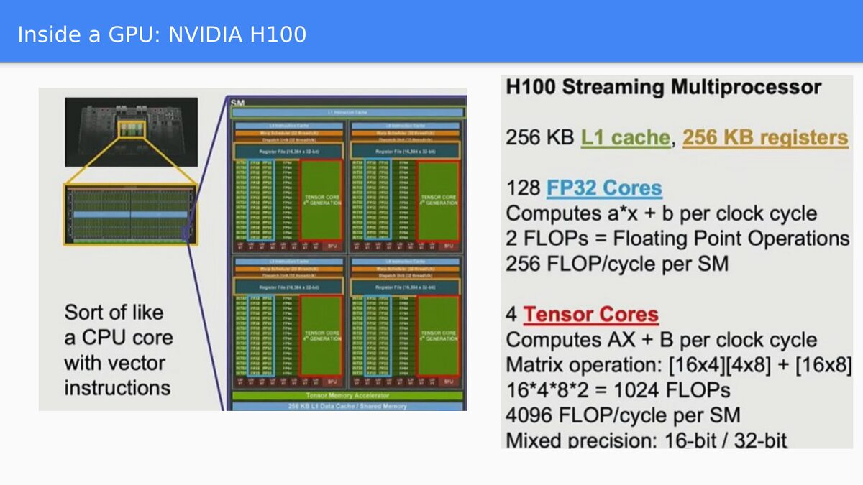
Figure 6. A single Streaming Multiprocessor inside the NVIDIA H100 — the deck's helpful analogy: “sort of like a CPU core with vector instructions.” Each SM contains dedicated FP32 cores for general arithmetic and specialized Tensor Cores for matrix operations, plus a private L1 cache and register file.

Two categories of compute unit inside each SM matter for an information-engineering student: the 128 FP32 cores, each capable of computing a general arithmetic operation of the form a×x + b per clock cycle (2 floating-point operations, or FLOPs, per core, yielding 256 FLOPs per cycle across the SM); and the 4 Tensor Cores, each specialized for exactly the operation that dominates neural-network computation, a matrix multiply-and-accumulate of the form A×X + B. A single [16×4]×[4×8] matrix operation of this kind performs 16·4·8·2 = 1,024 FLOPs, and across the SM's four Tensor Cores this totals 4,096 FLOPs per cycle — a roughly sixteen-fold throughput advantage over the general-purpose FP32 cores for exactly the workload neural networks generate. This is the concrete, chip-level reason why specialized Tensor Cores, not general-purpose arithmetic units, are what actually make large-scale model training tractable.

16 From Chip to Cluster: Servers, Racks, Pods, and Data Centers
Slide reference: “GPU Server, GPU Rack and GPU Pod”; “GPU Cluster = One Huge Compute”; “Data Center and Scaling Law.”
No single GPU, however capable, can train a frontier-scale model alone. The course deck walks through the physical hierarchy by which individual chips are aggregated into the enormous compute clusters that make frontier-model training possible — a hierarchy every information engineer working in this space should be able to reason about quantitatively, not just conceptually.
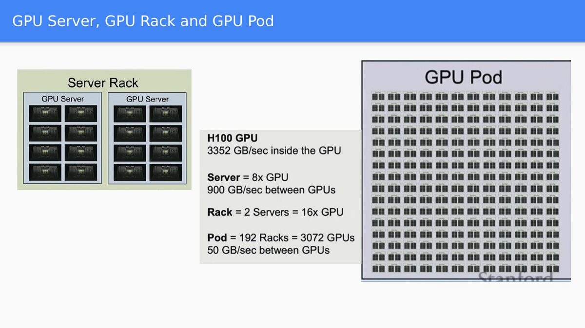
Figure 7. The physical aggregation hierarchy: eight H100 GPUs form a server; two servers form a rack; 192 racks form a full GPU pod. Interconnect bandwidth (measured in GB/sec) shrinks at each successive level, from 3,352 GB/sec inside a single GPU down to roughly 50 GB/sec between GPUs at the pod's outer boundary.

The deck's numbers, reproduced in Figure 7, are worth internalizing as a chain of multiplication: a single H100 GPU offers roughly 3,352 GB/sec of internal memory bandwidth; a server aggregates 8 such GPUs, with roughly 900 GB/sec of bandwidth available between GPUs within that server; a rack aggregates 2 servers into 16 GPUs; and a full pod aggregates 192 racks — 3,072 GPUs — with inter-GPU bandwidth falling to roughly 50 GB/sec at that outermost scale.
Scaling one level further, the course deck describes a full GPU cluster as eight pods, for a staggering aggregate of 24,576 GPUs, 1,875 petabytes of combined GPU memory, 415 million FP32 cores, 13 million Tensor Cores, and a combined throughput of 24.3 exaFLOPs per second (24.3 × 10¹⁸ floating-point operations per second) — while inter-GPU bandwidth across the full cluster falls to under 50 GB/sec. The course deck states the goal of building such a structure in the plainest possible terms: to train one giant neural network on this cluster.

Why Bandwidth Shrinks as Scale Grows — and Why That Matters
The pattern in Figure 7 — bandwidth falling by roughly an order of magnitude at each successive level of aggregation — is not an oversight; it is a fundamental physical and economic constraint. Wiring every GPU in a 24,576-GPU cluster with the same bandwidth available between two GPUs on the same server would be physically and economically impractical. This constraint is precisely why the Transformer's parallelizability (Section 12) matters so much in practice: training algorithms and model architectures must be explicitly designed to minimize how much data needs to cross these lower-bandwidth boundaries, distributing computation so that the most bandwidth-hungry operations stay confined to the fastest, most tightly coupled tier of the hierarchy.

Scaling Laws Meet the Data Center
The course deck closes this section by connecting the abstract scaling laws introduced in Section 13 — governing compute, dataset size, and model size — to the literal physical footprint required to satisfy them. Table 5 reproduces the deck's comparison between a typical large AI training center and a “frontier” AI supercluster of the kind associated with projects such as Stargate or Colossus.
Feature | Large AI Training Center (Typical) | “Frontier” AI Supercluster
Power capacity | 100–300 MW | 1,000 MW (1 GW) – 5,000 MW (5 GW)
Building size | 200,000–500,000 sq. ft. | 1–4 million sq. ft.
Land area | 30–100 acres | 800–2,500+ acres (campus scale)
Chip count | 50,000–100,000 GPUs | 200,000–2,000,000 AI chips

A power capacity of 1–5 gigawatts is, for scale, comparable to the output of a large nuclear power plant — dedicated to a single computing facility. This table is the clearest possible illustration of the course's broader thesis: the mathematics of Part II and the architectures of Part III are inert without the physical infrastructure of Part V, and the scale of that infrastructure has become one of the defining strategic and economic questions in contemporary AI development.

Part V — Checkpoint and Discussion

Discussion Questions
- Tensor Cores deliver roughly sixteen times the FLOPs-per-cycle of general-purpose FP32 cores on the same H100 Streaming Multiprocessor. Explain, referring back to Section 8's matrix formulation of a neural network, why matrix-multiply-and-accumulate is the operation that benefits most from this specialization.
- Interconnect bandwidth falls from roughly 3,352 GB/sec inside a single GPU to under 50 GB/sec across a full pod. What engineering strategies might a training system use to keep the most bandwidth-sensitive computation confined to the fastest tier of this hierarchy?
- A “frontier” AI supercluster can require 1–5 gigawatts of power. What does this figure suggest about the future constraints on AI progress — is the binding constraint more likely to be algorithmic innovation, chip design, data availability, or energy supply? Defend your answer.
PART VI · AGENTIC AI — THE NEXT FRONTIER

17 Defining Agent AI: Perception, Decision-Making, Action
Slide reference: “Artificial Intelligence Agents: Advanced Computational Tools.”
Every architecture discussed so far in this report — regression models, classifiers, sequence models, even a fully aligned chatbot — shares one structural limitation: given an input, it produces an output, and its involvement in the world ends there. Agent AI is defined by the course deck as a departure from that pattern: an artificial intelligence system designed to act autonomously in an environment, perceive changes, make decisions, and take actions to achieve specific goals.
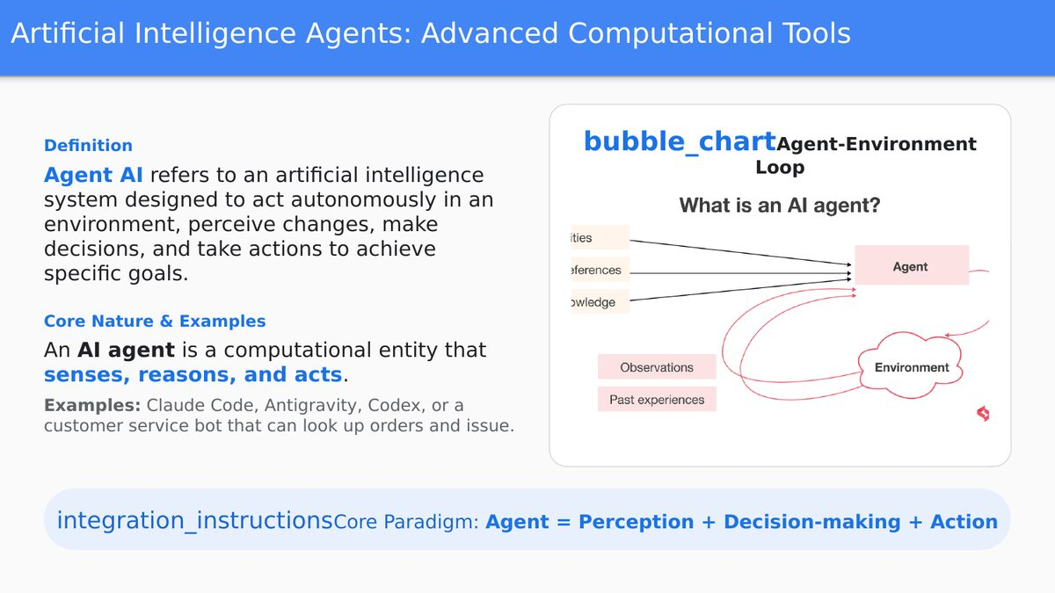
Figure 8. The agent–environment loop: the agent draws on its capabilities, preferences, and knowledge to act, observes the resulting state of the environment, and incorporates past experience into its next decision.

The course deck's core paradigm compresses this into a single, memorable equation:
“Agent = Perception + Decision-making + Action”
An AI agent, in this formulation, is a computational entity that senses, reasons, and acts — a description the course deck grounds with concrete, contemporary examples: coding agents such as Claude Code, Antigravity, and Codex, as well as more conventional examples such as a customer-service bot capable of looking up a customer's order and resolving an issue autonomously, without a human operator manually executing each step.
It is worth being precise about what changed to make this possible. The underlying language model inside a coding agent may be architecturally identical to the chatbot described in Section 14. What differs is everything around the model: the tools it can call, the memory it can draw on, and the loop that lets it act, observe the result, and act again. This distinction — same brain, different architecture around it — is the organizing idea of the remainder of Part VI.

18 The Architecture of an Autonomous Agent: Brain, Planning, Memory, Tools
Slide reference: “Core Architecture of an Agent” (two-part sequence).
The course deck decomposes the architecture of an autonomous agent into four fundamental pillars. Read together, they form a checklist any student can use to evaluate whether a given system is “truly” agentic or merely a chatbot with a friendlier interface.

Pillar 1 — The Core LLM (The Brain)
The foundational language model, built and trained exactly as described in Sections 12–14, serves as the agent's central controller. It processes incoming input, interprets user intent, coordinates the agent's other architectural components, and decides what action to take next. Everything else in this section exists to extend what this core model can perceive, remember, and act upon.

Pillar 2 — Planning and Reflection
To solve complex, multi-step goals, an agent must decompose them. The course deck names two component skills here: task decomposition, in which the agent splits a large objective into a sequence of manageable sub-goals, and self-reflection, in which the agent critiques its own outputs or the results of its own tool executions, correcting its course when a particular approach fails. This second capability — treating one's own failed attempt as informative feedback rather than a dead end — is what separates a merely capable model from a genuinely agentic one, and it is examined in mechanical detail in Section 19.

Pillar 3 — Memory
An agent operating over an extended task requires memory to maintain consistency and context. The course deck distinguishes two tiers: short-term memory, the current context window of the ongoing conversation, letting the agent recall the immediate steps of the task it is midway through, and long-term memory, external storage — commonly a vector database — that lets the agent retain and retrieve historical facts, past interactions, or documents over much longer periods than any single context window could hold. This distinction directly parallels human cognitive architecture (working memory versus long-term memory) and, technically, long-term memory in this sense is close cousin to the retrieval component of the RAG system described in Section 14.

Pillar 4 — Tools
Tools are what let an agent act on the physical or digital world rather than merely describe it. By executing external code, calling APIs, or searching the web, an agent extends its capability beyond static text prediction to completing real-world tasks — writing and running a script, querying a live database, booking a calendar event, or, as the course deck's own examples illustrate, resolving a customer's order issue directly rather than merely explaining how the customer could resolve it themselves.

19 The Agentic Loop: Plan, Execute, Evaluate, Reflect
Slide reference: “Agentic AI and Agentic Loop”; “In Agentic AI Loop.”
The course deck draws a sharp conceptual line between a standard large language model and an agentic AI system. A standard LLM, it notes, operates on a simple input-output model: a prompt goes in, a response comes out, and the interaction ends. Agentic AI, by contrast, is given a goal rather than a prompt — it plans, takes sequential actions, observes the results of those actions, and adapts, often with minimal human intervention along the way.
The course deck lists the defining characteristics of an agentic system explicitly, and they double as a practical checklist:
- Maintains state and memory across steps (Section 18, Pillar 3).
- Selects and uses tools — web search, code execution, APIs, file systems (Section 18, Pillar 4).
- Engages in multi-step reasoning and replanning (Section 18, Pillar 2).
- Can operate over long time horizons, well beyond a single prompt-response exchange.
- Produces actions in the world, not just text.
Crucially, the course deck makes a point that is easy to miss but architecturally central: standard LLMs become agentic when given tools, memory, and the ability to loop. The underlying model may be identical to a non-agentic chatbot; it is the architecture wrapped around it that determines whether the system behaves reactively or agentically. The agentic loop is the name for the operational cycle that carries this architecture from a high-level goal to a verified, completed task without ongoing human intervention — the course deck describes it as embedding the LLM inside a continuous feedback engine, in place of the simple input-output model.

Walking Through the Loop
The course deck illustrates the loop with a concrete, minimal example — an agent tasked with creating a Python function that sorts an array using quicksort — and traces it through four explicit stages, which map directly onto the RL loop of Section 11 and the agent pillars of Section 18:
- Plan (Goal Decomposition) — the agent receives the objective and its core LLM (Pillar 1) decomposes it into a logical sequence: setup, implementation, and testing.
- Execute (Action via Tools) — the agent generates the code and uses its tools (Pillar 4) to act on its environment, writing the script to a digital workspace and executing it inside a sandboxed code interpreter.
- Evaluate (Observation) — rather than merely inspecting its own generated text, the agent observes the actual system output: compiler logs, execution times, or error traces.
- Reflect (Self-Correction) — the agent treats an error log as new context (Pillar 3, short-term memory), analyzes why the code failed, adjusts its understanding, and feeds that reflection back into the planning stage to generate a refined plan (Pillar 2).
“A standard model fails the moment it writes a bug; an agentic loop treats a bug as a standard prompt to trigger the next optimization cycle.” — course lecture deck, Slide 37
This is, in the report's assessment, the single most important conceptual sentence in the entire course deck's treatment of agentic AI. It reframes failure itself: in the standard input-output paradigm, an error is a terminal outcome requiring human intervention; inside the agentic loop, an error is simply more information to reason about, and the system is architected from the outset to expect and recover from it. This property — error tolerance built into the control loop rather than bolted on afterward — is what allows an agent to complete tasks that would be brittle or impossible for a single-shot model call.

20 The Theoretical Shift: From Input–Output to PEAS and Rational Agency
Slide reference: “The Core Theoretical Shift: autonomy, planning, and action.”
The course deck closes its treatment of agentic AI with a claim that is more philosophical than technical, but no less important for an information engineer to internalize: standard AI is best understood through the classical machine-learning frame of input → output. Agentic AI is better understood through a different and older framework — PEAS (Performance measure, Environment, Actuators, Sensors) — drawn from Russell and Norvig's foundational textbook treatment of rational agents. An agentic system, the course deck argues, is a rational agent in the full sense of that term, not merely a more elaborate input-output function.

Unpacking PEAS
- Performance measure — the criterion by which the agent's success is judged (did the code pass its tests? did the customer's issue get resolved?).
- Environment — everything the agent perceives and acts within (a codebase and sandboxed interpreter, a customer database, the live web).
- Actuators — the mechanisms through which the agent acts on its environment; in Section 18's terms, its tools.
- Sensors — the mechanisms through which the agent perceives its environment's state; in Section 19's terms, its evaluation/observation step.
Mapping the course's own agentic-loop example onto this framework makes the connection concrete: the performance measure is whether the quicksort function is correctly implemented and passes its tests; the environment is the sandboxed code-execution workspace; the actuators are the code-writing and code-execution tools; and the sensors are the compiler logs, execution times, and error traces the agent reads back.

Why the Framing Matters Philosophically
The course deck is explicit that this is not merely a taxonomic exercise: agentic systems exhibit goal-directedness, and goal-directedness raises questions about alignment, oversight, and accountability that simply do not arise with a model that only produces text. A text-only model's worst failure mode is an incorrect or misleading sentence, contained entirely within a conversational output. An agent's worst failure mode is an incorrect or misaligned action taken in the world — a file deleted, a transaction executed, an email sent — which is why the ethical and philosophical foundations flagged back in Section 1 (“Philosophy and Ethics: ensuring responsible, transparent, and safe AI design”) become sharply more consequential, not less, as systems move from the chatbot paradigm of Part IV into the agentic paradigm of Part VI.

21 Technical Competencies for Practitioners
Slide reference: “Technical Competencies for Leveraging Agentic Artificial Intelligence.”
The course deck closes its practical treatment of agentic AI with a skills map for students who intend to build, rather than merely study, these systems. It separates foundational prerequisites — skills required for AI work broadly — from agentic-specific engineering skills, which it notes is where the field diverges sharply from standard AI work.

Foundational Prerequisites

Programming
- Python — the dominant language across the agentic ecosystem.
- Asynchronous programming (asyncio) — agents routinely run concurrent, non-blocking tasks, such as calling multiple tools or waiting on multiple external responses at once.
- API consumption and REST/JSON fluency — nearly every tool an agent calls (Section 18, Pillar 4) is exposed as a REST API returning JSON.
- Version control (Git) — essential not just for code but for managing prompt and configuration changes as agent behavior is iterated on.

Core AI Literacy
- Understanding of LLM mechanics — tokens, context windows, temperature, and sampling, all of which trace back to the architecture in Sections 8 and 14.
- Prompt engineering — instruction design, chain-of-thought prompting, and few-shot patterns for shaping model behavior without retraining it.
- Familiarity with model capabilities and failure modes — including hallucination and context loss, both of which become higher-stakes once a model is empowered to act (Section 20).

Agentic-Specific Engineering Skills: Agent Architecture and Frameworks
The course deck notes that this is where the field diverges sharply from standard AI work, and it grounds the point in a concrete comparison of the leading agent-orchestration frameworks in current use, reproduced in Table 6.
Framework | Primary Use
LangChain / LangGraph | General agent pipelines, graph-based control flow
AutoGen (Microsoft) | Multi-agent conversation systems
CrewAI | Role-based agent teams
LlamaIndex | Data-centric agents, RAG pipelines
Anthropic Claude API | Direct agent construction with tool use

Each framework in Table 6 is, in essence, a different opinionated implementation of the four pillars from Section 18 and the loop from Section 19 — differing in how explicitly they model multi-agent collaboration (AutoGen, CrewAI), graph-structured control flow (LangGraph), retrieval-centric workflows (LlamaIndex), or minimal, direct tool-calling (the Anthropic Claude API). Recognizing the shared underlying architecture across these frameworks — rather than treating each as an unrelated tool to memorize — is the fastest route to genuine fluency in this part of the field.

22 Current Limitations: AI Meets the Physical World
Slide reference: “Advancements in Large Language Models and Their Implications for Robotics.”
The course deck closes its technical survey with an important corrective to any narrative of frictionless AI progress: the same large language models that power the chatbots and agents discussed above face substantial, currently unresolved challenges the moment they are asked to control a physical body operating in the real world.

Server-Based Dependency
Most LLMs operate as centralized, server-based systems. This creates a heavy reliance on remote cloud infrastructure (precisely the infrastructure quantified in Part V), which limits real-time response times and local autonomy in dynamic physical environments where a robot cannot afford network latency before deciding whether to stop moving.

Lack of Sensory Grounding
LLMs primarily process text and lack direct sensory grounding. A robot, by contrast, must interpret and act instantly on multimodal input — vision, motion, sound, and touch — a much richer and more continuous sensory stream than the tokenized text described in Section 14.

High Power Consumption
LLMs are extremely power-hungry during both training and inference, a point the physical infrastructure figures in Part V make viscerally concrete. The course deck cites a striking projection: by approximately 2030, data centers are projected to consume up to 11.7% of total U.S. power, creating severe energy challenges that compound further for any robotics application that would need to run comparable models with onboard, battery-constrained power.

Static vs. Dynamic Adaptation
LLMs are trained on vast but ultimately static datasets, whereas robots must operate in highly unpredictable, constantly changing environments. Real-time learning and context-specific adaptation — updating behavior mid-task based on something genuinely novel in the environment, rather than merely retrieving from a fixed training distribution — remain critical, largely unsolved problems at the intersection of AI and robotics.
Read alongside Part VI, this section functions as a deliberate reality check: the agentic loop of Section 19 works remarkably well in digital environments (a code sandbox, a REST API, a file system) precisely because those environments are fast, cheap to query, and forgiving of a failed attempt. A physical environment is none of these things, which is why embodied, physical-world agentic AI remains meaningfully behind its digital counterpart even as the course was being taught.

Part VI — Checkpoint and Discussion

Discussion Questions
- Using the PEAS framework from Section 20, specify the performance measure, environment, actuators, and sensors for a home-delivery robot, and identify which of the four robotics challenges in Section 22 would most threaten each PEAS component.
- The course deck states that “standard LLMs become agentic when given tools, memory, and the ability to loop.” Using a chatbot you have used personally, describe what would need to be added, concretely, to make it agentic under this definition.
- Section 20 argues that agentic systems raise questions of alignment, oversight, and accountability that text-only models do not. Propose one concrete oversight mechanism (technical or procedural) that could reduce the risk of an agent taking an unwanted real-world action, and explain which PEAS component it targets.
PART VII · SYNTHESIS

23 Conclusion: AI as High-Order Value Creation, Not Mere Search
Slide reference: the course deck's closing synthesis slide, “The Core of AI is Not Search, But Processes, Creation, and Systems.”
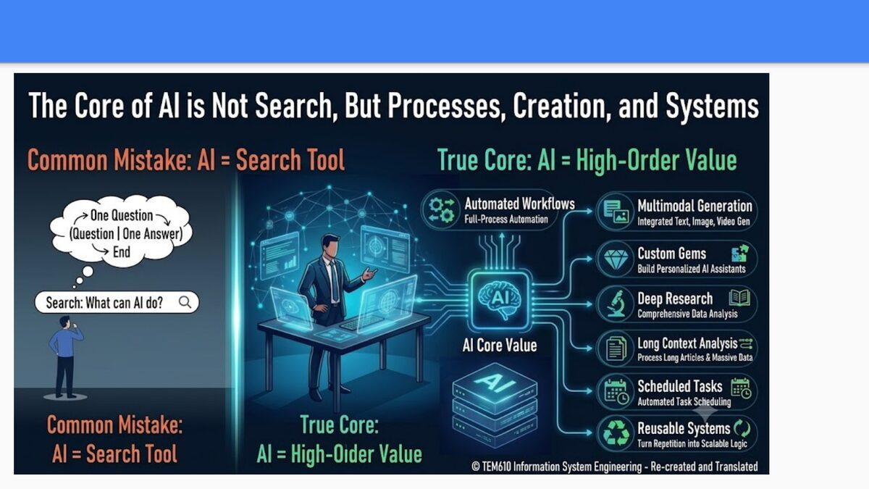
Figure 9. The course's closing thesis, contrasting the common mistake of treating AI as a one-question, one-answer search tool against its true core value: automated workflows, multimodal generation, custom assistants, deep research, long-context analysis, scheduled tasks, and reusable systems.

The course deck ends deliberately, not with another technical diagram, but with a correction of a common misconception — one worth holding onto as the single takeaway from this entire report. The common mistake, as the closing slide frames it, is to treat AI as a search tool: a system for the pattern one question, one answer, end. Type a query, receive a reply, done. Everything covered in this report argues against that framing being sufficient. The true core value of AI, as the course deck states it, lies in high-order value: automated workflows that carry out full processes rather than single answers, multimodal generation spanning text, image, and video, custom assistants tailored to a specific task, deep research synthesizing across many sources, long-context analysis of entire articles or datasets at once, scheduled and autonomous task execution, and reusable systems that turn one-off effort into scalable, repeatable logic.
This report has tried to earn that conclusion rather than merely assert it, by tracing exactly how each layer of the AI stack makes the next layer's “high-order value” possible. Regression and Bayesian inference (Part I) gave the mathematical vocabulary for prediction and belief-updating. The perceptron and its training loop (Part II) turned that vocabulary into a learnable computational unit. RNNs, LSTMs, reinforcement learning, and attention (Part III) extended that unit to handle sequence, memory, interaction, and context at scale. Generative AI and RLHF alignment (Part IV) turned a trained network into something that could converse naturally with a human. GPUs and data-center infrastructure (Part V) supplied the physical substrate without which none of the preceding scale would be computationally possible. And agentic architecture, the agentic loop, and the PEAS framework (Part VI) took a conversational model and gave it the capacity to plan, act, observe, and reflect — moving it, finally, from something that answers a single question to something that can execute an entire process.
The course deck closes with a broader mission statement from Professor Fei-Fei Li — described in the source material as the “First Lady of AI” — that reframes the entire technical arc of this report in human terms:
“Building AI to See What Humans See. Building AI to See What Humans Don't See. Building AI to See What Humans Want to See.” — Prof. Fei-Fei Li
Read against the material this report has covered, each clause of that mission maps onto a concrete technical capability. “Seeing what humans see” is Perception AI (Part III, Section 6 and its technical foundations): recognizing objects, understanding language, processing sound, at or beyond human-level accuracy. “Seeing what humans don't see” is the pattern-detection power of models trained across petabyte-scale, information-theoretically compressed representations of data (Part I, Section 5; Part IV, Section 13) — correlations and structures too vast or subtle for any individual human to notice unaided. And “seeing what humans want to see” is, ultimately, the alignment problem addressed by RLHF (Part IV, Section 14) and by the accountability questions raised by agentic autonomy (Part VI, Section 20): building systems whose outputs and actions actually serve the humans they are built for.
For a student of Information Engineering, the most important habit of mind this report can leave behind is not any single formula, diagram, or benchmark figure — it is the ability to trace a claim about “what AI can do” back down through this stack to the specific mathematical and engineering mechanism that makes it possible. That is the difference between using AI and understanding it, and it is the difference this course, and this report, were built to teach.

Appendix A — Glossary of Key Terms
- Activation function. A non-linear function (e.g., ReLU, sigmoid, softmax) applied to a neuron's weighted input sum, without which a stacked network would collapse mathematically into a single linear model.
- Agentic loop. The plan–execute–evaluate–reflect cycle that lets an autonomous agent pursue a goal through repeated action and self-correction rather than a single input-output exchange.
- Attention. A mechanism allowing a model to assign different importance weights to different parts of its input, enabling it to focus on the most contextually relevant elements.
- Backpropagation. The algorithm that computes the gradient of a network's loss with respect to every weight, via the chain rule, by propagating error backward from the output layer.
- Bayes' theorem. A formula for updating the probability of a hypothesis given new evidence, combining a prior probability with a likelihood to produce a posterior probability.
- Cross-entropy loss. An information-theoretic loss function measuring the difference between a model's predicted probability distribution and the true distribution; the standard loss for classification and next-token prediction.
- Entropy. A measure of the uncertainty inherent in a probability distribution; higher entropy means greater unpredictability.
- Gradient descent. An optimization algorithm that iteratively updates a model's parameters in the direction that most reduces the loss function, scaled by a learning rate.
- LSTM (Long Short-Term Memory). A recurrent neural network variant using gated units (forget, input, output gates) to preserve information across long sequences without vanishing gradients.
- PEAS. A framework (Performance measure, Environment, Actuators, Sensors) from Russell and Norvig for formally specifying a rational agent.
- Perceptron. The simplest neural network unit: a weighted sum of inputs plus a bias, passed through an activation function to produce an output.
- RAG (Retrieval-Augmented Generation). A technique that supplies a language model with retrieved external documents at query time, extending its effective knowledge beyond its training data.
- Reinforcement learning (RL). A learning paradigm in which an agent learns a policy by interacting with an environment and receiving reward signals, rather than from labeled examples.
- RLHF (Reinforcement Learning from Human Feedback). A three-stage alignment process (supervised fine-tuning, reward modeling, optimization) that shapes a pre-trained language model into a helpful, well-behaved assistant.
- Scaling laws. Empirical relationships describing how model performance improves as compute, dataset size, and model size increase together.
- Self-attention. A form of attention in which every element of a sequence computes attention scores against every other element of the same sequence.
- Tensor Core. A specialized GPU compute unit optimized for matrix multiply-and-accumulate operations, offering far higher throughput than general-purpose cores for neural-network workloads.
- Tokenization. The process of breaking raw text into discrete units (tokens) that a language model can process numerically.
- Transformer. A neural network architecture, introduced in 2017, that relies entirely on (self-)attention rather than recurrence to model relationships within sequential data.

Appendix B — Sources Cited in the Course Lecture Deck
The following sources were cited directly within the original TEM610 course slides and underpin several sections of this report.
- NVIDIA (Tuesday). GTC March 2025 Keynote [video]. YouTube. https://www.youtube.com/watch?v=_waPvOwL9Z8
- CLOSER (2020). Regression Analysis [video]. YouTube. https://www.youtube.com/watch?v=vPde9bYrr80
- Ace Tutors (2023). Bayes' Theorem Explained with Examples [video]. YouTube. https://www.youtube.com/watch?v=cqTwHnNbc8g
- Vaswani, A., Shazeer, N., Parmar, N., Uszkoreit, J., Jones, L., Gomez, A. N., Kaiser, Ł., & Polosukhin, I. (2017). Attention Is All You Need. Advances in Neural Information Processing Systems, 30. Curran Associates, Inc.
- Li, F.-F. Course-cited mission statement, presented in the closing slide of the lecture deck.
This report additionally draws on well-established, broadly documented foundations of machine learning, deep learning, information theory, GPU computer architecture, and multi-agent systems engineering to expand on and contextualize the material presented in the course slides.

