1. 更新拓扑

接口名

updateBaseStationSignal

数据

[{

"id": 10952001,

"num": "1",

"name": "节点1",

"ip": "192.168.1.1",

"mac": "01:01:01:01:01:01",

"signalArray": [{

"mac": "01:01:01:01:01:02",

"intensity": -95

}, {

"mac": "01:01:01:01:01:03",

"intensity": -95

}]

}, {

"id": 72,

"num": "2",

"name": "节点2",

"ip": "192.168.1.2",

"mac": "01:01:01:01:01:02",

"signalArray": [{

"mac": "01:01:01:01:01:01",

"intensity": -33

}, {

"mac": "01:01:01:01:01:03",

"intensity": -33

}]

}, {

"id": 22,

"num": "3",

"name": "节点3",

"ip": "192.168.1.3",

"mac": "01:01:01:01:01:03",

"signalArray": [{

"mac": "01:01:01:01:01:01",

"intensity": -33

}, {

"mac": "01:01:01:01:01:02",

"intensity": -33

}]

}]

显示

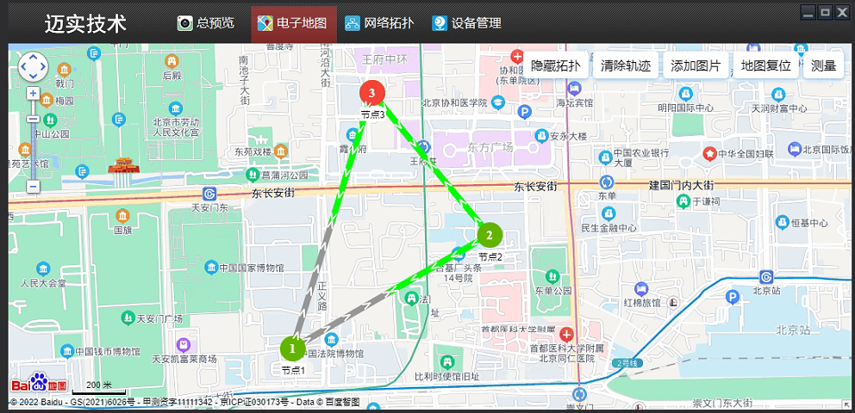

1. 更新基站位置

接口名

UpdateBaseStationPos

数据

Id，基站id

Longitude，经度

Latitude，维度

显示效果

红色为没有经纬度，绿色有经纬度

管理后台接口每次会取所有点位的经纬度列表，如果地图上的结点不在经纬度列表里则显示红色。

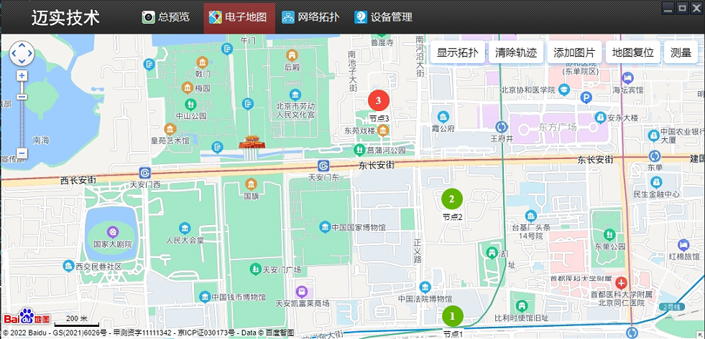

1. 更新基站列表

接口名

updateBaseStationMap

数据

[{

"id": 10952001,

"num": "1",

"name": "节点1",

"ip": "192.168.1.1",

"mac": "01:01:01:01:01:01"

}, {

"id": 72,

"num": "2",

"name": "节点2",

"ip": "192.168.1.2",

"mac": "01:01:01:01:01:02"

}, {

"id": 22,

"num": "3",

"name": "节点3",

"ip": "192.168.1.3",

"mac": "01:01:01:01:01:03"

}]

显示效果

节点1（红框）为初次显示并且没有经纬度，这时显示在按钮的左面，如果有多个无经纬度的节点依次排开显示在按钮左面，拖动地图时节点不会在地图上移动，保持在按钮左面。管理后台显示效果保持一样。

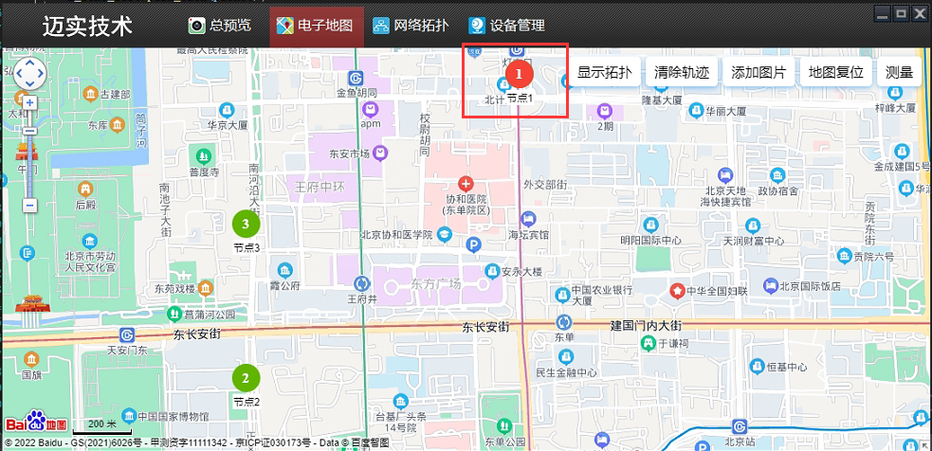

1. 显示轨迹

接口

showTrack

数据

[{

"id": 127650,

"ip": "192.168.1.2",

"longitude": "116.400100",

"latitude": 39.905000

}, {

"id": 127654,

"ip": "192.168.1.2",

"longitude": "116.400300",

"latitude": 39.905000

}, {

"id": 127660,

"ip": "192.168.1.2",

"longitude": "116.400600",

"latitude": 39.905000

}, {

"id": 127664,

"ip": "192.168.1.2",

"longitude": "116.400800",

"latitude": 39.905000

}, {

"id": 127670,

"ip": "192.168.1.2",

"longitude": "116.401100",

"latitude": 39.905000

}, {

"id": 127672,

"ip": "192.168.1.2",

"longitude": "116.401300",

"latitude": 39.905000

}, {

"id": 127675,

"ip": "192.168.1.2",

"longitude": "116.401600",

"latitude": 39.905000

}, {

"id": 127678,

"ip": "192.168.1.2",

"longitude": "116.401900",

"latitude": 39.905000

}, {

"id": 127680,

"ip": "192.168.1.2",

"longitude": "116.402100",

"latitude": 39.905000

}]

显示效果

