The degree of success with this project is about 85%. I specify main purpose of the project first, the main frame of executing the project. By doing so, I could generalize the whole requirements and all needs that I want to achieve. Beyond that, I should imagine the blue print of the project at the very beginning, do not let some less important details impede the progress of the whole project. After building the whole frame of the project we should complete the details of the individual parts. In this project , I should specify the explicit purpose of the project from the very beginning. Say parent printing all the credentials, creating pipe, spawning child, reading the pipe, sending the child signal etc. Child need to print credentials, set up signal handler to handle SIGTERM signal the parent send, write a message, enter an endless loop, use exec system call, load the new executable program exc. After that, I complete and revise all the details.

Actually, it was very hard for me to finish this assignment. I have watched every recorded video no less than 3 times that I get to understand the assignment that I should finish. I have tried to finish this assignment carefully, but I still get some unexpected warnings when I run the program. The warning says “ unused variable ‘proc_mask’ [-Wunused-variable] sigset_t mask, proc_mask .I have already try to get rid of the warning, but I failed in doing so. Still the first time that I try to load PROF program in the handle, I came across some error. Then I include the <stdlib.h> to the assign1.c, the problems disappeared.

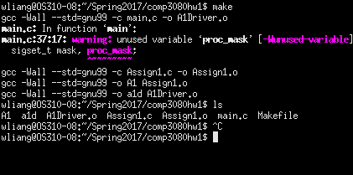

Email address: Wen_Liang@student.uml.edu