EX1
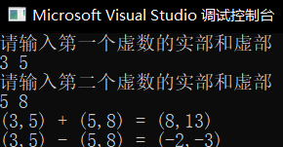
#include<iostream>
using namespace std;
class Complex
{
public:
Complex(double a = 0, double b = 0);
void Adding(Complex m, Complex n);
void Subtracting(Complex m, Complex n);
void print();
private:
double realPart, imaginaryPart;

};

Complex::Complex(double a, double b)
{
realPart = a;
imaginaryPart = b;
}//构造函数，使实部虚部得到初始化,设置默认参数(0,0)

void Complex::Adding(Complex m, Complex n)
{
imaginaryPart = m.imaginaryPart + n.imaginaryPart;
realPart = m.realPart + n.realPart;
}//加法

void Complex::Subtracting(Complex m, Complex n)
{
imaginaryPart = m.imaginaryPart - n.imaginaryPart;
realPart = m.realPart - n.realPart;
}//减法

void Complex::print()
{
cout << "(" << realPart << "," << imaginaryPart << ")";
}

int main()
{
double a, b, c, d;
cout << "请输入第一个虚数的实部和虚部" << endl;
cin >> a >> b;
cout << "请输入第二个虚数的实部和虚部" << endl;
cin >> c >> d;
Complex num1(a, b);
Complex num2(c, d);
Complex result1, result2;

result1.Adding(num1, num2);
result2.Subtracting(num1, num2);

num1.print();
cout << " + ";
num2.print();
cout << " = ";
result1.print();
cout << endl;

num1.print();
cout << " - ";
num2.print();
cout << " = ";
result2.print();
return 0;
}

EX2
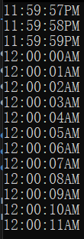
#include<iostream>
#include<iomanip>
#include<stdexcept>
using namespace std;
class Time
{
friend void tick(Time &t);//友元函数
public:
explicit Time(int = 0, int = 0, int = 0);

void setTime(int, int, int);
void setHour(int);
void setMinute(int);
void setSecond(int);

unsigned int getHour() const;
unsigned int getMinute() const;
unsigned int getSecond() const;

void printUniversal() const;
void printStandard() const;

void tick();

private:
unsigned int hour;
unsigned int minute;
unsigned int second;
};

Time::Time(int hour, int minute, int second)
{
setTime(hour, minute, second);
}

void Time::setTime(int h, int m, int s)
{
setHour(h);
setMinute(m);
setSecond(s);
}

void Time::setHour(int h)
{
if (h >= 0 && h < 24)
{
hour = h;
}
else
throw invalid_argument("hour muse be 0-23");

}

void Time::setMinute(int m)
{
if (m >= 0 && m < 60)
{
minute = m;
}
else
throw invalid_argument("minute muse be 0-59");
}

void Time::setSecond(int s)
{
if (s >= 0 && s < 60)
second = s;
else
throw invalid_argument("second muse be 0-59");
}

unsigned int Time::getHour() const
{
return hour;
}

unsigned int Time::getMinute() const
{
return minute;
}

unsigned int Time::getSecond() const
{
return second;
}

void Time::printUniversal() const
{
cout << setfill('0') << setw(2) << getHour() << ":"
<< setw(2) << getMinute() << ":" << setw(2) << getSecond();
}

void Time::printStandard() const
{
cout << ((getHour() == 0 || getHour() == 12) ? 12 : getHour() % 12)
<< ":" << setfill('0') << setw(2) << getMinute()
<< ":" << setw(2) << getSecond() << (hour < 12 ? "AM" : "PM");
}

void Time::tick()//时间增长一秒的判断
{
if (second + 1 >= 60)
{
second -= 59;
if (minute + 1 >= 60)
{
minute -= 59;
if (hour + 1 < 24)
hour += 1;
else
hour -= 23;
}
else
minute += 1;
}
else
second += 1;

}

int main()
{
Time time(23, 59, 57);
while (true)
{
time.printStandard();
time.tick();
getchar();//用于暂停
}
return 0;
}

EX3
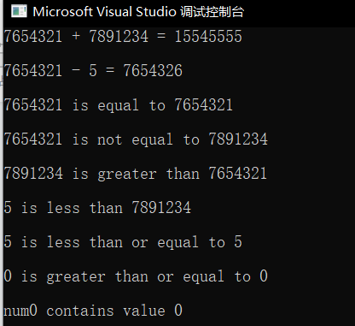
#include<iostream>
#include<cmath>
using namespace std;

class HugeInteger
{
public:
HugeInteger(int = 0);
HugeInteger(const char *);

HugeInteger add(const HugeInteger &);
HugeInteger add(int);
HugeInteger add(const char *);
HugeInteger subtract(const HugeInteger &);
HugeInteger subtract(int);
HugeInteger subtract(const char *);

bool isEqualTo(HugeInteger &); // is equal to
bool isNotEqualTo(HugeInteger &); // not equal to
bool isGreaterThan(HugeInteger &); // greater than
bool isLessThan(HugeInteger &); // less than
bool isGreaterThanOrEqualTo(HugeInteger &); // greater than or equal to
bool isLessThanOrEqualTo(HugeInteger &); // less than or equal
bool isZero(); // is zero
void input(const char *); // input
void output(); // output

private:
int integer[40]; // 40 element array
}; // end class HugeInteger

HugeInteger::HugeInteger(int num)
{
for (int i = 0; i < 40; i++)
{
integer[i] = 0;
}//数组初始化
int n = 0;
while (int(num / pow(10, n)) > 0)//转化为int使循环及时结束
{
integer[n] = int(num / pow(10, n)) % 10;//先记录最低位，再记录高位
n += 1;
}

}

HugeInteger::HugeInteger(const char *number)
{
for (int i = 0; i < 40; i++)
{
integer[i] = 0;
}//数组初始化

char*p = (char*)number;
int n = 0;
for (int j = 0; *(p + j) != NULL; j++)
{
if (*(p + j) != NULL)
n++;//记录字符串中数字的位数
}
for (int k = 0; k < n; k++)
{
integer[k] = *(p + n - 1 - k) - '0';//先记录最低位，再记录高位
}

}

HugeInteger HugeInteger::add(const HugeInteger &num1)
{
HugeInteger num2(0);
for (int i = 0; i < 40; i++)
{
if (num1.integer[i] + integer[i] >= 10)
{
num2.integer[i] = num1.integer[i] + integer[i] + num2.integer[i] - 10;
if (i < 39)
num2.integer[i + 1] += 1;//进位
}
else
num2.integer[i] = num1.integer[i] + integer[i] + num2.integer[i];//不进位
}

return num2;
}

HugeInteger HugeInteger::add(int num1)
{
HugeInteger num2(num1);//将num1写进类num2中
HugeInteger num3 = add(num2);
return num3;
}

HugeInteger HugeInteger::add(const char* num1)
{
HugeInteger num2(num1);//将num1写进类num2中
HugeInteger num3 = add(num2);
return num3;
}

HugeInteger HugeInteger::subtract(const HugeInteger &num1)
{
HugeInteger num2(0);
for (int i = 0; i < 40; i++)
{
if (integer[i] - num1.integer[i] < 0)
{
num2.integer[i] = integer[i] - num1.integer[i] + 10;
if (i < 39)
num2.integer[i + 1] -= 1;//退位
}
else
num2.integer[i] = integer[i] - num1.integer[i];//不退位
}

return num2;
}

HugeInteger HugeInteger::subtract(int num1)
{
HugeInteger num2(num1);//将num1写进类num2中
HugeInteger num3 = subtract(num2);
return num3;
}

HugeInteger HugeInteger::subtract(const char* num1)
{
HugeInteger num2(num1);//将num1写进类num2中
HugeInteger num3 = subtract(num2);
return num3;
}

bool HugeInteger::isEqualTo(HugeInteger &num1)
{
for (int i = 0; i < 40; i++)
{
if (num1.integer[i] == integer[i])
{
continue;
}
else
return false;
}
return true;
}//判断相等

bool HugeInteger::isNotEqualTo(HugeInteger &num1)
{
return !isEqualTo(num1);
}//对判断相等的结果取反

bool HugeInteger::isGreaterThan(HugeInteger &num1)
{
for (int i = 0; i < 40; i++)
{
if (integer[39 - i] != 0 && num1.integer[39 - i] == 0)return true;//判断数位
if (integer[39 - i] == 0 && num1.integer[39 - i] != 0)return false;
if (integer[39 - i] == 0 && num1.integer[39 - i] == 0)continue;//数位均为0时进入下一位判断
if (integer[39 - i] != 0 && num1.integer[39 - i] != 0)
{
if (integer[39 - i] == num1.integer[39 - i])continue;//相等时进入下一位判断
else
{
if (integer[39 - i] > num1.integer[39 - i])return true;
else
return false;
}
}
}
}//判断大于

bool HugeInteger::isLessThan(HugeInteger &num1)
{
return!isGreaterThan(num1);
}//对判断大于的结果取反

bool HugeInteger::isGreaterThanOrEqualTo(HugeInteger &num1)
{
if (isGreaterThan(num1) || isEqualTo(num1))
return true;
else
return false;
}

bool HugeInteger::isLessThanOrEqualTo(HugeInteger &num1)
{
if (isLessThan(num1) || isEqualTo(num1))
return true;
else
return false;
}

bool HugeInteger::isZero()
{
for (int i = 0; i < 40; i++)
{
if (integer[i] != 0)
return false;
}
return true;

}

void HugeInteger::input(const char *num)
{
for (int i = 0; i < 40; i++)
{
integer[i] = 0;
}//数组初始化

char*p = (char*)num;
int n = 0;
for (int j = 0; *(p + j) != NULL; j++)
{
if (*(p + j) != NULL)
n++;//记录字符串中数字的位数
}
for (int k = 0; k < n; k++)
{
integer[k] = *(p + n - 1 - k) - '0';//先记录最低位，再记录高位
}
}

void HugeInteger::output()
{
int isfirst = 1;
for (int index = 39; index >= 0; index--)
{
if ((integer[index] != 0 && isfirst == 1) || isfirst != 1)
{
cout << integer[index];
isfirst = 0;
}
}
if (isZero())
cout << "0";
}

int main()
{
const char*s1 = "7654321";
const char*s2 = "7891234";
int m = 5;

HugeInteger num0(0);
HugeInteger num1(m);
HugeInteger num2(0);
HugeInteger num3(s2);

num2.input(s1);

HugeInteger num4 = num2.add(num3);

num2.output();
cout << " + ";
num3.output();
cout << " = ";
num4.output();
cout << endl << endl;//输出加法结果

HugeInteger num5 = num2.subtract(m);

num2.output();
cout << " - ";
num1.output();
cout << " = ";
num5.output();
cout << endl << endl;//输出减法结果

if (num2.isEqualTo(num2))
{
num2.output();
cout << " is equal to ";
num2.output();
}//判断num2=num2
cout << endl << endl;

if (num2.isNotEqualTo(num3))
{
num2.output();
cout << " is not equal to ";
num3.output();
}//判断num2!=num3
cout << endl << endl;

if (num3.isGreaterThan(num2))
{
num3.output();
cout << " is greater than ";
num2.output();
}//判断num3>num2
cout << endl << endl;

if (num1.isLessThan(num3))
{
num1.output();
cout << " is less than ";
num3.output();
}//判断num1<num3
cout << endl << endl;

if (num1.isLessThanOrEqualTo(num1))
{
num1.output();
cout << " is less than or equal to ";
num1.output();
}//判断num1<=num1
cout << endl << endl;

if (num0.isGreaterThanOrEqualTo(num0))
{
num0.output();
cout << " is greater than or equal to ";
num0.output();
}//判断num0>=num0
cout << endl << endl;

if (num0.isZero())
{
cout << "num0 contains value ";
num0.output();
}//判断num0=0
cout << endl << endl;
return 0;
}

EX4
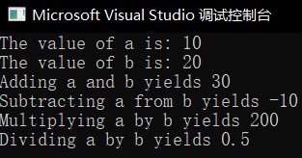
#include<iostream>
using namespace std;
class SimpleCalculator
{
public:

double add(double a, double b) { return a + b; }//加法
double subtract(double a, double b) { return a - b; }//减法
double multiply(double a, double b) { return a * b; }//乘法
double divide(double a, double b) { return a / b; }//除法

};

int main()
{
double a, b;
SimpleCalculator sc;
cout << "The value of a is: ";
cin >> a;

cout << "The value of b is: ";
cin >> b;

cout << "Adding a and b yields " << sc.add(a, b) << endl;
cout << "Subtracting a from b yields " << sc.subtract(a, b) << endl;
cout << "Multiplying a by b yields " << sc.multiply(a, b) << endl;
cout << "Dividing a by b yields " << sc.divide(a, b) << endl;
return 0;
}

EX5
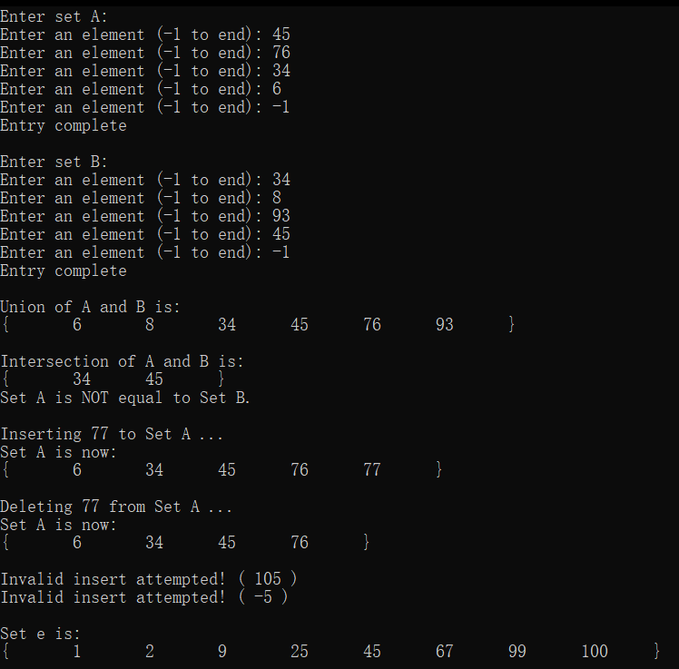
#include<iostream>
using namespace std;

class IntegerSet
{
public:
IntegerSet(int num = -1)
{
if (num != -1)//判断初始化时是否输入数字
insertElement(num);
}

IntegerSet(int arr[], int size)
{
for (int i = 0; i < size; i++)
{
insertElement(arr[i]);
}
}

void inputSet();//输入数据
void unionOfSets(IntegerSet, IntegerSet);//并集
void intersectionOfSets(IntegerSet, IntegerSet);//交集
void insertElement(int);//插入数据
void deleteElement(int);//删除数据
void printSet();//打印数据
bool isEqualTo(IntegerSet);//判断集合是否相等

private:
int integer[101] = { 0 };
};

void IntegerSet::inputSet()//输入数据
{
int num;
while (true)
{
cout << "Enter an element (-1 to end): ";
cin >> num;
if (num == -1)
{
cout << "Entry complete" << endl;
break;
}
else

insertElement(num);
}
}

void IntegerSet::insertElement(int a)//插入数据
{
if (a < 0 || a > 100)
{
cout << "Invalid insert attempted!" << " ( " << a << " ) " << endl;
}
else
{
if (integer[a] == 1)
{
cout << "Already inserted!" << " ( " << a << " ) " << endl;
}
else
integer[a] = 1;
}
}

void IntegerSet::deleteElement(int a)//删除数据
{
if (a < 0 || a > 100 || integer[a] == 0)
{
cout << "Invalid delete attempted!" << " ( " << a << " ) " << endl;
}
else
integer[a] = 0;
}

void IntegerSet::printSet()//打印数据
{
cout << "{\t";
for (int i = 0; i <= 100; i++)
{
if (integer[i] == 1)
cout << i << "\t";
}
cout << "}" << endl;
}

void IntegerSet::unionOfSets(IntegerSet a, IntegerSet b)//并集
{
for (int i = 0; i <= 100; i++)
{
if (a.integer[i] == 1 || b.integer[i] == 1)
integer[i] = 1;
}
}

void IntegerSet::intersectionOfSets(IntegerSet a, IntegerSet b)//交集
{
for (int i = 0; i <= 100; i++)
{
if (a.integer[i] == 1 && b.integer[i] == 1)
integer[i] = 1;
}
}

bool IntegerSet::isEqualTo(IntegerSet a)//判断集合是否相等
{
int count = 0;
for (int i = 0; i <= 100; i++)
{
if (integer[i] == a.integer[i])
{
count++;
}
else
{
return false;
}
}
return true;
}

int main()
{
IntegerSet a;
IntegerSet b;
IntegerSet c;
IntegerSet d;

cout << "Enter set A:" << endl;
a.inputSet();
cout << endl << "Enter set B:" << endl;
b.inputSet();

c.unionOfSets(a, b);//取并集
d.intersectionOfSets(a, b);//取交集

cout << endl << "Union of A and B is:" << endl;
c.printSet();
cout << endl << "Intersection of A and B is:" << endl;
d.printSet();

cout << "Set A is" << (a.isEqualTo(b) ? " " : " NOT ") << "equal to Set B." << endl << endl;

cout << "Inserting 77 to Set A ..." << endl;
a.insertElement(77);//向集合A插入数据77
cout << "Set A is now:" << endl;
a.printSet();

cout << "\nDeleting 77 from Set A ..." << endl;
a.deleteElement(77);//从集合A删除数据77
cout << "Set A is now:" << endl;
a.printSet();

cout << endl;
const int arraySize = 10;
int intArray[arraySize] = { 25,67,2,9,99,105,45,-5,100,1 };
IntegerSet e(intArray, arraySize);

cout << "\nSet e is:" << endl;
e.printSet();

return 0;
}

