东 南 大 学 考 试 卷（ A 卷）
学号 姓名
封
封
线
课程名称 | 程序设计基础及语言2 |  | 考试学期 | 10-11-3
适用专业 | 计算机科学与技术  软件工程 | 考试形式 | 半开卷 | 考试时间长度 | 笔试  120分钟
机试
100分钟
总分：100分

试题 | 得分 | 评阅人
第一部分：笔试
第二部分：机试
成绩合计：

东 南 大 学 考 试 卷（ A 卷）
课程名称 | 程序设计基础及语言2 |  | 考试学期 |  | 10-11-3 |  | 卷面 | 60分
适用专业  学号 姓名  密  封 | 计算机科学与技术  软件工程 | 考试形式 |  | 半开卷 |  | 考试时间长度 |  |  | 笔试  120分钟
仅 允 许 携 带 课 程 指 定 教 材
请将答案写在答题纸上
第一部分 笔试

Note: All answers must be writen on answer sheet!
I．Answer the following questions and Read the following programs：（20 scores）
1．Please give three usages of overloading mechanism. ( 3 scores)

2．What does the following program output? ( 2 scores)
#include <iostream>
class V {
public:
V(){ cout << “Hello world!” << endl; }
~V(){cout << “Good Bye!” << endl; }
};
main()
{
V my;
}

3．What does the following program output? ( 4 scores)
#include <iostream>
template <class T>
class point{
public:
point(T a, T b){ x = a; y = b; }
void move(T a, T b){ x = x + a; y = y + b; }
void show(){cout<<"Current Coordinate:" << x << " " << y << endl; }
private:
T x,y;
};
void main()
{
point<int> m(3,4);
m.show();
m.move(1,2);
m.show();
point<float> n(2.5,3.4);
n.show();
n.move(1.3,2.3);
n.show();
}

4．What does the following program output? ( 3 scores)
#include<iostream >
class Vector {
public:
Vector& setx( int a ){ x = a; return *this; }
Vector& sety( int b ){ y = b; return *this; }
Vector& setz( int c ){ z = c; return *this; }
void show()
{
cout << "(x,y,z)" << "=" << "(" << x << "," << y << "," << z << ")" << endl;
}
private:
int x,y,z;
};
void main()
{
Vector a;
a.setx(3).sety(4).setz(5);
a.show();
}

5. What does the following program output? ( 8 scores)
#include<iostream.h>
class A {
public:
A( int ID )
{ objectID = ID; cout << "Obj " << objectID << " is constructed!" << endl; }
A( A& a )
{ objectID = a.objectID; cout << "Obj " << objectID << " is constructed!" << endl; }
~A()
{
cout << "Obj " << objectID << " is destructed!" << endl;
}
private:
int objectID;
};
void create( void )
{
A third( 3 );
static A fourth( 4 );
}
void fun1( A ){ }

A first( 1 );
int main()
{
create();
A *p = new A( 2 );
create();
fun1( A( 5 ) );
delete p;
return 0;
}

II．Fill in the following blanks to complete programs. （20 score）
1．According to the output, complete the following program. (10 scores)
#ifndef TEST_H
#define TEST_H
class B;
class A {
___(1)___ void f7(A&,B&);
public:
A(int,int);
void f1();
___(2)___ void f2();
static int m;
protected:
void f3();
private:
int x;
int y;
};
class B : protected A {
friend void f7(A& ,B& );
public:
B(int,int);
void f1();
void f2();
private:
int x;
int y;
};
class C : public A {
public:
C(int,int);
void f1 ( ) ;
void f5 ( );
void f3 ( );
private:
int x;
int y;
};
#endif

//---------------------------------
#include <iostream>
#include "test.h"

A::A(int a,int b){x=a;}
void A::f1(){cout<<"A的f1"<<endl;}
void A::f2(){cout<<"A的f2"<<endl;}
void A::f3(){cout<<"A的f3"<<endl;}
int A::m = 88;

B::B(int a,int b):A(a,b){x=a;}
void B::f1(){ ___(3)___ cout<<"B的f1"<<endl;}
void B::f2(){cout<<"B的f2"<<endl;}

C::C(int a,int b):A(a,b){x=a;}
void C::f1 ( ) {cout<<"C的f1"<<endl;}
void C::f5 ( ){cout<<"C的f5"<<endl;}
void C::f3 ( ){ A::f3( );cout<<"C的f3"<<endl;}

void f7(A& a,B& b){cout<<"friend:"<<a.x+b.x<<endl;}

//-----------------------------
#include <iostream>
#include "test.h"

void main()
{
cout<<"-------"<<endl;
cout<< ___(4)___ <<endl;
A a(2,3),*p1,*p2,*p3;
B b(3,5);
C c(0,0);
cout<<"-------"<<endl;
c.f3();
cout<<"-------"<<endl;
p1=&a;
p2=(A *)&b;
p3=&c;
p2->f1();
b.f1();
p3->f1();
c.f1();
cout<<"-------"<<endl;
p1->f2();
___(5)___->f2();
p3->f2();
cout<<"-------"<<endl;
f7(a,b);
}

Output is:
-------
88
-------
A的f3
C的f3
-------
A的f1
A的f1
B的f1
A的f1
C的f1
-------
A的f2
B的f2
A的f2
-------
friend:5

2．Assume that we want to implement a overloding function.which can write an instance of class A to output stream. Please complete the following overloding function. (10 scores)
#include <iostream>
class A {
friend __(1)__ operator __(2)__ ( ostream& __(3)__, __(4)__ my )
{
out << my.x; return __(5)__;
}
public:
…
private:
int x;
};

III．Write programs pies according to the requests（20 score）
1．Write an overloading member function and an overloading non-member function to implement the concatenation operator of string. For example, we can get “abcd1234” by “abcd”+”1234”. (8 scores)

2．According to the following requirements, design a class: (12 scores)
1) to include a constructor which create a n×n integer matrix(整数矩阵)by dynamic manner base on the parameter n, and initialize it to 0;
2) to include a destructor which destruct n×n integer matrix;
3) to include a utility function which print n×n integer matrix;
4) to include a get function which output the sum of major diagonal line（主对角线，从左上到右下）of n×n integer matrix;
5) to include a access function which create a integer matrix as following:
n = 6: (i.e. n is even) n = 5: (i.e. n is odd)
3 3 3 3 3 3 3 3 3 3 3
3 2 2 2 2 3 3 2 2 2 3
3 2 1 1 2 3 3 2 1 2 3
3 2 1 1 2 3 3 2 2 2 3
3 2 2 2 2 3 3 3 3 3 3
3 3 3 3 3 3
6) to separate interface from implementation;

东 南 大 学 考 试 卷（ A 卷）
课程名称 | 程序设计基础及语言2 |  | 考试学期 |  | 10-11-3 |  | 卷面 | 40分
适用专业 | 计算机科学与技术  软件工程 | 考试形式 |  | 半开卷 |  | 考试时间长度 |  |  | 机试  100分钟
仅 允 许 携 带 课 程 指 定 教 材

第二部分 机试
要求：
- 编程：
  - 在本地D：或E：盘中，建立自己的文件夹，用来完成程序的编写和调试。
  - 可以：第一题Project(项目名)为Pro1，第二题Project(项目名)为Pro2，以此类推。
- 提交：
考试结束后，在10分钟之内完成以下操作：
  - 在虚拟Z：盘上建立一个以自己的学号命名的文件夹，用于保存上交的考试程序的源文件。
  - 将每题的所有源程序文件“*.cpp”、自定义头文件“*.h”和可执行程序“*.exe”存入Z：盘自己的目录中。
IV Write and test programs according to the requests（40 scores）
1．(12 scores) According to the following pictures, implement two classes and output the results. Assume that every member function only output its function name. (By separating interface from implementation)
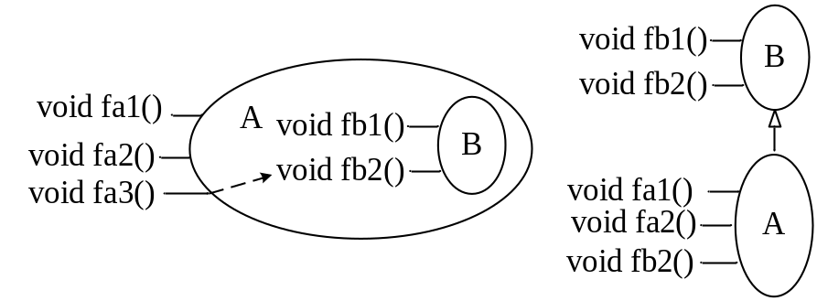

2. (28 scores) Input two integer arrays from file stream, and sort, combine and output them. You must implement following member function: a sort function, a combine function, a print function, constructor and destructor. (By separating interface from implementation)(Note that you must create two data files named as file1A.txt and fileB.txt and each file includes ten integers separated by a space.)
东 南 大 学 考 试 答 题 纸 ＡＮＳＷＥＲ ＳＨＥＥＴ

