**5.42：**

设图像 $f(x, y)$ 白色的像素值为 $c$，大圆的半径为 $R$，小圆的半径为 $r$

当 $s<r$ 时：

$$g\left(s,θ\right)=2\left(\sqrt{R^{2}−s^{2}}−\sqrt{r^{2}−s^{2}}\right)⋅c$$

当 $r≤s≤R$ 时：

$$g\left(s,θ\right)=2\sqrt{R^{2}−s^{2}}⋅c$$

当 $s>R$ 时

$$g\left(s,θ\right)=0$$

其Radon变换图为：

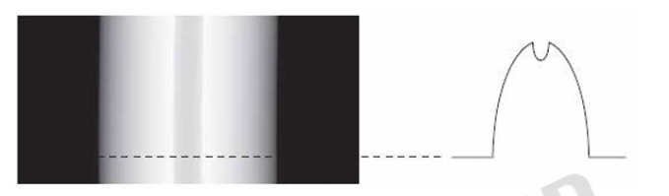

**6.6：**

下表表示各种颜色的RGB成分：

|  |  |  |  |  |  |  |
| --- | --- | --- | --- | --- | --- | --- |
| **Color** | **R** | **G** | **B** | **Mono R** | **Mono G** | **Mono B** |
| Black | 0 | 0 | 0 | 0 | 0 | 0 |
| Red | 1 | 0 | 0 | 255 | 0 | 0 |
| Yellow | 1 | 1 | 0 | 255 | 255 | 0 |
| Green | 0 | 1 | 0 | 0 | 255 | 0 |
| Cyan | 0 | 1 | 1 | 0 | 255 | 255 |
| Blue | 0 | 0 | 1 | 0 | 0 | 255 |
| Magenta | 1 | 0 | 1 | 255 | 0 | 255 |
| White | 1 | 1 | 1 | 255 | 255 | 255 |
| Gray | 0.5 | 0.5 | 0.5 | 128 | 128 | 128 |

单分量RGB图为：

