## 简述多路复用和多路分解。

## 计算下列两个16位字的校验和。

## 01111001 10111001            this binary number is 31161 decimal (base 10) 11101010 00001100            this binary number is 59916 decimal (base 10)

## (P24) Answer true or false to the following questions and briefly justify your answer: a. With the SR protocol, it is possible for the sender to receive an ACK for a packet that falls outside of its current window. ( )

## b. With GBN, it is possible for the sender to receive an ACK for a packet that falls outside of its current window. ( ) c. The alternating-bit protocol is the same as the SR protocol with a sender and receiver window size of 1.

## ( ) d. The alternating-bit protocol is the same as the GBN protocol with a sender and receiver window size of 1 ( )

## 可靠传输有哪些策略？

## 回退N步（GBN）和选择重传（SR）有什么相同和不同点？

## UDP和TCP报文头部有什么区别？为什么有这些区别？

8.（P27）主机A和B经一条TCP连接通信，并且主机B已经收到了来自A的最长为126字节的所有字节。假定主机A随后向主机B发送两个紧接着的报文段，第一个和第二个报文段分别包含了80字节和40字节的数据。在第一个报文段中，序号是127，源端口号是302，目的地端口号是80。无论何时主机B接受到来自主机A的报文段，它都会确认发送。

1. 在从主机A发往B的第二个报文段中，序号、源端口号和目的端口号各是什么？
2. 如果第一个报文段在第二个报文段之前到达，在第一个到达报文段的确认中，确认号、源端口号和目的端口号各是什么？
3. 如果第二个报文段在第一个报文段之前到达，在第一个到达报文段的确认中，确认号是什么？
4. 假定由A发送的两个报文段按序到达B。第一个确认丢失了而第二个确认在第一个超时间隔之后到达。画出时序图，显示这些报文段和发送的所有其他报文段和确认。（假设没有其他分组丢失。）对于图上每个报文段，标出序号和数据的字节数量；对于你增加的每个应答，标出确认号。

9. 流量控制和拥塞控制有什么区别？TCP的拥塞控制是如何实现的？

10. Consider the figure below, which plots the evolution of TCP's congestion window at the beginning of each time unit (where the unit of time is equal to the RTT); see Figure 3.53 in the text. In the abstract model for this problem, TCP sends a "flight" of packets of size cwnd at the beginning of each time unit. The result of sending that flight of packets is that either (i) all packets are ACKed at the end of the time unit, (ii) there is a timeout for the first packet, or (iii) there is a triple duplicate ACK for the first packet. In this problem, you are asked to reconstruct the sequence of events (ACKs, losses) that resulted in the evolution of TCP's cwnd shown below.

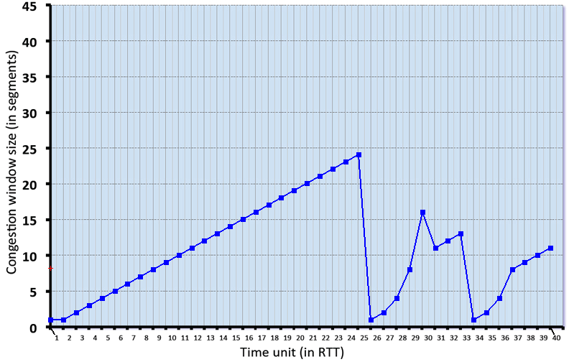

Consider the evolution of TCP's congestion window in the example above and answer the following questions. The initial value of cwnd is 1 and the initial value of ssthresh (shown as a red +) is 8.

### QUESTION LIST

1. Give the times at which TCP is in slow start. Format your answer like: 1,3,5,9 (If none submit blank)
2. Give the times at which TCP is in congestion avoidance. Format your answer like: 1,3,5,9 (If none submit blank)
3. Give the times at which TCP is in fast recovery. Format your answer like: 1,3,5,9 (If none submit blank)
4. Give the times at which packets are lost via timeout. Format your answer like: 1,3,5,9 (If none submit blank)
5. Give the times at which packets are lost via triple ACK. Format your answer like: 1,3,5,9 (If none submit blank)
6. Give the times at which the value of ssthresh changes (if it changes between t=3 and t=4, use t=4 in your answer)