# 第四章 作业

1. R17. 假定主机A向主机B发送封装在一个IP数据报中的TCP报文段. 当主机B接受到该数据报时, 主机B中的网络层怎样知道它应当将该报文段(即数据报的有效载荷)交给TCP而不是UDP或某个其他东西呢?

Suppose Host A sends Host B a TCP segment encapsulated in an IP datagram. When Host B receives the datagram, how does the network layer in Host B know it should pass the segment (that is, the payload of the datagram) to TCP rather than to UDP or to some other upper-layer protocol?

1. R18. 在IP首部中, 哪个字段能用来确保一个分组的转发不超过N台路由器.

What field in the IP header can be used to ensure that a packet is forwarded through no more than N routers?

1. R19. 前面讲过因特网检验和被用于运输层报文段以及网络层数据报.现在考虑一个运输层报文段封装在一个IP数据报中.在报文段首部和数据报首部中的检验和要遍及IP数据报中的任何共同字节进行计算吗?

Recall that we saw the Internet checksum being used in both transport-layer segment (in UDP and TCP headers) and in network-layer datagrams (IP header ). Now consider a transport layer segment encapsulated in an IP datagram. Are the checksums in the segment header and datagram header computed over any common bytes in the IP datagram? Explain your answer.

4. P2假设两个分组在完全相同的时刻到达一台路由器的两个不同输入端口。同时假设在该路由器中没有其他分组。

a.假设这两个分组朝着两个不同的输入端口转发。当交换结构使用一条共享总线时，这两个分组可能在相同时刻通过该交换结构转发吗？

b.假设这两个分组朝着两个不同的输出端口转发。当交换结构使用经内存交换时，这两个分组可能在相同时刻通过该交换结构转发吗？

c.假设这两个分组朝着相同的输出端口转发。当交换结构使用纵横式时，这两个分组可能在相同时刻通过该交换结构转发吗？

5. P8考虑互联3个子网（子网1，子网2和子网3）的一台路由器：假定这3个子网的所有接口要求具有前缀223.1.17/24。还假定子网1要求支持多达60个接口，子网2要求支持多达90个接口，子网3要求支持多达12个接口。提供三个满足这些限制的网络地址（形式为a.b.e.d/x）。

Consider a router that interconnects three subnets: Subnet 1, Subnet 2, and Subnet 3. Suppose all of the interfaces in each of these three subnets are required to have the prefix 223.1.17/24. Also suppose that Subnet 1 is required to support at least 60 interfaces, Subnet 2 is to support at least 90 interfaces, and Subnet 3 is to support at least 12 interfaces. Provide three network addresses (of the form a.b.c.d/x) that satisfy these constraints.

1. P12 Consider the topology shown in Figure 4.20 . Denote the three subnets with hosts (starting clockwise at 12:00) as Networks A, B, and C. Denote the subnets without hosts as Networks D, E, and F. a. Assign network addresses to each of these six subnets, with the following constraints: All addresses must be allocated from 214.97.254/23; Subnet A should have enough addresses to support 250 interfaces; Subnet B should have enough addresses to support 120 interfaces; and Subnet C should have enough addresses to support 120 interfaces. Of course, subnets D, E and F should each be able to support two interfaces. For each subnet, the assignment should take the form a.b.c.d/x or a.b.c.d/x – e.f.g.h/y. b. Using your answer to part (a), provide the forwarding tables (using longest prefix matching) for each of the three routers

考虑图4-20中显示的拓扑。（在12:00以顺时针开始）标记具有主机的3个子网为网络A、B和C，标记没有主机的子网为网络D、E和F。

1. 为这6个子网分配网络地址，要满足下列限制：所有地址必须从214.97.254/23起分配；子网A应当具有足够地址以支持250个接口；子网B应当具有足够地址以支持120个接口：子网C应具有足够地址以支持120个接口。当然，子网D、E和F应当支持两个接口，对于每个子网，分配采用的形式是a.b.c.d/x或a.b.c.d/x-e.f.g.h/y.
2. 使用你对（a）部分的答案，为这3台路由器提供转发表（使用最长前缀匹配）。

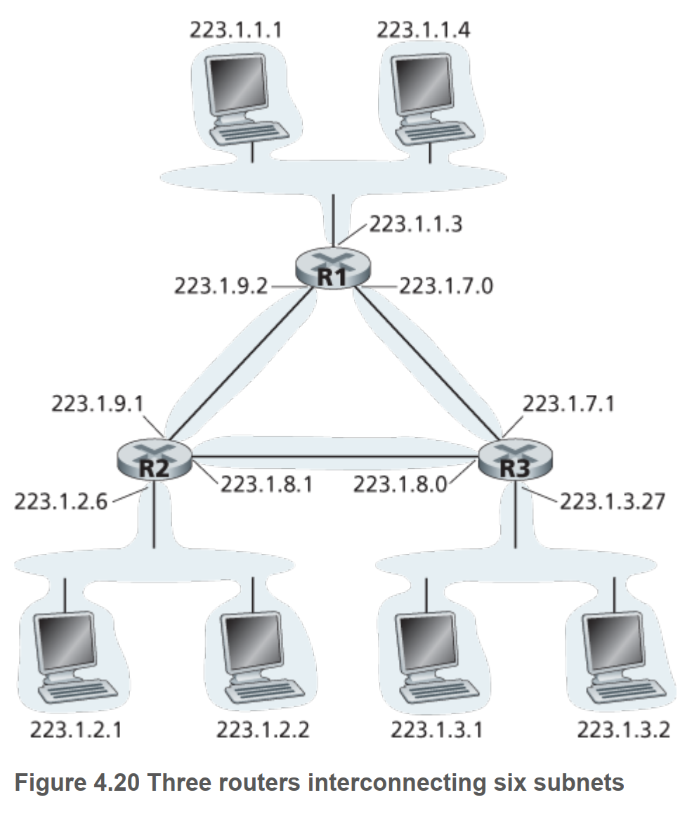

1. P14 Consider sending a 2400-byte datagram into a link that has an MTU of 700 bytes. Suppose the original datagram is stamped with the identification number 422. How many fragments are generated? What are the values in the various fields in the IP datagram(s) generated related to fragmentation? P15. Suppose datagrams are limited to 1,500 bytes (including header) between source Host A and destination Host B. Assuming a 20-byte IP header, how many datagrams would be required to send an MP3 consisting of 5 million bytes? Explain how you computed your answer. P16. Consider the network setup in Figure 4.25 . Suppose that the ISP instead assigns the router the address 24.34.112.235 and that the network address of the home network is 192.168.1/24. a. Assign addresses to all interfaces in the home network. b. Suppose each host has two ongoing TCP connections, all to port 80 at host 128.119.40.86. Provide the six corresponding entries in the NAT translation table.

提醒：偏移量以8个字节为一个单位。

考虑向具有700字节MTU的一条链路发送一个2400字节的数据报。假定初始数据报标有标识号422。将会生成多少个分片？在生成相关分片的数据报中各个字段的值是多少？