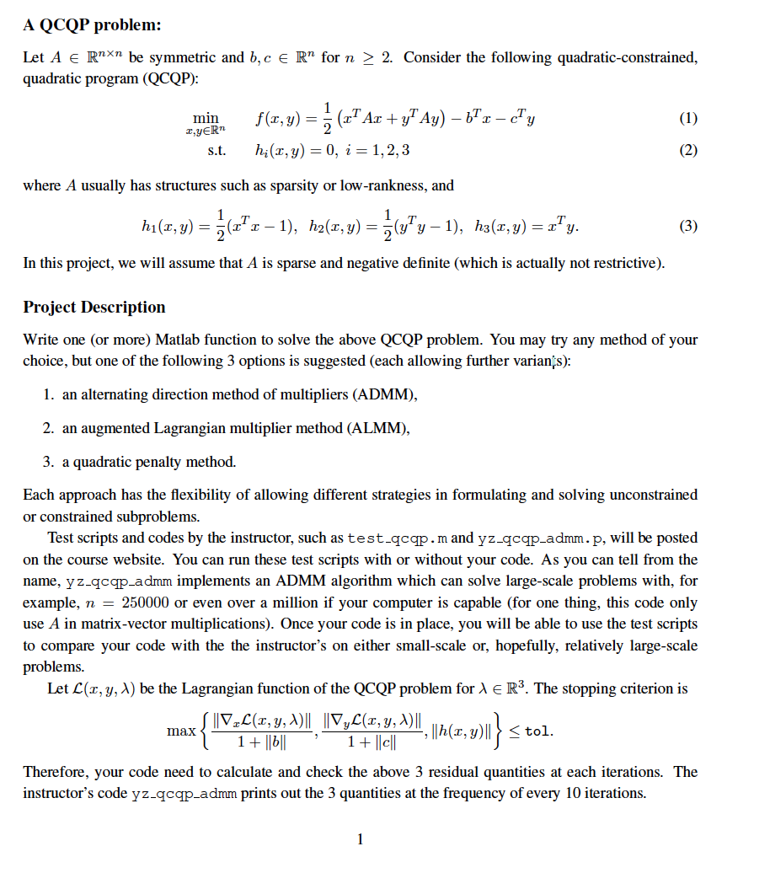

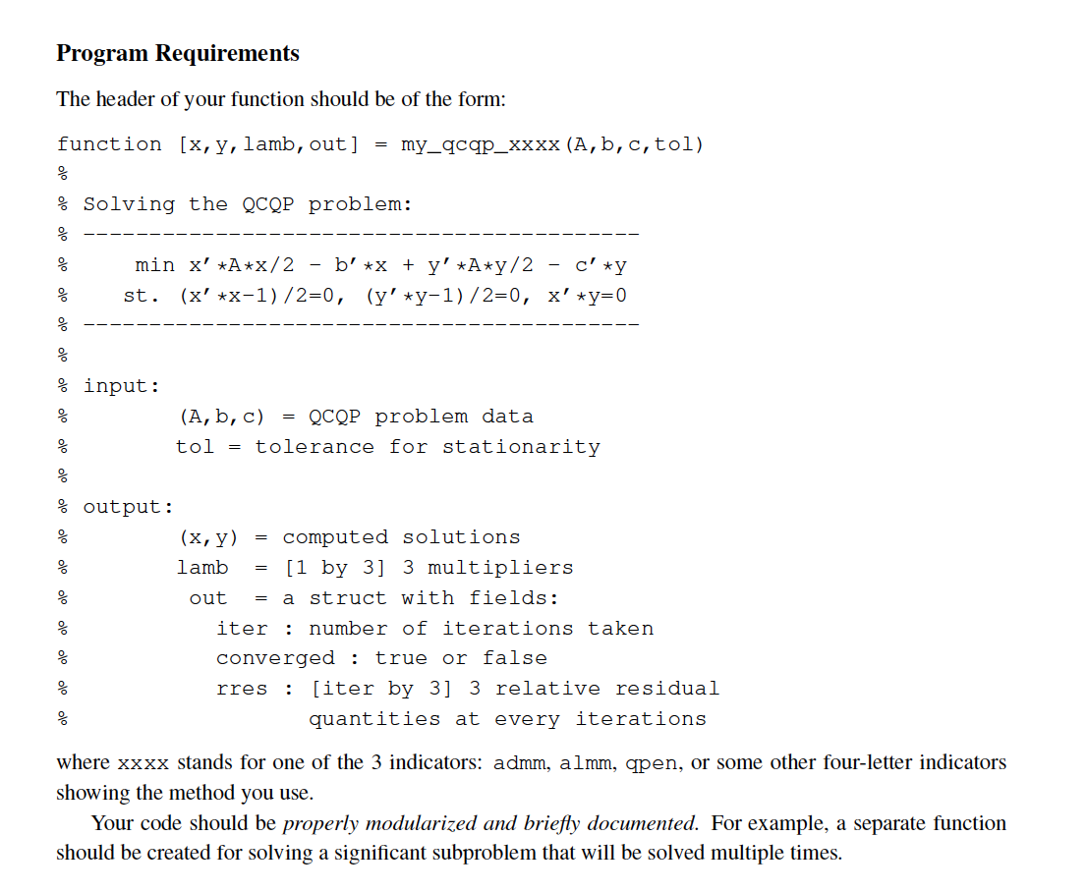

性能要求：

within 1 minute you code is able to correctly

solve larger-sized problems with n up to tens of thousands. Run test qcqp with

n = 90000 and s = 10,

n = 90000 and s = 1