

Functional Safety Concept Lane Assistance

**Document Version: 1.0**

**Template Version 1.0, Released on 2017-06-21**



# 

# Document history

|  |  |  |  |
| --- | --- | --- | --- |
| Date | Version | Editor | Description |
| 08.13.2018 | 1.0 | Liang Zhang | First attempt |
|  |  |  |  |
|  |  |  |  |
|  |  |  |  |
|  |  |  |  |

# Table of Contents

Document history

Table of Contents

Purpose of the Functional Safety Concept

Inputs to the Functional Safety Analysis

Safety goals from the Hazard Analysis and Risk Assessment

Preliminary Architecture

Description of architecture elements

Functional Safety Concept

Functional Safety Analysis

Functional Safety Requirements

Refinement of the System Architecture

Allocation of Functional Safety Requirements to Architecture Elements

Warning and Degradation Concept

# Purpose of the Functional Safety Concept

Functional safety concept identifies new requirements of the Lane Assistance item and allocate these requirements to system diagrams.

# Inputs to the Functional Safety Concept

## Safety goals from the Hazard Analysis and Risk Assessment

|  |  |
| --- | --- |
| **ID** | **Safety Goal** |
| Safety_Goal_01 | The oscillating steering torque from LDW shall be limited. |
| Safety_Goal_02 | The Lane Keeping Assistance function shall be time limited, and additional steering torque shall end after a given time interval so the driver cannot misuse the system for autonomous driving. |

## Preliminary Architecture

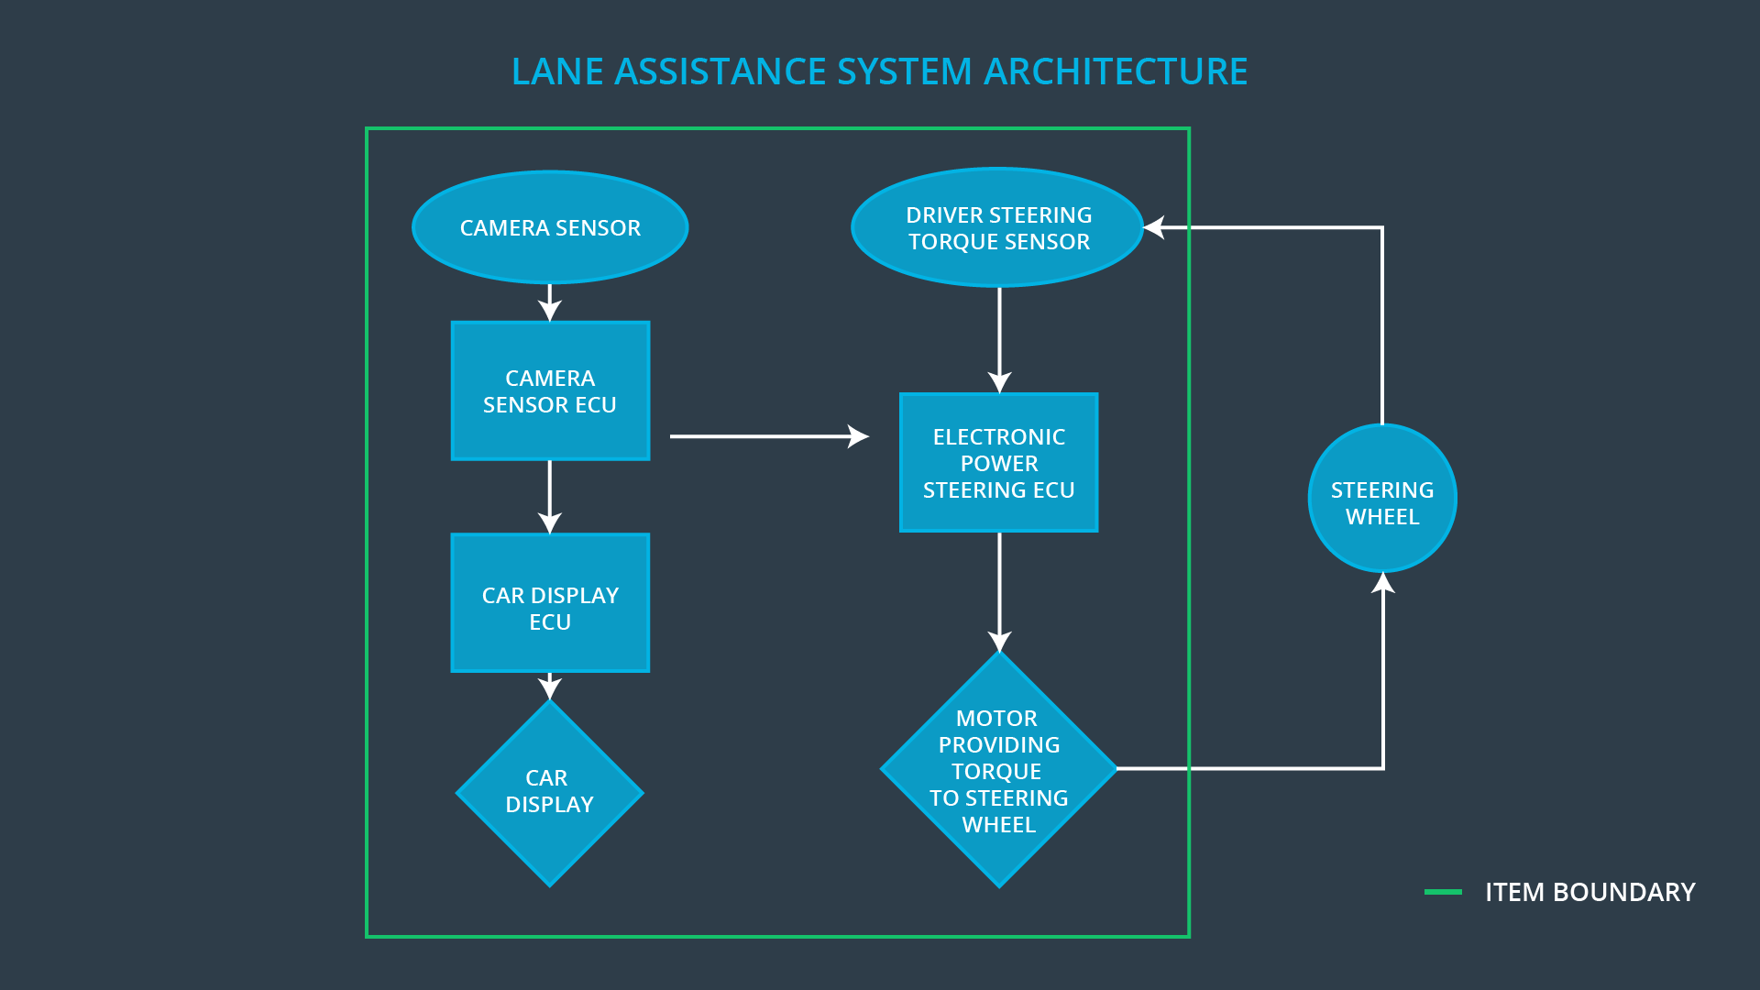

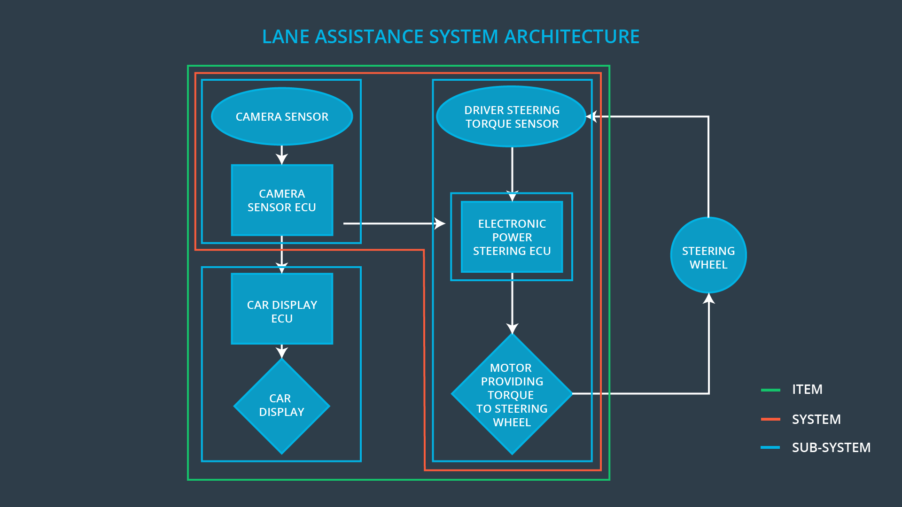

### Description of architecture elements

|  |  |
| --- | --- |
| **Element** | **Description** |
| Camera Sensor | Send recording images to camera sensor ECU. |
| Camera Sensor ECU | Identify if the vehicle departs from lane. If Yes, send a message to electronic power steering ECU for applying a steering torque. Meantime, send a message to car display ECU for activating lane assistance system. |
| Car Display | Inform driver the status of the lane assistance system and activation/deactivation of the system. Warn drivers if there is a malfunction. |
| Car Display ECU | Identify the status of the lane assistance system, activation/deactivation of the system and if there is a malfunction. |
| Driver Steering Torque Sensor | Measure amplitude, frequency and duration of steering torque from steering wheel and send them to electronic power steering ECU. |
| Electronic Power Steering ECU | Receive messages from camera sensor ECU and measurements from driver steering torque sensor, output torque request to Motor. |
| Motor | Receive torque request from electronic power steering ECU, then provide torque to steering wheel. |

# Functional Safety Concept

The functional safety concept consists of:

* Functional safety analysis
* Functional safety requirements
* Functional safety architecture
* Warning and degradation concept

## Functional Safety Analysis

|  |  |  |  |
| --- | --- | --- | --- |
| **Malfunction ID** | **Main Function of the Item Related to Safety Goal Violations** | **Guidewords (NO, WRONG, EARLY, LATE, MORE, LESS)** | **Resulting Malfunction** |
| Malfunction_01 | Lane Departure Warning (LDW) function shall apply an oscillating steering torque to provide the driver a haptic feedback | MORE | The lane departure warning function applies an oscillating torque with very high torque amplitude (above limit) |
| Malfunction_02 | Lane Departure Warning (LDW) function shall apply an oscillating steering torque to provide the driver a haptic feedback | MORE | The lane departure warning function applies an oscillating torque with very high torque frequency (above limit) |
| Malfunction_03 | Lane Keeping Assistance (LKA) function shall apply the steering torque when active in order to stay in ego lane | NO | The lane keeping assistance function is not limited in time duration which leads to misuse as an autonomous driving function. |

## Functional Safety Requirements

Lane Departure Warning (LDW) Requirements:

|  |  |  |  |  |
| --- | --- | --- | --- | --- |
| **ID** | **Functional Safety Requirement** | **ASIL** | **Fault Tolerant Time Interval** | **Safe State** |
| Functional  Safety  Requirement  01-01 | The lane assistance item shall ensure that the lane departure oscillating torque is below Maximum_Torque_Amplitude. | C | 50ms | Turn off the lane assistance item |
| Functional  Safety  Requirement  01-02 | The lane assistance item shall ensure that the lane departure oscillating torque is below Maximum_Torque_Frequency. | C | 50ms | Turn off the lane assistance item |

Lane Departure Warning (LDW) Verification and Validation Acceptance Criteria:

|  |  |  |
| --- | --- | --- |
| **ID** | **Validation Acceptance**  **Criteria and Method** | **Verification Acceptance**  **Criteria and Method** |
| Functional  Safety  Requirement  01-01 | **Method: test** with how drivers (> 100) react to different torque amplitude.  **Acceptance Criteria**: all the drivers can handle the torque amplitude. | **Method**: software test by inserting a torque amplitude bigger than Maximum_Torque_Amplitude.  **Acceptance Criteria**: the lane assistance output is set to zero within the 50 ms fault tolerant time interval. |
| Functional  Safety  Requirement  01-02 | **Method: test** with how drivers (> 100) react to different torque frequency.  **Acceptance Criteria**: all the drivers can handle the torque frequency. | **Method**: software test by inserting a torque amplitude bigger than Maximum_Torque_Frequency.  **Acceptance Criteria**: the lane assistance output is set to zero within the 50 ms fault tolerant time interval. |

Lane Keeping Assistance (LKA) Requirements:

|  |  |  |  |  |
| --- | --- | --- | --- | --- |
| **ID** | **Functional Safety Requirement** | **ASIL** | **Fault Tolerant Time Interval** | **Safe State** |
| Functional  Safety  Requirement  02-01 | The electronic power steering ECU shall ensure that the lane keeping assistance torque is applied for only Max_Duration. | B | 500 ms | Turn off the lane assistance item |

Lane Keeping Assistance (LKA) Verification and Validation Acceptance Criteria:

|  |  |  |
| --- | --- | --- |
| **ID** | **Validation Acceptance**  **Criteria and Method** | **Verification Acceptance**  **Criteria and Method** |
| Functional  Safety  Requirement  02-01 | **Method: test** with how drivers (> 100) react to different torque duration.  **Acceptance Criteria**: The duration dissuades all drivers from taking their hands off the wheel | **Method**: software test by inserting a torque duration longer than Max_Duration.  **Acceptance Criteria**: the lane assistance output is set to zero within the 500 ms fault tolerant time interval. |

## Refinement of the System Architecture

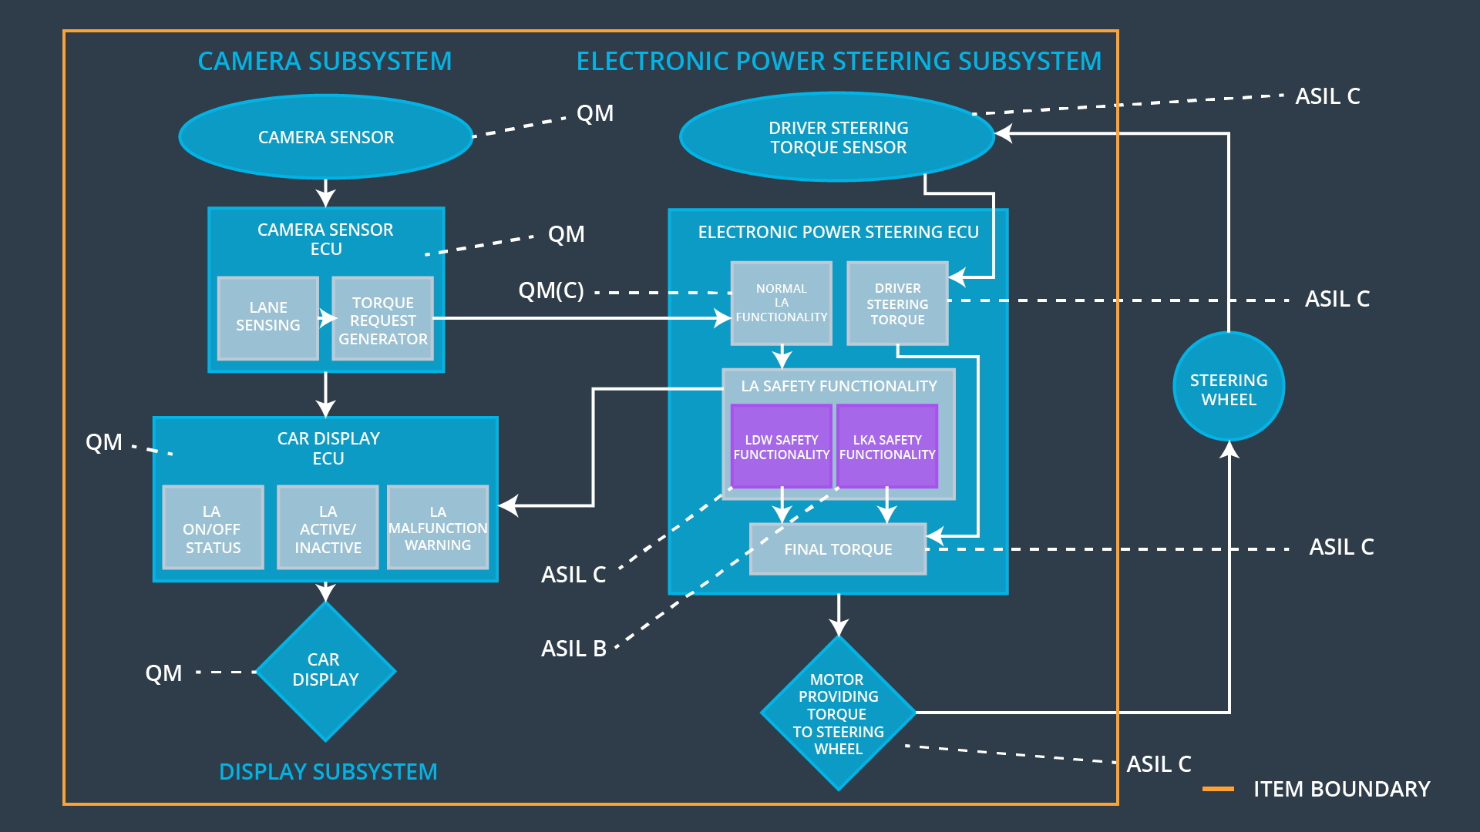

## Allocation of Functional Safety Requirements to Architecture Elements

|  |  |  |  |  |
| --- | --- | --- | --- | --- |
| **ID** | **Functional Safety Requirement** | **Electronic Power Steering ECU** | **Camera ECU** | **Car Display ECU** |
| Functional  Safety  Requirement  01-01 | The lane assistance item shall ensure that the lane departure oscillating torque is below Maximum_Torque_Amplitude. | **x** |  |  |
| Functional  Safety  Requirement  01-02 | The lane assistance item shall ensure that the lane departure oscillating torque is below Maximum_Torque_Frequency. | **x** |  |  |
| Functional  Safety  Requirement  02-01 | The electronic power steering ECU shall ensure that the lane keeping assistance torque is applied for only Max_Duration | **x** |  |  |

## Warning and Degradation Concept

|  |  |  |  |  |
| --- | --- | --- | --- | --- |
| **ID** | **Degradation Mode** | **Trigger for Degradation Mode** | **Safe State invoked?** | **Driver Warning** |
| WDC-01 | Turning the lane assistance system off, i.e. the torque request from the lane keeping assistance will be set to zero | The lane departure oscillating torque is above Maximum_Torque_Amplitude or Maximum_Torque_Frequency | Yes | A warning that the oscillating torque is above the maximum value |
| WDC-02 | Turning the lane assistance system off, i.e. the torque request from the lane keeping assistance will be set to zero | The lane keeping assistance torque is applied longer than Max_Duration | Yes | A warning that this function is meant for autonomous driving |