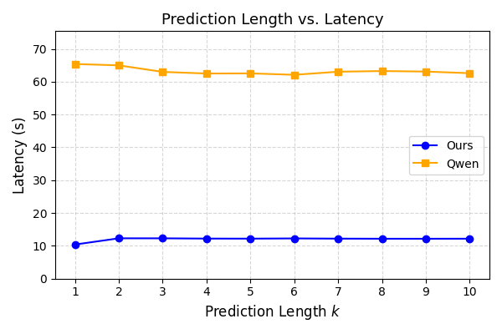

Batch size = 64，单位(ms)。例：k= 1 | Our Model: 10399.4±2157.8 ms

Ours：

k,Ours_mean_ms,Ours_std_ms

1,10399.42265625,2157.819140625

2,12293.34765625,122.3535400390625

3,12288.8828125,86.219287109375

4,12209.3578125,105.848193359375

5,12189.60390625,165.76697998046876

6,12257.5125,52.63026123046875

7,12192.4421875,129.943896484375

8,12163.5671875,73.06142578125

9,12160.01875,65.81878051757812

10,12172.5296875,113.7297119140625

Qwen：

k,Qwen_mean_ms,Qwen_std_ms

1,65406.0,167.1773193359375

2,64987.25,198.68350830078126

3,62999.83125,202.42288818359376

4,62503.1375,111.1411376953125

5,62546.93125,161.48896484375

6,62106.1875,144.2621337890625

7,63054.2375,209.772900390625

8,63259.01875,144.74849853515624

9,63095.325,866.33046875

10,62607.1,323.92346875