train_MultiModalEncoderDecoderModel.py

BeamMM_checkpoints/vision_s6.pth

LOSS="TOPK"/"MSE"/"HYBRID"（top3）

EPOCHS=50

BATCH_SIZE=64

LEARNING_RATE=1e-4

PATIENCE=5

---------------------------------

mse：

Test Loss (MSE): 0.0012

Test Loss (NMSE): 0.2125

Accuracy@1 : 0.3465

Accuracy@5 : 0.6917

---------------------------------

top3：

Test Loss (MSE): 10.3943

Test Loss (NMSE): 1793.6765

Accuracy@1: 0.4012

Accuracy@5: 0.6700

---------------------------------

hybrid：

Test Loss (MSE): 12.3461

Test Loss (NMSE): 2133.4838

Accuracy@1: 0.5069

Accuracy@5: 0.6994

---------------------------------

hybrid（加了与topkloss相同逻辑的topk计算）：

Test Loss (MSE): 12.3461

Test Loss (NMSE): 2133.4838

Accuracy@1: 0.5069

Accuracy@5: 0.6994

accuracy@1: 0.5069

accuracy@5: 0.9322

0.7

开始训练模型1（使用预训练编码器：/data2/wzj/BeamMM_checkpoints/mmwave_gps_joint_s8.pth）...

Found 8 CSV files for training.

Total Training samples: 11400

Total Validation samples: 1425

Total Testing samples: 1425

Using device: cuda (NVIDIA A100-SXM4-80GB)

Loaded state_dict from /data2/wzj/BeamMM_checkpoints/mmwave_gps_joint_s8.pth

Encoder weights loaded successfully.

Using Hybridloss as the loss function.

模型1训练完成，日志保存在 ./fig1/wirelessbind_s8/training_log_20250519_211516.txt

开始评估模型1：./fig1/wirelessbind_s8/multimodal_encoder_decoder_best.pth

Found 8 CSV files for testing.

Total Training samples: 11400

Total Validation samples: 1425

Total Testing samples: 1425

Loaded state_dict from ./fig1/wirelessbind_s8/multimodal_encoder_decoder_best.pth

Encoder weights loaded successfully.

Test Loss (MSE): 10.8420

Test Loss (NMSE): 2114.7101

Accuracy@1: 0.4297

Accuracy@5: 0.7091

accuracy@1: 0.4297

accuracy@5: 0.9242

开始评估模型1的泛化能力：./fig1/wirelessbind_s8/multimodal_encoder_decoder_best.pth

Found 1 CSV files for testing.

Total Training samples: 4009

Total Validation samples: 501

Total Testing samples: 502

Loaded state_dict from ./fig1/wirelessbind_s8/multimodal_encoder_decoder_best.pth

Encoder weights loaded successfully.

Test Loss (MSE): 6.4011

Test Loss (NMSE): 583.9240

Accuracy@1: 0.1003

Accuracy@5: 0.2707

accuracy@1: 0.1003

accuracy@5: 0.3493

0.5

模型1训练完成，日志保存在 ./fig1/wirelessbind_s8/training_log_20250522_090336.txt

开始评估模型1：./fig1/wirelessbind_s8/multimodal_encoder_decoder_best.pth

Found 8 CSV files for testing.

Total Training samples: 11400

Total Validation samples: 1425

Total Testing samples: 1425

Loaded state_dict from ./fig1/wirelessbind_s8/multimodal_encoder_decoder_best.pth

Encoder weights loaded successfully.

Test Loss (MSE): 10.9949

Test Loss (NMSE): 2144.7180

accuracy@1: 0.4351

accuracy@5: 0.9174

开始评估模型1的泛化能力：./fig1/wirelessbind_s8/multimodal_encoder_decoder_best.pth

Found 1 CSV files for testing.

Total Training samples: 4009

Total Validation samples: 501

Total Testing samples: 502

Loaded state_dict from ./fig1/wirelessbind_s8/multimodal_encoder_decoder_best.pth

Encoder weights loaded successfully.

Test Loss (MSE): 6.0821

Test Loss (NMSE): 555.3181

accuracy@1: 0.0910

accuracy@5: 0.3227

=============================

开始训练模型1（使用预训练编码器：/data2/wzj/BeamMM_checkpoints/mmwave_gps_joint_s8.pth）...

Found 8 CSV files for training.

Total Training samples: 11400

Total Validation samples: 1425

Total Testing samples: 1425

Using device: cuda (NVIDIA A100-SXM4-80GB)

Loaded state_dict from /data2/wzj/BeamMM_checkpoints/mmwave_gps_joint_s8.pth

Encoder weights loaded successfully.

Using CrossEntropyLoss as the loss function.

=============================

开始评估模型1：./fig1/wirelessbind_s8/multimodal_encoder_decoder_best.pth

Found 8 CSV files for testing.

Total Training samples: 11400

Total Validation samples: 1425

Total Testing samples: 1425

Loaded state_dict from ./fig1/wirelessbind_s8/multimodal_encoder_decoder_best.pth

Encoder weights loaded successfully.

Test Loss (MSE): 11.0015

Test Loss (NMSE): 2145.6732

accuracy@1: 0.4400

accuracy@5: 0.9184

开始评估模型1的泛化能力：./fig1/wirelessbind_s8/multimodal_encoder_decoder_best.pth

Found 1 CSV files for testing.

Total Training samples: 4009

Total Validation samples: 501

Total Testing samples: 502

Loaded state_dict from ./fig1/wirelessbind_s8/multimodal_encoder_decoder_best.pth

Encoder weights loaded successfully.

Test Loss (MSE): 6.0825

Test Loss (NMSE): 556.0452

accuracy@1: 0.0863

accuracy@5: 0.3260

=============================

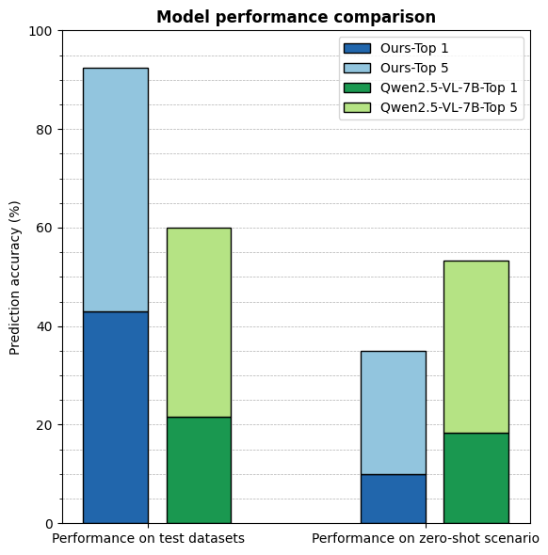

Ours test（scenario1-8）：

accuracy@1: 0.4297

accuracy@5: 0.9242

Ours zero-shot（scenario9）：

accuracy@1: 0.1003

accuracy@5: 0.3493

Qwen2.5-VL-B test（scenario1-8）：

accuracy@1: 0.2158

accuracy@5: 0.6004

Qwen2.5-VL-B zero-shot（scenario9）：

accuracy@1: 0.1833

accuracy@5: 0.5336

（Qwen使用的是4000样本（共约14400个样本）划分训练、验证、测试数据集，且冻住了主干网络，仅训练输出头）

尺寸不对：

Zeroshot acc@1: 0.1456

Zeroshot acc@3: 0.3578

Zeroshot acc@5: 0.5157

尺寸相同：

Zeroshot acc@1: 0.1833

Zeroshot acc@3: 0.3911

Zeroshot acc@5: 0.5336

Loaded best model for testing.

Testing...

Test Loss (HYBRID): 1.1309, Acc@1: 0.4346, Acc@5: 0.9237

Zero-shot evaluation:

Found 1 CSV files for zero-shot testing.

Zero-shot Loss (HYBRID): 3.1133, Acc@1: 0.1098, Acc@5: 0.3582