|  |  |  |  |  |
| --- | --- | --- | --- | --- |
| <Cell '员工信息'.A1> | <Cell '员工信息'.B1> | <Cell '员工信息'.C1> | <Cell '员工信息'.D1> | <Cell '员工信息'.E1> |
| EMP1001 | 刘勇 | 市场部 | 13314.82 | 2020-10-20 00:00:00 |
| EMP1002 | 罗梅 | 市场部 | 11883.98 | 2021-07-26 00:00:00 |
| EMP1003 | 石楠 | 人事部 | 12093.58 | 2021-05-01 00:00:00 |
| EMP1004 | 秦秀荣 | 财务部 | 21327.2 | 2024-05-29 00:00:00 |
|  |  |  |  |  |

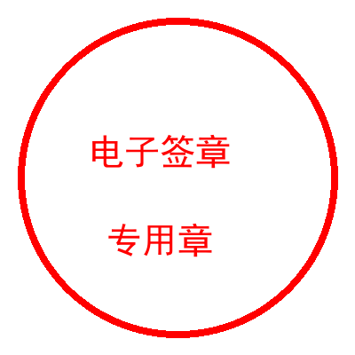

|  |  |  |  |  |
| --- | --- | --- | --- | --- |
| <Cell '员工信息'.A1> | <Cell '员工信息'.B1> | <Cell '员工信息'.C1> | <Cell '员工信息'.D1> | <Cell '员工信息'.E1> |
| EMP1006 | 施雪梅 | 财务部 | 10248.59 | 2024-10-31 00:00:00 |
| EMP1007 | 夏瑜 | 财务部 | 21922.65 | 2022-07-31 00:00:00 |
| EMP1008 | 吴丹丹 | 市场部 | 9207.15 | 2022-05-04 00:00:00 |
| EMP1009 | 左晶 | 市场部 | 8280.81 | 2023-05-12 00:00:00 |
| EMP1005 | 米小红 | 财务部 | 21405.89 | 2024-09-12 00:00:00 |



|  |  |  |  |  |
| --- | --- | --- | --- | --- |
| <Cell '员工信息'.A1> | <Cell '员工信息'.B1> | <Cell '员工信息'.C1> | <Cell '员工信息'.D1> | <Cell '员工信息'.E1> |
| EMP1011 | 陈畅 | 技术部 | 8310.12 | 2021-03-31 00:00:00 |
| EMP1012 | 王桂荣 | 人事部 | 13508.84 | 2022-11-27 00:00:00 |
| EMP1013 | 李梅 | 市场部 | 23845.28 | 2022-03-29 00:00:00 |
| EMP1014 | 王萍 | 技术部 | 13513.61 | 2024-01-01 00:00:00 |
| EMP1010 | 徐佳 | 技术部 | 24848.16 | 2023-11-22 00:00:00 |



|  |  |  |  |  |
| --- | --- | --- | --- | --- |
| <Cell '员工信息'.A1> | <Cell '员工信息'.B1> | <Cell '员工信息'.C1> | <Cell '员工信息'.D1> | <Cell '员工信息'.E1> |
| EMP1016 | 李桂荣 | 人事部 | 15795.01 | 2021-06-09 00:00:00 |
| EMP1017 | 李桂香 | 财务部 | 14220.35 | 2021-06-19 00:00:00 |
| EMP1018 | 李淑英 | 市场部 | 18643.98 | 2023-01-11 00:00:00 |
| EMP1019 | 何秀英 | 财务部 | 9080.73 | 2024-09-26 00:00:00 |
| EMP1015 | 韩小红 | 人事部 | 16453.37 | 2022-03-23 00:00:00 |



|  |  |  |  |  |
| --- | --- | --- | --- | --- |
| <Cell '员工信息'.A1> | <Cell '员工信息'.B1> | <Cell '员工信息'.C1> | <Cell '员工信息'.D1> | <Cell '员工信息'.E1> |
|  |  |  |  |  |
|  |  |  |  |  |
|  |  |  |  |  |
|  |  |  |  |  |
| EMP1020 | 白博 | 人事部 | 11687.36 | 2021-12-14 00:00:00 |

