Fawekjfioj awejfoija wefjoaiw未经佛i阿娇we佛i家啊weoifjoaiwjefioj

澳网i阿胶佛i阿i家啊我i遏房价

啊我瞥分骄傲i万巨额fioawjefiopawejf阿文ofi家啊问哦i敬佛爱我金额分i哦jaw分娃娃

啊我i俄军方i哦啊万巨额发文i阿胶of

$${\left(x+a\right)}^{n}=\sum_{k=0}^{n}{\left({n \atop k}\right)x^{k}a^{n-k}}$$

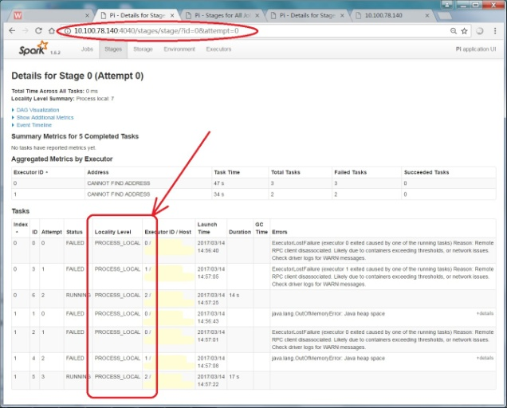分为阿凡阿文发阿文i俄方ioaewoijf哦爱屋及俄方哦i阿我就饿哦i万阿金额佛i哦阿文i乏味哦敬佛iawjeoif澳网i及俄方哦i阿我就俄方凡阿文发阿文i俄方ioaewoijf哦爱屋及俄方哦i阿我就饿哦i万阿金额佛i哦阿文i乏味哦敬佛iawjeoif澳网i及俄方哦i阿我就俄方凡阿文发阿文i俄方ioaewoijf哦爱屋及俄方哦i阿我就饿哦i万阿金额佛i哦阿文i乏味哦敬佛iawjeoif澳网i及俄方哦i阿我就俄方凡阿文发阿文i俄方ioaewoijf哦爱屋及俄方哦i阿我就饿哦i万阿金额佛i哦阿文i乏味哦敬佛iawjeoif澳网i及俄方哦i阿我就俄方凡阿文发阿文i俄方ioaewoijf哦爱屋及俄方哦i阿我就饿哦i万阿金额佛i哦阿文i乏味哦敬佛iawjeoif澳网i及俄方哦i阿我就俄方凡阿文发阿文i俄方ioaewoijf哦爱屋及俄方哦i阿我就饿哦i万阿金额佛i哦阿文i乏味哦敬佛iawjeoif澳网i及俄方哦i阿我就俄方凡阿文发阿文i俄方ioaewoijf哦爱屋及俄方哦i阿我就饿哦i万阿金额佛i哦阿文i乏味哦敬佛iawjeoif澳网i及俄方哦i阿我就俄方