Alejandro O. Horca

Landscape:

Food:

Nature: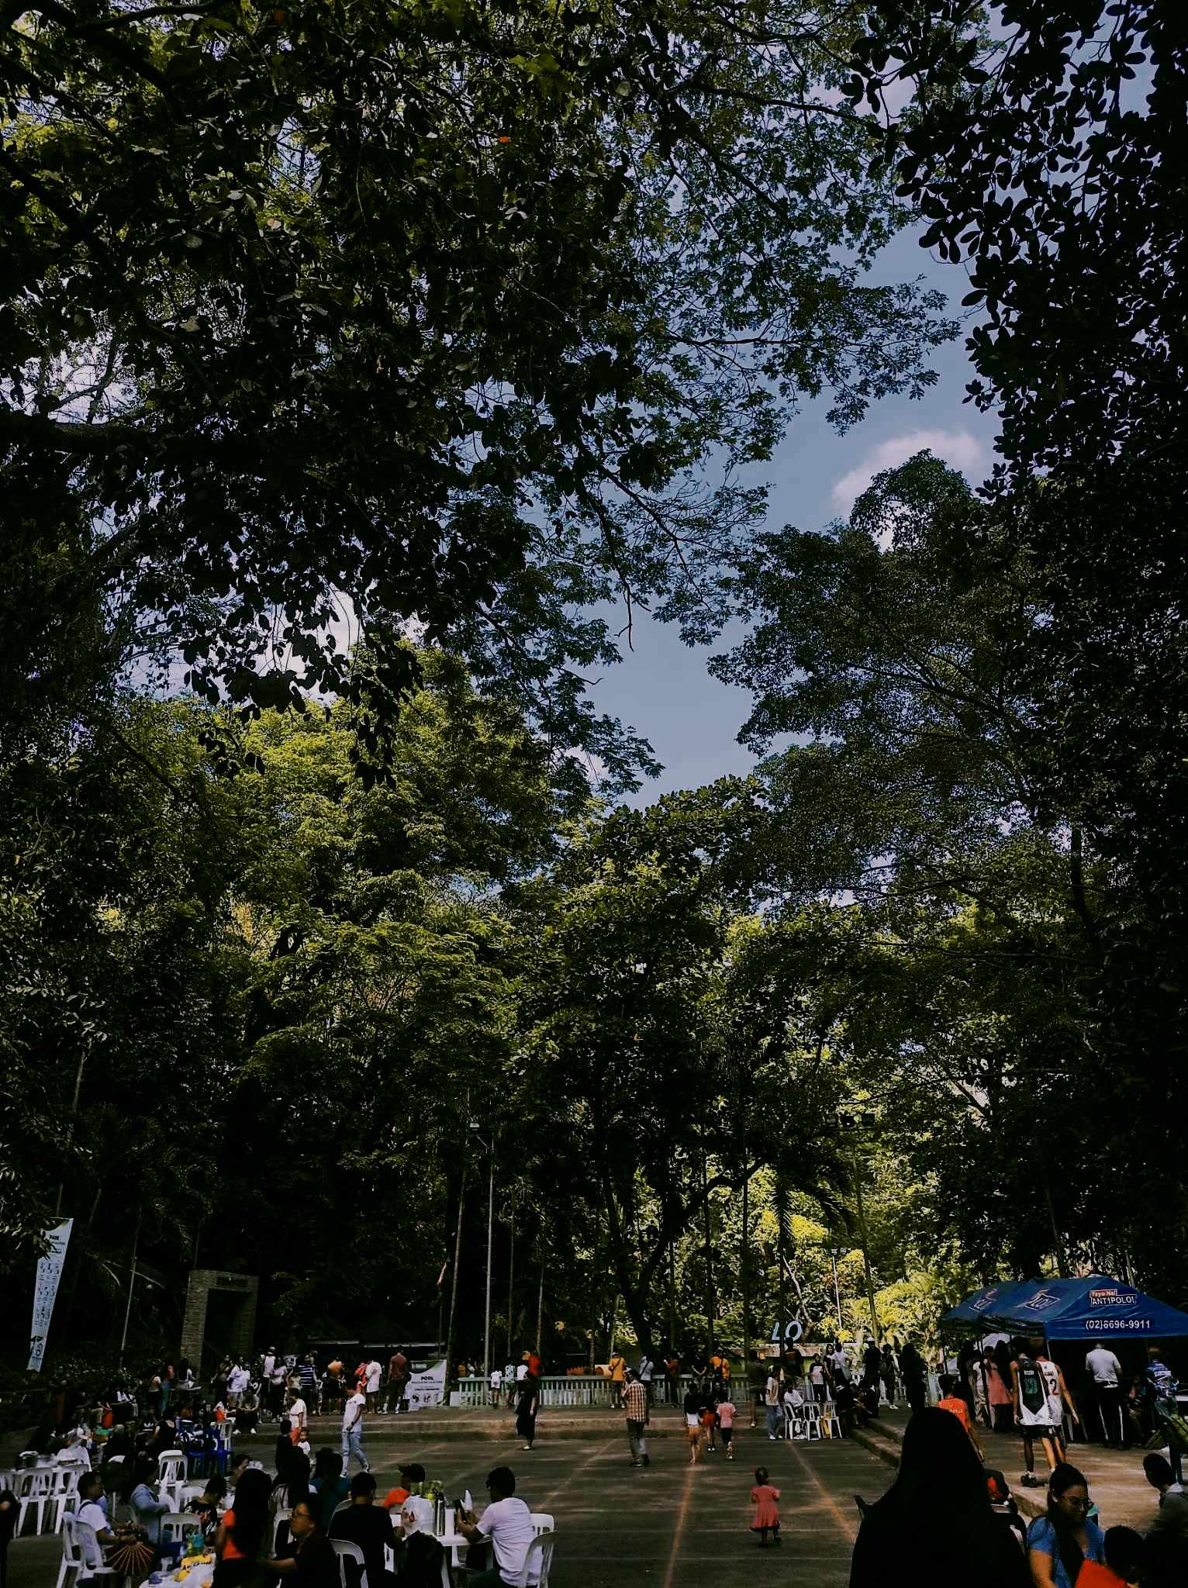

Portrait: