

**Soil Temperature Humidity And EC Sensor**

**Weihai Gemho Digital Mining Co., Ltd**

**Manual**

Chapter I product introduction and background knowledge

## **1.1 Background Knowledge**

## **1.1.1 Effects of soil conductance (salinity) on plants**

The effects of excessive soil salinity on plant growth are diverse, and the main hazards are as follows:

(1) Physiological drought. There are too many soluble salts in the soil, and the soil water potential decreases due to the increase of infiltration potential. According to the principle of water flowing from high water potential to low water potential, the water potential of root cells must be lower than that of the surrounding medium to absorb water. Therefore, the more soil salt, the more difficult it is for roots to absorb water, and even there is a risk of external infiltration of water in the body. Therefore, the general manifestation of salt damage is actually a drought damage, especially in the case of low atmospheric relative humidity, with the increase of transpiration, the salt damage is more serious, the plant growth is abnormal, the plant is short, the leaves are small and dark green, like drought and water shortage.

(2) Toxic effect of ions. Plants reject the absorption of other nutrients because they absorb too much salt.

(3) Destroy normal metabolism. Excessive salinity can inhibit the synthesis of chlorophyll and the occurrence of various enzymes in photosynthetic apparatus, especially the formation of leaf green protein. For crops growing in saline soil, the net photosynthetic rate is generally lower than that of plants in light soil, and the net photosynthetic production rate is low, which is not conducive to growth. Chloroplast is the main place for photosynthesis in plants. Chlorophyll content is a physiological index reflecting the intensity of plant photosynthesis. Therefore, under salt stress, the effect on plant photosynthesis is mainly on chloroplasts in plants. Under salt stress, plants can not absorb enough water and mineral nutrition, resulting in malnutrition, resulting in low chlorophyll content and affecting photosynthesis. In addition, too much salt reduced the activity of shuttle enzyme and shuttle enzyme, chloroplast tended to decompose and chlorophyll was destroyed. The biosynthesis of chlorophyll and carotenoids is blocked and stomata are closed, which reduces the photosynthetic rate and affects crop yield.

(4) Effect on plant cell membrane structure. Salt stress directly affects the membrane lipid and membrane protein, increases the permeability of lipid membrane and membrane lipid peroxidation, and affects the normal physiological function of membrane. Under normal circumstances, the cell wall and plasma membrane contact each other, and the plasma membrane shrinks when the cell loses water. Due to the different elasticity between the plasma membrane and the cell wall, the plasma wall "tears" and deforms each other, resulting in mechanical stress, causing the increase of intracellular free calcium concentration and inducing the burst of plant reactive oxygen species. Salt stress forces cells to lose water, causing changes in cell turgor and osmotic pressure.

（5）Hinder crop protein synthesis. Excessive salt has an obvious impact on protein metabolism. Inhibiting synthesis and promoting decomposition may be the direct reason for inhibiting protein synthesis, which may be due to the destruction of amino acid synthesis. For example, under salt stress, the synthesis of hemicystine and methionine in Vicia faba leaves decreases, resulting in the reduction of protein content. Make crops produce toxic substances. Salt stress forces plants to accumulate toxic metabolites, such as protein decomposition products, free amino acids, amines, ammonia, etc. these substances have toxic effects on plants, resulting in poor growth of plant leaves, inhibition of root growth, blackening and necrosis of tissues, etc.

## **1.1.2 Significance of measuring soil conductance (salinity)**

The total salt content in the soil is the total content of salts in the soil. Since various salts in the soil leaching solution generally exist in the form of ions, the total salt amount can also be expressed as the sum of the amount of various cations and anions in the soil leaching solution. In recent years, the total salt content of soil has increased year by year, resulting in soil acidification and secondary salinization. This is mainly due to the change of water and heat balance under natural state (high temperature, lack of rain leaching and strong evaporation) due to perennial or seasonal soil coverage, and the soil can not be fully leached by rain, resulting in the accumulation of salt on the soil surface; It is also caused by unreasonable fertilization. In soil analysis, salt content is an important comprehensive index, and the determination of electrical conductivity in soil can directly reflect the content of mixed salt. Therefore, it is very necessary to monitor the conductivity in soil to grasp its pollution status.

Soil conductivity is an indispensable and important parameter in the study of precision agriculture. It contains rich information reflecting soil quality and physical properties. For example, soil salinity, moisture, temperature, organic matter content and texture structure all affect soil conductivity to varying degrees. The effective acquisition of soil conductivity is of great significance to determine the temporal and spatial distribution of various field parameters, which also lays a foundation for the popularization and popularization of modern precision agriculture based on information and knowledge.

(1) To understand the dynamics of water and salt and its harm to crops, so as to provide reference for the prediction and prediction of soil salt, so as to take effective measures to ensure the normal growth of crops.

(2) Understand the effect of measures for comprehensive treatment of saline soil.

(3) According to the soil salt content and its composition, the saline soil is classified and reasonably planned to achieve the purposes of reasonable planting, reasonable irrigation and reasonable drainage.

(4) Identify the quality of irrigation water and determine the salt content of irrigation water, so as to make rational use of water resources, reclaim wasteland and prevent soil salinization.

**1.1.3 Judgment of plants under Salt Stress**

The higher the conductivity EC Value of the soil matrix, the greater the concentration of soluble salt ions in the soil. In this way, it is possible to form reverse osmosis, replace the water in the plant root system, damage the root tip, and then lose the ability to absorb water and nutrition. This is also the reason why excessive fertilization will cause seedling burning.

1. The symptoms of aboveground plants are wilting, yellowing, tissue necrosis or short plants.
2. The symptoms of the root are: the root tip turns brown, the lateral roots wither and there is no root hair in mild cases, and the whole root system rots and necrosis in severe cases. High soil EC value will also increase the incidence of root rot (caused by cotton rot). When it is found that the growth of crop plants is slow or stops growing, do not blindly Topdressing and supplement nutrition. Firstly, the condition of plant roots should be observed, combined with the characteristics of matrix and the management of water and fertilizer, and the EC Value of soil should be detected by soil conductivity (salt) tester. When the absorption capacity of plant roots decreases, unreasonable fertilization will cause soil salt to accumulate again and accelerate plant death; Secondly, the soil was irrigated and flushed with water with low EC Value in order to reduce the soil salt concentration; Third, rooting agents can be used appropriately to promote the growth of plant roots and accelerate the recovery of plants to normal

## 1.1.4 Measurement of conductivity and salinity

Generally, electrical conductivity EC (electrical conductivity) is an index used to measure the concentration of soluble salt in the solution. The unit is Siemens s / m per meter (1s / M = 10ms / cm = 10000us / cm = 10ds / M). According to the nature that the conductivity of soil matrix or nutrient solution depends on its temperature and salinity (i.e. salinity), the salinity can be obtained by measuring its conductivity and temperature. The measurement temperature of EC value is usually 25 ℃. In the same solution, the lower the measurement temperature, the lower the EC value. Under normal temperature conditions, every 1 ℃ difference

The change value of conductivity is about 2%, and the conductivity is roughly linear with salt content. Based on the temperature of 25 ℃, the proportion is: 1 μ S / cm = 0.55 ~ 0.75mg/l salt content. At other temperatures, it needs to be corrected, that is, the salt content changes by about 1.5-2% every 1 ℃ change in temperature. Use negative value when the temperature is higher than 25 ℃ and positive value when the temperature is lower than 25 ℃. Therefore, the conductivity can be estimated according to the salt content.

## 1.1.5 Effect of soil moisture content on plants

Moderate water is an important condition for plant growth. If there is too much or lack of water, the growth will be affected by the following aspects.

(1) Effect on plant morphology

Plants carry out photosynthesis and dry matter accumulation through water supply. The amount of accumulation is directly reflected in the dynamic changes of plant height, stem diameter, leaf area and yield formation. After water stress, the individual plants were low, the photosynthetic leaf area decreased significantly, and the yield decreased.

(2) Effect on blade change

Leaf is the main place of photosynthesis and transpiration. Mesophyll cell expansion and leaf growth are very sensitive to water conditions. To keep the plant leaves upright, it depends not only on the support of cellulose, but also on the support of higher turgor in the tissue. The wilting phenomenon when the plant is short of water is the manifestation of the decrease of turgor.

(3) Effect on Yield Formation

Crop yield is the accumulation of solar energy into chemical energy on crops. Soil water status affects plant root water absorption and leaf transpiration, then affects dry matter accumulation, and finally affects crop yield.

1. Effect of water on root cap development

Plant root system is the main organ of water absorption, and its development is affected by many aspects, but the main role is soil moisture and ventilation. The soil water condition affects the vertical distribution of roots. When the soil water content is high, the resistance of root diffusion by soil becomes smaller, which is conducive to the occurrence of new roots and the development of roots. The soil usually contains a certain amount of available water, so the root itself is not prone to water deficit. When the soil is dry or the water supply is insufficient, the root system absorbs limited water, first meets its own needs, and transports little to the aboveground part. Therefore, when soil moisture is insufficient, the impact on the aboveground is greater than that on the underground. The root shoot ratio increased. On the contrary, if the soil moisture is too much and the soil ventilation condition is poor, the impact on the underground part is greater than that on the aboveground part, and the root shoot ratio decreases. Moderate and slow water deficit can increase the absolute root weight, inhibit the growth of aboveground parts, reduce the dry matter accumulation of aboveground parts and reduce the unit yield, but it is conducive to dense planting, so as to improve the total yield. The results showed that water deficit in a certain period was beneficial to improve yield and quality. Drought in the early stage can enhance the drought resistance in the later stage, and mild drought resistance in the seedling stage can promote the "compensatory growth" of roots and improve the drought resistance of plants.

**Chapter II product introduction**

The soil moisture / conductivity / temperature sensor has stable performance and high sensitivity. It is used to observe and study the occurrence of saline soil

It is an important tool for evolution, improvement and water salt dynamics. By measuring the dielectric constant of soil, it can directly and stably reflect all kinds of soil

True moisture content of soil. The soil moisture sensor can measure the volume percentage of soil moisture, which is in line with the current international standards

Standard soil moisture measurement method. It is applicable to soil moisture monitoring, scientific experiment, water-saving irrigation, greenhouse, flowers and vegetables

Vegetable, grassland and pasture, soil rapid measurement, plant culture, sewage treatment, precision agriculture and other occasions. The sensor has the following characteristics:

(1) The three parameters of soil moisture content, conductivity and temperature are integrated.

(2) It can also be used for the conductivity of water fertilizer integrated solution and other nutrient solutions and substrates.

(3) The electrode is made of specially treated alloy material, which can withstand strong external force impact and is not easy to be damaged.

(4) It is completely sealed and resistant to acid and alkali corrosion. It can be buried in soil or directly put into water for long-term dynamic detection.

(5) High precision, fast response and good interchangeability. The probe insertion design ensures accurate measurement and reliable performance.

(6) Perfect protection circuit and various signal output interfaces are optional.

**2.1Comprehensive parameter table**

|  |  |  |  |
| --- | --- | --- | --- |
| **Name** | | **Parameter** | |
| Signal output type | Voltage output 0-2V (output impedance is about 0 ohms) | Current output 4-20mA  (Load resistance <500ohm) | RS485 interface  Modbus protocol |
| Supply voltage | 3.6-30V/DC | 12-30V/DC | 3.6-30V/DC |
| Static power | 6mA@24V DC | 50mA@24V DC  (Both current output channels are  20mA) | 6mA@24V DC |
| Soil Moisture Range | Optional range: 0-50%, 0-100%  Resolution: 0.03% within 0-50%, 1% within 50-100%  Accuracy: 2% within 0-50%, 3% within 50-100% | | |
| Conductivity range | Optional range: 0-5000us/cm, 10000us/cm, 20000us/cm  Resolution: 10us/cm within 0-10000us/cm, 50us/cm within 100000-20000us/cm  Accuracy ±3% in the range of 0-10000us/cm; ±5% in the range of 10000-20000us/cm | | |
| Conductivity temperature compensation | Built-in temperature compensation sensor, compensation range 0-50℃ | | |
| Temperature measurement range | Range: -40~80℃, Resolution: 0.1℃, Accuracy: ±0.5℃ | | |
| Measurement principle and measurement method | Soil Moisture FDR Method, Soil Conductivity AC Bridge Method  Soil in situ insertion or immersion into culture solution, water and fertilizer integrated nutrient solution for direct test | | |
| Protection class | IP68 immersion in water for long-term use | | |
| Operating environment | -40~85℃ | | |
| Probe material | Anti-corrosion special electrode | | |
| Sealing material | Black flame retardant epoxy resin | | |
| Installation method | All buried or all probes inserted into the measured medium | | |
| Default cable length | 2 meters, cable length can be customized on request | | |
| Connection method | Pre-assembled Crimp Terminals | | |
| Dimensions | 45*15*145mm | | |
| electrode length | 70mm | | |

# Chapter 3 Sensor Wiring

|  |  |
| --- | --- |
| **Model** | **Wiring diagram** |
| Voltage Signal | Red (V +): positive power supply  Black (g): power ground  Blue (O1): output signal (type selection can be soil moisture, conductivity and temperature output)  Brown (O2): output signal (type selection can be soil moisture, conductivity and temperature output) |
| 1. Current Output | Red (V +): positive power supply  Black (g): power ground  Blue (O1): output signal (type selection can be soil moisture, conductivity and temperature output)  Brown (O2): output signal (type selection can be soil moisture, conductivity and temperatureoutput) |
| RS485 Modbus  Protocol | Red (V +): positive power supply  Black (g): power ground  Yellow (T +): RS485 + / A / T+  White (T -): RS485 - / B / T-  Green (set): when connected to V + (power timing), power on and start the module to enter the "setting mode". When not connected or connected to G (power supply ground), power on and start to enter "operation mode".    The configuration parameters of the module, such as MODBUS address, baud rate, check bit, communication protocol, etc., are stored in the EEPROM (power down storage device) inside the module. Sometimes the specific configuration of these parameters will be forgotten, resulting in failure to communicate with the module. To prevent this problem, the module has a special mode called "setting mode". When the module is powered on and started in "setting mode", the module will communicate with the following parameters: 1 The Modbus address is fixed to 02 The communication configuration is 9600, N, 8,1 (9600bps, no check bit, 8 data bits, one stop bit) 3 The communication protocol is Modbus rtueeprom. The configuration parameters in the EPROM will not change when the module enters the "setting mode". When the module is in the "operation mode", it will still communicate according to these configuration parameters in EEPROM |

## Chapter IV overall dimensions, selection and ordering

## 4.1 Shell size

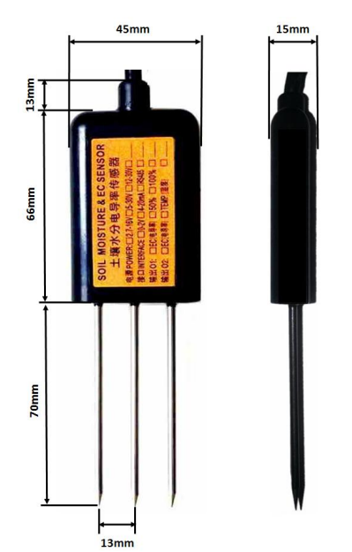

**4.2 Model selection and ordering**

|  |  |
| --- | --- |
| Name | Introduction |
| Product | Soil humidity ，Temperature EC |
| Hum Range | 0-50%  0-100% |
| Soil EC Range | 0-5000us/cm  0-10000us/cm  0-20000us/cm  Customizable |
| Power Supply | 3.6-30V DV  1.3-5.6V DC  12-30V DC（4-20mA Output） |
| Output Signal | RS485/4-20mA/0-5V/0-10V 4G/LoRa/NB-Iot |
| Line | Customizable |

**Chapter V installation and measurement**

Since the electrode directly measures the conductivity of soluble salt ions in the soil, the soluble ions in the soil can correctly reflect the conductivity of the soil when the soil volume moisture content is higher than about 20%. In long-term observation, the measured value after irrigation or rainfall is closer to the real level. If quick measurement is carried out, water the tested soil first, and measure it after the water is fully penetrated.

(1) Rapid measurement method: select a suitable measurement location, avoid stones, ensure that the electrode will not touch hard objects such as stones, dig the topsoil according to the required measurement depth, maintain the original tightness of the soil below, hold the sensor body and insert it vertically into the soil. During insertion, do not shake from front to back to left and right to ensure close contact with the soil. It is recommended to measure multiple times and average within a small range of a measuring point.

# (2) Buried measurement method: according to the required depth, dig a pit with a diameter greater than 20cm vertically. The depth shall be according to the measurement needs, and then insert the sensor steel needle horizontally into the pit wall at the given depth, and then fill and compact the pit to ensure that the electrode is in close contact with the soil. After stabilizing for a period of time, it can be measured and recorded continuously for several days, months or even longer. If the measurement is carried out on a hard surface, the hole shall be drilled first (the hole diameter shall be less than the probe diameter), then inserted into the soil and compacted, and then measured; The sensor shall be protected from violent vibration and impact, and hard objects shall not be used to knock. As the sensor is packaged in black, it will raise the temperature sharply (up to more than 50 ℃) under the strong sunlight. In order to prevent the excessive temperature from affecting the temperature measurement of the sensor, please pay attention to shading and protection when using in the field or in the field.

**Chapter VII RS485 communication and protoco**

**7.1 Modbus Communication Protocol**

Modbus is a serial communication protocol. It is the standard of communication interface for various instruments and intelligent sensors. It is widely used in intelligent sensors. Modbus protocol is a master-slave architecture protocol. There is one master node, and other nodes that use Modbus protocol to participate in communication are slave nodes. Each slave device has a unique device address. The conductivity sensor has RS485 interface and supports Modbus protocol.

The factory default values of communication parameters are: baud rate 9600bps, one start bit, eight data bits, no verification, and one stop bit. The communication protocol is Modbus RTU protocol. The communication parameters can be changed by the setting program or MODBUS command. After the communication parameters are changed, the sensor needs to be powered on again to take effect.

**7.3 RS485 Output**

|  |  |  |
| --- | --- | --- |
| Register address | Conten | Operation |
| 0006H | Soil Tem | Read-only |
| 0007H | Soil Hum | Read-only |
| 0008H | Soil EC | Read-only |

（1）Read the conductivity, temperature and humidity values of the equipment address 0x02

|  |  |  |  |  |  |
| --- | --- | --- | --- | --- | --- |
| Address Code | Function Code | Register Start Address | Register Length | CRC L | CRC H |
| 0x01 | 0x03 | 0x00,0x06 | 0x00,0x03 | 0x05 | 0xF8 |

Answer Frame：（For example, it is read that the temperature is - 10.1 ° C, the humidity is 65.8% RH and the conductivity is 7500US / cm）

|  |  |  |  |  |  |  |  |
| --- | --- | --- | --- | --- | --- | --- | --- |
| Address Code | Function  Code | Effective number of bytes | Tem | Hum | EC | CRC L | CRC H |
| 0x01 | 0x03 | 0x06 | 0x01,0x2C | 0x02,0x9 2 | 0x1D,0x 4C | 0xEC | 0xA6 |

Temperature: upload in the form of complement when the temperature is lower than 0℃

012C H(hexadecimal)=300=>Tem=3.00°C

**Hum：**

0292 H(hexadecimal)=658=>Hum=6.58%RH

**EC：**

1D4C H(hexadecimal)=7500=>EC=7500us/cm

|  |  |  |
| --- | --- | --- |
| Temperature Value | | |
| Parameter Range | -4000-8000 Corresponding -40.00~80.00℃ |  |
| Parameter Storage | Without |  |

Meaning: temperature measurement value, negative number is represented by complement.

For example: if the returned value is 0702h (hexadecimal, original code), the high byte of the first byte is 07h and the low byte of the second byte is 02h, then the temperature measurement value is (07h * 256 + 02h) / 100 = 17.94 ℃.

If the returned value is ff05h (hexadecimal, complement), the high byte of the first byte is FFH and the low byte of the second byte is 05H, then the temperature measurement value is ((FFH * 256 + 05H) - ffffffh-1h) / 100 = (ff05h-ffh-1h) / 100 = - 2.51 ℃

**（2）Modify device address**

Reading the current device address can only be completed independently by a single offline sensor.

The range of address code is 00 ~ 255 (hexadecimal, which needs to be converted to hexadecimal when writing)

Example of modifying the equipment address to 03:

Send: 01 06 02 00 00 03 C8 73

Return: 01 06 02 00 00 03 C8 73

After setting, the device needs to be powered on again before reading with the modified address.

1. **Example of modifying device baud rate**

|  |  |
| --- | --- |
| Byte | Baud |
| 0000 | 1200 |
| 0001 | 2400 |
| 0002 | 4800 |
| 0003 | 9600 |
| 0004 | 19200 |
| 0005 | 38400 |

## Example of modifying the device address to 4800:

## Sent: 01 06 02 01 00 02 58 73

## Return: 01 06 02 01 00 02 58 73

## After setting, the device needs to be powered on again to use the modified

## baud rate.

**Chapter VIII host computer software configuration of 485 version**

**（1）**Connect the device to the computer：

The device is connected to the computer serial port through "RS485 to USB" or "RS485 to 232" devices.

**（2）**Check whether the device is connected

1）Open the computer device manager, check whether a new device is added under the port (COM and LPT), and remember the port number of this device (the following figure is only a schematic diagram, and the port numbers displayed on different computers are different)

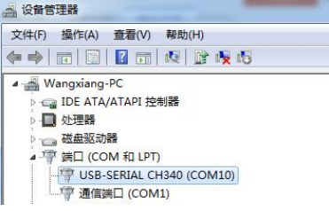

1. **（3）**（3）**Read Data**

1）Run "environmental monitoring setting software".

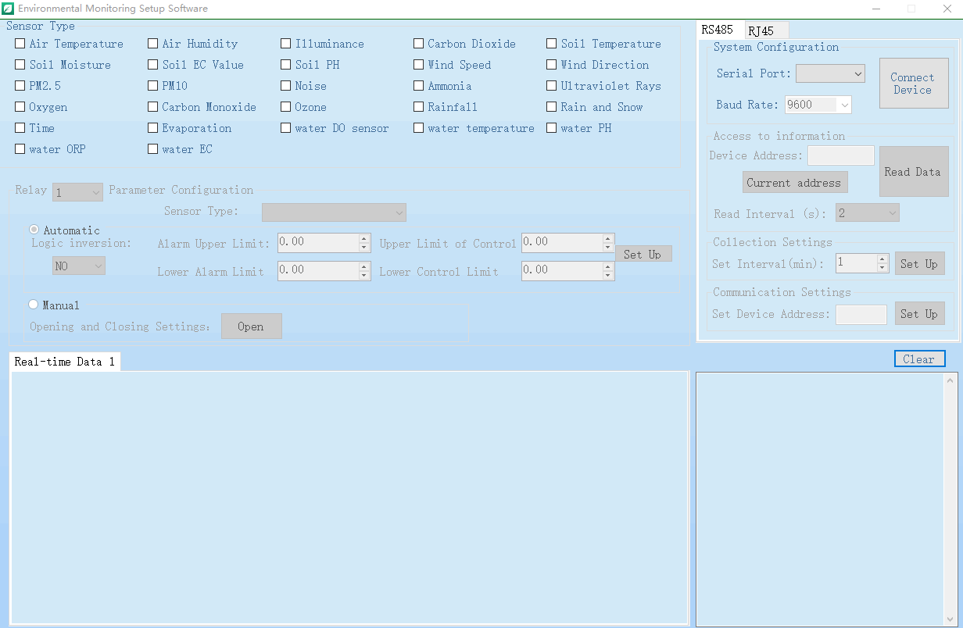

1. **RS485：**

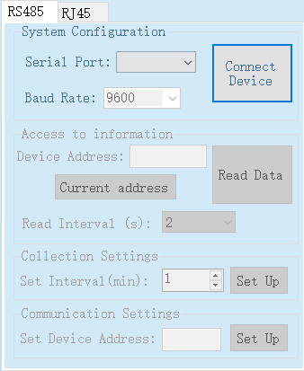

Select serial port number and baud rate (9600 by default, not selected), and click Connect device

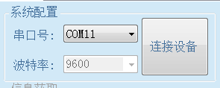

After the device is connected, the device address in [information acquisition] is loaded; In [sensor type selection], the function set in the current panel is checked by default; The checked function list is displayed in [real time data]. As shown in the figure:

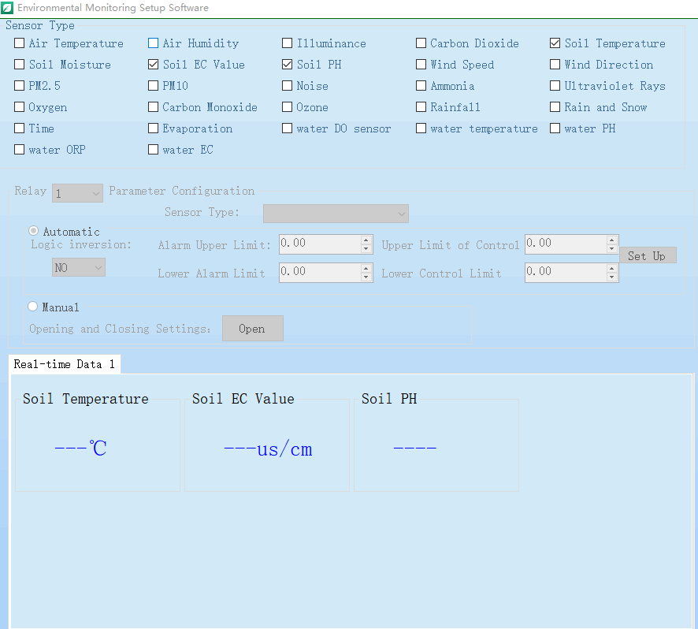

Click the [device address] button to get the latest address of the current device. If it is empty, you can click the [Set up] button

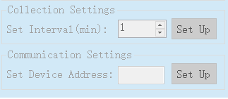

（4）To modify the device address: select [communication settings], fill in the address to be modified in [set device address], and click [settings] to complete the modification.

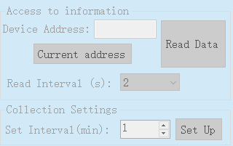

After the modification is completed, you will be prompted that the modification is successful。

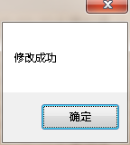

## Fault analysis and quality assurance

## 9.1 Fault Analysis

|  |  |  |  |  |  |  |
| --- | --- | --- | --- | --- | --- | --- |
| **NUM** |  | **Performance** |  | **Possible Faults** |  | **Solution** |
| 1 |  | No communication signal |  | Cable fault |  | Check the power supply circuit with a multimeter |
|  |  |  |
| 2 |  | No Data |  | Interface connection failure |  | Interface connection failure |
|  |  |  |
| 3 |  | Wrong Data |  | Probe Wrong |  | Contact Us |