

**RS485/4-20mA Soil NPK Sensor**

**Instrucn**

**Weihai Gemho Digital Mine Co., Ltd**

## Chapter I Product Overview

# **1.1 Introduction**

## Ghhb-031-485 Soil NPK sensor is a new integrated sensor. The value of nitrogen, phosphorus and potassium content in the soil where the equipment is located can be obtained through the acquisition equipment.

# **1.2 Product description**

# The NPK sensor adopts FDR frequency domain reflection principle. Based on the principle of electromagnetic pulse and the propagation frequency of electromagnetic wave in the medium, the apparent dielectric constant of soil is measured, so as to obtain the content of

# soil nitrogen, phosphorus and potassium.

# **1.3 Sensor characteristics**

# Low power consumption, high precision, high sensitivity, wide linear range, strong anti-interference ability, excellent repeatability and stability.

# **1.4 Applicable scenarios**

# The product can be widely used in environmental monitoring, meteorological monitoring, intelligent agriculture, orchard nursery, flowers and soil research. Compared with the traditional Internet of things sensors, it has the advantages of high precision and easy installation.

# **1.5 Precautions for use**

# the sensor is made of waterproof, dustproof and impact resistant materials, but the precision instrument needs to be used and maintained carefully to avoid impact and use in harsh environments such as corrosive liquid or gas.

# the aging time before use shall not be less than 48 hours. the air inlet of the sensor shall not be blocked or polluted.electrolyte leakage will cause damage. Do not disassemble the sensor at will.do not use if the shell is damaged or deformed.the sensor shall avoid contact with organic solvents (including silicone rubber and other adhesives), coatings, chemicals and fuel oils.it is not recommended to test the sensor with non-standard methods, and the front vertical air intake must be avoided, such as directly placing the sensor on concentrated ammonia, spraying cigarettes towards the sensor, approaching the sensor after the lighter is lit, exhaling towards the sensor, approaching the sensor to alcohol, etc.

# which will damage the sensor.After being used in high concentration gas environment for a long time (it is forbidden to store and use in high concentration acid gas for a long time), it will recover to the initial state slowly.when the sensor is stored, the working electrode and reference electrode shall be in a short circuit state.hot plugging is not allowed for the sensor. The sensor must be plugged in after the power supply is turned off, otherwise the sensor may be damaged or abnormal phenomena may occur;

# when using, please pay attention to whether there are requirements to restrict the use of wireless communication equipment on this occasion. If there are such restrictions, please do not use the equipment. For example, in the process of aircraft flight and takeoff and landing, gas stations, gas stations or other occasions with inflammables and explosives.

# Chapter II Product Introduction

## 2.1 Product Appearance

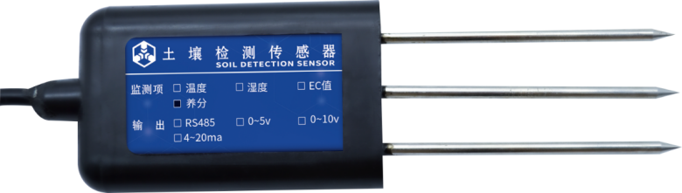

## 2.2 Power Supply

## The user provides the equipment with a DC power supply with an input of 9 ~ 18V. We can use the 220VAC to DC power supply provided by us, or use 12V solar panel and battery for power supply to meet the needs of different occasions.

## 2.3 Main Product Parameters

|  |  |
| --- | --- |
|  | **Parameter** |
| POWER SUPPLY | 9V-18V DC |
| Output Signal | RS485/0-5V/0-10V/4-20mA/4G/NB-IoT/LoRa/WiFi |
| Measuring Range | 0-1999mg/kg |
| Resolving Power | ±2%F.s |
| Accuracy | ±2%F.s |
| Response Time | ≤10s |
| Size | 72mm*45mm*15mm |
| Temperature | 5℃~45℃ |
| Humidity | 15%RH~90%RH |
| Pressure | Atmospheric Pressure± 10% |
| Waterproof Grade | IP67 |

# Chapter III System Architecture

## 3.1 RS485 Output Signal

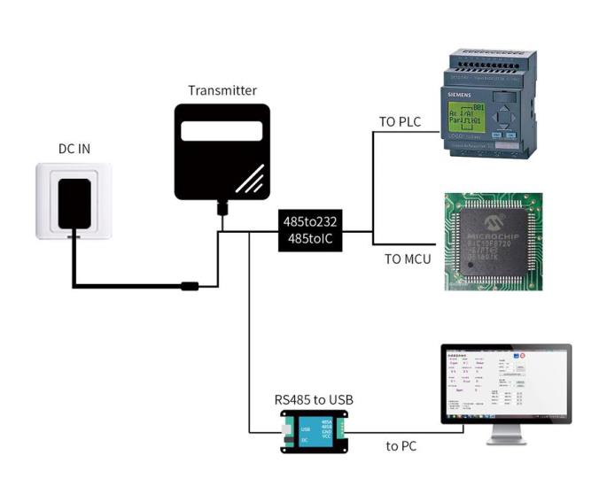The sensor is powered by 12V DC power supply and connected to PLC with RS485 interface. It can also be connected to MCU through RS485 interface chip. The MCU and PLC are programmed through the Modbus protocol specified later. Or use USB to RS485 to connect with the computer, and use the sensor configuration tool provided by our company for configuration and testing. Theoretically, one bus can connect more than 16 RS485 sensors. If more RS485 sensors need to be connected, RS485 repeaters can be used to expand more RS485 devices.

## 3.2 Analog Signal Out

Using 12V DC power supply, the sensor can be connected with acquisition equipment such as PLC or single chip microcomputer. Through the measured voltage or current value, the real-time data collected by the sensor can be obtained.

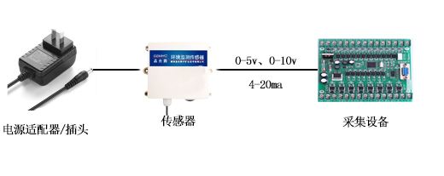

# Chapter IV Installation And Wiring Instructions

## 4.1 Equipment List

■1PCS NPK Sensor

■Product Certificate, Warranty Card And Manual

■Power Adapter (optional)

## 4.2 Installation Instructions

The sensor adopts buried installation design. According to the customer's installation requirements, the sensor is horizontally inserted into the soil at different depths for measurement.

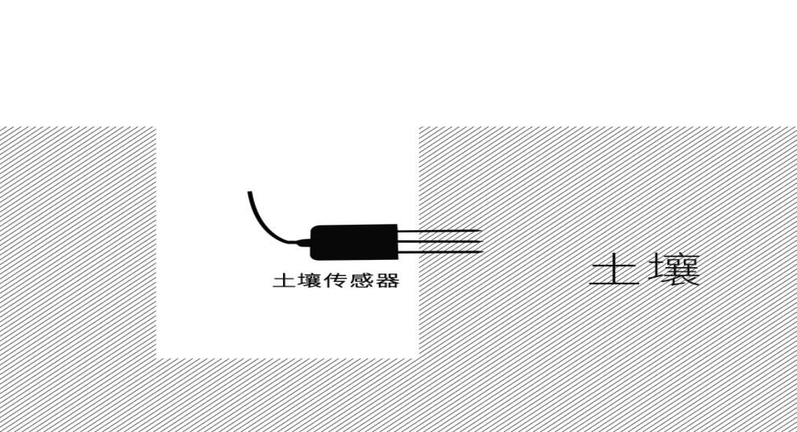

## Note: the measuring location should avoid stones to ensure that the steel needle will not touch hard objects. It is not allowed to shake left and right during insertion. It is recommended to measure multiple times to obtain the average value within a small range of a measuring point.

## 4.3 Wiring Instructions

1. **RS485 Line Description**

|  |  |  |
| --- | --- | --- |
|  | **Line Name** | **Line Color** |
| Power Supply | Positive power supply | Red |
| Negative power supply | Black |
| Output Signal | RS485A | Green |
| RS485B | Yellow |

1. **Analog Line Description**

|  |  |  |
| --- | --- | --- |
|  | **Line Name** | **Line Color** |
| Power Supply | Positive power supply | Red |
| Negative power supply | Black |
| Output Signal | Current / voltage output | Green |
| Without | Without |

Be Careful:

Please follow the wiring instructions strictly, otherwise it is easy to cause excessive current and damage the equipment.

If the power adapter is not purchased in our company, it is equipped with 4-core wire, and the customer needs to prepare 9-18vdc power supply by himself.

For customers who have purchased power adapters from our company, we will connect the DC female head to the equipment before the equipment leaves the factory. After receiving the product, the customer can plug in directly to supply power to the equipment.

# Chapter V RS485 Communication Protocol And Host Computer Configuration

## 5.1 RS485 Communication Protocol And Description

|  |  |
| --- | --- |
| **Parameter** | **Content** |
| **Coding** | 8 bit Binary |
| **Data bit** | 8-bit |
| **Parity bit** | Without |
| **Stop bit** | 1-bit |
| **Error Check** | CRC（redundant cyclic code） |
| **Baud Rate** | 9600 bit/s |

## 5.2 Data frame format definition

Adopt Modbus-RTU communication protocol, the format is as follows:

Initial structure ≥ 4 bytes of time

Address code = 1 byte

Function code = 1 byte

Data area = N bytes

Error check = 16-bit CRC code

End structure ≥ 4 bytes of time

Address code: is the address of the transmitter, which is unique in the communication network (factory default 0x01).

Function code: The instruction function of the command sent by the host. This transmitter only uses function code 0x03 (read register data).

Data area: The data area is the specific communication data. Note that the16-bit data high byte is in front!

CRC code: Two-byte check code.

**（1）Read NPK concentration value of device address 0x01**

Inquiry Frame：

|  |  |  |  |  |  |
| --- | --- | --- | --- | --- | --- |
| Address Code | Function Code | Register Start Address | Register Length | CRC L | CRC H |
| 0x01 | 0x03 | 0x00,0x1E | 0x00,0x03 | 0x65 | 0xCD |

Answer Frame：

|  |  |  |  |  |  |  |  |
| --- | --- | --- | --- | --- | --- | --- | --- |
| Address Code | Function  Code | Effective number of bytes | N | P | K | CRC L | CRC H |
| 0x01 | 0x03 | 0x06 | 0x00,0x25 | 0x00,0x31 | 0x00,0x28 | 0x41 | 0x07 |

0025H(hexadecimal)=37=>N=37mg/kg

0031H(hexadecimal)=49=>P=49mg/kg

0028H(hexadecimal)=40=>K=40mg/kg

**（2）Query device address**

Reading the current device address can only be completed independently by a single offline sensor.

Example of querying equipment address:

Send: FF 03 00 0f 00 01 A1 D7

Return: FF 03 01 00 60

The data returned by the sensor 0x01 is the device address 0x01.

**（3）Example of modifying equipment address:**

|  |  |  |  |  |
| --- | --- | --- | --- | --- |
| Code Address | Function  Code | Data  Address· | CRC L | CRC H |
|  | 06 | 0x00,0x0F |  |  |

## explain:

## 1. The range of address code is 0x01 ~ 0xFE, and the default value is 0x01;

## 2. This machine only supports writing the sensor address value. When writing, the high-order address is in the front and the low-order address is in the back;

## 3. When the device address is not known, the address code is written to FF

## Example of writing sensor address:

Change 01 address to 09 address:

## Send: 01 06 00 0f 00 09 79 CF

## Return: 01 06 01 09 20 4F

## 5.3 Upper computer reads equipment data and software configuration

（1）Connect the device to the computer

The device is connected to the computer serial port through "RS485 to USB" or "RS485 to 232" devices.

（2）Check whether the device is connected

1）Open the computer device manager, check whether a new device is added under the port (COM and LPT), and remember the port number of this device (the following figure is only a schematic diagram, and the port numbers displayed on different computers are different)

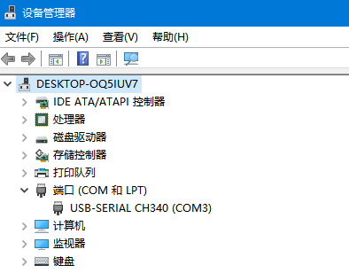

1. **Read Data**

1）Run "environmental monitoring setting software".

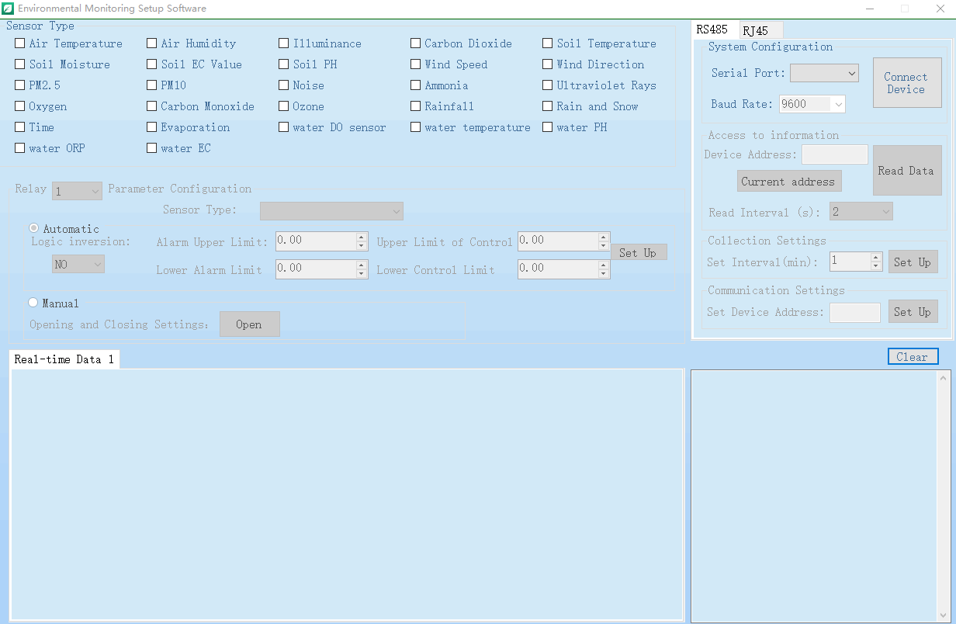

1. **RS485：**

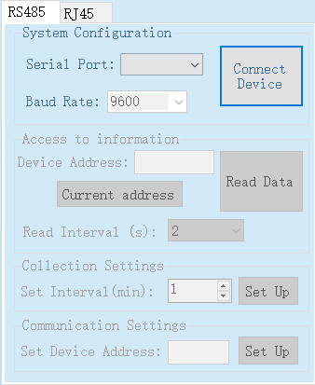

Select serial port number and baud rate (9600 by default, not selected), and click Connect device.

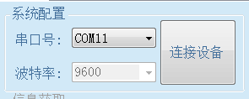

After the device is connected, the device address in [information acquisition] is loaded; In [sensor type selection], the function set in the current panel is checked by default; The checked function list is displayed in [real time data]. As shown in the figure:

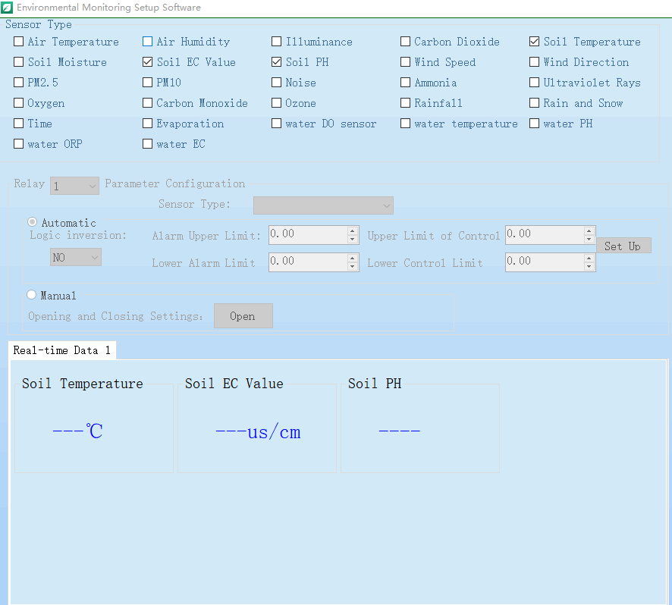

Click the [device address] button to get the latest address of the current device. If it is empty, you can click the [Set up] button.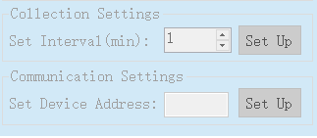

To modify the device address: select [communication settings], fill in the address to be modified in [set device address], and click [settings] to complete the modification

.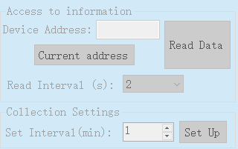

After the modification is completed, you will be prompted that the modification is successful。

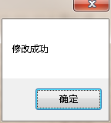

Chapter VI Analog Signal

**6.1** 4-20mA Output Signal

|  |  |
| --- | --- |
| Range | Current Output Range |
| 0mg/kg | 4mA |
| 2000mg/kg | 20mA |

P（N）=（I（Current）-4mA）*125mg/kg

Where p is in PPM and I is in mA.

## **6.2 0-5V Outout Signal**

|  |  |
| --- | --- |
| Range | Current Output Range |
| 0mg/kg | 0V |
| 2000mg/kg | 5V |

Calculation method P (n) = V (voltage) * 0.4

Where the unit of P is （mg / kg) and the unit of V is m（V).

## **6.3 0-10V Output Signal**

|  |  |
| --- | --- |
| Range | Current Output Range |
| 0mg/kg | 0V |
| 2000mg/kg | 10V |

Calculation method P (n) = V (voltage) * 0.2

Where the unit of P is（mg / kg） and the unit of V is m (V）.

# 

# Chapter VII Fault analysis and quality assurance

## 7.1 Fault Analysis

|  |  |  |  |  |  |  |
| --- | --- | --- | --- | --- | --- | --- |
| **NUM** |  | **Performance** |  | **Possible Faults** |  | **Solution** |
| 1 |  | No communication signal |  | Cable fault |  | Check the power supply circuit with a multimeter |
|  |  |  |
| 2 |  | No Data |  | Interface connection failure |  | Interface connection failure |
|  |  |  |
| 3 |  | Wrong Data |  | Probe Wrong |  | Contact Us |