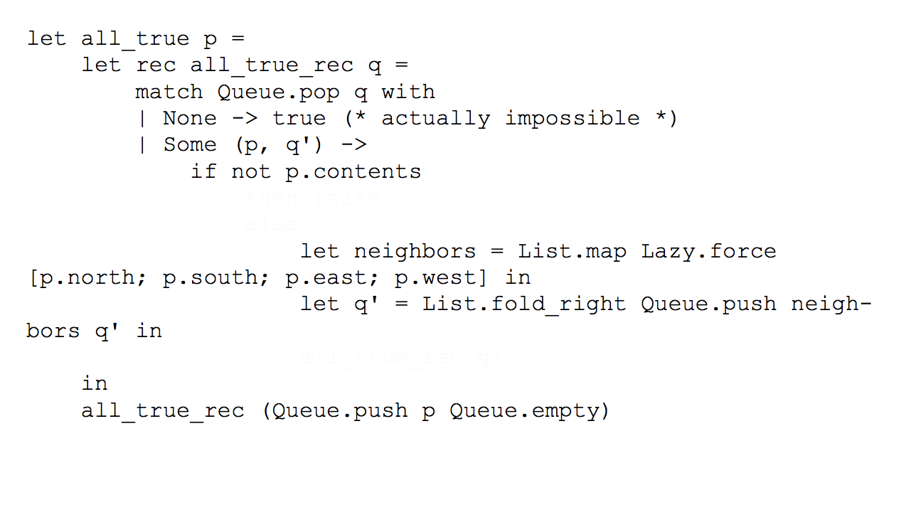
class c = object method foo = 41 end

class d = object
inherit c as super
method foo = 42
end

let obj = new d in Printf.printf "%d" d#foo

module type QUEUE = sig
type 'a t
val empty : 'a t
val push : 'a -> 'a t -> 'a t
val pop : 'a t -> ('a * 'a t) option
end
!
module Queue : QUEUE = struct
type 'a t = 'a list
let empty = []
let push v l = l @ [v] (* yay, O(n) *)
let pop l = match l with
| [] -> None
| hd::tl -> Some(hd, tl)
end

1. interface (class type)
signature for a class; an interface defines a new type and methods to
allow us to manipulate that type; does NOT provide a concrete
implementation (representation)

2. class
the blueprint for how to create an object of this class. Classes
include definitions of instance variables, methods, and how to
construct and initialize objects. Classes describe a particular
representation of data to implement a specification, while interfaces do
not.

3. object
an instance of a class. Each object has its own copy of instance variables.

4. representation
the implementation; for a class, the representation refers to how
we implement the class (e.g. what private instance variables we have,
what invariants we have on these variables)

5. inheritance
When class A inherits from class B, class A inherits the representation
of class B and can therefore use the representation of class B.
Inheritance allows us to pass around code to build new classes out of
existing variables.

Inheritance allows us to also add new instance variables or methods, as
well as override existing methods.

Inheritance is NOT subtyping.

6. subtyping polymorphism
Allows a single type to have many concrete forms. In our examples, a shape
type could really be a rect, square, circle, etc.

7. parametric polymorphism
A function is parametric polymorphic if the function is valid on
sets of types, specified by a type parameter. For example:

let id (x: 'a) : 'a = x

id (the identity) function is parametric polymorphic because it can work
on any type (the set of all types), denoted by 'a.

8. dynamic dispatch
Code to run is decided at runtime instead of compiletime (e.g. area).

9. open type vs. closed type
Algebraic data types are closed--we can't extend the type without
rewriting existing code.

Object Oriented data types are open--we can always extend a class type
by writing a new class that implements that class type.

