Team Member 1: Bench, L (220138718)
Team Member 2: Evans, MR (220021998)
Team Member 3: Mahlabe, KH (219202791)
Team Member 4: (215002544)

Problem Description:
See the recording that is uploaded for details.

Input:
- The type of person (investor or seed company) – via an input box
Via input boxes the following will be required if the user were to input Investor:
- The name of the investor
- The surname of the investor
- The gender of the investor
- The age of the investor
- The email address of the investor
- The phone number of the investor
- The country the investor originates from
- The “seed” amount the investor is willing to invest into the company
- Investors expertise – radio buttons
- A story about how the investor became so successful and what exactly the investor does.
Via input boxes the following will be required if the user were to input Seed Company:
- The companies name
- The founder’s full name
- The email address for the company
- The phone number for the company
- The country the company originates from
- The net profit for the previous year and this year
- The revenue for the previous year and this year
- The “seed” amount the company is asking for
- The percentage of the company the investor will receive
- The target markets for the company – via radio buttons
- The companies story

Output:
If the user is a Seed company the following will display in a multiline text box for all investors in the text file that suit the criteria.
- The name of the investor
- The surname of the investor
- The gender of the investor
- The age of the investor
- The email address of the investor
- The phone number of the investor
- The country the investor originates from
- The “seed” amount the investor is willing to invest into the company
- Investors expertise
- A story about how the investor became so successful and what exactly the investor does.
If the user is an investor the following will display in a multiline text box for all seed companies in the text file that suit the criteria.
- The companies name
- The founder’s full name
- The email address for the company
- The phone number for the company
- The country the company originates from
- The net profit for the previous year and this year
- The revenue for the previous year and this year
- The “seed” amount the company is asking for
- The percentage of the company the investor will receive
- The target markets for the company
- The companies story

Events & Actions:
EVENT | ACTION
Clicks Investor.txt | User will be asked to enter necessary input for the Investor(described above in the Input Section)
Clicks SeedCompany.txt | User will be asked to enter necessary input for the Seed Company(described above in the Input Section)
Clicks DisplayPossibilities.txt | This is display the possible matches for the Investor / Seed Company

Interface:
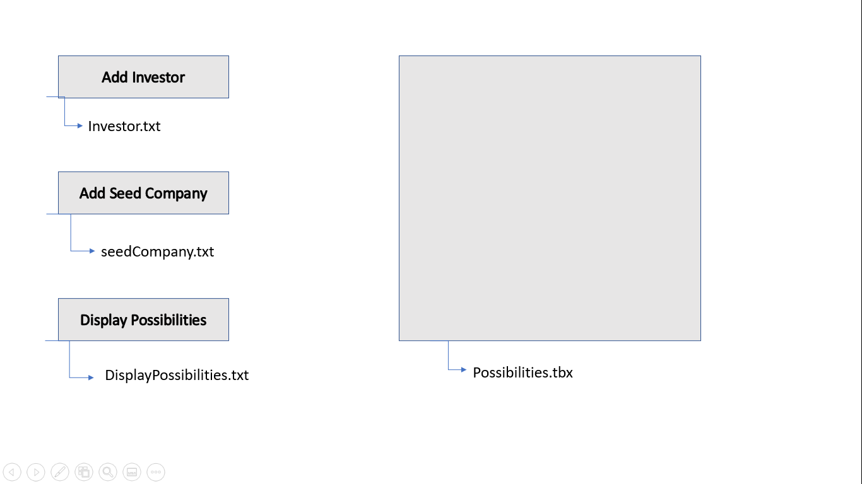

Test Data:

Algorithm:

UML Diagram:
