|  |
| --- |
| EE260 Exam 2 (Practice) |

**Submitted by:**

**Your Name**

Grade:



|  |  |
| --- | --- |
| Date of Submission: | Date |
|  |  |

1. (10 pts) An Exclusive NOR (XNOR) gate is a 2-input gate whose output is 1 if and only if both of its inputs are equal. Write a truth table, sum-of-productions expression, and the corresponding AND-OR circuit for Exclusive NOR function.
2. (10 pts) Assign variable to the inputs of the AND-XOR circuit below so that its output is F = m6 + m7 + m12 + m13. You may use a Karnaugh map if it helps you.

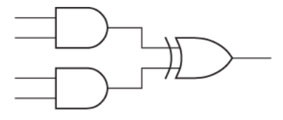

1. (10 pts) Use a Karnaugh map to find all of the static hazards in the corresponding two-level circuit, and design a hazard-free circuit that realizes the same logic functions:

F = W’X’ + Y’Z + W’XYZ + WXYZ’

1. Say you are working in a system where the only component you have available is a 2-to-1 MUX. Show how to build a 2-input NOR gate from those MUXes. You can freely connect inputs to “1” and “0” as needed. Label the inputs as “A” and “B”. Label the output as “X”. Your solution must use 3 or fewer of the MUXes to receive credit.
2. Show how to build the following functions using one 3-to-8 decoder with active-low outputs and four 2-input NAND gates

F = X’Y’Z’ + XYZ’

1. (10 pts) describe the behavior of the following Verilog module.

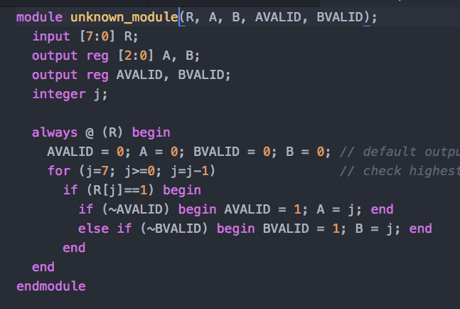

1. (15 pts) Consider a very unusual adder. It takes two 8-bit inputs, both representing number using the “one hot” representation scheme (Thus the inputs range in value from 0-7). The output is a 4-bit unsigned number that is a sum of the two inputs. In your design you may use the following devices: (Be sure to label all of the devices you use other than standard gates!).
   1. 2-input AND gates, 2-input OR gates, 2-input XOR gates, NOT gates
   2. 3-bit adders (inputs and outputs are both 3-bits) with carry-in and carry-out.
   3. 8 to 3 encoders (all wires active high)
   4. 3 to 8 decoders (all wires active high)
   5. 8 to 4 Multiplexers (all wires active high)

