Sensor Data Platform Web Application

**Application Tutorial**

**Arie Radilla Laureano**

**Isil Demir**

**Lyman Cao**

**Yazhisai Gowthaman**

# Tutorial

The Sensor Data Platform Web Application is hosted on Heroku and can be accessed locally from the github code in the below URL.

<https://github.com/cmusv-sc/ArchF2013-Project3-FT>

## Home Page

The homepage of the application is very informative and self descriptive of the features and contents of the website

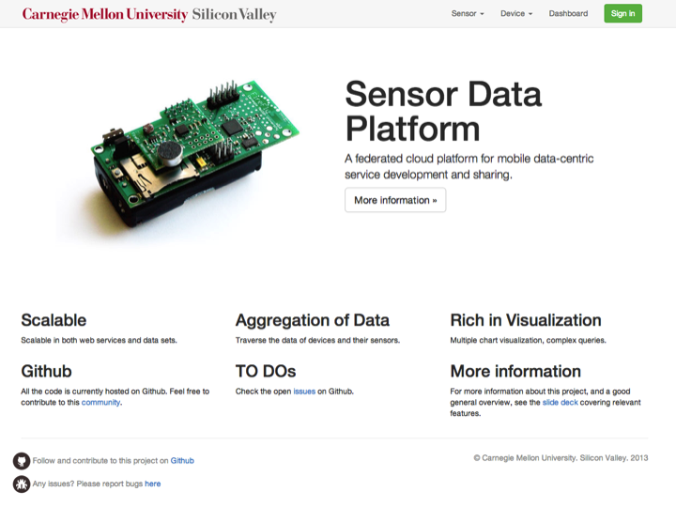

## Useful links

The home page gives access to some of the useful links that provides various resources which assists in using the application.

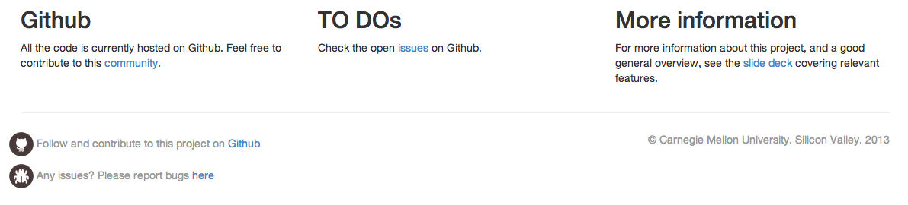

## Menu

The menu at the top of the application provides links to all the key functionalities of the application



## Sensor

Clicking on the “Sensor” menu and navigating to the “Sensors” sub menu takes the user to the page where all the sensors are listed.

Sensor >> Sensors

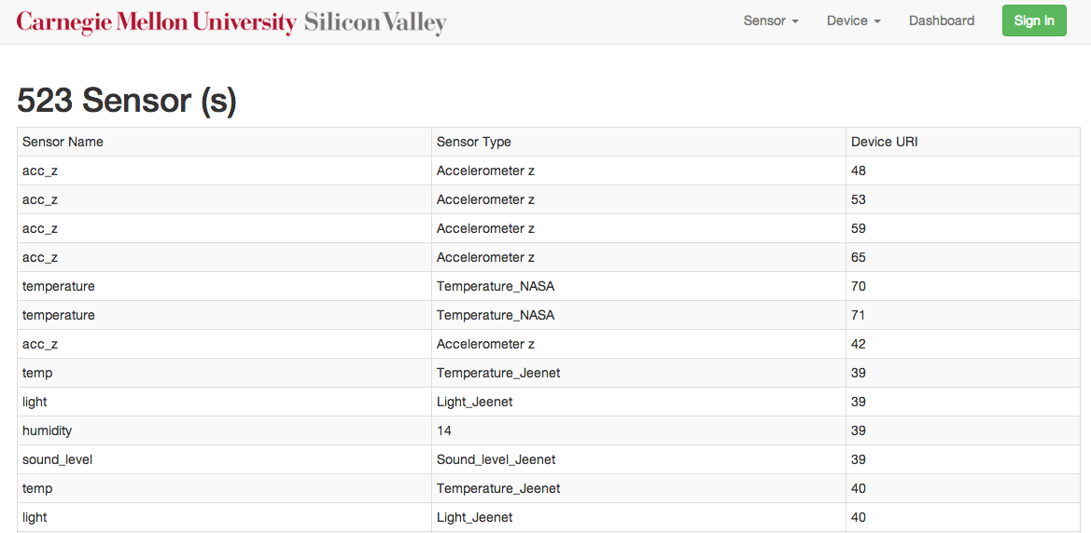

## Sensor Types

Clicking on the “Sensor” menu and navigating to the “Sensor Types” sub menu takes the user to the page where all the sensor types are listed.

Sensor >> Sensor Types

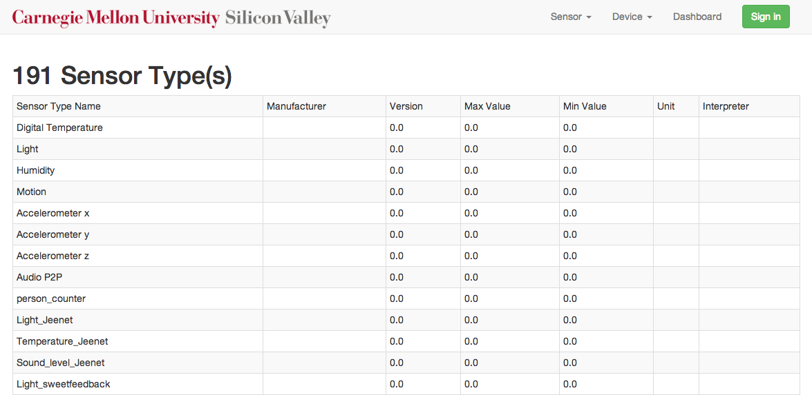

## Devices

Clicking on the “Device” menu and navigating to the “Devices” sub menu takes the user to the page where all the devices (to which the sensors are mapped) are listed.

Device >> Devices

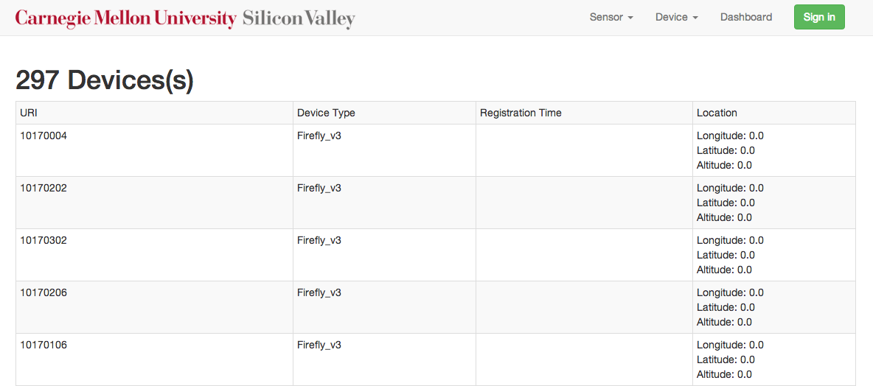

## Device Types

Clicking on the “Device” menu and navigating to the “Device Types” sub menu takes the user to the page where all the sensor types are listed.

Device >> Device Types

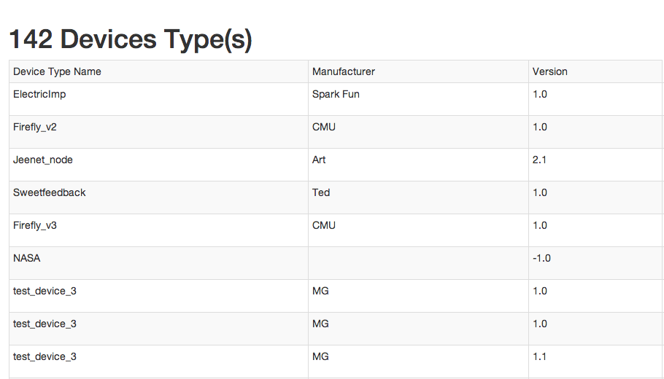

## Dashboard

The Dashboard acts as a one-stop page to view all the active and inactive sensors and get a high level picture of the sensor activity.

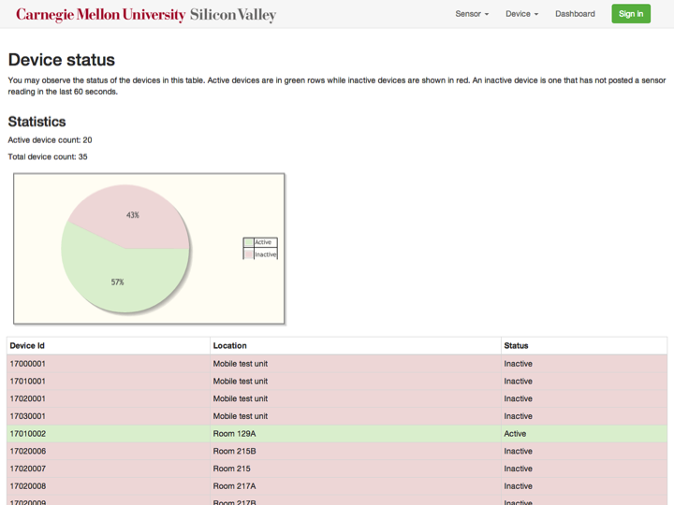

## Bug Report

Our application also provides an option for users to report bugs with the Bug Report feature, which can be found at the footer of all pages

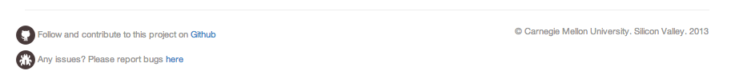

Clicking on this link, takes the user to the Bug Report page as shown below.

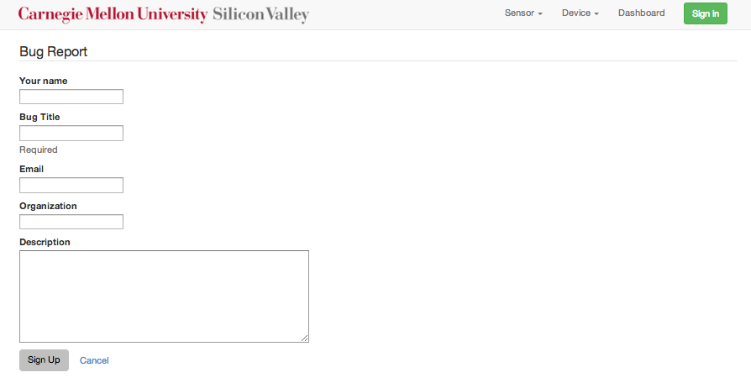

## Sign In

Apart from the above features, our application also provides authorized users with addition access as below.

Clicking on the sign-up link brings up the sign up page.

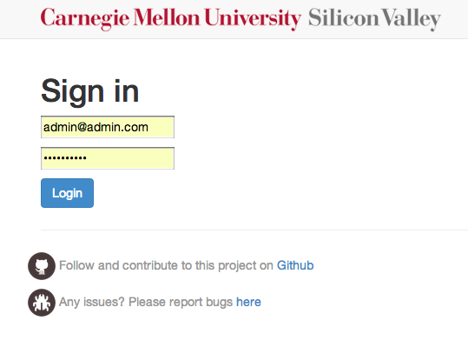

Signing in provides the additional features:

Option to Delete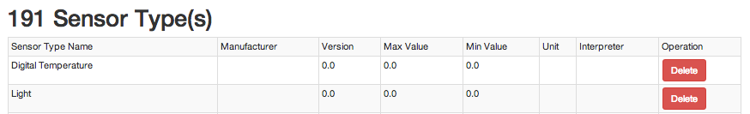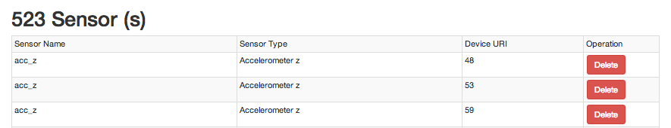

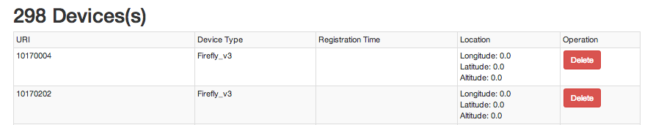

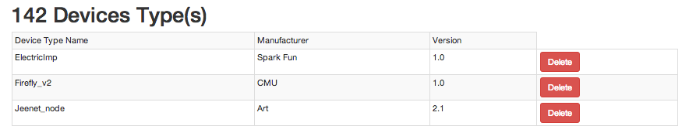

## Sensor Creation

Signed in users can create new sensors by clicking on the Sensors sub-menu from the Sensor menu. Authorized users will be able to see the fields to create a new sensor below the list items.

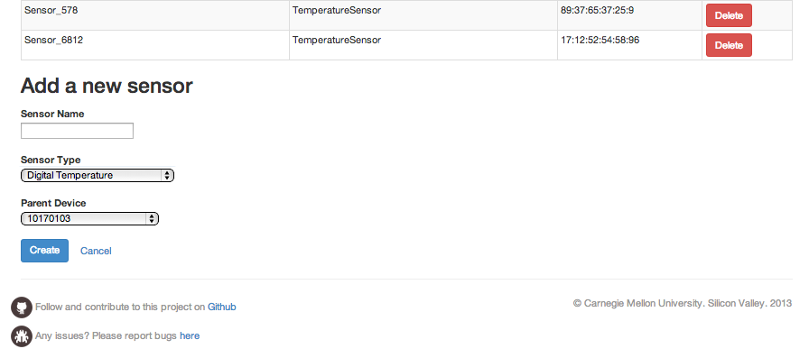

## Adding a new Sensor Type

Authorized users can create a new Sensor Type by navigating to the Sensor Types page. They will be able to see the fields to create a new sensor type below the list items.

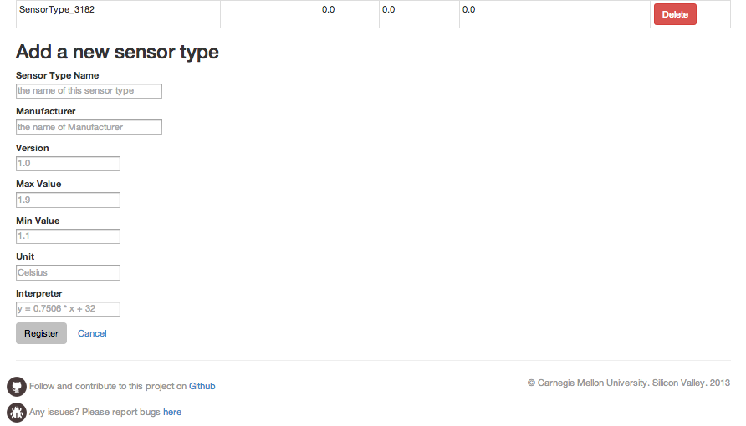

## Create a new Device

Authorized users can create a new Device by navigating to the Devices page. They will be able to see the fields to create a new Device below the list items.

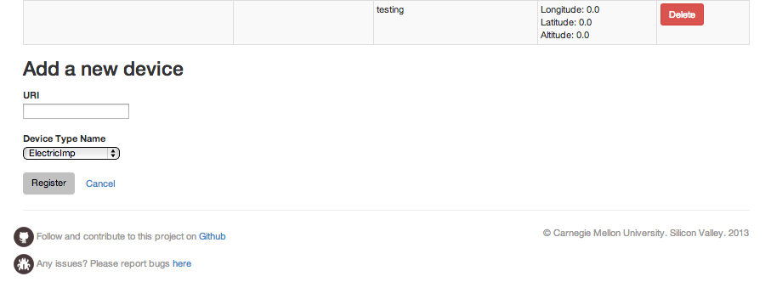

## Create a new Device Type

Authorized users can create a new Device Type by navigating to the Device Types page. They will be able to see the fields to create a new Device Type below the list items.

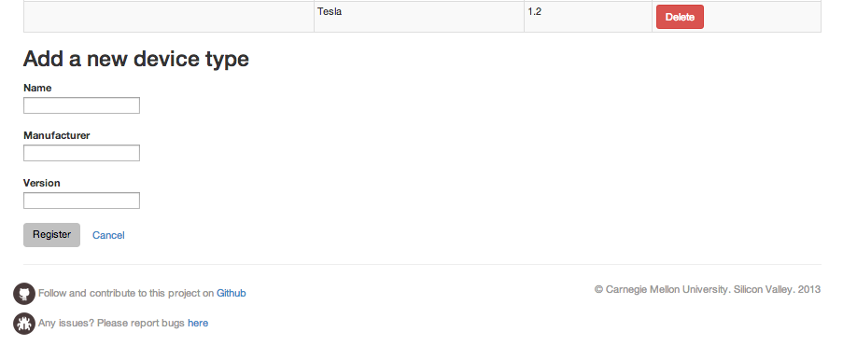

## View Bug Reports

Authorized users can view logged bugs in addition to creating a new bug reports. Signed in users will be able to see an additional menu item under Bug Report to view the logged bugs.

Bug Report >> Reports

