Final Project Proposal for ECE 496

Implementation of Rotational 3D Scanner

Supervisor: Professor Moshovos

Administrator: Mr. John Taglione

Project # 381

Prepared by: Emily Miao, Jing Guan, Sen Yang

Date: October 27, 2015

Executive Summary

As 3D modelling becomes more predominant in society, people start to see the efficiency and productivity benefits 3D modelling brings. 3D modelling with Computer Aided Design (CAD) software is both difficult and time consuming whereas 3D scanners currently available in the consumer market are expensive. Furthermore, the more affordable Do-It-Yourself (DIY) scanners do not offer all the features desired by mass consumers, and require a certain level of technical background to assemble and use. The affordability can be achieved by sacrificing accuracy for cheaper hardware parts, and using software algorithms to account for inaccuracies in scanning while still offering the features and functionalities of high-end scanners.

The team is to implement a system which is able to observe a tangible object and produce a digital model that resembles the original object. The generated files should be compatible with current CAD programs and 3D printers. To emphasize the importance of affordability and efficiency, the product should not cost more than $50, and take no more than 20 minutes to complete the scanning process. Furthermore, the system should be able to support scanning of objects weighing up to 350 grams within physical dimensions of a cylinder of 20 centimeters in radius and height.

The team has come up with four design alternatives to complete the 3D scanning process: using a handheld device, using light and shadow, using sound echolocation, and using a laser and a camera. After comparing the alternative designs, the team has come to the conclusion that a 3D rotational scanner with a laser and a camera is the alternative that best achieves the project goals. This solutions builds on top of existing solutions to address the public’s need for affordable 3D scanners without foregoing functionality.

The hardware system consists of a rotational plate, a laser, and a camera. The object to be scanned is placed at the center of the plate which rotates at fixed intervals until 360 degrees is achieved. As the plate rotates, a laser continuously shines a vertical beam of light on the object and photos are taken by the camera. When a full rotation has been completed, an algorithm processes the photos taken. The points in the photos where the light reflected off the object can be mapped into points in 3D space using mathematical formulas. By connecting all the points mapped, the surface of the digital replica created.

To validate the system, the team will digitally replicate ten objects of varying shapes and sizes. Of these ten objects, one will be an object weighing 350 grams, and one will be a cylinder of 20 centimeters in radius and height. This is to test the maximum weight and physical dimensions the system should support. Furthermore, the digital replication data will be tested for file format compatibility. This will be done by opening generated 3D image files to existing CAD programs, as well as sending these files to 3D printers for physical replication.

# **1. Project Description**

This section will provide some background on the 3D digital scanning industry, identify key benefits brought by digitally replicated models, and identify obstacles that have stagnated 3D models to be widely available to consumers. This section will also outline requirements and validation metrics of implemented solutions tailored to addressing the specific obstacles identified.

## **1.1 Project Background**

The demand for efficient, illustrative and comprehensible media is rapidly increasing, and is continuously replacing traffic for obsolete text-based media. 3D digital models are starting to replace 2D pictures from online catalogues and illustrations at work and home. Digital models provide accurate illustrations, improve productivity, and are vital inputs to design automations, simulations, websites, multimedia and most importantly, to the rapidly increasing amount of 3D printing applications in today’s electronics market [1]. As one example from a civil architectural structures modelling assessment reported, students used 410 hours to model using 2D tools where it took 248 hours using 3D modelling – “… [which resulted in] productivity improvement… of 21% to 61%.” [2]

In spite of the mass demand and productivity improvement 3D models promise, the main obstacle that prevents the majority of consumers from using 3D models is the difficulty in producing digital models from real-life objects. Correctly drawing a 3D object by hand using even the most advanced Computer Aided Design (CAD) tools can easily take 3 to 5 hours even for designers with experience [3]. A more feasible, efficient solution on the market are 3D scanners, which are devices that are capable of scanning physical objects using advanced optical devices and patterned lights. Most of the scanners, such as the MakerBotTM Digitizer, can easily cost more than $1,000 [4] and present economic barriers for small business groups and individual developers with limited budgets. On the other hand, low-end or Do-It-Yourself (DIY) scanners such as SardauscanTM [5] do not satisfy many of the functional needs sought out by the majority of identified users, such as creating a printer-ready model from scanning. In addition, such DIY scanners also require the user to buy separate parts, assemble the scanner, and download the algorithms used onto the system assembled. This assembly process requires the user to have a technical background that most consumers do not possess.

The main gap to be addressed is the lack of consumer products segmented toward consumers with limited budget and technical background knowledge who require additional functionalities that current low-end scanners do not provide. The market is short of a cheap, efficient solution that can take a physical object, produce its digital 3D model and provide additional features such as printing automation.

## **1.2 Project Motivation**

The main motivation for this project is the team members’ collective interests in implementing a complex electronic system that requires project planning, technical design, as well as learning and applying electronics, programming, computer graphics, and data processing knowledge into practise. In addition, successfully implementing this project provides members with a functional, fully customizable scanner which could otherwise cost thousands of dollars. The scanner can be used for 3D printing applications, and other projects that use 3D models such as animation and games.

## **1.3 Project Goal**

The end objective of this project is to implement a scanning system which observes a physical object of limited size and weight, and to digitally produce the corresponding 3D model files for monitor display and 3D printing.

## **1.4 Project Requirements**

This subsection enumerates the list of expected project requirements, restrictions, and desirable but optional attributes under objectives.

### **1.4.1 Functional Requirements**

* The system will accurately produce a 3D digital model of the object observed in .OBJ [6], and .STL format [7] which is a simplification of the .OBJ format for 3D printers. Please refer to Appendix A for details on file formats.
* The rotational system will use a motor to expose all 360 degrees of the scanned object to an image taking device. The motor will rotate objects up to 350 grams [8] centered at the axis of rotation. This weight is limited by the torque rating of the selected motor, under a $15 budget [9].
* The produced 3D digital replica must achieve at least a resolution of 10 pixels/cm2 from the surface of the scanned object. This is set by an optimal tradeoff point between the requirements of model definition and model data processing speed.
* The system will receive commands and send produced files to connected computer via an USB 2.0 connection, the mostly widely used protocol for PCs [10].
* The C++ implementation must be compatible with a machine with the Windows 10 operating system. The program will not use more than 4GB of memory - the memory limit of the provided computation unit available to the group.
* The system will provide a preview of the scanned object on a connected display device, such a monitor.
* The user will be able to rotate and scale the object on the display given.

### **1.4.2 Performance and Quantitative Requirements**

* The apparatus will be as lightweight as possible. The scanner will be lighter than 2.0 kilograms, a weight estimate of the components employed.
* The digital replication process will have comparable scanning time to that of most low-end competition scanners [5]. It will take no longer than 20 minutes to scan an object.
* The apparatus will be as portable as possible, and will not exceed the portable shoe-box dimension of 35.56cm x 25.4cm x 12.7cm [11].
* The system will observe and digitally replicate objects that can fit into a cylinder of 20 cm radius and height. This is restricted by the strength and quantity of lasers and cameras employed.

### **1.4.3 Project Constraints**

* Hardware input power supply must not exceed 110 volts, at 60 Hertz if using AC, which is the power supply standards for North America [12].
* The project goal must be met no later than March 30, 2016, as outlined by project syllabus [13].
* Materials and parts cost must not exceed $150 for prototype, and $50 each for production estimated for 1,000 units [6]; these costs excludes labor and overhead costs.

### **1.4.4 Optional Objectives**

* The scanner should be able to scan colour as well as depth; each scanned pixel should have an associated RGB (primary colour mixture for screen pixel) value assigned to it.
* The scanner should be made compatible with computation units across various operating system platforms such as OS X, Unix, and other versions of the Windows operating system.
* The digital replication process should be as systematic as possible; the user should take no more than 5 minute to set up the apparatus for the digital replication process.

## 

## **1.5 Validation and Acceptance Tests**

**Table 1.5 Validation Metrics**

|  |  |
| --- | --- |
| **Functional Requirements Tested** | **Method of Testing** |
| Produce digital model in .OBJ and .STL format | The generated files can be imported and opened with various CAD software such as 3DSlash [14] |
| The motor is able to rotate an object of 350 grams in 360 degrees. | The motor is able to complete 360 degrees rotation while supporting a non-transparent cup filled with food, such as rice, to achieve weight of 350 grams |
| The surface of the digital replica achieves a precision of 10 points per square centimeter | The generated .OBJ files have at least 10 points for every square centimeter of the object’s surface area scanned. |
| Transmit information to computation device through USB 2.0 | The system is able to scan an object, and send data to the computation device through USB 2.0 |
| The compiled software C++ code is compatible with Windows 10, and can operate on a machine with 4GB of memory | The software runs on a Windows 10 computer with at least 4GB of memory, and is able to generate .OBJ and .STL files |
| Preview digital replica on a display | The generated file is able to be imported and displayed using CAD programs |
| Rotate and scale displayed digital replica based on user input | The object displayed in the CAD program is able to zoom in and out based on keyboard controls |
| Apparatus is no heavier than 2.0 kilograms | When weighted on a scale, the system should not be more than 2.0 kilograms |
| Digital replication process takes less than 20 minutes | 10 objects of different shapes and sizes are digitally replicated and the corresponding scanning time is recorded. All the recorded scanning time should be less than 20 minutes |
| Apparatus dimensions are no larger than 35.56 x 25.4 x 12.7 centimeters | The completed system should be able to fit inside a box of dimensions 35.56 x 25.4 x 12.7 centimeters |
| The system is able to digitally replicate object that can fit into cylinder with radius of 20 cm and height of 20 cm | A hollow cylinder 20 centimeters in radius is created using a 3D printer. The system should be able to digitally replicate the printed cylinder |

The validation process will consist of digitally replicating multiple physical objects, and be able to produce a digital replica of the object with 3D printing technology. At least 10 objects of various shapes, sizes, and weight will be digitally replicated using the system. One object will be a cup filled with food to achieve a total weight of 350 grams, and another will be a 3D printed cylinder with a radius and height of 20 centimeters. This is to test the maximum weight and physical dimensions the system should support.

After scanning each object, the generated files will be imported and opened with a CAD program so the 3D image of the scanned object is displayed on a monitor. Further testing will consist of viewing the object from different perspectives by zooming into the object and rotating the object using the CAD program. The validation methods to test the requirements are outlined in table 1.5 above.

# **2. Technical Design**

This section presents the various design alternatives able to meet the functional requirements and constraints. Their main advantages and disadvantages are analyzed and the most suitable alternative is then selected and assessed based on a weighted decision matrix system explained in Appendix B.

## **2.1 Possible Solutions and Design Alternatives**

The possible design alternatives are outlined and described in the following sections. Table 2.1 below is a summary of how well each design alternative meets the requirements.

**Table 2.1 Design Alternative Comparison**

|  |  |  |  |  |
| --- | --- | --- | --- | --- |
| Method of 3D Scanning | laser and camera | handheld device | light and shadows | sound echolocation |
| Time to complete scan | fixed | variable | variable | fixed |
| Accuracy of digital replica | fixed | variable | variable | many factors can cause inaccuracies |
| Complexity of algorithm | simple | complicated | complicated | simple |
| Systematic and simple to use system | yes | no | no | yes |
| Weight of system | relatively heavier | very light | light | relatively heavier |
| Portability of system | relatively less portable | very portable | portable | relatively less portable |
| Maximum dimension of object to be scanned | limited | no restriction | no restriction | limited |
| Maximum weight of object to be scanned | limited | no restriction | no restriction | limited |

Details of each design alternative are summarized below, including the major components of each design, the procedure used to complete the scanning of the object, the methodology used to collect data, and the technique used to compute an accurate 3D model of an object using the data collected. Furthermore, the trade-offs of each design are elaborated in detail.

### **2.1.1 3-D rotational scanner using laser and camera**

The hardware system will consist of a rotational plate, a laser, and a camera. The object to be replicated will be placed on a rotational plate. The plate will rotate while a laser is continuously shining a vertical beam of light on said object. Both the laser and camera will be mounted at a designated angle relative to one another, at a designated distance from the rotational plate. See Appendix C for diagram of design. Photos will be taken as the object rotates at fixed angle intervals, and will be saved for further processing until a 360 degree rotation has been achieved.

When a full rotation has been completed, an algorithm will go through each photo taken, and detect the position of the laser beam that’s reflected off the object in the photo. Using the position of the laser, the camera, and the position of the laser beam, each point on the laser beam can be mapped into points in 3 dimensional space using trigonometry. Then by connecting all the points mapped, an algorithm is able to digitally create a surface that is the replica of the scanned object.

Advantages

· System is simple to use: user places object on the rotating plate, and presses start. The rotating and scanning is automated.

· Algorithm is relatively simple, consists of line detection, 3D point mapping, and generating surface with mapped points.

· Always take same amount of time to complete one full rotation.

· Accuracy of replication process depends on angle of rotation and resolution of camera, does not depend on user input.

Disadvantages

· Size of the object to be scanned will be limited by the size of the rotational plate and weight will be limited by the torque of the motor used.

· Portability will depend on the size of rotational plate and other hardware parts.

### **2.1.2 3-D scanning using handheld device**

The object can be placed on any surface, such as a table or countertop. Using a handheld device with a camera and processor, such as a smartphone, photos of object can be taken from various angles. Using data from the gyroscopes embedded inside the device, it is possible to calculate the relative angle and position of each photo taken.

An algorithm will be used to recognize the object and extract the surface captured in each photo. By taking in the angle and position each photo is taken and putting together the surfaces extracted from the photos, the object can then be digitally replicated.

Advantages

· Very portable: the scanning system consists of solely a handheld device

· No restriction on the weight of the object. This method can even be used on stationary statues

Disadvantages

· Accuracy of replica depends on the number of photos taken and the quality of the camera

· Scanning process is not systematic, user needs to receive instructions on how many photos to take, and approximate position and angle where each photo is taken

· Time of scanning depends on size of object and how long it took to take all the pictures

· Complicated algorithm that need to take into account position and angle each photo is taken

### **2.1.3 3-D scanning using light and shadows**

This system consists of a camera, and a light source with a filter. By placing a filter with a known pattern, such as stripes or a checkered pattern over the light, and shining the filtered light onto the object, a known shadow pattern is projected onto the object. The shadow projected onto the object to be scanned will be a distorted if the surface isn’t flat, and the camera will then capture the distorted shadow patterns. A complex algorithm will then be used to digitally reproduce the surface of the object based on the shadow distortions.

Advantages

· No restriction on the weight of the object. This method can even be used on stationary statues

· Relatively portable, consisting of only a camera, light source such as a flashlight, and a patterned light filter

Disadvantages

· Scanning process not systematic, user needs to receive instructions on how to filter the light, where to position the camera to take the photo, and input data into the program, such as the distance between the light and object and distance between the camera and object

· Complicated algorithm that can map surfaces based on shadow distortions

· Accuracy depends on algorithm, resolution of camera, and resolution of patterned filter. The more condensed the pattern is, the more resolution can be achieved

· Time of scanning depends on size of object

### **2.1.4 3-D scanning using sound echolocation**

The system consists of a rotational plate, a speaker, and two or more microphones in an enclosed sound-proof space. The object to be scanned will be rotated 360 degrees while a sound is produced from the speaker mounted a certain distance away from the plate. The sound will bounce off the object to be scanned, and the echo will be captured by the microphones. The time each microphone senses the echo is captured.

Knowing the location of the microphones, and the relative location of the microphones from the speaker, the point at which the sound echoed off the object can be calculated based on the time difference between when sound was produced by the speaker and when the echo reaches each microphone. Using this method, all the points on the surface of the object can be found. By connecting all the points, the surface of the object can be digitally replicated.

Advantages

· System is simple to use: user places object on the rotating plate, presses start, and the rotating and scanning is automated

· Algorithm is relatively simple, consisting of sound sensing and collecting time stamps, 3D point mapping, and generating surface with mapped points

· Always take same amount of time to complete one full rotation

Disadvantages

· Size of the object to be scanned will be limited by the size of the rotational plate and weight will be limited by the torque of the motor used

· Portability will depend on the size of rotational plate and other hardware parts

· Inaccuracies from data distortion due to curves and holes in object

· Inaccurate data collection due to sound echo from walls of enclosed system

· External sound noise due to inadequate sound proofing system

Based on the advantages and disadvantages of each of the alternatives, as well as the weighted decision matrix in Appendix A, the team has decided that a “3-D Rotational Scanner using laser and camera” is the design alternative that best meets the functional requirements of the project.

## **2.2 System-level Overview**

This section gives a high-level overview of the proposed solution as well as a system block diagram that illustrates the process flow of the project. The selected alternative builds on top of existing solutions available on the market, such as the SardauscanTM [5], to make 3-D scanning affordable to the general public while improving functionality.

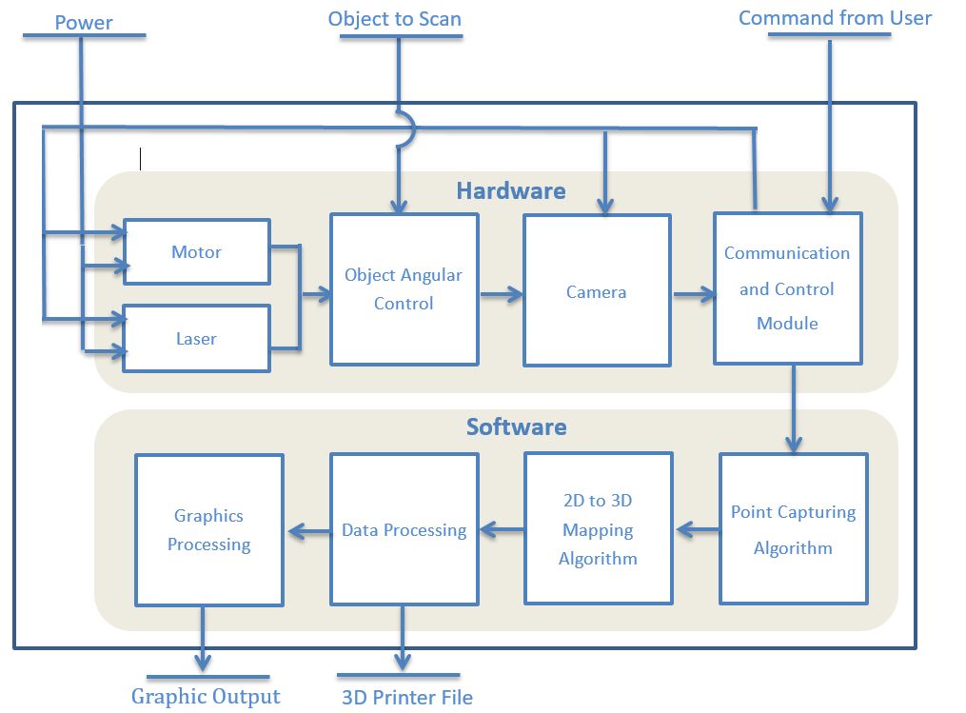

**Figure 2.2 1** System Block Diagram of Laser Line Scanner

As Figure 2.2 illustrates, a motor rotates a plate on which an object is placed while a laser shines a continuous line on the object for the camera to capture. The image data is then transmitted to a computer. The collection of 2D images is computed to extract 2D points, which are mapped to 3D points in space. The 3D data is further processed to certain formats suitable for 3D printing and graphical display. Please refer to Appendix C for images of the design setup, and Appendix D for visual descriptions of the algorithms employed.

## **2.3 Module-level Descriptions**

This section provides detailed descriptions of the modules outlined in the system level diagram above.

### **2.3.1 Hardware**

|  |
| --- |
| **Motor** |
| *Input*: Power, and control signal from communication and control module |
| *Output*: Rotational movement of the original object |
| *Requirement:*  · The motor’s input power will be 110 volts, 60 Hertz (AC)  · The angles of rotation will be consistent |
| *Function*: The motor should be able to rotate and stop at fixed intervals until a 360 degree rotation is achieved |

|  |
| --- |
| **Laser** |
| *Input*: Power, and control signal from communication and control module |
| *Output*: Vertical beam of light |
| *Requirement:*  · The laser will use a DC supply of 5 volts, the standard DC output from Arduino board |
| *Function*: This laser is mounted at a certain angle to the rotational plate and the camera, sending a beam of light towards object to scan |

|  |
| --- |
| **Object Angular Control** |
| *Input*: Uses the output of motor, laser and object to be scanned |
| *Output*: An angle specific, visible and deformed line from the laser on the object to be scanned |
| *Function*: Composed of the plate, motor and laser, this system provides an angular control of the object to scan and sets up the image for the camera to capture |

|  |
| --- |
| **Camera** |
| *Input*: Power, and the scene set up by the scene generator |
| *Output*: Image file of the object |
| *Requirement:*  ·The camera has a resolution of at least 1.3 Megapixel. This is the resolution of common, inexpensive webcams currently available that satisfy the resolution requirement |
| *Function*: The camera takes pictures of the object and sends image files to the communication and control module for further processing |

|  |
| --- |
| **Communication and Control Module** |
| *Input*: User commands, and image data captured by the camera |
| *Output*: Control signals to hardware units, and image data into the computer’s memory |
| *Requirement:*  · The system interconnection and communication module is done using USB 2.0 |
| *Function*: The module starts and stops hardware modules according user commands. It transmits the data of captured pictures from camera to computer for processing |

### **2.3.2 Software**

|  |
| --- |
| **Point Capturing Algorithm** |
| *Input*: Data of captured pictures |
| *Output*: Computed two dimensional position of laser beam represented by its value in a 2D Cartesian coordinate |
| *Requirement:*  · The algorithm should be able to eliminate the noise |
| *Function*: The module scans the captured images for pixels that are laser points, and records these point coordinates |

|  |
| --- |
| **2D to 3D Point Transformation** |
| *Input*: Coordinates of 2D points from point capturing algorithm |
| *Output:* Coordinates of laser beam in 3D Cartesian coordinate |
| *Function*: The module computes a corresponding 3D point from each of the given 2D point from input file using trigonometric mappings based on the angle and position of the camera and the laser |

|  |
| --- |
| **Data Processing** |
| *Input*: Collection of all 3D points computed from the 2D to 3D transformation module |
| *Output*: .OBJ file and .STL file that represents the scanned object |
| *Requirement:*  · The mesh object created must be free of floating data points  · The mesh object must be written using both .OBJ file and .STL file format |
| *Function*: The module will transform the 3D points into surfaces by meshing the 3D points. The module will also prepare the mesh so that it will be acceptable for 3D printers and graphic tools |

|  |
| --- |
| **Graphics Processing** |
| *Input*: An .OBJ file describing the positions of the polygons that makes up an object’s surface |
| *Output*: 3D data stream required for displaying such object on a display monitor |
| *Requirement:*  · Written code must be compatible for OpenGL processor  · The user will be able to rotate and scale the object in real time |
| *Function*: The module will process 3D model description data and display them on a monitor, while allowing the user to rotate and scale the object displayed in real-time |

## **2.4 Assessment of Proposed Solution**

This section will evaluate the benefits and drawbacks of the proposed solution, as well as stating trade-offs made during decision.

The proposed solution, a 3-D rotational scanner using lasers and sensors, offers advantages of scanning time, simplicity, and cost.

1. Scanning time: Based on estimation, scanning and data collection takes no more than six minutes, and the subsequent data processing requires at most two minutes. Therefore, the whole process takes no more eight minutes. In comparison, the time needed for handheld device will depend on desired accuracy and object size, and can be “unbearably slow” according to an online review [15].
2. Simplicity: The proposed solution is simple for the user to use, as the user just needs to place the object on the plate and press “start”. Because the scanning process is automated and the set-up procedure is straightforward, a user with little relevant technology background can easily operate the scanner. In comparison, the handheld device requires the user to manually scan through the object holding the device. Also, many products require a complex and time-consuming set-up procedure before the first scan.
3. Cost: A web-camera, a Servo motor and a PVC plastic plate can achieve the required precision as well as the strength to hold an object up to 350 grams. Therefore, the estimated cost will not exceed $50. In comparison, current products on the market takes from $500 up to over $10,000.

The proposed solution has unavoidable disadvantages in capabilities of scanning large-scale, heavy objects. This is mainly restricted by the motor and size of the completed system. Also, it’s slightly heavier and larger compared with the handheld device.

Since the goal is to develop an easy-to-use, relatively fast and affordable 3D scanning system for the consumer market, the solution trades the capability to scan large items for low cost and ease of use. Please refer to Appendix for the weighted decision matrix used during the project selection process.

# **3. Work Plan**

This section will focus on the planning aspect of the project. Work breakdown, labour division, resource scheduling, budget forecasts, Gantt charts and feasibility assessments are presented in this section.

## **3.1 Work Breakdown Structure**

The project has been decomposed into various stages and tasks, as classified below in Figure 3.1.

The following task description is intended to provide additional methodological and technical descriptions on each of the tasks previously identified in Figure 3.1.

Stage 1 - Project Goal Setting and Administrative Items

1. Create project proposal, compare existing alternatives, selection of solution from alternatives, project feasibility assessment
2. Work distribution and Gantt Charts
3. Research and purchase required project material and equipment
4. Write the Project Proposal

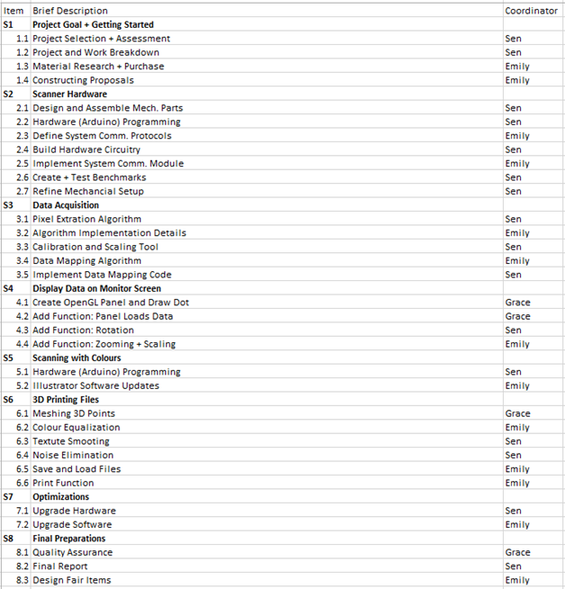

**Figure 3.1.1** Brief Breakdown of Project Tasks and Task Coordinators

Stage 2 - Developing Basic Scanner Hardware

1. Design and assemble scanner’s mechanical components.
2. Write Arduino code to control the motor and laser according to input signals.
3. Develop and establish communication protocols and channels between the Arduino hardware module and the main software.
4. Build power circuitry and system interconnection circuitry.
5. Develop communication and control protocols between the connected camera and the software, and enable the software to store image files in the computer’s memory.
6. Create and use benchmark software to test hardware functionality.
7. Refine the mechanical setup of the hardware to enhance precision and control.

Stage 3 - Developing Data Acquisition Software

1. Design high level pixel extraction algorithm.
2. Develop program to extract the points of the laser beam from the rest of the captured image.
3. Develop calibration tool that will allow scaling of image pixels to actual length in centimeters.
4. Produce high level algorithm for converting extracted 2D Cartesian points to 3D Cartesian points.
5. Test the software program previously developed.

Stage 4 - Displaying Data on Monitor Screen

1. Create an illustration program using OpenGL. It must be able to create a drawing panel, open a 3D image file, and display the imported 3D image.
2. Modify the coordinate conversion program to save data into the file compatible for the illustration program.
3. Modify the illustration program to allow the rotation of objects and points.
4. Add functions to allow zooming and scaling.

Stage 5 - Optional: Scanning with Colours

1. Implement colour detection algorithm. Please refer to Appendix C for details.
2. Add this change to the illustration program to allow the display of coloured pixels.

Stage 6 - 3D Printing Files

Note: In order to have 3D printers print objects, the object file must specify the model as a solid object, and not a set of floating dots in 3D space. These points needs to be meshed and saved in a specific format compatible for most 3D printers.

1. Mesh 3D points into polygons using data processing algorithms that will connect the points and convert them into surfaces .
2. Create a colour equalization tool that will spread the colour of the points scanned to its nearest polygon mesh.
3. Develop a smoothing algorithm which will delete points that are too close to each other. This will make the image smoother and computations run faster, at the expense of model resolution.
4. Develop noise detection algorithm which will detect noises in the form of floating dots isolated in 3D space, and will remove such points from the data set.
5. Develop a save function for saving meshed data into a 3D printer compatible file .
6. Develop a print function to send produced files to a 3D printer.

Stage 7 - Developing Improved Scanner Hardware

1. Improve the existing hardware by laser strength amplification, laser length extension, camera sight and angle adjustments. Additionally, variable laser and camera angular separation using motors can reduce obstructed blind spots.
2. Improve calibration method to account for slight camera view distortion with respect to points of varying heights and planar positions.

Stage 8 - Testing and Documentation

1. Quality assurance by testing the system with described functionalities and objectives.
2. Produce final reports in required formats by this course.
3. Design Fair preparation, including presentation layouts, demonstration strategies and presentation material.

## **3.2 Gantt Chart**

A few notes on the Gantt Chart:

-The granularity of time unit is weekly as tasks are divided to shorter items across the year to allow work to be done in parallel. This also gives flexibility for team members to juggle between the project and other academic commitments.

- Project cells are shaded with the pattern associated with the team member responsible for that particular item, as seen in the legend.

-Milestones are placed in the Gantt chart to help the group keep track of actual and expected progress and are identified by bold font, indicating the end of a specific group of functional similar tasks.

- For all of the tasks identified, the group expects the coordinator to be fully in charge of the task, while all other members are expected to assist when requested.

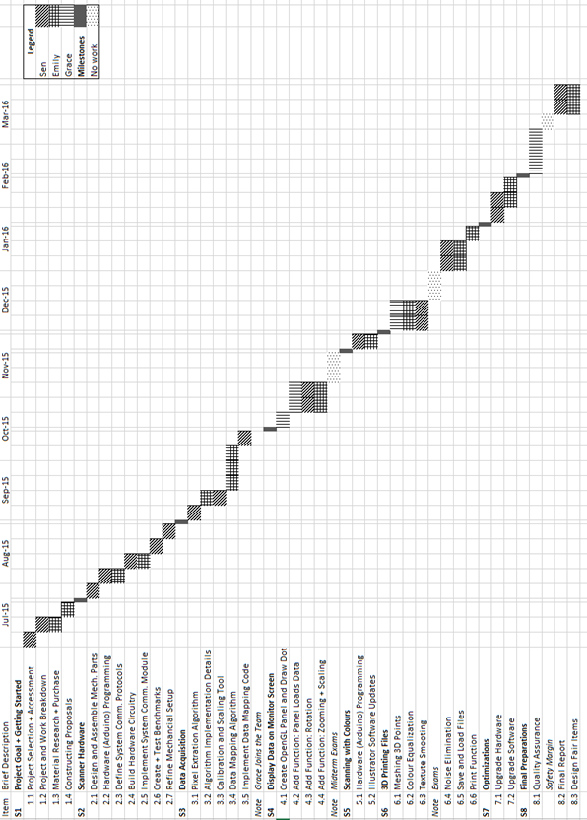

**Figure 3.2 –** Gantt Chart

## **3.3 Financial Plan**

The following chart records past spendings and project future spending for this project. Items listed below include consumable material, capital equipment and labour. Human resource costs are identified by the required roles to better illustrate the tasks the project entails.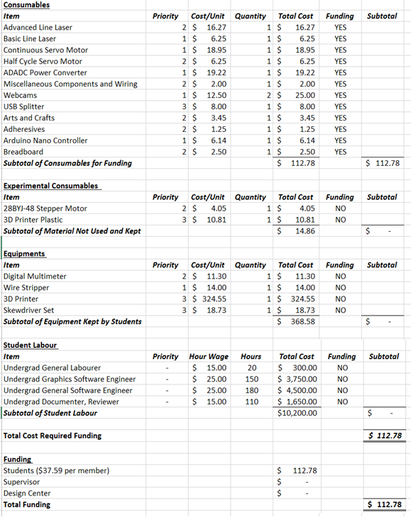

**Figure 3.3.1** Financial Plan Forecast

## **3.4 Feasibility Assessment**

This subsection will identify some of the main challenges in implementing the identified solution. An accurate evaluation of the available group skills and resources will be performed to assess the likeliness of project delivery, and to plan for risk mitigation.

Skills currently possessed by group members include signal control, mathematics, software programming, and computer graphics using OpenGL. Skills are lacking in electronic circuitry and optics applications.

**Scanner Visibility Limitations**

One of the main disadvantages of employing the rotational scanner is the sight limitations of the scanned lines. When scanning certain items with ragged and sharp edges, the lines of laser emitted onto the object may be hidden from the visible field of the digital camera.

To minimize the effects of blocked light signals, the group attaches the laser to another motor, and moves the line of laser until it is visible by the camera.

Assessment: The group will likely have a very high probability of successfully adding the motor system onto the existing Arduino control module, controlling signal traffic with a resource scheduling software algorithm. However, accurately moving the motor is difficult and may distort image.

Risk mitigation: If the resolution of the object scanned is still unacceptable, the team will then implement multiple lasers controlled by the scheduler. The positions of the lasers are accurate since they are stationary, and provide a speed boost when using a motor. This approach may not eliminate the problem of blocked light signals, but will certainly reduce it.

**Loss of Laser Intensity and Focus due to Light Diffusion**

The laser shown towards certain material may be subjected to greater light diffusion than other material, causing a thick blurred line around the center as opposed to a thin focused line.

This problem is solved by increasing the light intensity threshold used for laser beam detection to eliminate some of the diffused light.

Assessment: Depending on the degree of light diffusion, using a light intensity threshold may not eliminate all the diffused light. In addition, if the degree of light diffusion is significant, there would be no significant difference in light intensity.

Risk mitigation: The team will devise an algorithm that will compute the light intensity of each pixel for all rows of an image, and will compute the midpoint of all the pixels above a given intensity. This will be an approximate position of where the laser is focused.

**Light Scattering Effects and Random Noise**

Since the scanned object must be continuous and free of random pixels floating around for certain applications such 3D printing, it is also important to address the challenge of light scattering when laser reflects off the rotating plate during scanning. This scattering results in random points getting registered by the scanner.

The group plans to experiment with various materials in order to find the material with the least amount of light dispersion. The challenge is to design a scanning system that produces no light reflection other than the scanned object.

Assessment: The risk of having light reflected off the rotational plate of the scanner above the light intensity threshold is very high. The design and search for materials that minimizes light reflection will require professional aid or industrial grade material that is very difficult to obtain.

Risk mitigation: Because the light reflect off the rotational plate of the scanner should be unavoidable, a software module is intended to be implemented to analyze 3D point density from the model database. Locations with low point density will be found and removed. Locations with small number of data points often indicate scattered noise. This is an effective way to filter out noise at the expense of limited definition loss.

# **4. Conclusion**

Although 3D modelling with CAD tools is productive in the workplace, it is also difficult and time consuming. 3D scanners currently in the consumer market are too expensive for small businesses, while affordable scanners may not offer all the functionalities consumers are looking for. The team solves this problem by building on top of existing 3D scanning technology to produce a 3D scanning system that is efficient and affordable without sacrificing functionality. By using a 3D rotational scanner with a laser and camera, the team is able to produce a system that captures the 2D images of the object with hardware components, and processes the information captured to produce the 3D digital replica with software. Overall, this system achieves the goals of providing an affordable and efficient 3D scanner that produces a 3D printer compatible file.

# **References**

[1] Mark Driscoll, “Kickstart your manufacturing productivity with 3D design tools”, 3DxBlog, [Online] 2013, URL: http://blog.3dconnexion.com/blog/bid/266767/Kickstart-Your-Manufacturing-Productivity-with-3D-Design-Tools Accessed: 2015 September

[2] Dr. Rafael Sacks, “A Qualitative and Quantitative Assessment of the Impact of 3D Modelling of Building Structures on Engineering Productivity” Israel Institute of Technology, Espoo, Finland, 2005

[3] Blake Senftner, “How long does it take an experienced 3D artist to model a basic 3D humanoid model from scratch?”, Quora, [Online] 2014, URL: https://www.quora.com/How-long-does-it-take-an-experienced-3D-artist-to-model-a-basic-3D-humanoid-model-from-scratch Accessed: 2015 September

[4] “MakerBot Digitizer - 3D Scanner”, Dell, [Online], URL: http://accessories.us.dell.com/sna/productdetail.aspx?c=ca&l=en&s=&cs=cadhs1&sku=A7516720&dgc=ST&cid=31209&lid=5353066&acd=1230881384347400&ven1=sBvAgmohk&ven2 Accessed: 2015 September

[5] “Sardauscan $30 DIY 3D Scanner”, 3D Printing .com, [Online] 2015, URL: http://3dprinting.com/how-to/sardauscan-30-usd-diy-3d-scanner-3d-print/ Accessed 2015 September

[6] “Object Files”, Paul Bourke, [Online], 2015, URL:

http://paulbourke.net/dataformats/obj/ Accessed: 2015 October

[7] “What is an STL File?”, 3D Systems. [Online] 2015, URL:

http://www.3dsystems.com/quickparts/learning-center/what-is-stl-file Accessed: 2015 October

[8] “How much does a coffee mug weigh in grams”, ChaCha, [Online] 2011, URL: http://www.chacha.com/question/how-much-does-a-coffee-mug-weigh-in-grams Accessed: 2015 September

[9] “Results for Servo Motors”, Amazon Canada, [Online] 2015, URL: https://www.amazon.ca/s/ref=nb_sb_noss_1?url=search-alias%3Daps&field-keywords=servo+motor Accessed: 2015 October

[10] “The Universal Serial Bus: What it is and how it works”, G. Knagge, [Online] 2015, URL:

http://www.geoffknagge.com/uni/elec101/essay.shtml Accessed: 2015 September

[11] “Standard Shoe Box Dimensions”, DimensionsInfo, [Online] 2011, URL: http://www.dimensionsinfo.com/standard-shoe-box-dimensions/ Accesed: 2015 September

[12] “Country Household Voltages and Plug Styles”, PowerStream, [Online] 2015, URL: http://www.powerstream.com/cv.htm Accessed: 2015 September

[13] “ECE496 Course Milestones and Deliverables Summary”, University of Toronto, [Online] 2015, URL: https://internal.ece.toronto.edu/ece496.1415/pages/students/schedule-deadlines.html Accessed: 2015 September

[14] “3D Modelling Tools”, 3D Printing for Beginners, [Online] 2015, URL: http://3dprintingforbeginners.com/software-tools/ Acessed: 2015 September

[15] Digital Harbor Foundation, “[3D Scanners: A Quick Review](http://www.digitalharbor.org/2014/10/10/3d-scanners-quick-review/)”, 3D Printing for Educators, [Online] 2014, URL:

## http://www.digitalharbor.org/2014/10/10/3d-scanners-quick-review/ Accessed: 2015 October

# **Appendices**

## 

## **Appendix A - File Formats**

The scanner implemented will generate two separate output files for each object scanned. The first will be the generic object file .OBJ. Object files define the geometry and other visual properties of a 3D model, and can be used to make visual transformations from certain applications [6]. We will use this file primarily for the purpose of displaying the scanned object on a display monitor, as well as allowing users to rotate and scale the scanned object on the screen.

The .STL file, on the other hand, is produced from the OBJ file. It is essentially a file that describes the geometry of a 3D model using triangles. It acts as an approximation of the 3D model, and a common data transmission format for devices such as 3D printers [7]. A STL file can be easily converted from an OBJ file using almost all of the current CAD tools.

## **Appendix B - Alternatives Design Weighted Decision Making Matrix**

By consensus, the group has determined the relative importance of satisfying previously identified objectives for the alternative design. The rankings are done in consideration of the needs of mass consumers. This include consumers of low budgets and various technical background, who highly value efficiency and ease of use rather than the scanned object’s properties, such as object weight. The importance index is a scale from 0 to 10 where 10 indicates such function is extremely desired. The implementation feasibility criteria indicate given the project timeline and allocation and alignment of group resources, how likely will the alternative be implemented completely.

Without considering the weights of these objectives, we then ranked each alternative on a scale of 0-10 on how well they satisfy each objective. Then we computed the weighted score (WS) of each alternative, which is the product of objective score and objective weight.

The group then re-evaluated the importance of the objectives towards our customer segment and confirmed that the laser and camera system is ideal as a solution from other alternatives.

Appendix C - Design Hardware Setup

As seen on the image below, the current hardware prototype consist of a motor underneath the black circular wheel, and a laser that shines directly towards the middle of the spinning wheel. The angular position of the object to be scanned is controlled by the turning motor. The signal which controls the motor is sent from the Arduino module, which is controlled by the main scanner program from the connected PC. Communication of signals is done through a USB connection. Similarly, a webcam (not shown in this figure) will capture the image with the deformed laser line and sent it to the PC connected.

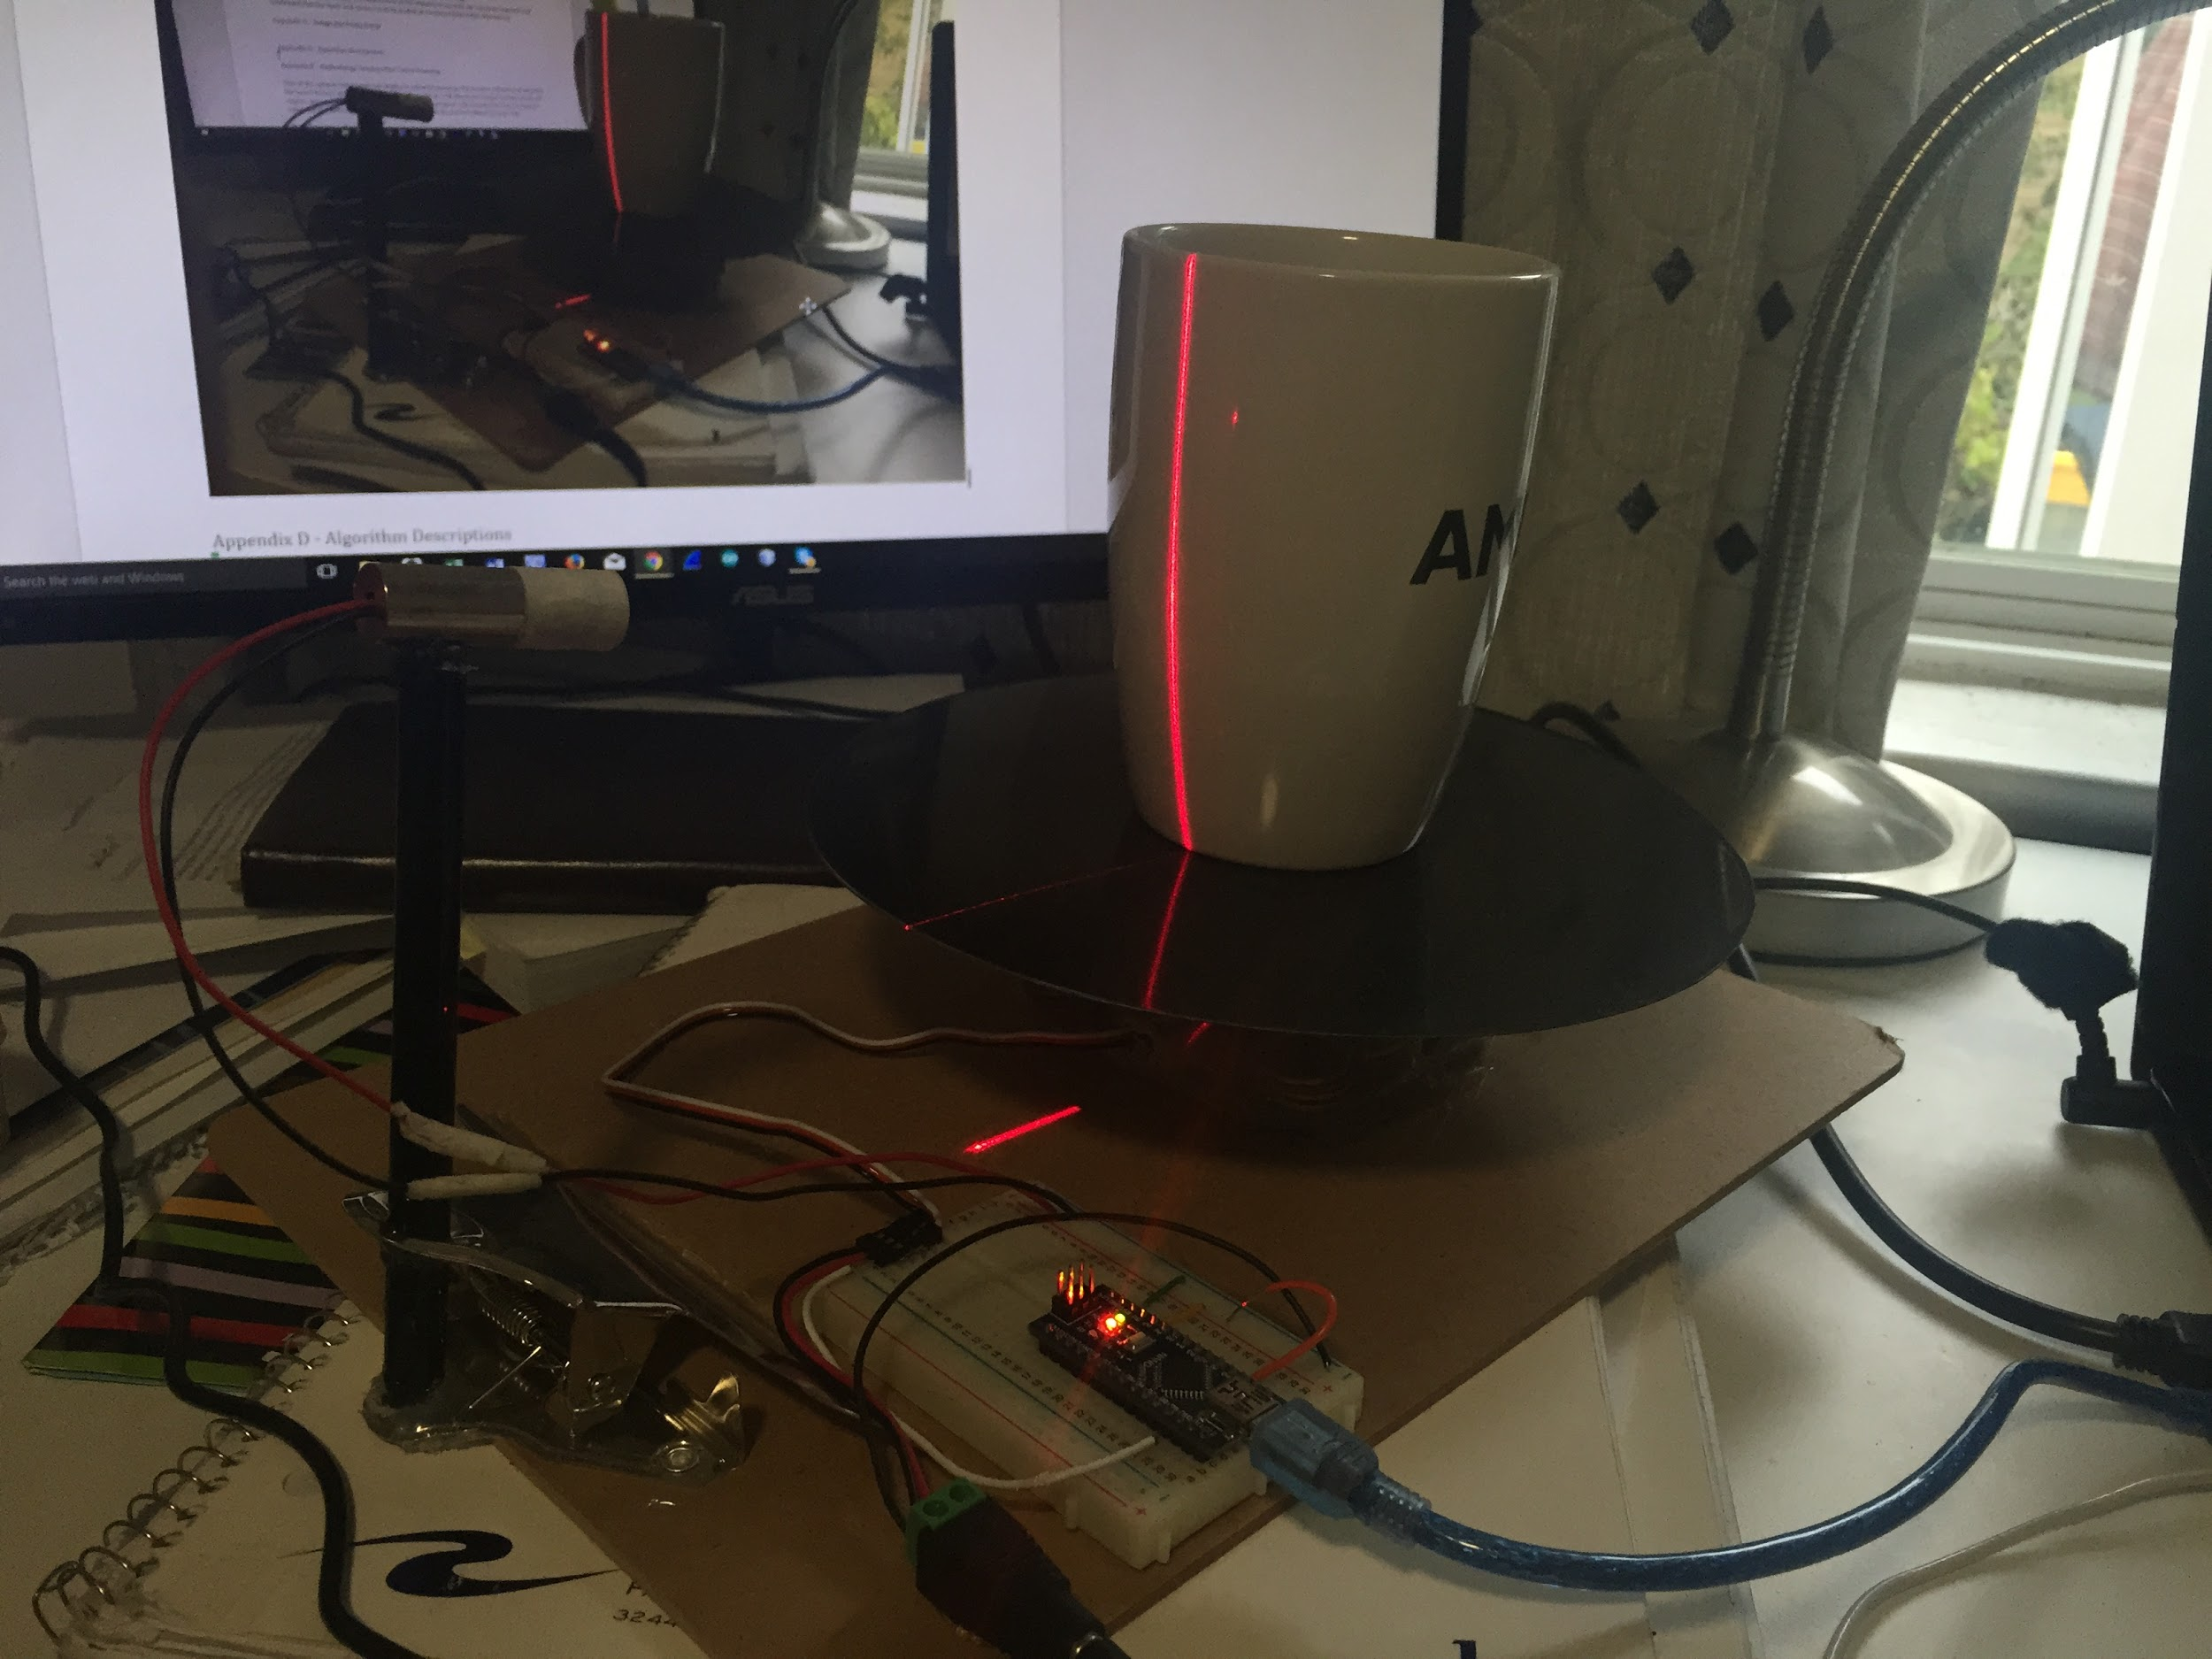

Appendix D - Algorithm Descriptions

The pixel extraction algorithm will scan the light intensity of each of pixel of each row and record the column positions for that row where the intensity is greater than some threshold. An average of the positions will be computed to produce the final coordinate. This data will be fed into the 2D to 3D transformation algorithm.

The transformation algorithm will use the fact that the deformed laser line lies on the laser plane so that every pixel captured from the image maps to an unique point on that plane. Using trigonometric calculations, the relative 3D position can be computed.

When the 3D points are obtained, an algorithm will run through all the points of the data, and connect nearby points into triangular surfaces. A distance threshold will be defined such that meshing will only be done for points that are separated no further than such threshold. Similarity, points that do not connect to the majority of the points will be identified as noise and be removed.

The transformed file is effectively an object file. For it describes the geometry of the scanned object. This information can be used for graphic transformations such as rotation and scaling on a display monitor, and can be also used to generate STL files for 3D printers.

Appendix E - Methodology Employed for Colour Scanning

One of the options the scanner can employ is coloured scanning. The scanner software will schedule the lasers to turn on and off to achieve this. The software will obtain two images instead one for all angles, one with the laser line and one without it. The program will compute the laser location as usual, but in addition also will extract colour data from the picture without the laser line.

The colour data will only reside within the points captured. In order to have the surfaces coloured as well, an approximation approach will be taken; the average of the colour values from the three points which defines the surface will be the colour of that surface.

Accepting to work in colours is currently an optional objective. This is because with colouring, the scanning procedure must be carried out in an environment that supplies an ample amount of light for the camera to capture the colour. Excess amount of light will cause unwanted light flooding, which will reduce the visibility of the laser line and distort image quality. Therefore, coloured scanning will only be carried out if there is a way to guarantee minimal light flooding.

Appendix F - Student Supervisor Agreement Form

**ECE496 Design Project**

**Student – Supervisor Agreement**

Our signatures below indicate that we have read and understood the following agreement, and that all parties will do their best to live up to the word as well as the spirit of it.

We agree to meet at least once every two weeks for at least half an hour to discuss progress, plans, and problems that have arisen. Before each meeting, the group will prepare a brief progress report that will form the basis for the discussions at the meeting.

If a meeting has to be cancelled by the supervisor, she/he should advise the group as early as possible. If a student cannot attend a meeting, she/he should advise members of the group as well as the supervisor as early as possible.

Both the supervisor and the students will:

· Inform themselves of the course expectations and grading procedure.

The supervisor will:

· Provide regular guidance, mentoring, and support for his/her design project group(s),

· Take an active role in evaluating the work and performance of the students’ by completing the supervisor’s portion of the grading forms for each course deliverable expediently.

· Return a photocopy of the completed grading evaluation forms to the appropriate section administrator in a timely fashion.

· Be aware of the aims and processes of the course as outlined in the Supervisor’s Almanac.

We have read and understood this agreement. Date: ________________

Signature of supervisor: ______________________________________

Signature of student: _________________________________________

Signature of student: _________________________________________

Signature of student: _________________________________________

Appendix G - Report Attribution Table

# **Project Proposal Document Attribution Table**

This table is filled out to accurately reflect who contributed to each section of the report and what they contributed.

|  |  |  |  |
| --- | --- | --- | --- |
| **Section** | **Emily Miao** | **Jing Guan** | **Sen Yang** |
| Executive Summary | RD, ET | ET | ET |
| 1 Project Description | ET | ET | RD, ET |
| 1.1 Project Background | ET | ET | RS, RD, ET |
| 1.2 Project Motivation | ET | ET | RD, ET |
| 1.3 Project Goal | ET | ET | RD, ET |
| 1.4 Project Requirements | ET | ET | RS, RD, ET |
| 1.5 Validation and Acceptance Tests | RS, RD, ET | ET | ET |
| 2 Technical Design | RD, ET | ET | ET |
| 2.1 Possible Solutions and Design Alternatives | RS, RD, ET | ET | ET |
| 2.2 System Level Overview | ET | RD, ET | ET |
| 2.3 Module Level Descriptions | ET | RS, RD, ET | ET |
| 2.4 Assessment of Proposed Solutions | ET | RD, ET | ET |
| 3 Work Plan | ET | ET | RD, ET |
| 3.1 Work Breakdown Structure | ET | ET | RD, ET |
| 3.2 Gantt Chart | ET | ET | RD, ET |
| 3.3 Financial Plan | ET | ET | RD, ET |
| 3.4 Feasibility Assessment | RD, ET | ET | RD, ET |
| 3 Conclusion | RD, ET | ET | ET |
| References | RD | RD | RD, OR1 |
| Appendices | ET |  | RD, ET |
| Final Editing | FP | FP | FP |
| Final Formatting |  |  | CM |

**Abbreviation Codes:**

Fill in abbreviations for roles for each of the required content elements. You do not have to fill in every cell. The “**All**” row refers to the complete document and should indicate who was responsible for the final compilation and final read through of the completed document.

RS – responsible for research of information

RD – wrote the first draft

MR – responsible for major revision

ET – edited for grammar, spelling, and expression

OR – other

“All” row abbreviations:

FP – final read through of complete document for flow and consistency

CM – responsible for compiling the elements into the complete document

OR - other

OR1 - Formatting the References into IEEE citation style

**Signatures**

By signing below, we verify that we have read the attribution table and agree that it accurately reflects our contribution to this document.

|  |  |  |  |  |  |
| --- | --- | --- | --- | --- | --- |
| ***Name*** |  | ***Signature*** |  | ***Date:*** |  |
| ***Name*** |  | ***Signature*** |  | ***Date:*** |  |
| ***Name*** |  | ***Signature*** |  | ***Date:*** |  |