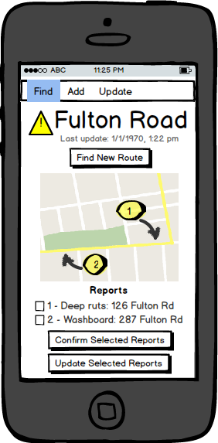
Elements of the mud minder

roads
id, name, city_fkey, state_fkey, country_fkey, postal_fkey

cities
id, name, state_fkey, country_fkey

states_provinces
id, name, country_fkey

countries
id, name

postal_codes
id, code, city_fkey

locations
id, latitude, longitude, nearest_911_address, road_fkey

waypoints
id, latitude, longitude, location_id_fkey
(Google map feature that forces alternate route via the waypoints)

statuses
id, description, timestamp, status_type(new, update, confirm), user_id_fkey

road_status_xref
id, road_id_fkey, status_id_fkey

users
id, screen_name, email, password
