爬虫整合说明 v2.0
===============================================================================
作者：Javacoo
日期：2012-05-12
QQ：164863067
QQ群：217690017
个人网站：www.meishih.com,www.javacoo.org
==============================================================================

新增的jar包：commons-beanutils-1.7.jar，ezmorph.jar，json-lib-2.2.2-jdk15.jar，nekohtml.jar，xercesImpl.jar，IKAnalyzer3.2.8.jar，commons-collections-3.2.jar，httpmime-4.1.3.jar，httpcore-4.1.4.jar，httpclient-cache-4.1.3.jar，httpclient-4.1.3.jar
注意：这里使用了新的httpclient包，整合时请将原httpclient相关包（httpcore-4.1.jar，httpclient-4.0.3.jar）删除
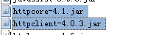
新加的lib包截图
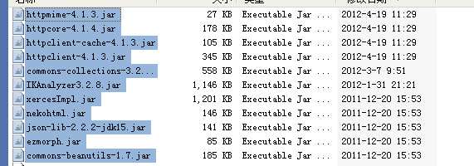
======================================================
添加：/WEB-INF/config/javacoo-context.xml
修改: web.xml
<context-param>
<param-name>contextConfigLocation</param-name>
<param-value>
/WEB-INF/config/application-context.xml
/WEB-INF/config/cache-context.xml
/WEB-INF/config/captcha-context.xml
/WEB-INF/config/jeecore-context.xml
/WEB-INF/config/jeecms-context.xml
/WEB-INF/config/javacoo-context.xml
</param-value>
</context-param>
======================================================
修改：/WEB-INF/config/javacoo-servlet-admin-action.xml
<context:component-scan base-package="org.javacoo.expand.jeecms.action"></context:component-scan>
======================================================
修改：jeecms-servlet-admin.xml
添加：<value>/WEB-INF/languages/crawler/messages</value>
<bean id="messageSource" class="org.springframework.context.support.ReloadableResourceBundleMessageSource">
<property name="cacheSeconds" value="-1"/>
<property name="basenames">
<list>
<value>/WEB-INF/languages/jeecore_admin/messages</value>
<value>/WEB-INF/languages/jeecms_admin/messages</value>
<value>/WEB-INF/languages/jeecms_tpl/messages</value>
<value>/WEB-INF/languages/fck/messages</value>
<value>/WEB-INF/languages/crawler/messages</value>
</list>
</property>
</bean>
======================================================
修改：application-context.xml
添加 ：<value>classpath*:/org/javacoo/expand/jeecms/entity/hbm/*.hbm.xml</value>
<property name="mappingLocations">
<list>
<value>classpath*:/com/jeecms/core/entity/hbm/*.hbm.xml</value>
<value>classpath*:/com/jeecms/cms/entity/main/hbm/*.hbm.xml</value>
<value>classpath*:/com/jeecms/cms/entity/assist/hbm/*.hbm.xml</value>
<value>classpath*:/org/javacoo/expand/jeecms/entity/hbm/*.hbm.xml</value>
</list>
</property>
======================================================
修改：WEB-INF\jeecms_sys下 top.html
添加
<li class="sep"></li><li class="normal" id="tb_112" onclick="HoverLi(1,12,13);"><a href="frame/crawler_main.do" target="mainFrame"><@s.m "crawler.function"/></a></li>
<li class="sep"></li><li class="normal" id="tb_113" onclick="HoverLi(1,13,13);"><a href="frame/commontype_main.do" target="mainFrame"><@s.m "cms.function.commontype"/></a></li>
样式：.nav .normal{width:62px; text-align:center;}
======================================================
新增 WEB-INF\jeecms_sys下 common_type，crawler，scheduler文件夹
======================================================
新增 WEB-INF\jeecms_sys\frame 下 crawler_main.html，crawler_left.html，crawler_right.html，commontype_main.html
======================================================
新增 WEB-INF\ftl\pony\ui 下 crawler_form.ftl,修改 index.ftl 添加 <#include "crawler_form.ftl"/>

新增 WebRoot\WEB-INF\classes\crawler.properties

