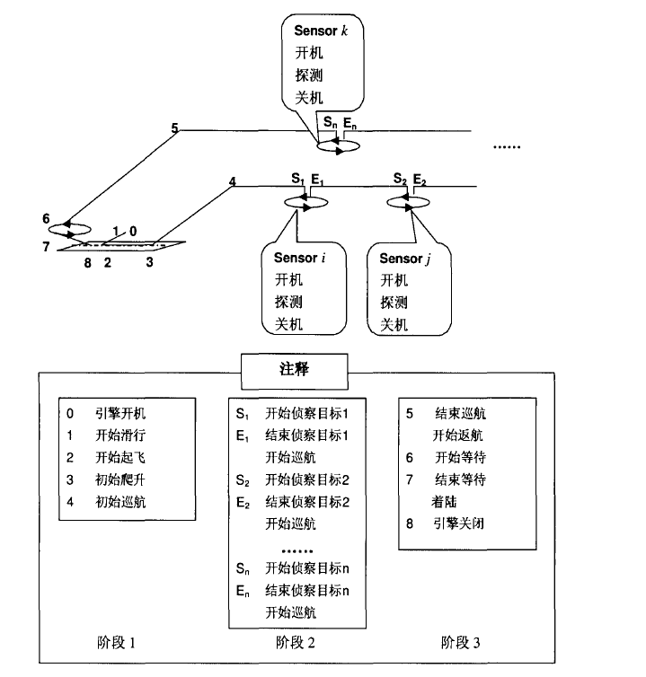

算法流程

Input: Tasks set *T*={1,2,…,*M*}, Observation Resources set *R*={*Ru,Rs*},

Subplanners set *S=*{*S1,S2,…,Sn*}, Taboo lists set Tabu={Tabu1,Tabu2},

Observation Opportunities set *Q*={*Qij* | *i*=1,2,…,*M*; *j*=1,2,…,*NV+NA*};

Output tasks assignment program *P*

1: **stage 1**

2: **while** 

3: select the highest weight task *i* ;

4: **for** each *Qij* calculate conflict degree *cij*;

5: **for** each *Sk* calculate utility value *Uik* according to *cij* ;

6: select Subplaner *s* with enough resources according to *Uis* = max{*Uik*|*k*=1,2,…,n};

7: select Observation Resource *l* of Subplaner *s* with enough resources according to

*Uil* = max{*Uij* | *j* in *Ss* };

8: allocate *i* to Subplaner *s* and Observation Resource *l* ;

9: **for** each Observation Resource and Subplaner update remaining resources;

10: *T* = *T*/{*i*};

11: **end while**

12: **Output** tasks assignment program *P*;

13: **stage 2**

14: **while** Iter_num < max_Iter_num

15: adopt UAV and Satellite Algorithm for *P* to compute *f*(*P*) and Schedule Program *G*;

16: get unscheduled tasks set *UG* according to *G* and *T*;

17: **for** *g* from 1 to 4

18: **while** the operation of deleting *t* from Subplaner *k* not in Tabu1

19: choose task *t* from *G* according to Delete-neighborhood operations rule-*g*;

20: **end while**

21: delete *t* from Subplaner *k*;

22: insert *t* into *UG*;

23: **end for**

24: update tasks assignment program *P* and *G*;

25: **while** 

26: execute operations from step3 to step5;

27: **while** the operation of inserting *i* to Subplaner *s* not in Tabu2

28: select Subplaner *s* with enough resources according to

*Uis* = max{*Uik*|*k*=1,2,…,n} without considering selected Subplaner;

29: **end while**

30: select Observation Resource *l* of *s* with enough resources according to

*Uil* = max{*Uij* | *j* in *Ss* };

31: allocate *i* to Subplaner *s* and Observation Resource *l* ;

32: update tasks assignment program *P* and *G*;

33: **for** each Observation Resource and Subplaner update remaining resources;

34: *UG* = *UG* /{*i*};

35: **end while**

36: update Tabu1 and Tabu2;

37: get new tasks assignment program *P’*, adopt UAV and Satellite Algorithm for *P’* to compute *f* (*P’*);

38: **if** *f* (*P’*) > *f* (*P*) **then**

39: *P* = *P’*;

40: **end if**

41: **end while**

42: **Output** tasks assignment program *P*