# CST8248 – Emerging Technologies

# **Assignment 2 – Project Quality and Testing**

P**urpose**:

To continue planning for your project deployment, ensure that platforms and services are operating as expected. (Identify the platforms, esrvices (ie ntp, https, etc)

**Objectives:**

**Quality Assurance:** As you progress through deploying platforms and services your network will increase in complexity. As a team you are tasked with developing a quality control plan to and ensure that your client receives the deliverable you have designed. Your quality assurance plan should include fit and finish items such as security configs (ie. Firewall) install files cleanup etc.

* How do we think the environment will run
* In case of contingency – will we add more hardware?
* How will we monitor this? (how do we monitor the environment?)
* Look for tools (ie a dashboard) [back up environment, pings, etc.]
* What’s our data recovery plan? Etc.
* Contingency plan

**Hardware Plan:** For each service detail the platform your team will be deploying and provide a table of specifications. (ie. CPU, Memory, Network, Storage etc.)

* “choose strategic place of server room” for our server room in the environment for example away from water/drain pipes, is it air conditioned?
* Look for physical planning
* Contacted electrician, to get the circuits connected even in the event of a power outage
* Planning for any server room issues (ie natural disasters, people, etc)
* Online we can find hardware plans
* Ie DC – What is the minimum requirement for this? everytime we see this, talk about service, what is the min requirement and do this, factor of safety (to multiply by., etc. 1.5, have enough CPU and memory for virtual environment

**Network Plan:** Provide a table of IP addresses as well as a network topology diagram detailing the connectivity between each platform and service.

* If we have web server, look at traffic, allowing port 80 or 553, if we need them, if we need to take them outside
* Firewall guy will create the rule
* DHCP for example, allowing PING, ICMP, what security will you have? Etc.

**Test Plan:** Provide a plan detailing how your team plans to ensure technical functionality. The test plan should compliment your quality assurance plan. Modify the rubric below to suit your needs when formulating this plan.

* Chaos monkey, go and poke the environment, unplug the server, to see what is happening in the environment, will keep poking it in rotation to help offer resiliency in the environment
* If chaos monkey does something then we can use that
* Can read up about it and mention that we are following this as a test behaviour
* Can also check out hystrix

|  |  |  |  |  |  |  |  |
| --- | --- | --- | --- | --- | --- | --- | --- |
| Source | Destination | connectivity (icmp) | Service | Test command | **Result** | Comment | Test Date |
| Win Client | Win File Server | PASSED | SMB | Net Use | FAILED | Check Firewall, service status, permissions, server/share name, DNS | 9/28/2020 0:56 |
| iSCSI Initiator | iSCSI Target | PASSED | iSCSI | mkdir | PASSED |  | 9/28/2020 1:04 |
|  |  |  |  |  |  |  |  |
|  |  |  |  |  |  |  |  |
|  |  |  |  |  |  |  |  |
|  |  |  |  |  |  |  |  |
|  |  |  |  |  |  |  |  |
|  |  |  |  |  |  |  |  |
|  |  |  |  |  |  |  |  |

Vpshere ic client

Want to install vclient

In order to have two things do something (host 1 and host 2) – will install ESXI

* Install ESXI 1 and ESXI 2
* Install vcenter in order to cluster it
  + Vcenter is the appliance
  + If you want to connect to the environment and manage it (assuming you rae in the jump box)
    - Enter into vcenter
  + We have 3 nodes in our environment – since we are new t it, we will deploy node 1 and node 2, minimum, need to have 2 nodes
  + Vcenter will let you manage the environment
    - Client will connect to vcenter
  + Will use vsphere to connect to the vcenter
  + Vsphere is what we use on the jumpbox to manage vcenter
    - Vsphere is the tool we use to connect to vcenter
* Have to create another jump box in the sphere – put the user interface into this cluster
* Both nodes are doing virtualization
  + In environment of virtualization could have multiple switches or one switch with multiple vlans
    - Could have vlan 1 for network between the machines
    - Vlan 2 for storage
    - Vlan 3 for public interface
  + 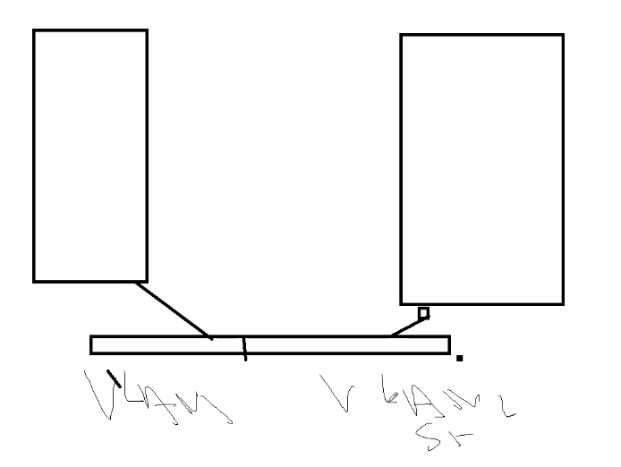usually stack switch (so if one fails, another one can pick up
* Now we have node 1 and node 2
  + EXSI deployed

What is first thing we deploy?

* First server to deploy?
  + Would put in AD or Domain controller first – one of the main items is active directory
    - Need to authenticate somewhere, would authenticate to live ID
  + Most of the companies will live with two domain controllers – for fault tolerance – will connect anywhere
  + DC1 and DC2

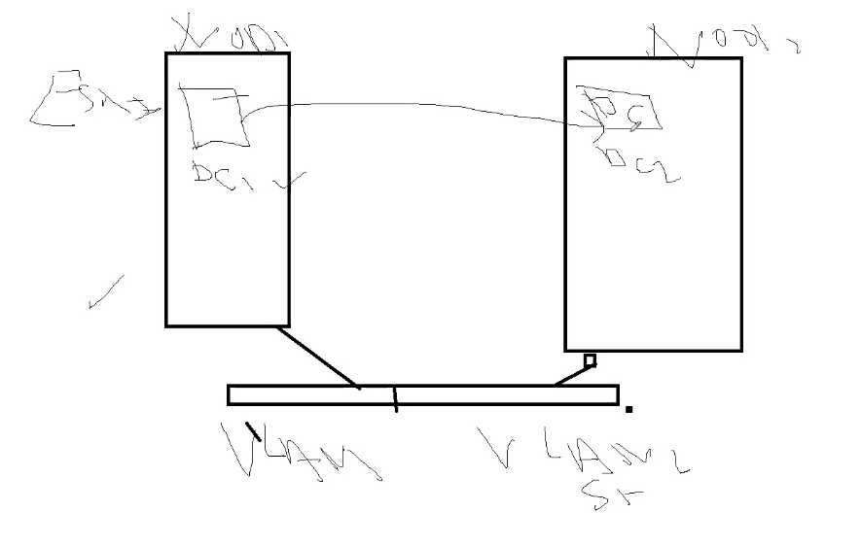

* Domain controller – deploy AD, then DNS, DC and DNS in the same box (first box)
* Assume it is 192.168.1.2 then the second DC would be 192.168.1.3
  + Would point to each other in the case of DNS failure
* In the client itself, it would also do that, in the DNS, would hav ethe first one, and then the other to be second one
  + Would try to connect to domain controller

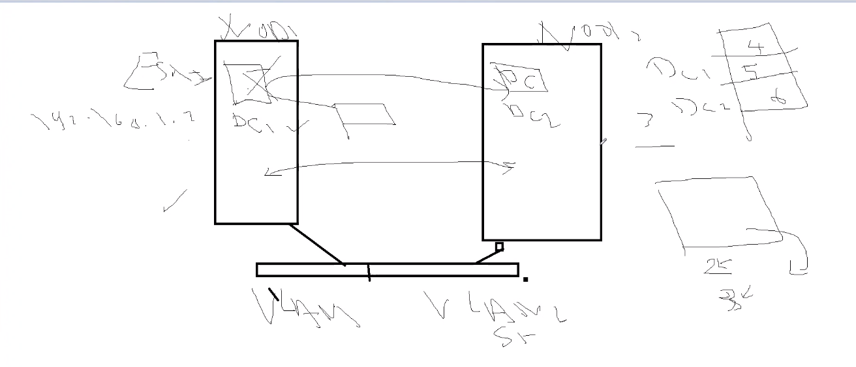

* Want to always avoid a single point of failure
* Avoid .com or .ca because it will try to go outside
  + Do .local or .lab or .xyz
* Vulnerability with using .local or .xyz
* Out of two machines, you would have 2 machines completed
  + DC1, DC2
  + So now we have 18 machines leftover
* Denis will ask us to deploy file server, and file server will talk back end (need to know SAAN and ISCSI, storage capabilities, etc.
* Also ask for us to deploy tools like admin center, back up server, then there are add ons,
* Windows update server center
* Back up server
* Monitoring machine
* Should install NTP so that all machines are synced to one place

GO TO RDP

CONNECT to jump box through the magic number

* 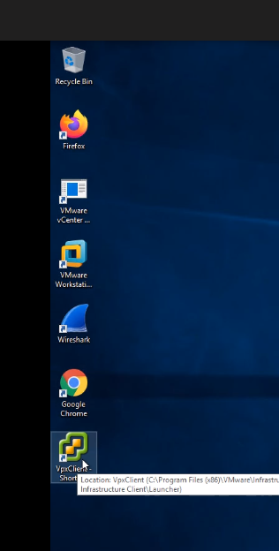
* Then we log into vpxclient
  + Click ok for everything

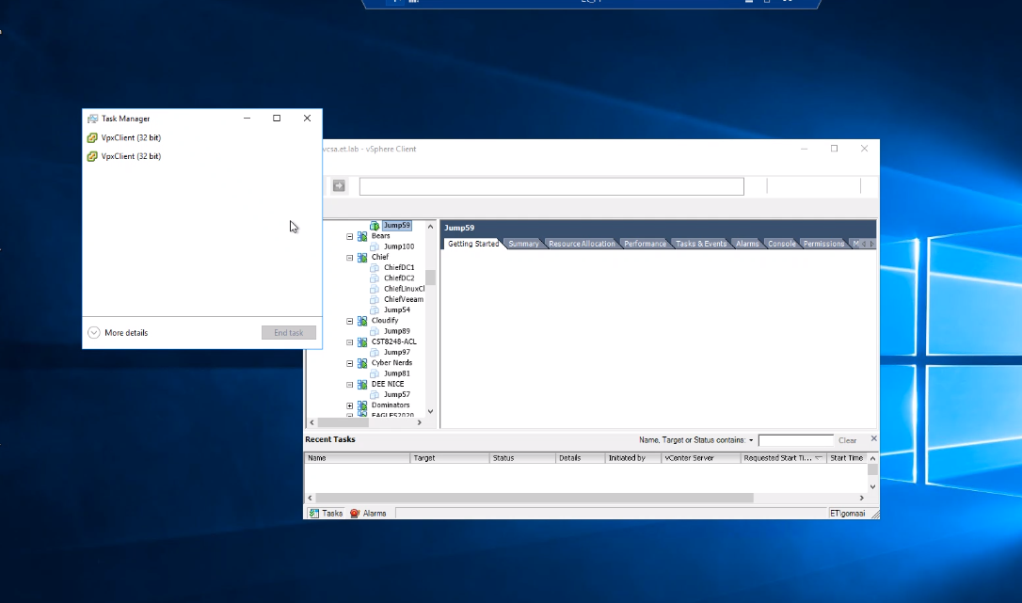

* Then we get vcenter that joins 3 machines
  + Machines get joined to cluster – they were EXSI

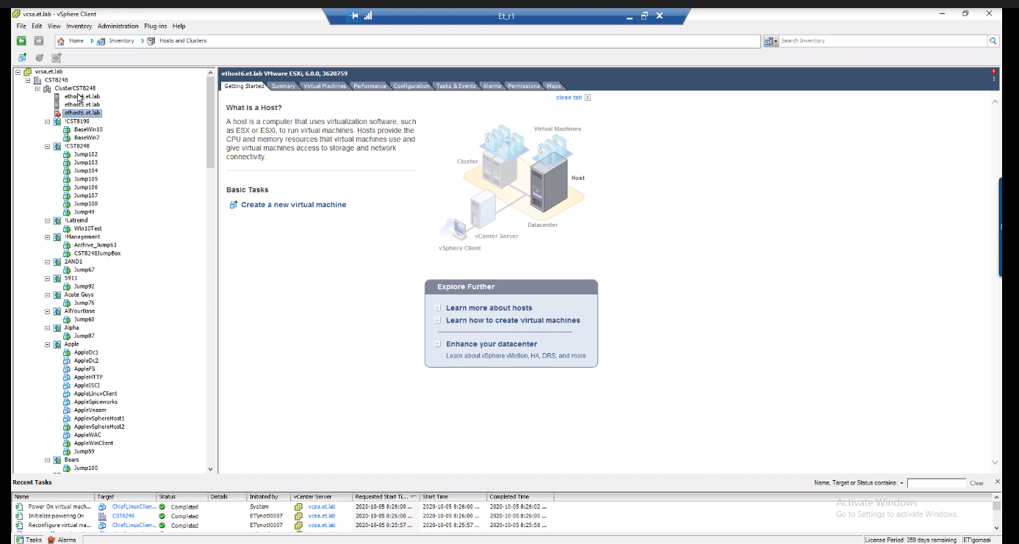- EXSI can be downloaded from digital resources

-exsi is installed already – DENIS will ask us to install EXSI to experience the installation

0 when we login

Jump57

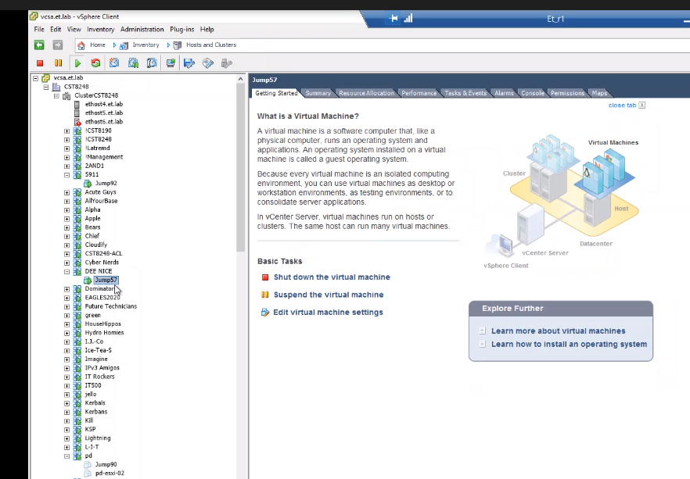we will only see jumpbox v57 (DEE NICE)

Create templates to help us

* Value add:
  + Use vphere to leverage ANSIBLE to deploy our vsphere
* If you go to jumpbox here

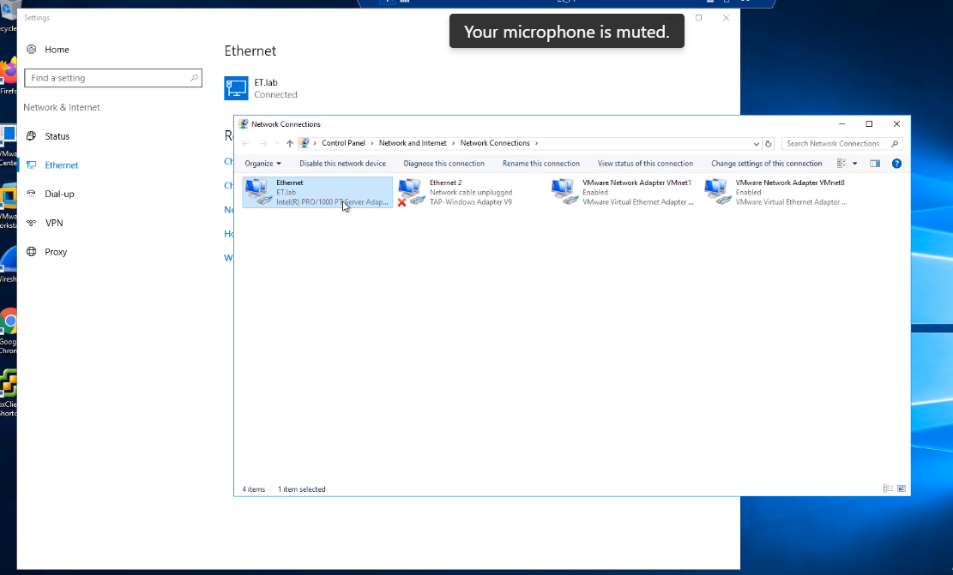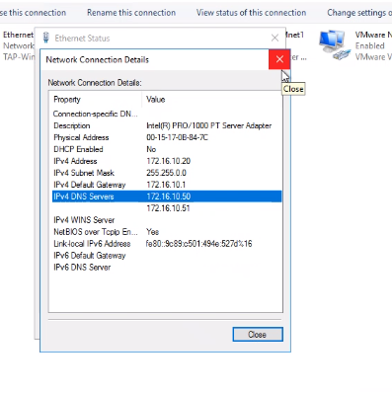NEED TO POINT TO THOSE TWO ADDRESSES OR CANNOT CONNECT FROM VSPHERE TO VCENTER

NEED TO CHANGE THE DNS

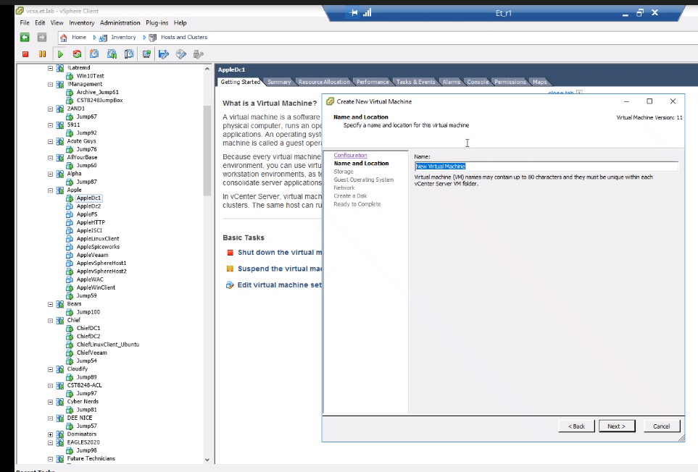

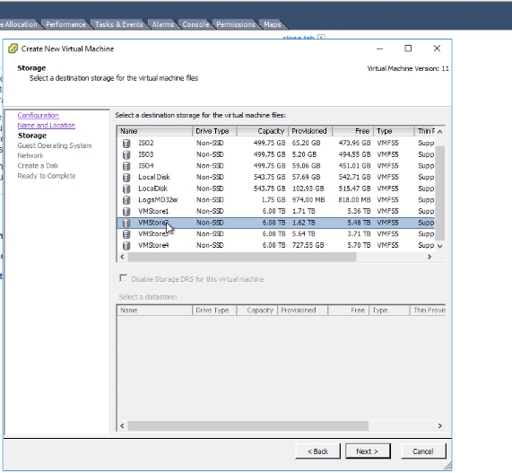

DC 1 to store 1 and DC2 at vm store 2

Install vm installer on one node, using different storage back and storage fry

Always segregate the traff

* These are storage discs
  + Not really advised to do this
* If we want to use HTTPs server, could use the disk on local disc 1 or local disc 2 etc.
* See how many connections like vmstore 1 or 2m,

VISIO

* CAN make a diagram, these are my hosts, storage, lan 1, lan 2, etc. most enterprises do not live with one network, they have multiple networks

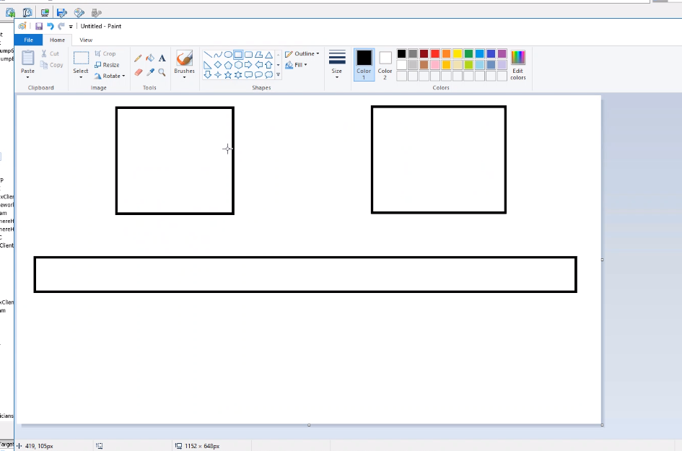

* Host 1, host 2 and switch
* Can have multiple interfaces
  + Can have NIC1, NIC2 and NIC3
* 1 for LAN
* 2 FOR STORAGE
* 3 for public internet
* 5 for Vmotion

Vlan 1, 2,3,4

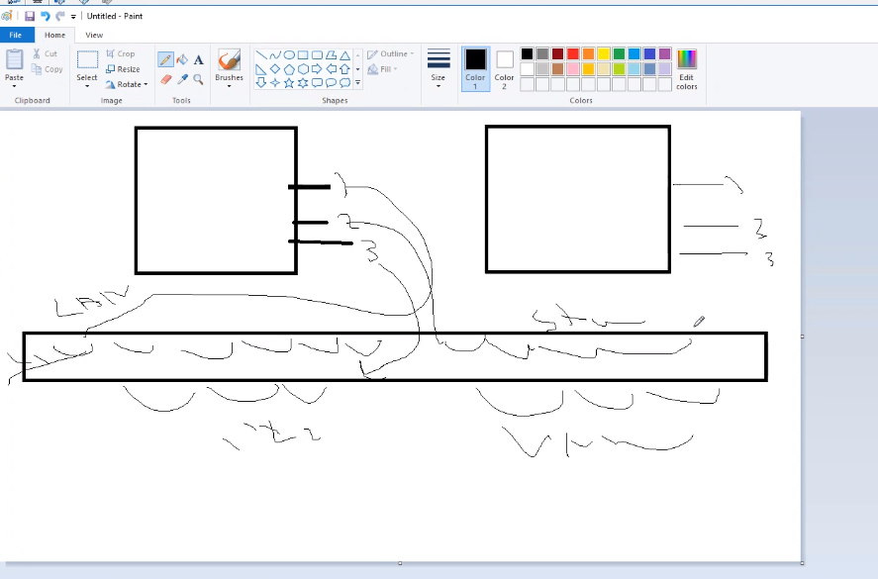

* Best practice: do not mix vlan with network
* This is why we carve the switch
* One switch (48 switches) is enough to deploy in an enterprise

For hardware

Can deploy terminal services configuration

* Terminal configuration services tool
* 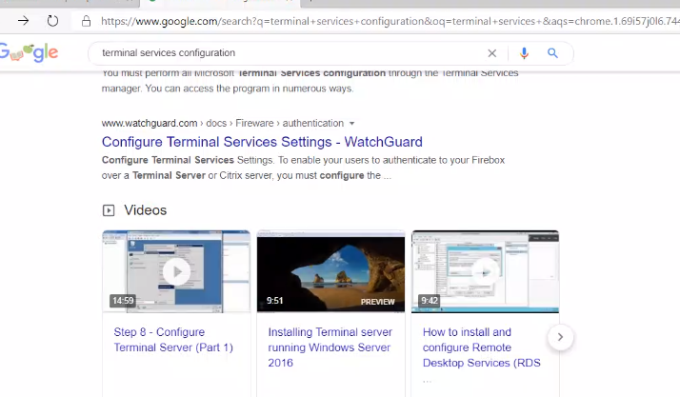
* can use this to connect
* go to jump box
  + edit settings
    - give itmore memory
* Template: can create once and use multiple times to get same results

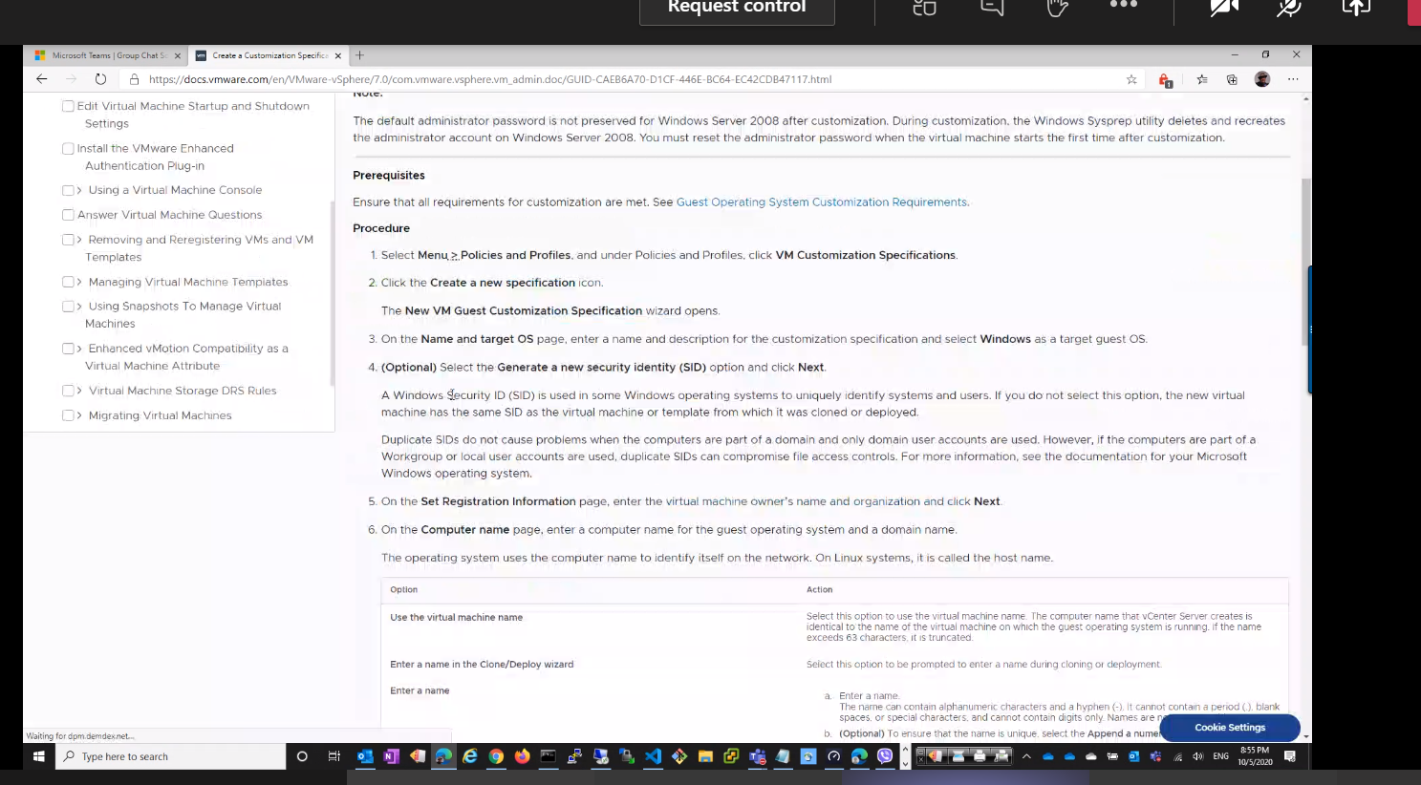- can create a template and then invoke it

- can configure user names and passwords, DNS, language, etc.

Once done, can save the VM as a template

Sysprep the machine – this is how we prep a machine – sysprep generalize – will create its own SID as soon as you boot it

* If we have the machine and do not sysprep it and we copy it, we will have an error then it willhave a duplicate identifier
* Will need to have the machine for the template to be generalized and vanilla on everything
* Before shutting down the machine, after we deploy the machines, we envoke it

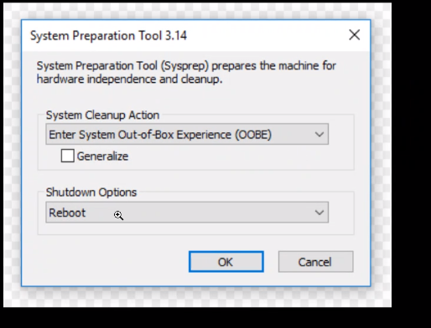

* We need to ensure this to save it and keep it intact to reproduce out of it

c/windows/system32

* Only need to run it one time for the template and then close the template
  + Need to create a machine of this template, copy the template again, turn on the machine and the machine will go thorugh the creation of the machine

To create template:

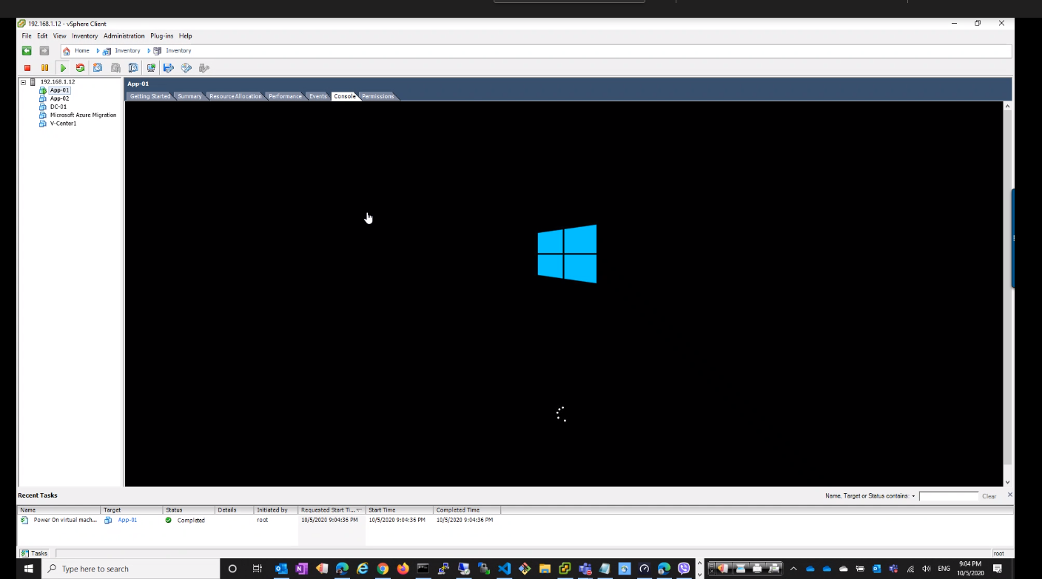

The template are the machines

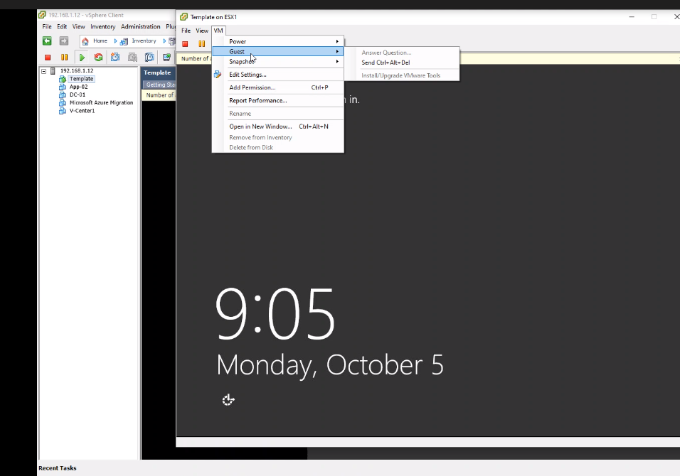

For sysprep for he machine

Then go to PS

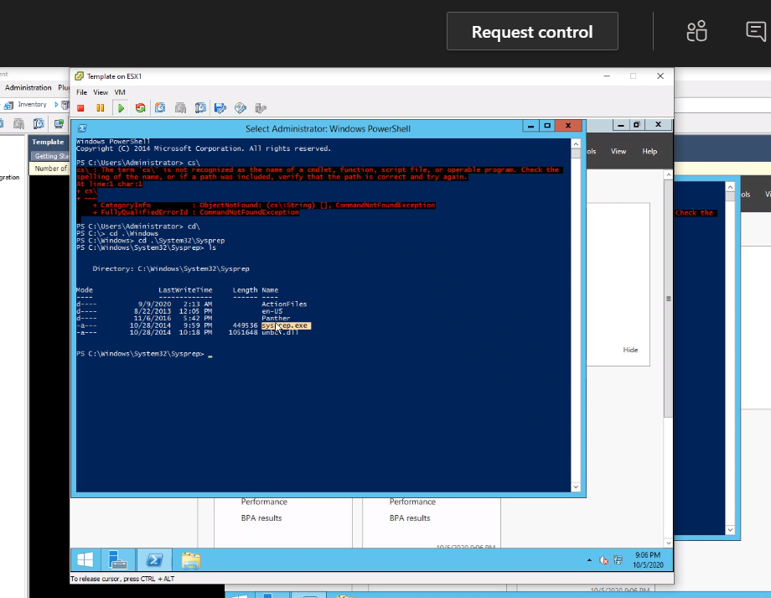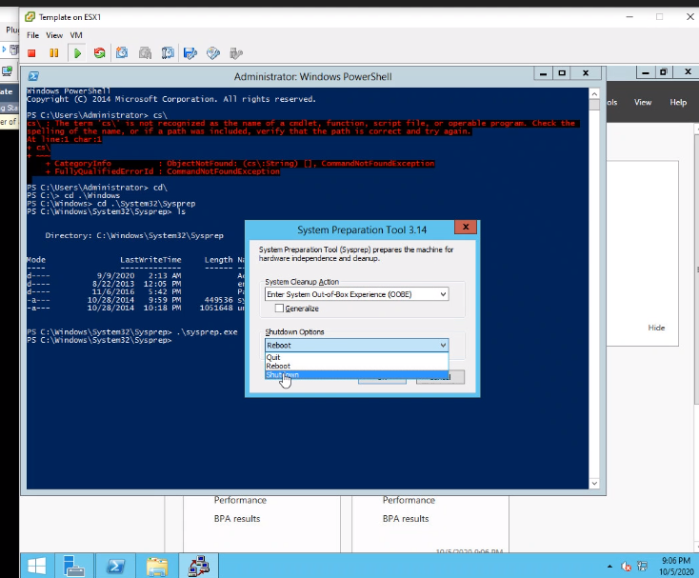

* Then we run that and execute it
  + Sid windows cmdlet
  + Get the command to get the SID
  + Doing the generalize will create a new SID for the machine
* But make sure you also do:
* Look up ansible VMWARE