Due April 10TH

1. Under UCINET, conduct E-I index analysis on \*ZACHARY (ZHCHE) data in the UCINET dataset. Use both “support” and “club” as group attributes. What do network-level and group-level E-I indexes tell you? Identify also the five most outward and inward looking individuals in each group.   
   \*BACKGROUND These are data collected from the members of a university karate club by Wayne Zachary. The ZACHE matrix represents the presence or absence of ties among the members of the club; the ZACHC matrix indicates the relative strength of the associations (number of situations in and outside the club in which interactions occurred).
2. Les Miserables network exercise: use the Les Miserables characters interaction network and do the following:
   1. Which node or nodes seem most important in this network? Which seem least important? What visualization techniques help you to draw your conclusion?
   2. Other than the importance of the nodes, list two other interesting structural features you see in this graph. These could be hubs, clusters, nodes with unusual structural properties, or any other interesting feature. Combined with your knowledge about the story, describe the insights you learned from these structural properties.
   3. Use Gephi to add other features to the network that make explicit the insights you found. This could be adjusting the color, size, of the edges or nodes; also experiment with different layout methods and give at least two best visualizations of the network.
3. Data collection assignment

For this assignment, you will generated a REAL network of at least 30 nodes and visualize it with Gephi. The data can be retrieved either obtrusively or non-obtrusively. ‘

3.1. Determine the domain and data collection method

The obtrusive data collection method is similar to the “who talked to whom” survey, in which you will have to actually ask the member of the community about their relationship. If you are using this mode of data collection, make sure the network you collect has a clear boundary. It could be, for example, a social club, a class, or a business unit.

The non-obtrusive method, on the other hand, involves retrieving records where relationship between entities can be inferred from co-occurrence or interaction patterns among entities such as persons, books, or merchandises.

You are, certainly, free to explore other topics that you are interested in.

3.2. Consider the attributes of the nodes or edges

Think also what node or edge attributes that might be relevant to make the visualization meaningful. These relevant features or attributes about the network should be driven by your hunch, curiosity or hypothesis that you believe can be visually demonstrated.

* 1. Data format

Use either adjacency matrix and node/edge lists (see example below).

Example of adjacency matrix data (UCINET), which can be done either in Excel or notepad. See examples for notepad below, make sure the encoding scheme is UTF-8 when saving .text files.

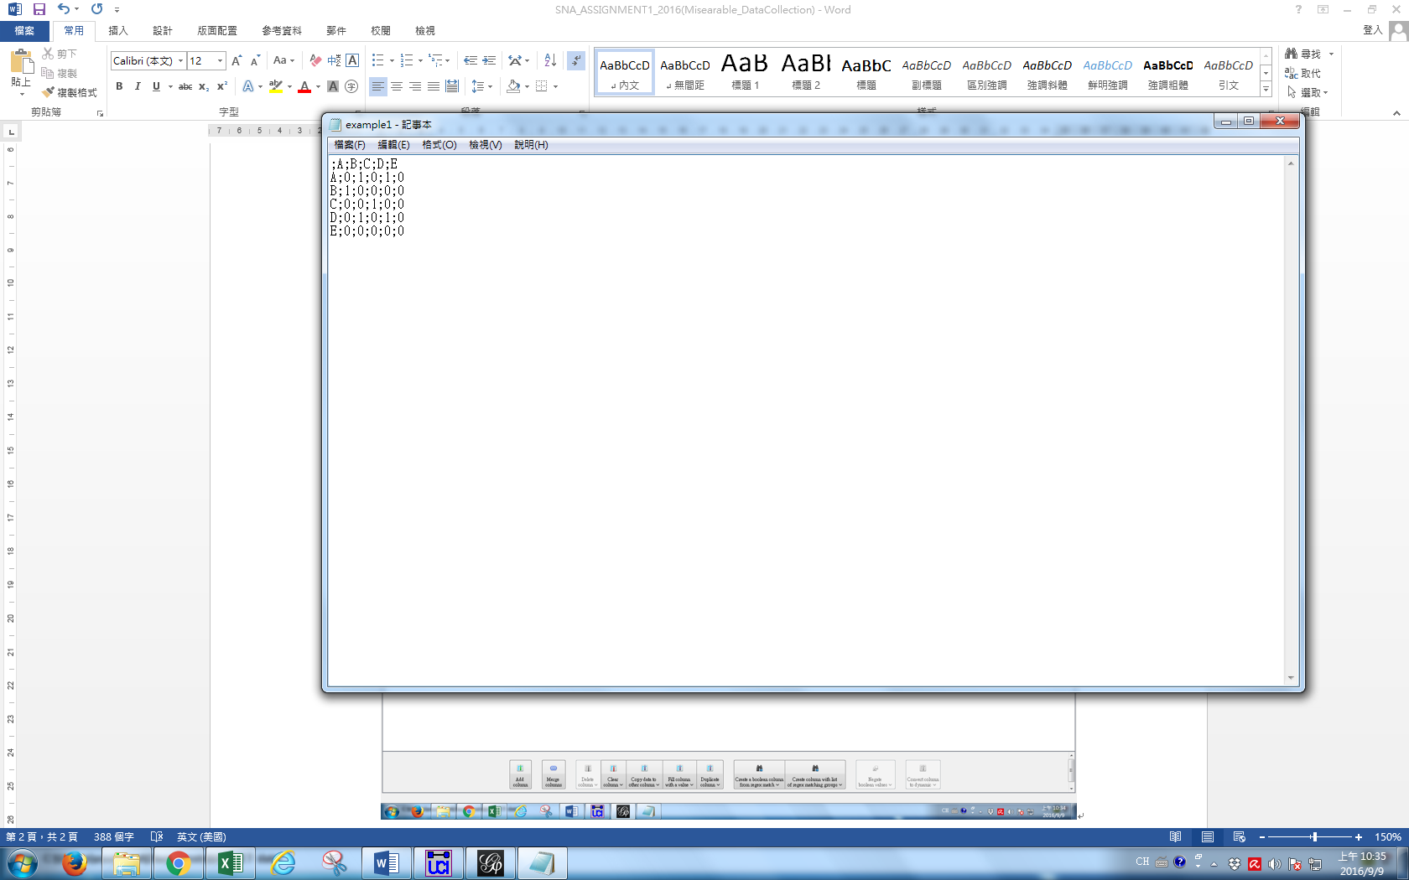

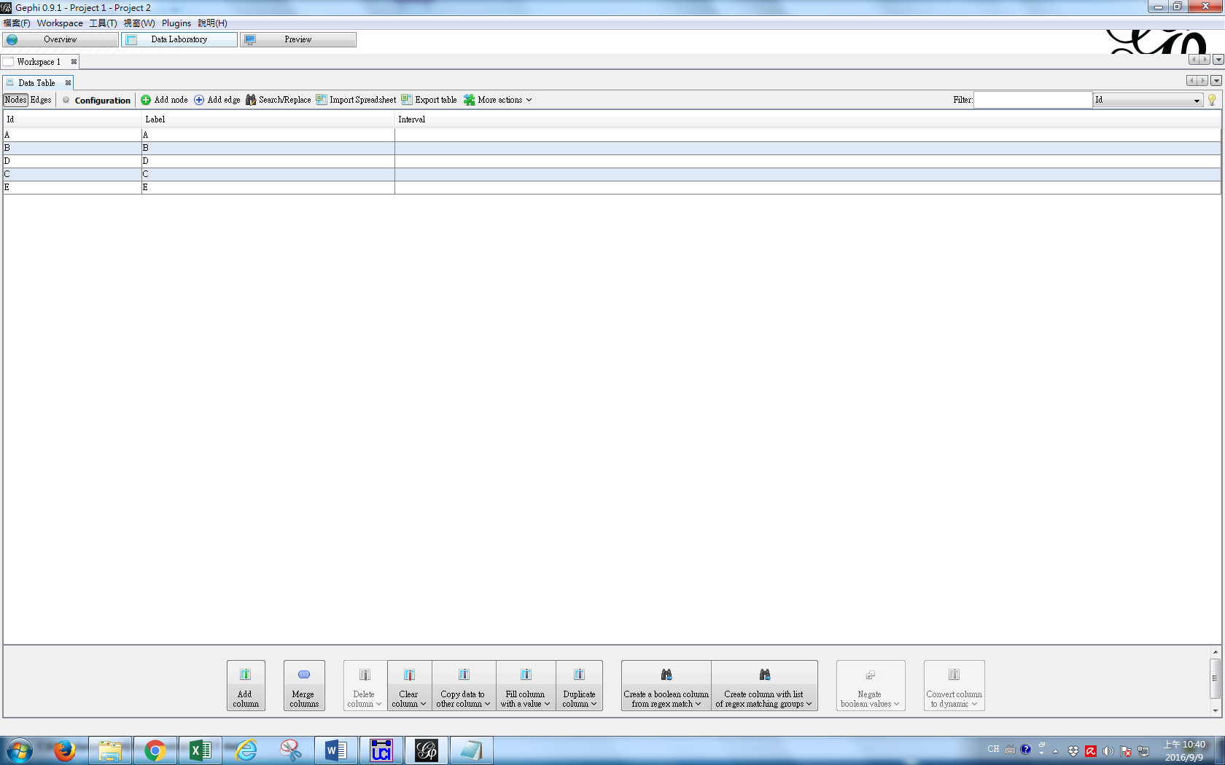

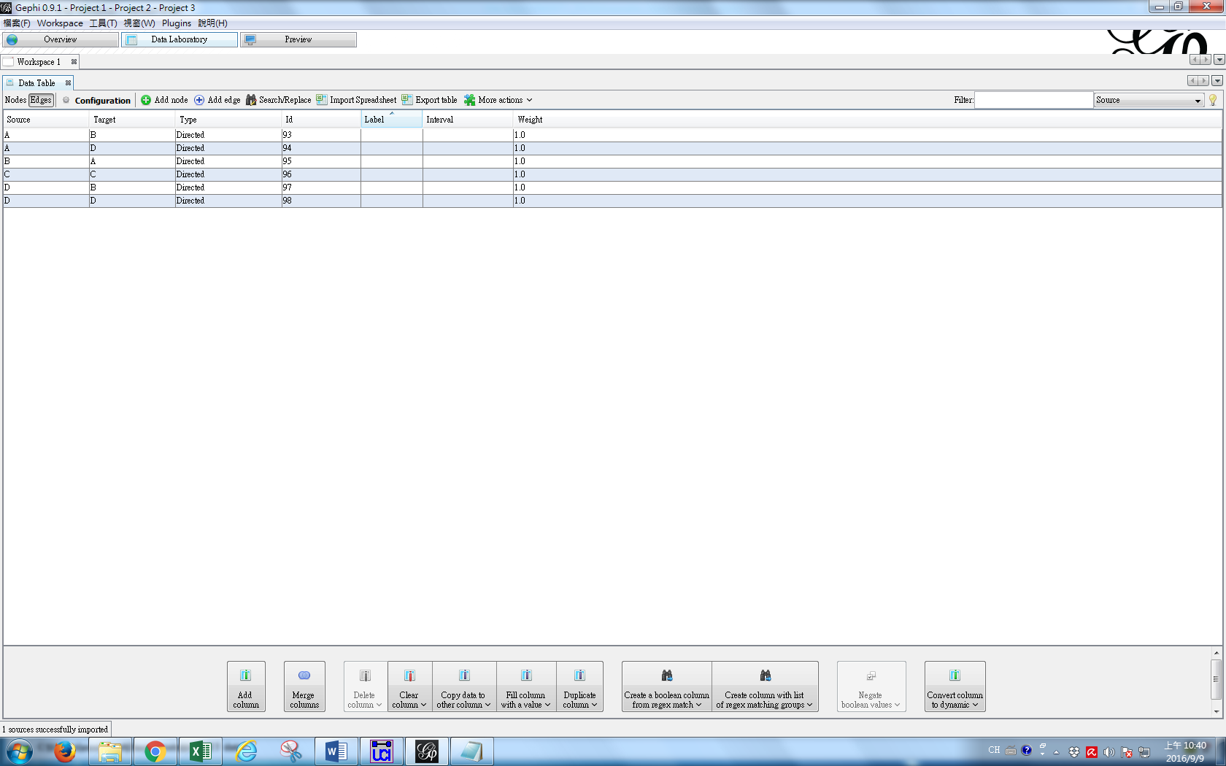

Node table and edge list table data (Gephi)

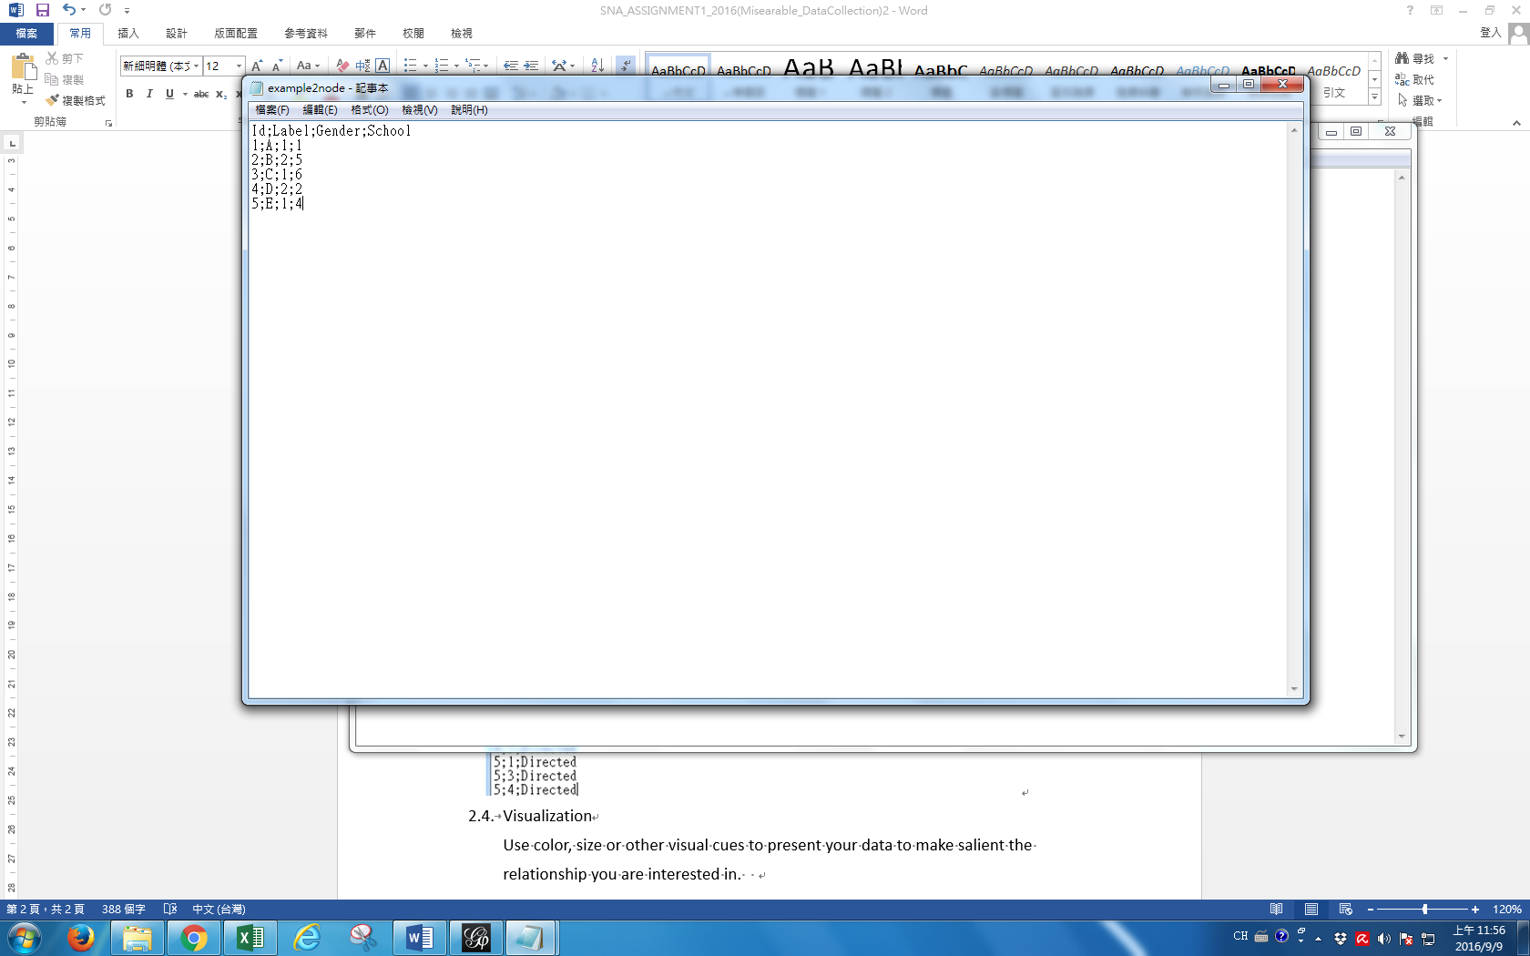

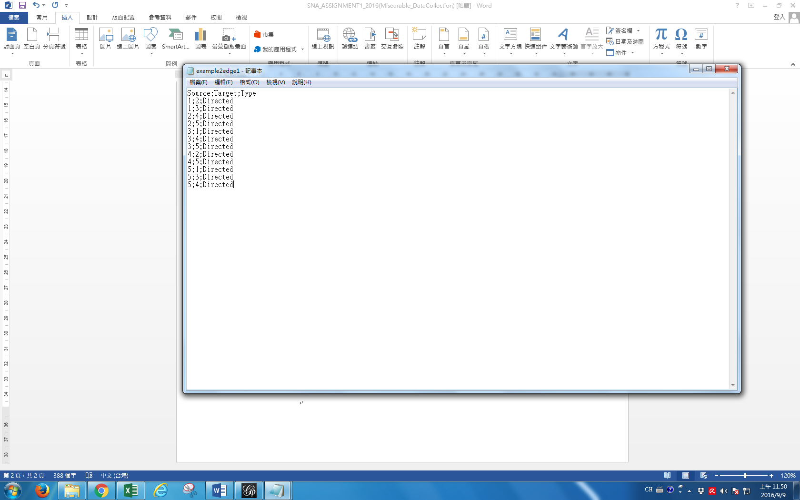

* 1. Visualization

Under Gephi, use color, size or other visual cues to present your data to make salient the relationship you are interested in.