**

iM-Connect®

Protocol Conversion Software User Guide

*July, 2024*

*Version Novakon_2.2.24.00*

©2022-2026 Copyrights Reserved

1. Alarm

Alarm enables the set tag to send alarm messages through Line Notify, Email, or MQTT when the defined condition is met. (e.g. value falls in the predefined range, or bit turns on, etc.).

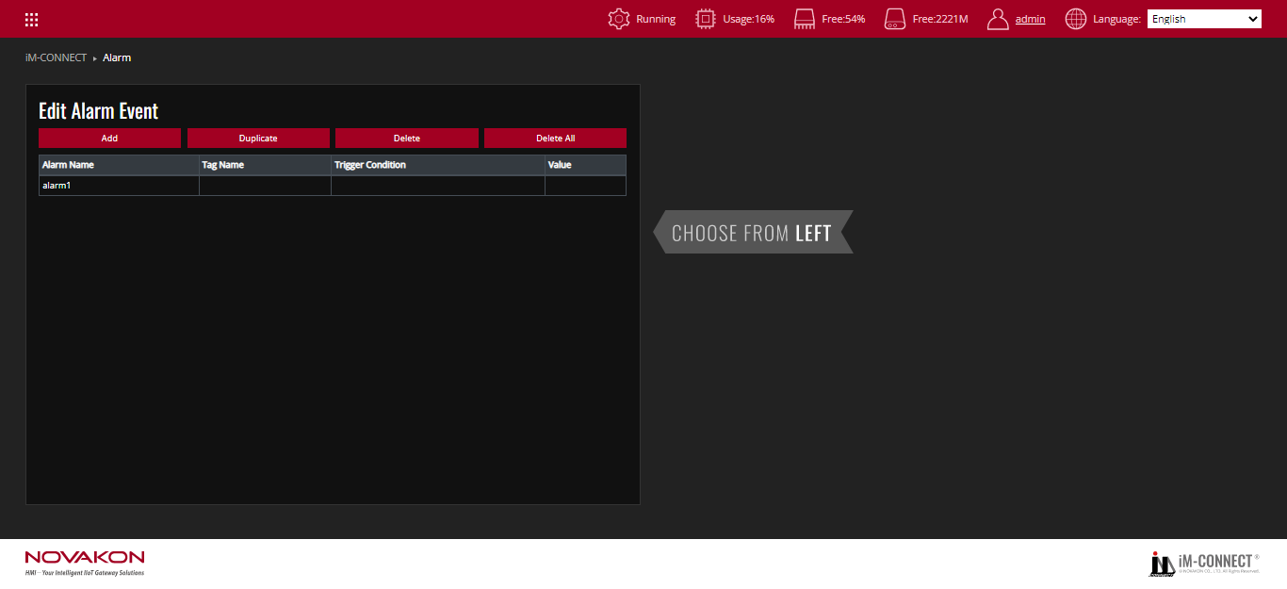

**Edit Alarm Event**

Edit Alarm Event can be used to edit the content of the alarm data, including [Add], [Duplicate],[Delete], and [Delete All].

|  |  |
| --- | --- |
| Add | Add an alarm. One alarm content can be added at a time. |
| Delete | Delete an alarm. Move the mouse cursor to an alarm and press [Delete] to delete the selected alarm. |
| Duplicate | Copy an alert. After moving the mouse cursor to an alarm, press [Duplicate] to duplicate the same alarm. The name of the duplicated alarm would be incremented by the default name (alarm). The rest of the content is the same. |
| Delete All | Delete all alarms at once. |

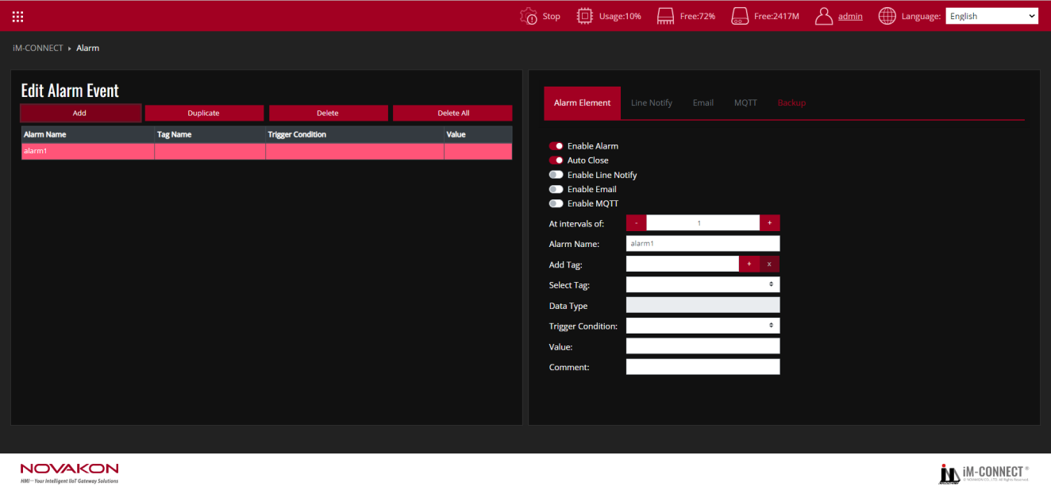

In the above figure, the orange frame on the left shows all the alarms that have been set.

|  |  |
| --- | --- |
| Alarm Name | Set the name of the alarm, which can be used to describe the content of the alarm. |
| Tag Name | Set the connected tag to determine whether an alarm occurs. |
| Trigger Condition | Display the trigger conditions. |
| Value | Display the condition value of the alarm. |

The blue frame on the right side of the figure above is the dialog box for the alarm setting.

|  |  |
| --- | --- |
| Enable Alarm | Activate the alarm. If this option is not activated, the alarm content would not be displayed regardless of whether the conditions are met. |
| Auto Close | When the alarm is cleared (the trigger condition is not met), the alarm is automatically closed. If this option is not activated, the alarm continues to be triggered even if the alarm condition has been removed. |
| Enable Line Notify | Set the Line Notify Messenger APP function when the alarm is triggered. |
| Enable Email | Set the function of sending email to a specified mailbox when the alarm is triggered. |
| Enable MQTT | Set the function of publishing message to the designated MQTT Broker when the alarm is triggered. |
| At intervals of | The interval between alarm sampling. The unit is seconds. |
| Alarm Name | Set the name of the alarm, which can be used to describe the content of the alarm. |
| Add Tag | Set the tag to determine whether an alarm has occurred. If the tag has not been created, press [+] on the right to add a tag. |
| Select Tag | The set tag can be selected as the one to judge the alarm. In the same alarm, [Add Tag] and [Select Tag] would have the same selected tag. |
| Data Type | Display the specified tag type. |
| Trigger Condition | Display the trigger conditions. When the trigger tag type is [Bit], [Set] or [Clear] can be selected to trigger an alarm. The various types of judgment mechanisms, including [=], [!=] (not equal to), [>], [>=], [<] and [<=] are available for selection. |
| Value | The value of the condition that the alarm is established. When the content of the [tag] meets the [value] of the [Trigger Condition], the alarm would be triggered. If the source type is [Bit], this field does not need to be set. |
| Comment | Set the description of the alarm. |

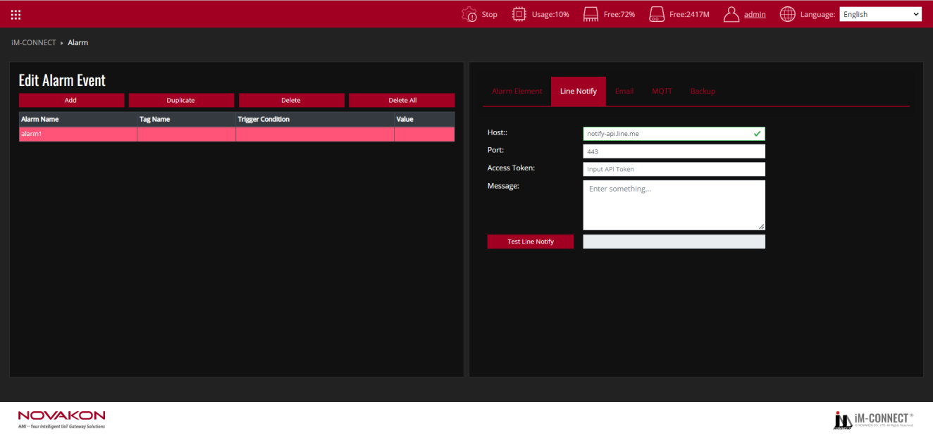

**Line Notify**

Set the line group and message to be sent when the alarm is triggered.

|  |  |
| --- | --- |
| Host | Display the default server address of Line Messenger App. |
| Port | Displays the default Port of Line Messenger App. |
| Access Token | Enter the access token for Line. For the line access token setting method, please refer to [Appendix:LINE Push Broadcast Setting]. |
| Message | Enter the content of the message to be pushed. Input[#{tag name}]in the Message Body if the message should contain Tag content. |
| Test Line Notify | Show the content of the response message after the push. |

For example:

STEP1.

Connect to the Line Notify website and click on "Log in with Line account".

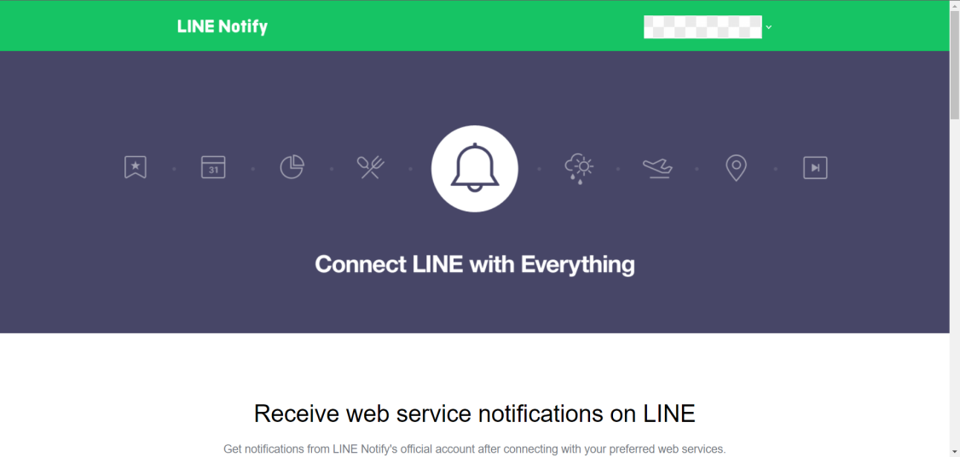

STEP2.

Click on "My page" to enter.

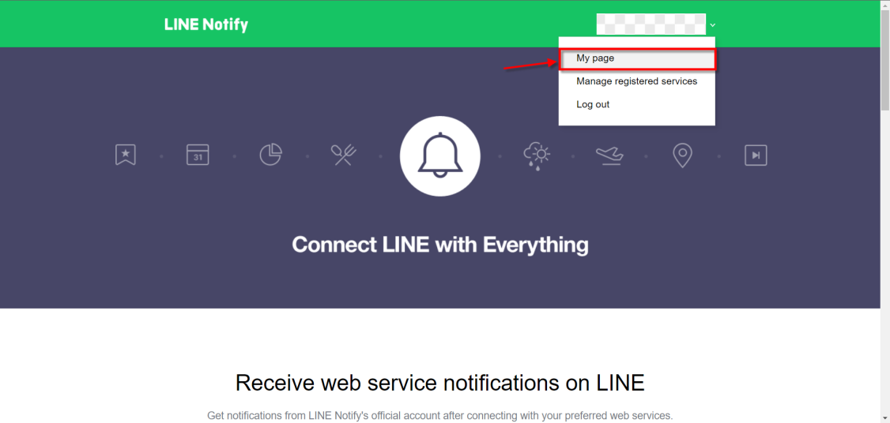

STEP3.

Click on "Generate token" to open the settings window.

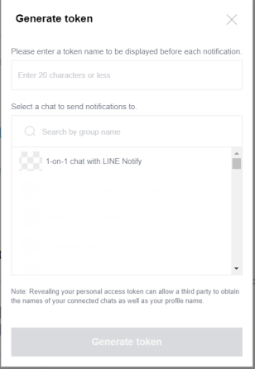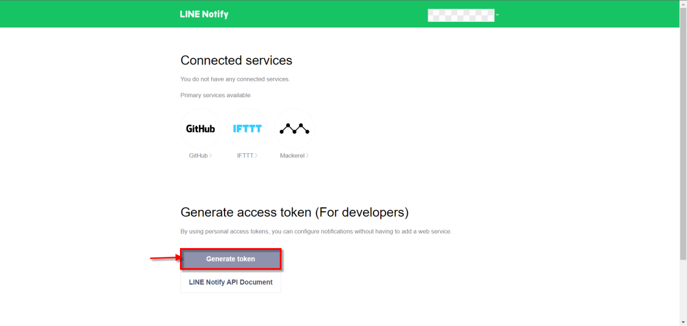

STEP4.

Enter a name and select the Line group to receive messages.

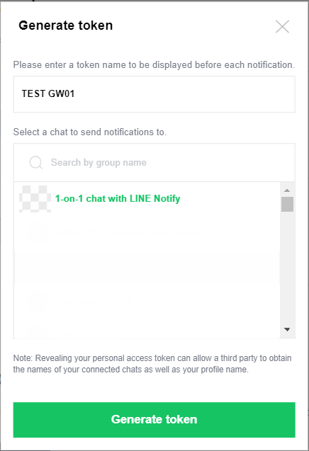

STEP5.

Obtain the token and copy it.

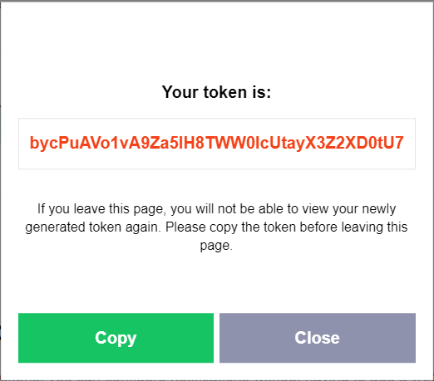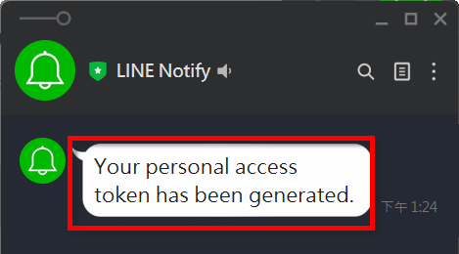

STEP6.

Paste the copied token into "Access Token" and enter the message you want to send in "Message".

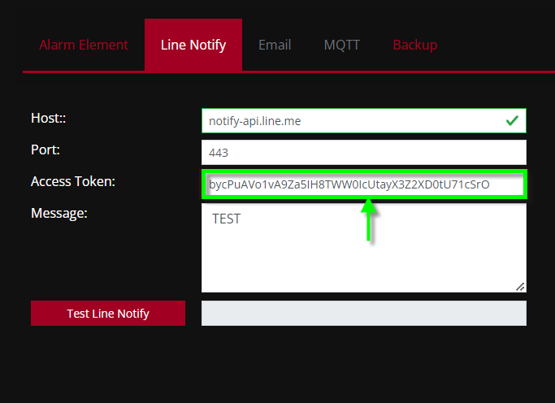

STEP7.

Click on "Test", and you will be able to see the message sent on Line Notify.

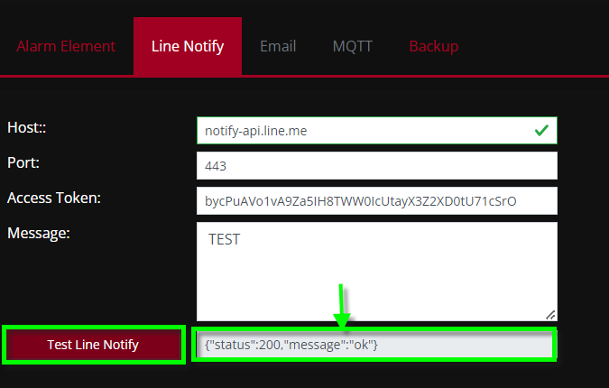

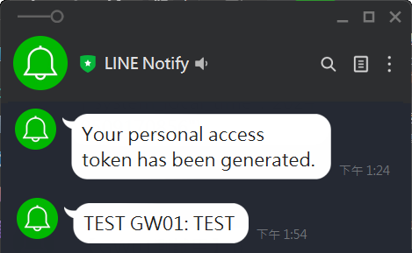

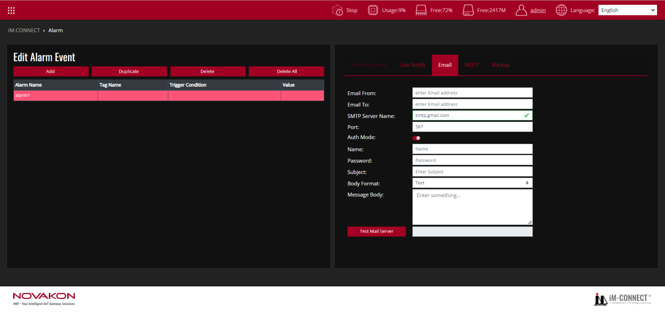

**Email**

Set the email message to be sent when the alarm is triggered.

|  |  |
| --- | --- |
| Email From | Enter the email address of the sender. |
| Email To | Enter the email address of the recipient. If multiple groups of emails need to be set up, please separate each group of emails with a comma. |
| SMTP Server Name | Enter the name of the SMTP server to be used. |
| Port | Display the port number to be used. |
| Auth Mode | Confirm whether to log in for verification. |
| Name | Enter the email address of the sender. |
| Password | Enter the sender's email password. |
| Subject | Enter the subject of the message. |
| Body Format | Enter the content body in [Text] or [Html] format of the email to be sent. |
| Message Body | The content of the response message to be shown after the email is sent. Input[#{tag name}]in the Message Body if the message should contain Tag content. |
| Test Mail Server | Displays the content of the response message after the email is sent. |

Note:

Please set up the above settings in accordance with the specifications of each email server. For example of Gmail, please set the [Allow Low-Security Applications] of the Google account to be [Enabled].

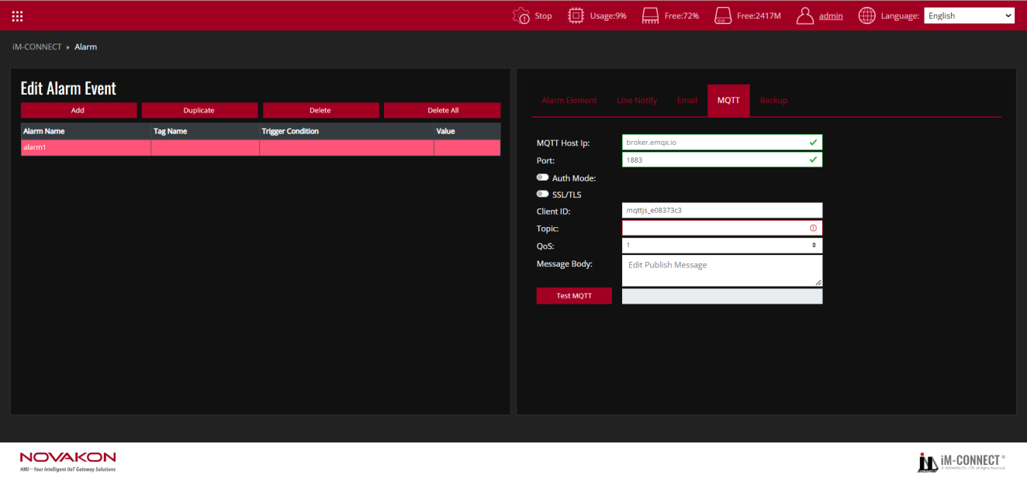

**MQTT**

Set the designated MQTT client that receives the alarm message when the alarm is triggered.

|  |  |
| --- | --- |
| MQTT Host IP | Set the MQTT Broker IP that receives the messages. |
| Auth Mode | Confirm whether authentication is required. If it is selected, the account name and password must be input. |
| SSL/TLS/Port | Set SSL/TLS port number. |
| Require Certificate | Confirm whether the certificate file is required or not. |
| Upload Cert File | Import the certificate provided by the Server. |
| Upload Key File | Import the key provided by the Server. |
| SSL Secure | After selecting it, the validity of the certificate file provided by the Server will be verified. |
| Client ID | Set the user’s ID. Every MQTT user needs a unique ID. MQTT Broker identifies the users through the Client IDs, and records the status of the users individually, such as subscription topics and communication quality setting. |
| Topic | Set the topic name. The name must comply with MQTT naming principles. |
| QoS | The quality of service is divided into three levels: 0, 1 and 2. The greater the number, the better the quality.  0:Sent once at most (in charge of sending messages only, suitable for less critical situations).  1:Sent once successfully at least (the data is correctly sent but message repetition may occur).  2:Sent once properly (rigorous delivery with the feedback of “message delivered”). |
| Message body | Input the message to be sent. If a tag is needed in the message, add [#{tag name}] in the message body. |
| Test MQTT | The response message sent after MQTT is published. |

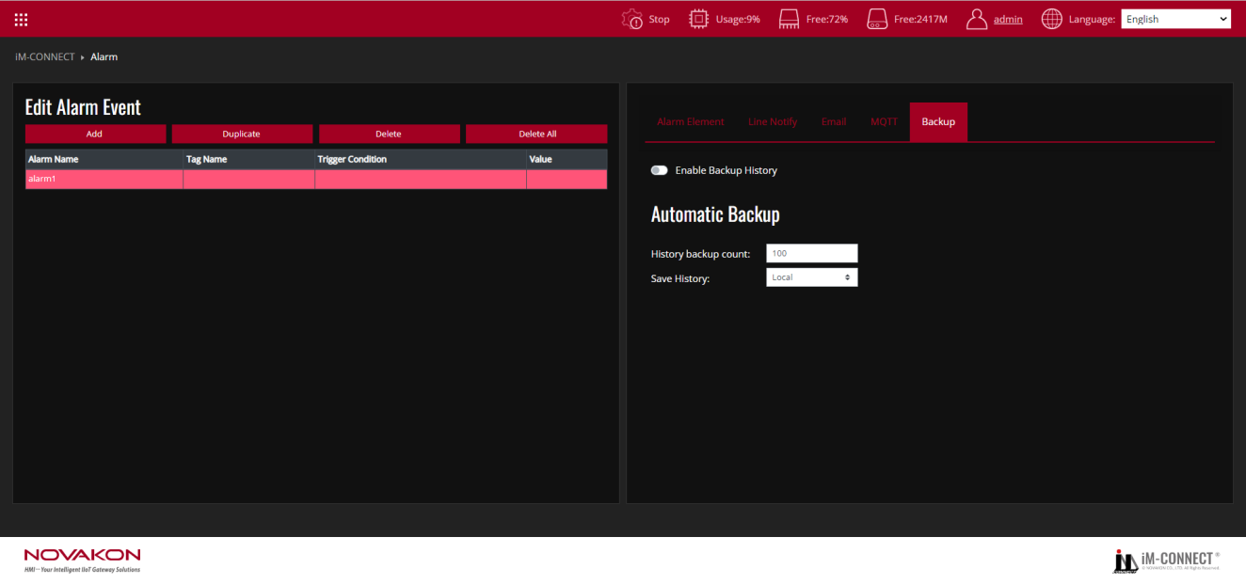

**Backup**

Set the number of alarm history to be backup and the destination where the log to be saved. When [Enable Backup History] is on, the condition of Automatic Backup can be set.

|  |  |
| --- | --- |
| History backup count | Set how many alarm history to be automatically backup to the appointed storage. |
| Save History | Set where to backup the history. [Local] for Gateway local storage or [USB] for external USB disk. |

Test Procedure: (Reference files:ALARM.dat)

1. In the Menu, choose ALARM.
2. Press "Add": Create a new alarm.
3. Activate the alarm: Go to the Alarm Element Tab and enable the alarm.
4. Set whether to activate "Auto Close" according to the actual situation. You can also choose to use the "Line Notify", "email", and "MQTT" functions to send alerts.
5. Configure alert details:

Under Time Interval, set the time interval for checking alerts.

Name the alarm in Alert Name.

Select the label associated with the alert.

Define the trigger condition that will start the alert.

Set the value that triggers the alarm.

Add a comment to get additional information about the alert.

1. Line Notification Settings (if enabled): Go to the Line Notification tab and configure the parameters required for Line Notification.
2. Email Settings (if enabled): Turn on the Email tab and set the email parameters required for alert notifications.
3. MQTT settings (if enabled): Navigate to the MQTT tab to configure the MQTT settings for alert alerts.
4. In the Backup Tab, you can enable alarm backup functionality. Additionally, you can configure the History Backup Count to specify how many alarm history records should be retained, and enable the Save History option to store alarm records.
5. Following the steps above, you can continue adding different alarms as needed, ensuring that each one is properly configured with its own specific parameters and backup settings.
6. Save and Compile: Go to the Menu, select PROJECT SETTING, and execute "Save and Compile" to compile the project.
7. Start the Project: Click "Start Project" to run the project.
8. Monitor the execution: Go back to the Menu, select ONLINE MONITOR, and choose the Tags you are using to monitor the project ’s execution results.