Data Logger

[Data Log]:Store the historical data in flash memory and move to database at the defined timing.

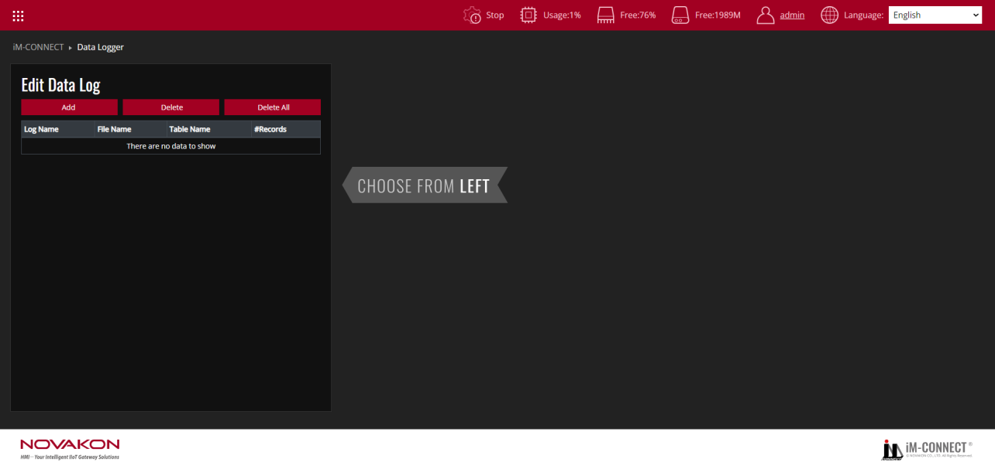

**Edit data log**

Set the basic parameters of the data record. A buffer is created for each data record, and historical data can be stored in the buffer.

|  |  |
| --- | --- |
| Add | Add a set of record. The records can be added up to 100 sets in maximum. |
| Delete | Delete the selected record name. |
| Delete All | Delete all the records at once. |
| Log Name | Display the log name. You can set the name in "Backup" -> "Param eter Settings", defaulting to "log1". |
| File Name | Display the name of the saved file. You can set it in "File Name", defaulting to "log1_{yyyy}{mm} {dd}{HH}{MM}{SS}" (file name_yearmonthdayhourminutesecond). |
| Table Name | Display the name of the database table. You can set it in "Database", defaulting to "logTable". |
| #Records | Display the number of backup entries. You can set it in "Backup" -> "Automatic Backup". |

[File (table) name][#record] is located in the same location as the above-edited data record content.

When using a database, [log name] is the table name of the database.

When the file does not exist in the MSSQL, MYSQL, or FTP path, it will be automatically added and then created based on the name.

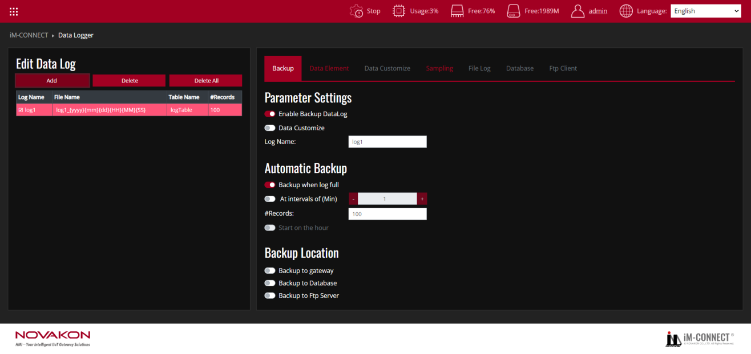

**Backup**

Set the backup time and device.

|  |  |
| --- | --- |
| Parameter Settings | Set whether to enable backup logging, Data Customize, and Log Name. |
| Enable Backup DataLog | Activate the data logging backup function. Once activated, you can edit the items of the data records in the[Data Element]section. |
| Data Customize | Activate the custom data logging backup function. Once activated, you can edit the items of the data records in the [Data Customize]section. If [Backup to Database] is activated in the[Backup Location], then [Data Customize] cannot be activated, and vice versa. |
| Log Name | Set the name of the data logging file. This name will be displayed in the [LogName] section of [Edit Data Log]. |
| Automatic Backup | Set the condition to trigger automatic backup. |
| Backup when log full | When this option is activated, the data record is backed up when it is full. And [At intervals of (Min)]and[Start on the hour]are mutually exclusive. |
| At intervals of(Min) | Set to backup records at fixed minute intervals. The default is every 1 minute. |
| #Rccords | Set the number of data backups.The maximum number is 65535.  If combined with [Data Customize]to create a table, it represents the number of times the data record is repeated in the data log. |
| Start on the hour | When this option is activated, the backup time will be set to the top of the hour (i.e., at 0 minutes), and the time will follow the [At intervals of (Min)] setting mentioned above. However, at this time, [At intervals of (Min)] can only be set to values that are divisible by 60. |
| Backup Location | Set the location to store data logs. Options include "Backup to gateway," "Backup to Database," and "Backup to FTP Server." |

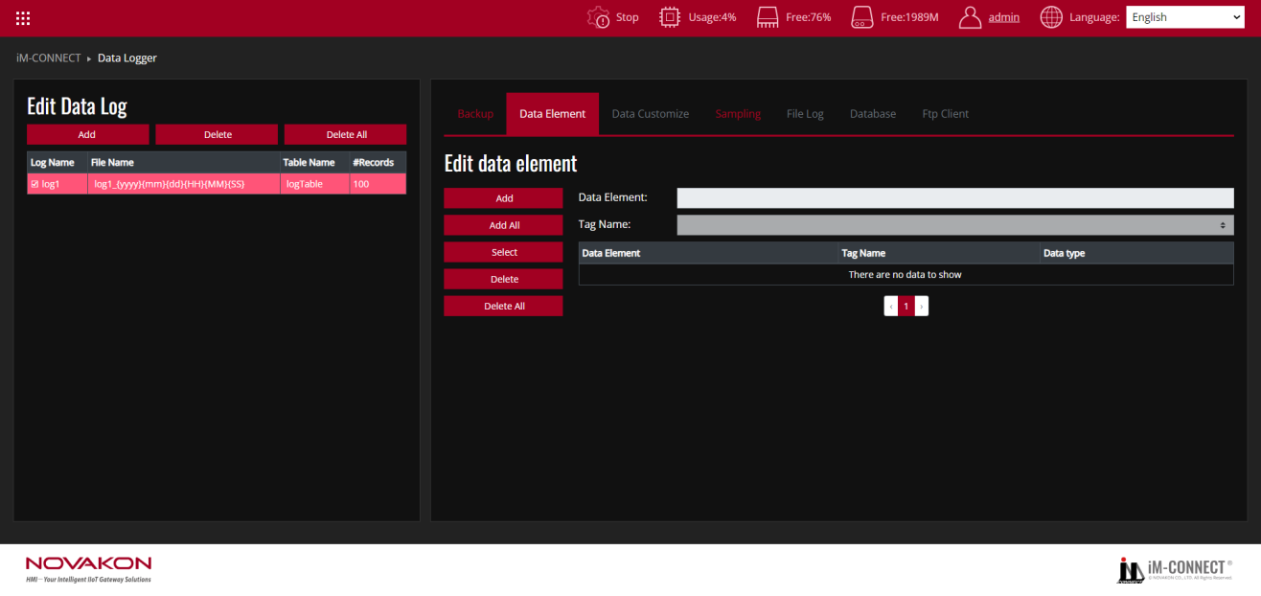

**Data Element**

Set the constituent items of the data record, including project uyname, tag, data format.

|  |  |
| --- | --- |
| Edit data element | Set the items and conditions of data records. |
| Add | Add a data element. The added items can contain 32 items in maximum. |
| Add All | Add all tags to the data record items. |
| Select | Select the existing tags as the item contents. |
| Delete | Delete the selected item. |
| Delete All | Delete all item at once. |
| Data Element | Set the item name. The name would be displayed in the database, and it supports multiple languages editing. Nevertheless, using English for naming is suggested. |
| Tag Name | Set the designated tag for each item. The tag type supports all formats. |
| Data type | Display the data type of each tags. |

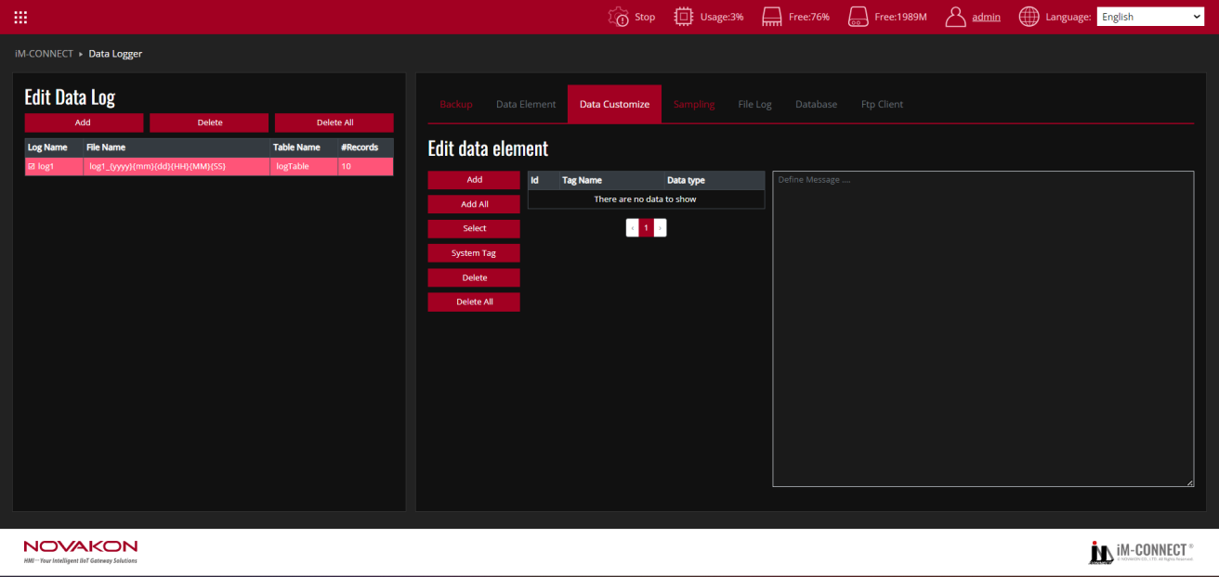

**Data Customize**

Customers can define the content of data record items themselves.

|  |  |
| --- | --- |
| Edit data element | Configure the components of the data record, including item name, tags, and data format. |
| Add | Add a tag. |
| Add All | Add all tags to the data record items , excluding system tags. |
| Select | Select the existing tags as the item contents. |
| System Tag | Select system tags to be used as the content of data record items. |
| Delete | Delete the selected item. |
| Delete All | Delete all item at once. |
| Define Message… | You can enter the defined message text here. Use the tag from GW01 with the format #{ID}. |

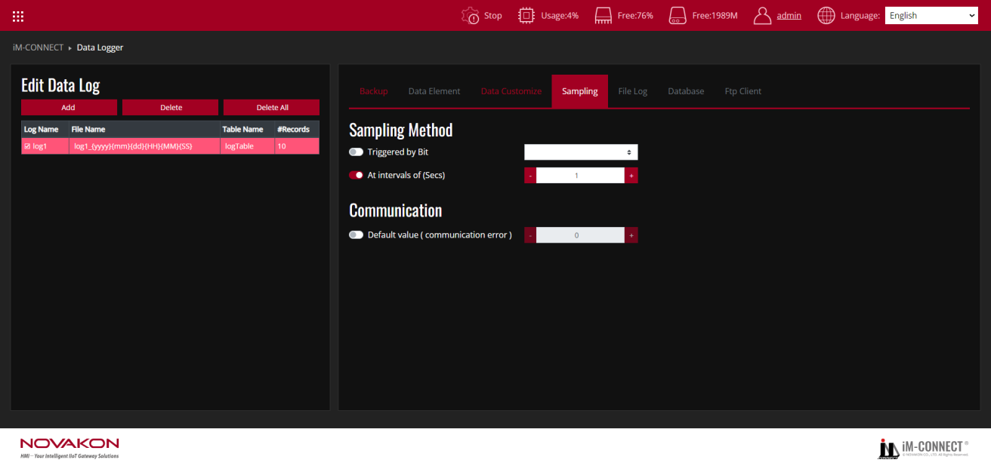

**Sampling**

Set the sampling conditions and the corresponding action.

|  |  |
| --- | --- |
| Triggered by Bit | Trigger the sampling based on Bit ON or Bit OFF. |
| At intervals of | Set the fixed time interval of seconds for sampling records. The default value is 1.0 seconds. |
| Default value (communication error) | Set the value to indicate communication error. |

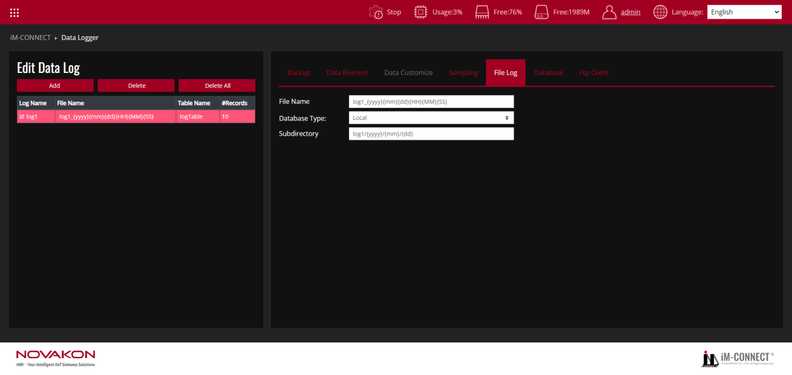

**File Log**

Configure the information for saving files.

|  |  |
| --- | --- |
| File Name | Set the name of the data log file for saving. This name will be displayed in[Edit Data Log]under[File Name]。The default is[log1_{yyyy}{mm}{dd}{HH}{MM}{SS}] |
| Database Type | Select the device type for accessing the database. Options include[Local]or[USB]. |
| Subdirectory | Set the subdirectory for storage. The default is [log1/{yyyy}/{mm}/{dd}]. |

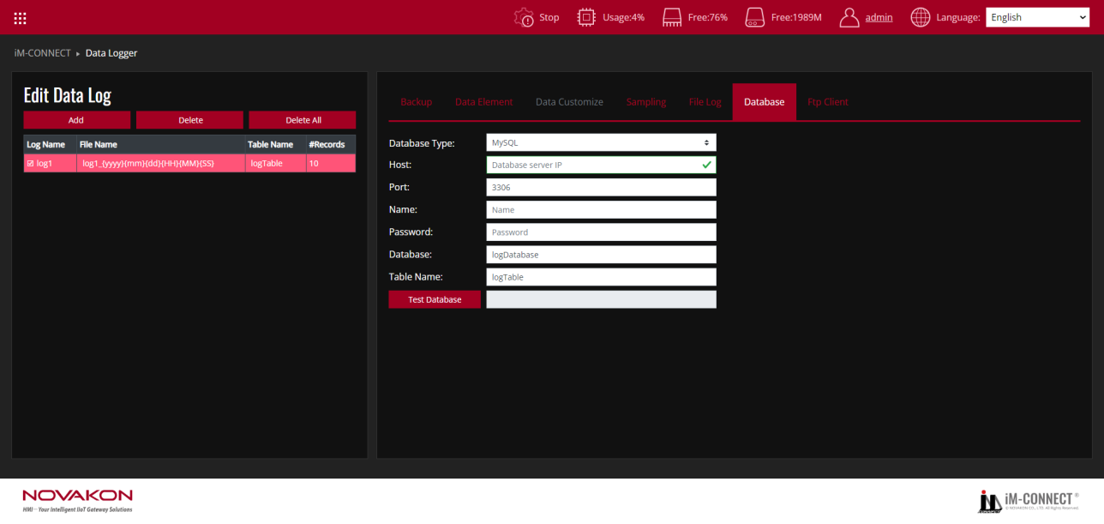

**Database**

Set the uploaded database information.

|  |  |
| --- | --- |
| Database Type | Set the database type. [MySQL]and[MS SQL]are currently available in the latest version. |
| Host | Set the name or IP of the server for the uploaded database. |
| Port | Set the Port number of the uploaded database. |
| Database | Set the name of the uploaded database. |
| Name | Enter the database username. |
| Password | Enter the database user password. |
| Database | Enter the name of the database. The default is[logDatabase]. If the database has not been created, it will be automatically created during the first data transmission. |
| Table Name | Enter the name of the database table. The default is[logTable]. If the database has not been created, it will be automatically created during the first data transmission. |
| Test Database | Test the settings of the database. You can test the connection with database here as long as the boxes of[Enable Backup Datalog]and [Enable Database Backup]are checked. |

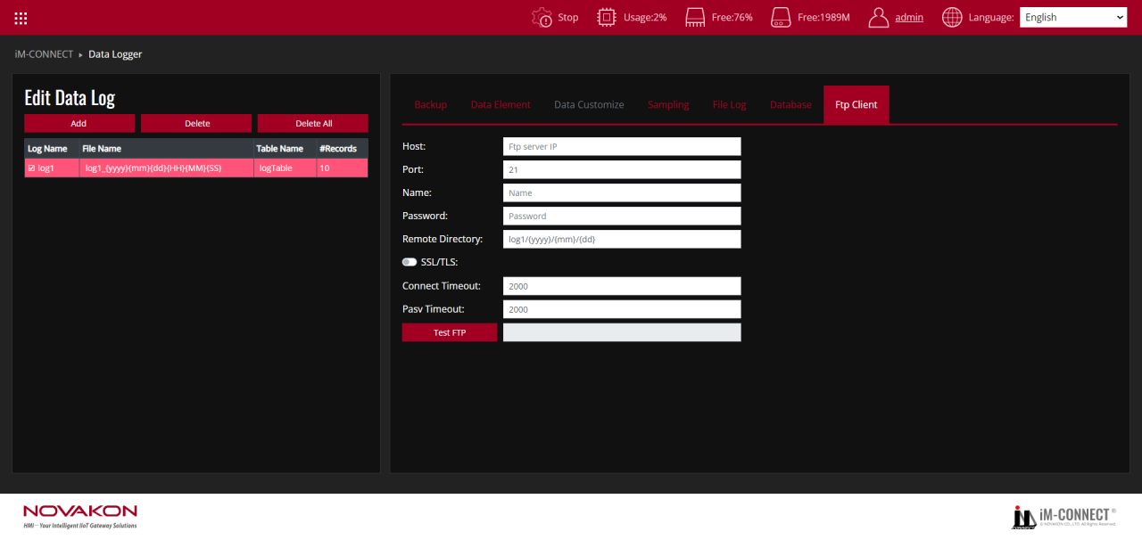

**FTP Client**

Set gateway as FTP Client with the condition and related information of FTP Server, to which gateway send data through Internet.

|  |  |
| --- | --- |
| Host | Input the server’s name for connection. |
| Port | Input the port number of the server to connect. |
| Name | Input the FTP client username. |
| Password | Input the FTP client password. |
| Remote Directory | Input the remote directory of FTP server for upload. |
| SSL/TLS | Check to enable connection encryption. |
| Connect Timeout | You can set the connection timeout period. The default is 2000 milliseconds. |
| Pasv Timeout | You can set the passive timeout period. The default is 2000 milliseconds. |
| Test FTP | Click to test the connection to FTP server. |

Test Procedure: (Reference files:DATALOG.dat)

1. In the Menu, choose DATA LOGGER.
2. Press "Add" to create a new Datalog.
3. In the **Backup Tab**, under **Parameter Settings**, enable **"Enable Backup Datalog"** and set the **Log Name**.
4. In **Automatic Backup**, configure the backup frequency; the default setting is **"Backup when log full"**.
5. In **Backup Location**, choose where to back up the Datalog: **Gateway**, **Database**, or **FTP Server**.
6. In the **Data Element Tab**, add the **Tag Name** for the datalog.
7. If **Data Customize** is selected in the **Backup Tab**, the option to back up to the **Database** becomes unavailable, and you can configure the data elements in the **Data Customize Tab**.
8. Set the **Sampling Method** in the **Sampling Tab**.
9. If **Backup Location** is set to **Gateway**, configure the **File Log Tab** for file logging.
10. If **Backup Location** is set to **Database**, configure the corresponding database settings for the Datalog.
11. If **Backup Location** is set to **FTP Server**, configure the relevant FTP server settings.
12. Save and Compile: Go to the Menu, select PROJECT SETTING, and execute "Save and Compile" to compile the project.
13. Start the Project: Click "Start Project" to run the project.
14. Monitor the execution: Go back to the Menu, select ONLINE MONITOR, and choose the Tags you are using to monitor the project ’s execution results.