1. MQTT

MQTT is generally used as a messaging protocol in IoT (Internet of Things), with the main features of lightweight, openness, and easiness. When the program capacity is limited or the network bandwidth is limited, such advantages become more explicit. It is suitable to be used on the continuous monitoring of the data such as temperature, humidity, pressures, electricity, water level, and others.

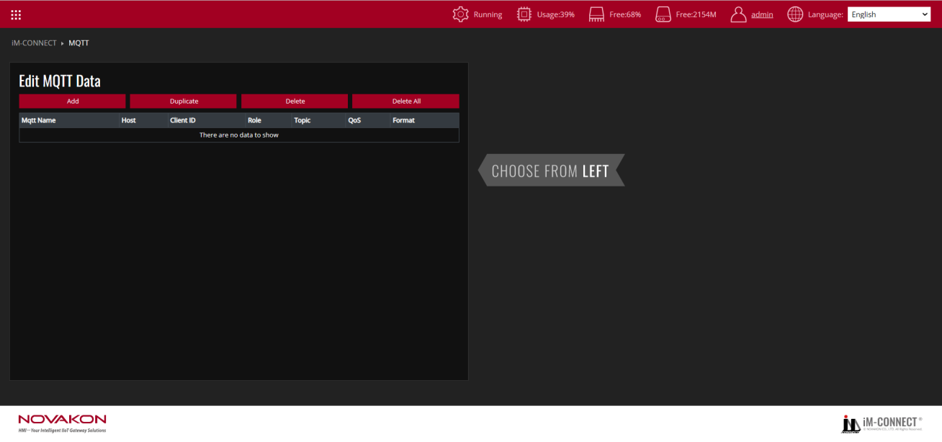

|  |  |
| --- | --- |
| Add | Add a set of MQTT items. |
| Delete | Delete the selected MQTT item. |
| Duplicate | Duplicate the selected set of MQTT items. |
| Delete All | Delete all the MQTT items. |

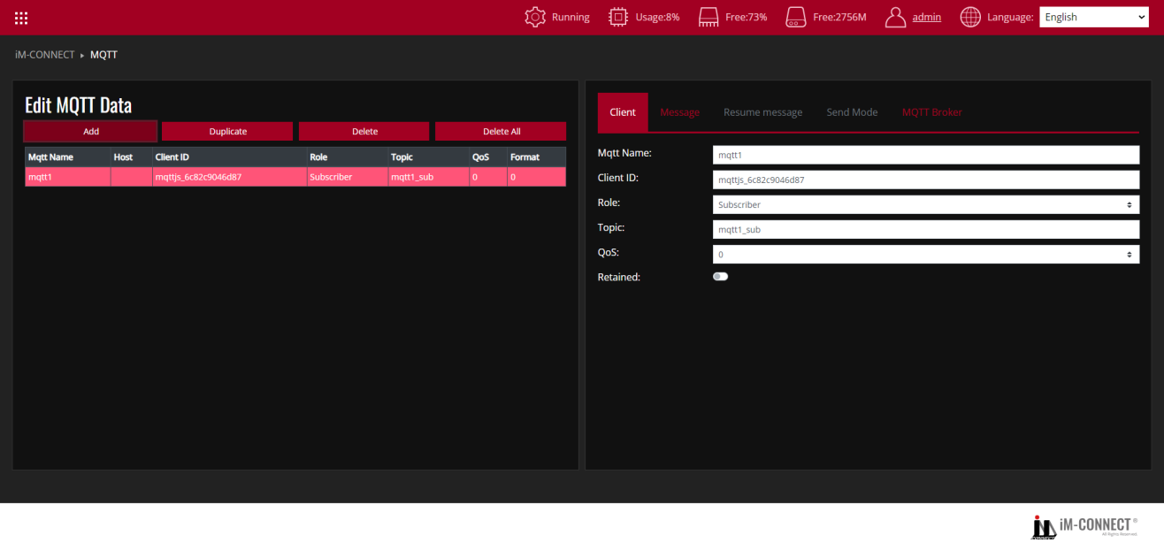

**Client**

|  |  |
| --- | --- |
| MQTT name | Assign a MQTT name. |
| Client ID | Set the User’s ID. Every MQTT user needs a unique ID. MQTT Broker identifies the users through the Client IDs, and records the status of the users individually, such as subscription topics and communication quality setting. |
| Role | Set the role in MQTT. There two major roles in the MQTT protocol: Publisher and Subscriber. The Subscriber must subscribe the topics that it needs. Then, when the Publisher publishes messages to the topic, the broker sends such messages to Subscribers who subscribed to the same topic.  Publisher:To set as a Publisher. The tag body will be published to the designated broker.  Subscriber:To set as a Subscriber. Subscribe the designated broker and set a value to the tag when receiving the data.  When the Role is set as the Publisher, the tag to be sent must be set up; otherwise, no tag will be sent as default. |
| Topic | Topic name to be used. |
| QoS | The quality of service is divided into three levels: 0, 1 and 2. The greater the number, the better the quality.  0:Sent once at most (in charge of sending messages only, suitable for less critical situations).  1:Sent once successfully at least (the data is correctly sent but message repetition may occur).  2:Sent once properly (rigorous delivery with the feedback of “message delivered”). |
| Retained | Retain the last message successfully sent. |

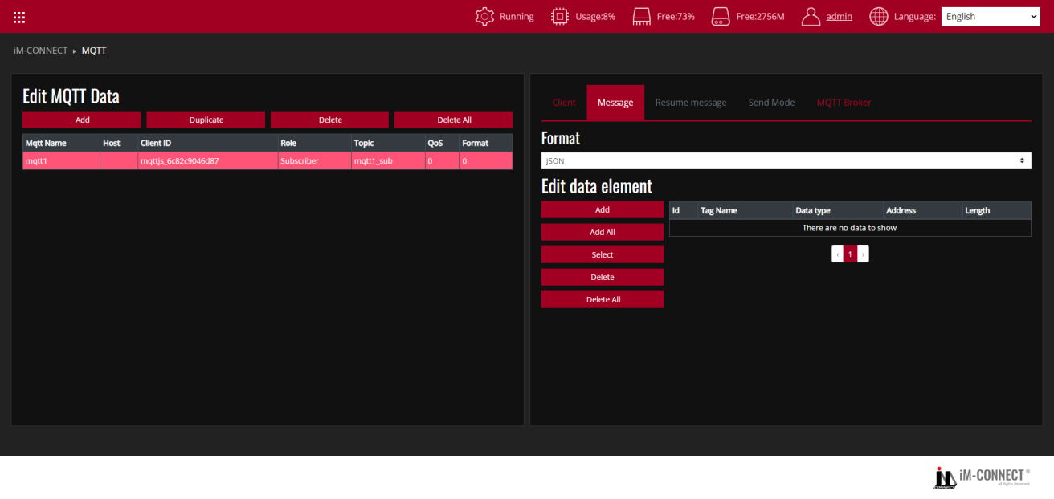

**Message**

|  |  |
| --- | --- |
| Format | Designate the MQTT format. Select [JSON](default), [Binary]or[Customize]. |
| JSON | Through the JSON standard format, the tag content set according to the Publisher is output. |

As shown in the following diagram, when the sending condition is established, the Publisher sends the content to the Subscriber(s) according to the content values of the set tags T01, T02, and T03.

The format consists of: {“Publisher_Tag name1”: Send value1,“Publisher_Tag name2”: Send value 2,” Publisher_Tag name3”: Send value 3 , and so on.}

Thus, the input format shall be: {“T01”:value,“T02”: value,”T03”: value }

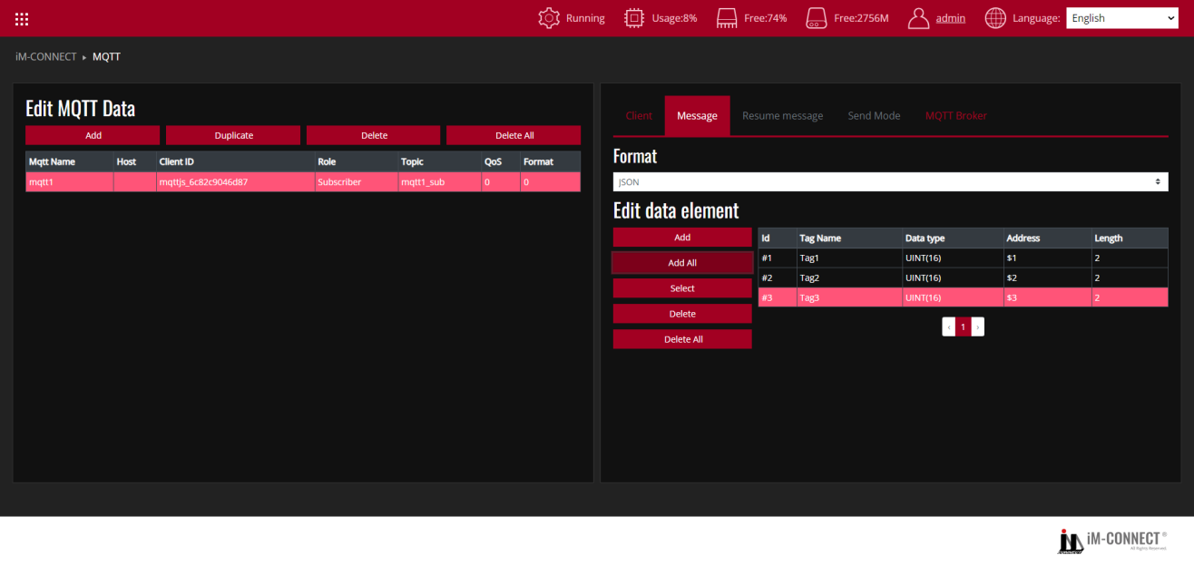

|  |  |
| --- | --- |
| Binary | The tag content set according to the Publisher will be reorganized into binary format and output. |

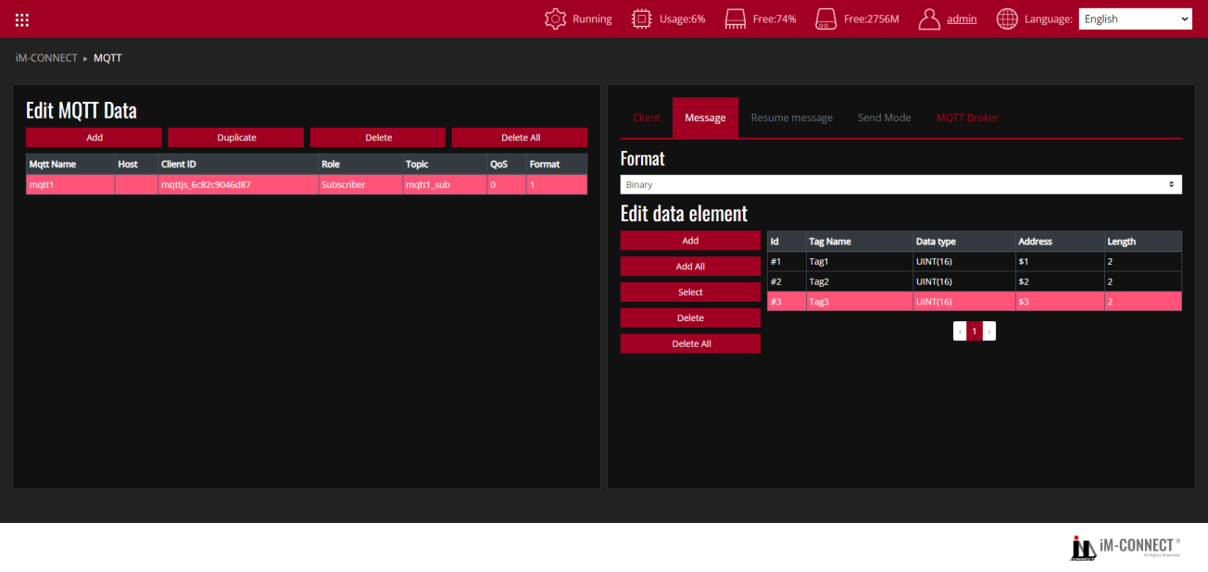

|  |  |
| --- | --- |
| Customize | The tag content is output based on the user’s customized format. |

As shown in the following diagram, when the sending condition is established, the Publisher sends the content of tags T04, T05, and T06 to the Subscriber(s) according to the content values of the set tags T01, T02, and T03.

The format consists of: {“Subscriber_Tag name1”: Publisher_ID1,“Subscriber_Tag name2”: Publisher_ID2,” Subscriber_Tag name3”: Publisher_ID3 , and so on.}

Thus, the input format in this case shall be: {“T04”:=#{0},“T05”:=#{1},”T06”:=#{2}}.

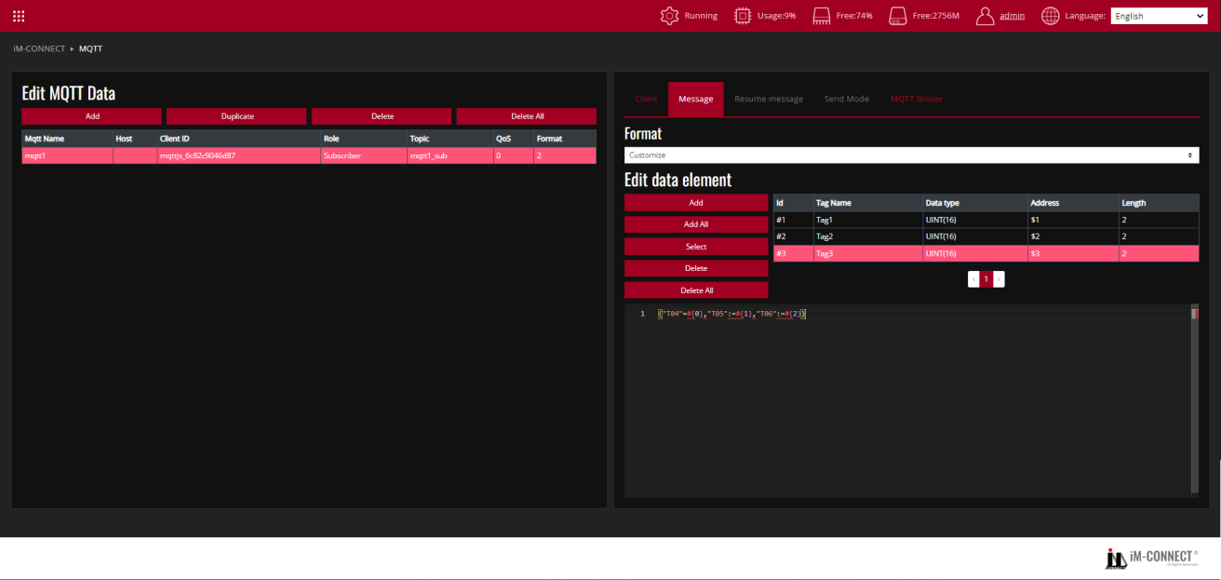

**Edit data element**

|  |  |
| --- | --- |
| Add | Add a MQTT item. |
| Add All | Add all tags to MQTT items. |
| Select | Select a MQTT item. |
| System tag | Use the system tag to obtain Gateway system time and other information. |
| Delete | Delete the selected MQTT item. |
| Delete all | Delete all the MQTT items. |

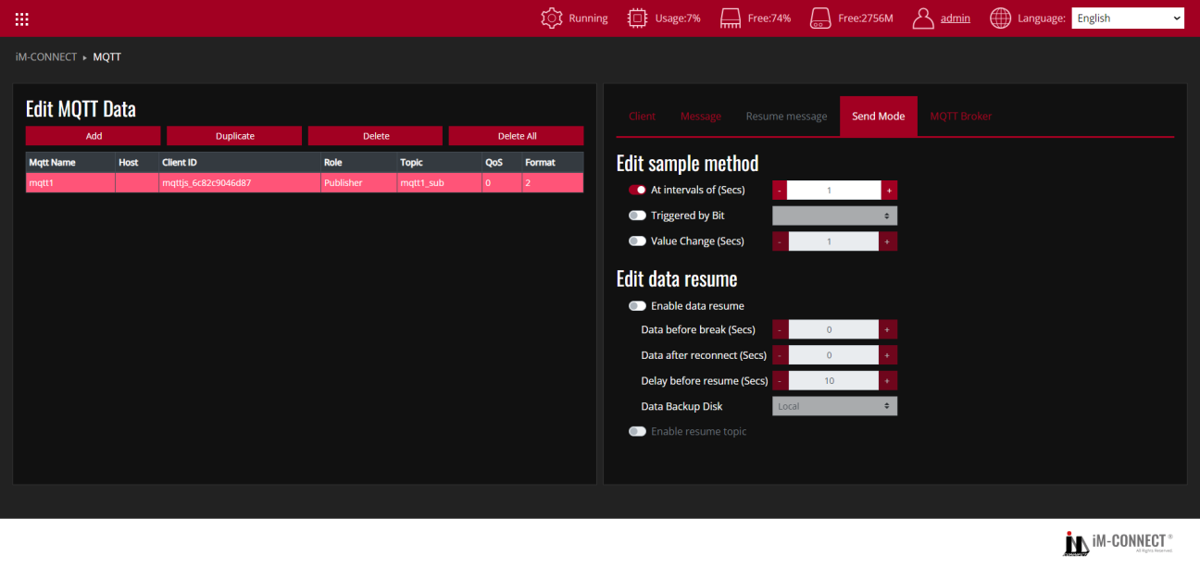

**Send Mode**

Set the method or condition for sending MQTT message.

**Edit sample method**

|  |  |
| --- | --- |
| At Intervals of(Secs) | Set to send MQTT message in a fixed interval in seconds. The default is 1 second. |
| Triggered by Bit | Set to send MQTT message when the status is triggered by bit, from OFF to ON. |
| Value Change(Secs) | Set to send MQTT message when the designated tag status is changed. |

**Edit data resume**

|  |  |
| --- | --- |
| Enable data resume | Check this option to activate MQTT data resuming functionality. |
| Data before break(Secs) | Set the time period before the break for data to be transmitted upon reconnection, in seconds. |
| Data after break(Secs) | Set the time period after the break for data transmission upon reconnection, in seconds. |
| Data before resume(Secs) | Set the delay time for transmitting data after a break and before reconnecting, default is 10 seconds. |
| Data Backup Disk | Set the location for backing up data for resuming from breakpoints, selectable options are [Local] or [USB]. |
| Enable resume topic | Check this option to activate designated resume topic content. This feature separates data during disconnection and connection periods, facilitating user differentiation. |

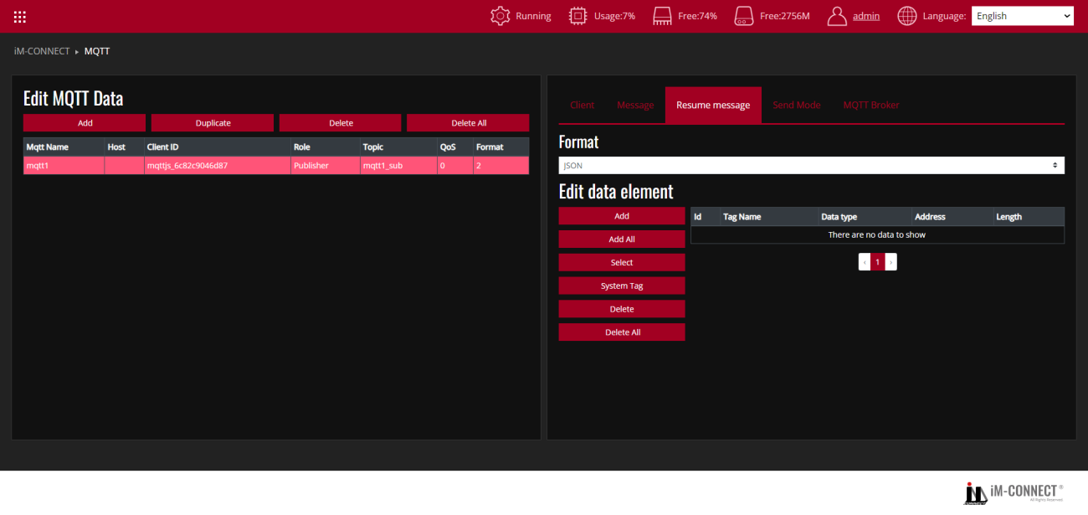

**Resume message**

This allows configuring the content of the resume message for resuming from breakpoints, utilizing the same method as described in[Message]above. This enables differentiation between data during connection and disconnection times.

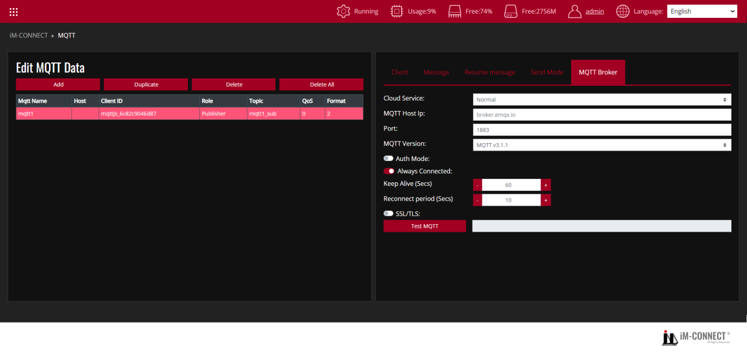

**MQTT Broker**

|  |  |
| --- | --- |
| Cloud Service | Select[Normal],[AWS IoT],[Azure IoT Hub],[Google Cloud IoT] according to the requirement. |

**Normal**

|  |  |
| --- | --- |
| MQTT Host IP | Set the MQTT broker’s IP, to receive the messages. |
| Port | Set the port number that allows the connection with an external device. |
| MQTT Version | Set the version of MQTT. |
| Auth Mode | Confirm whether authentication is required. If it is selected, the account name and password must be input. |
| SSL/TLS | Enable SSL/TLS encryption mechanism. |
| Require Certificate | Confirm whether the certificate file needs to be verified.  Note:Enable either[SSL/TLS]or[Require Certificate]at one time according to actual use case requirement. |
| Upload Cert File | Import the certificate file provided by the Server. |
| Upload Key File | Import the key file provided by the Server. |
| SSL Secure | After selecting it, the validity of the certificate provided by the Server is verified. |
| Test MQTT | It shows the response message sent by MQTT. |

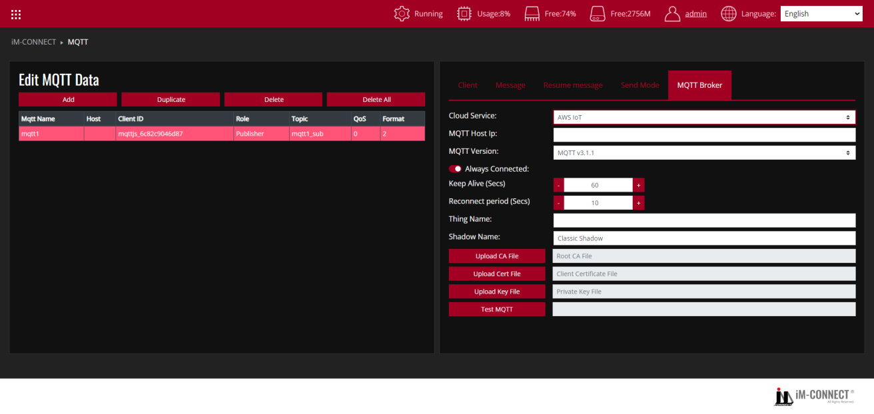

**AWS IoT**

Choose AWS IoT as Broker by using Thing to send message with Shadow support.

|  |  |
| --- | --- |
| MQTT Host IP | Set the IP address of MQTT Broker in use. |
| MQTT Version | Set the version of MQTT Broker in use. |
| Always Connected | Set the MQTT to be always connected. |
| Thing Name | Set the name of AWS IoT Thing. |
| Shadow Name | Set the Shadow name that AWS IoT Thing corresponds to. Shadows can make a device’s state available to apps and other services whether the device is connected to AWS IoT or not. |
| Upload CA File | Upload the client certificate signed by Certificate Authorities (CA) verified by Amazon. |
| Upload Cert File | Upload the certificate file. |
| Upload Key File | Upload the key file. |
| Test MQTT | Show the message received after MQTT publish. |

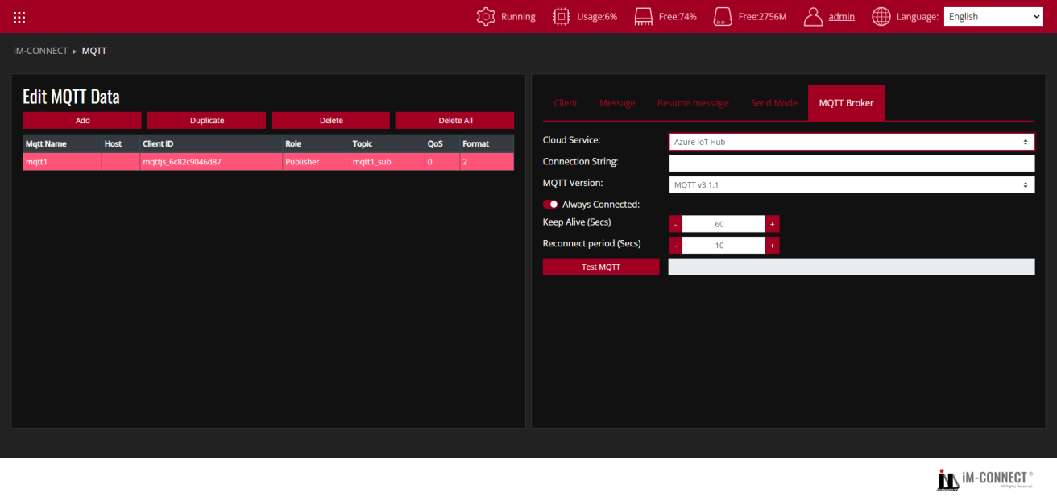

**Azure IoT Hub**

Set Microsoft Azure IoT Hub as Broker, input the correct connection string.

|  |  |
| --- | --- |
| Connection String | Input the [Connection String] acquired from Microsoft Azure IoT Hub. |
| MQTT Version | Set the corresponding MQTT version. |
| Always Connected | Set the MQTT to be always connected. |
| Test MQTT | Show the messaged received after MQTT publish. |

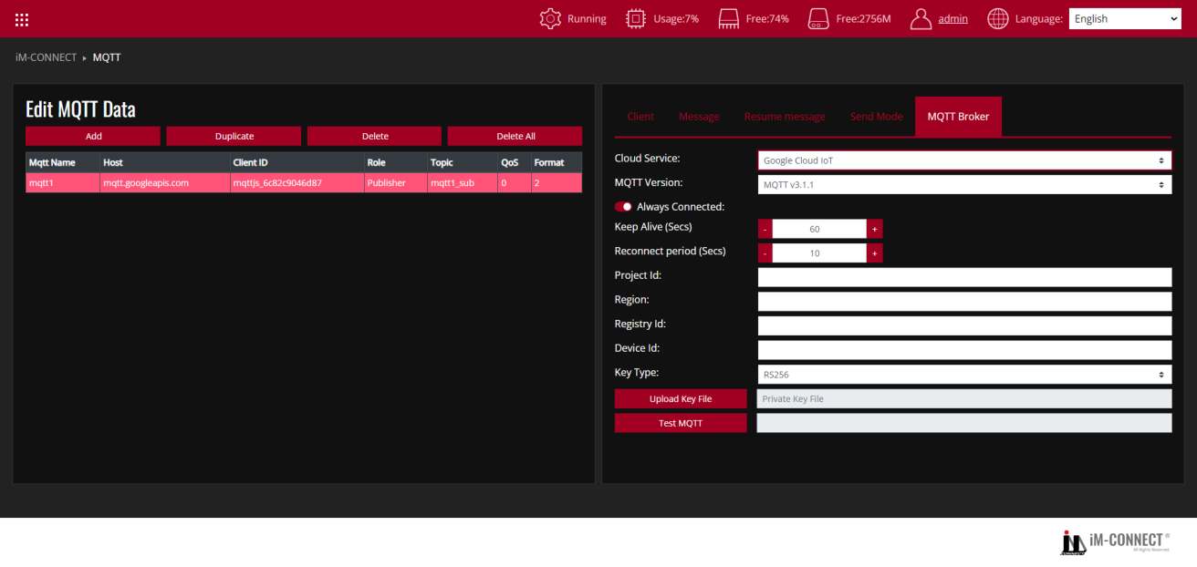

**Google Cloud IoT**

Set Google Cloud IoT Core as Broker, input the required parameters and certificate for connection.

|  |  |
| --- | --- |
| MQTT Version | Set the corresponding MQTT version. |
| Always Connected | Set the MQTT to be always connected. |
| Project ID | Input the Project ID to be used. |
| Region | Select the region of cloud service. Now only [us-central1],[europe-west1]and[asia-east1]are available. |
| Registry ID | Input the registry ID created in Google Cloud. |
| Device ID | Input the device ID. |
| Key Type | Select the key type between [RS256] and [ES256]. |
| Upload Key File | Upload the assigned key file. |
| Type MQTT | Show the message received after MQTT publish. |

Test Procedure: (Reference files:MQTT.dat)

1. In the Menu, choose MQTT: From the Menu, select the MQTT.
2. Press "Add": Create a new MQTT entry by clicking "Add".
3. Switch to Client Tab: Go to the Client Tab and configure MQTT Client-related parameters.
4. Set MQTT Name: Specify the name of the MQTT client.
5. Set Client ID: Define the unique Client ID for the MQTT client.
6. Configure Role: Set the MQTT client’s role as either Publisher or Subscriber.
7. Set MQTT Topic: Specify the Topic for the MQTT communication.
8. Assign QoS: Configure the QoS (Quality of Service) level for the MQTT messages.
9. Enable Retained: If you need to retain the last successfully transmitted message, enable the Retained setting.
10. Switch to Message Tab: In this tab, configure the MQTT message format and edit the Data Element used for publishing or subscribing.
11. Switch to Send Mode Tab: If the role is set as Publisher, define how or under what conditions to send MQTT messages, including configuring the Sample Method and Data Resume.
12. Switch to Resume Message Tab: If Enable Resume Topic was activated in the Send Mode Tab, switch to this tab to configure the content of the recovery message for interrupted transmissions.
13. Switch to MQTT Broker Tab: Choose the appropriate MQTT Broker based on the application needs. Options include Normal, AWS IoT, Azure IoT Hub, or Google Cloud IoT.
14. Save and Compile: Go to the Menu, select PROJECT SETTING, and execute "Save and Compile" to compile the project.
15. Start the Project: Click "Start Project" to run the project.
16. Monitor the execution: Go back to the Menu, select ONLINE MONITOR, and choose the Tags you are using to monitor the Macro’s execution results.