1. OPCUA

OPC was primarily developed to address the compatibility issues arising from manufacturers' proprietary software designs, which made monitoring difficult due to lack of compatibility. It established communication protocol standards. OPC UA, on the other hand, removes the limitations of OPC DA tied to Windows COM/DCOM technology and instead adopts a new protocol based on HTTP for further development.

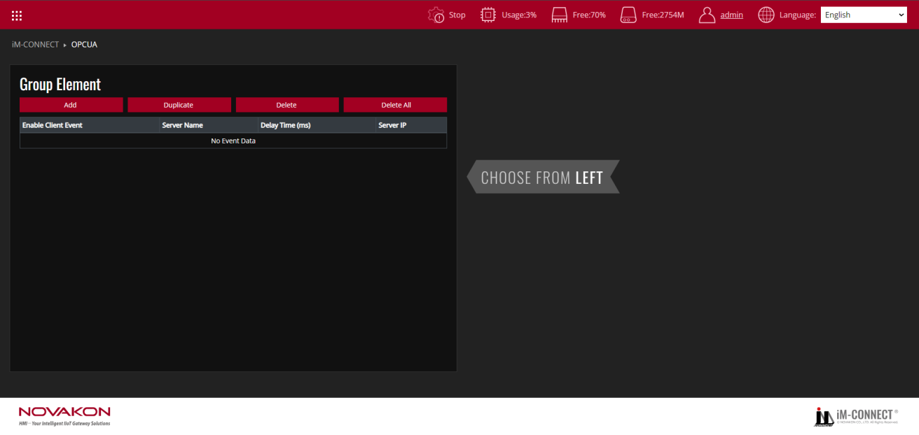

|  |  |
| --- | --- |
| Add | Add a set of OPCUA Client. |
| Duplicate | Duplicate the selected setting of the set of OPCUA Client. |
| Delete | Delete the selected setting of the set of OPCUA Client. |
| Delete All | Delete all the events of OPCUA Client. |

Start the OPCUA Client setting after selecting [Add].

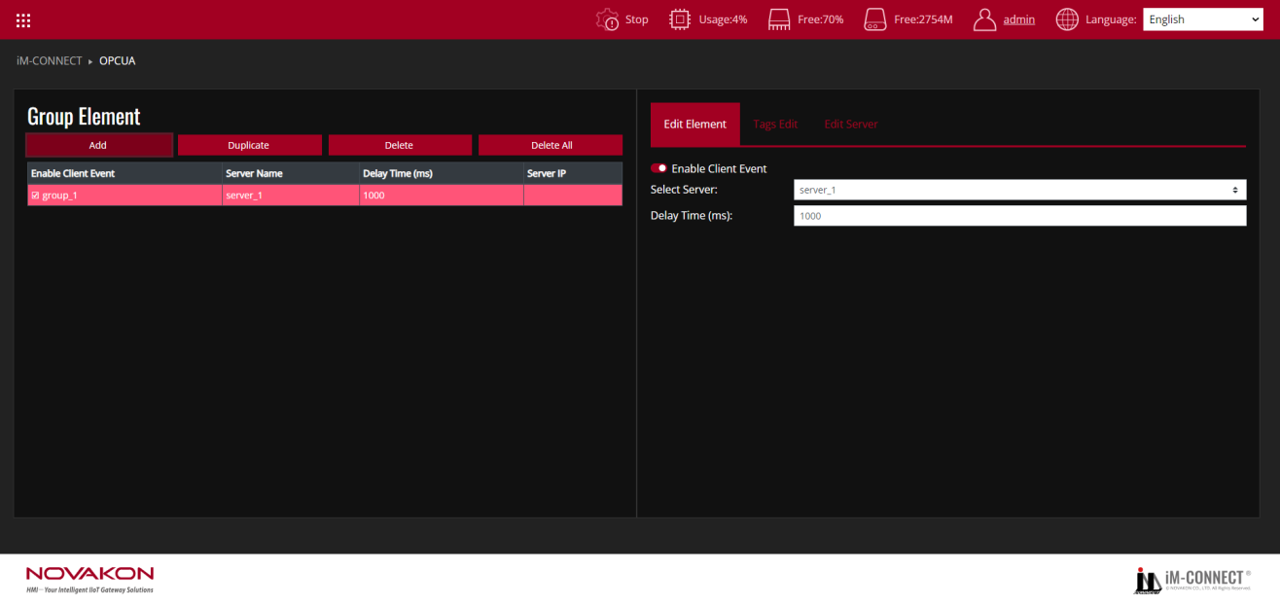

**Edit Element**

Definite a OPCUA event.

|  |  |
| --- | --- |
| Enable Client Event | Enable a OPCUA Client item. |
| Select Server | Select the name of the OPCUA Server to be connected with. |
| Delay Time | Set OPCUA delay time. |

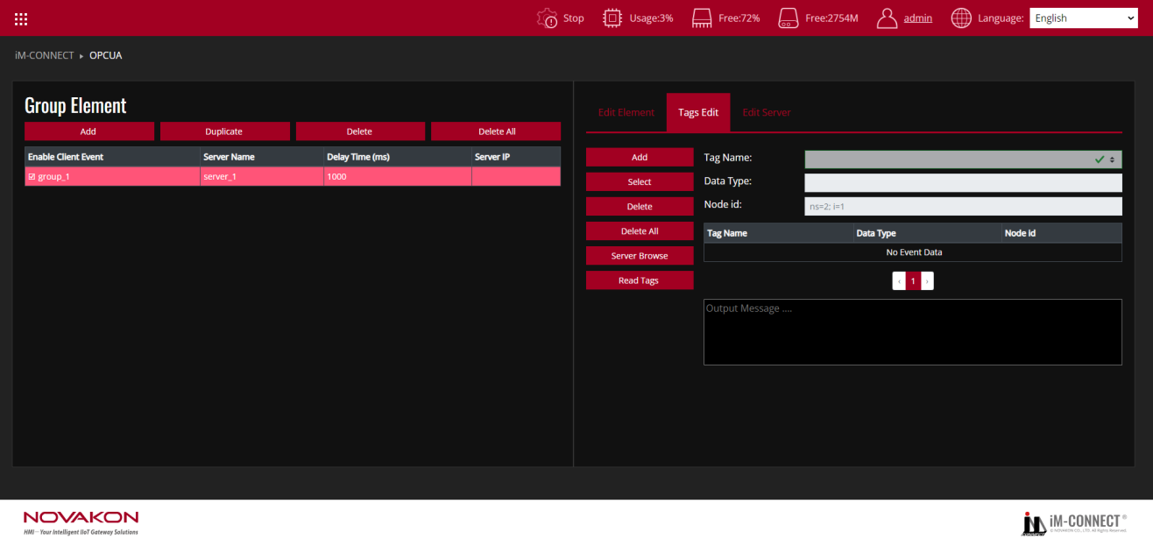

**Tags Edit**

|  |  |
| --- | --- |
| Add | Add a tag as the monitor of OPCUA Client. |
| Select | Select an already established tag as the OPCUA Client. |
| Delete | Delete the selected tag(s). |
| Delete All | Delete all the tag(s) of this event. |
| Server Browse | Import the selected tags from OPCUA server. |
| Tag name | It shows the tag name of the OPCUA Client. |
| Data Type | It shows the tag type of the OPCUA Client. |
| Node ID | Input the Node ID of the element address on the OPCUA Client. The names defined by each equipment may differ, so it shall be input based on each of the definitions. |

The established Tag Name, Data Type, Node ID, Output Message, and other data are listed in sequence below.

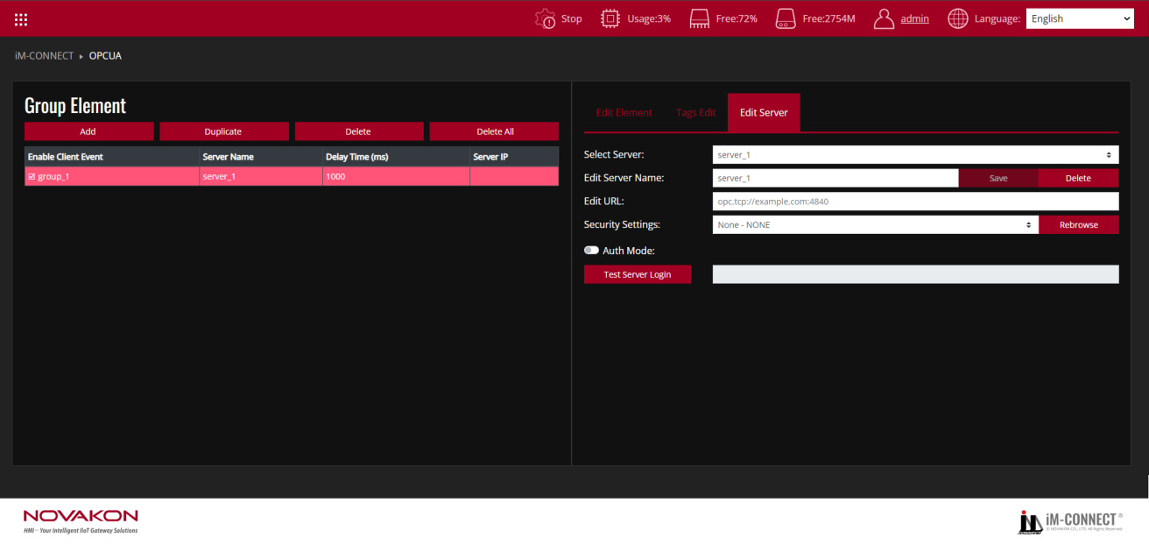

**Edit Server**

Define the relevant data of the OPCUA Server.

|  |  |
| --- | --- |
| Select Server | Select the name of the OPCUA Server to be connected with. |
| Edit Server Name | Edit the name of the OPCUA Server. |
| Server IP | Input the IP of the OPCUA Server to be connected with. |
| Port | Set the port number of the OPCUA Server. |
| Security Settings | Set the security mode for communication according to the connected Server. |
| Auth Mode | Select whether the to-be-logged-in OPCUA Server needs an authentication. If it needs authentication, input the account name and password to be logged in. |
| Test OPC UA Server | Test connection status after selecting it. |

Test Procedure: (Reference files:OPCUA.dat)

1. In the Menu, choose OPCUA: Select the OPCUA option from the Menu.
2. Press "Add": Add a new OPCUA Client by clicking "Add".
3. Enable OPCUA Client Event: Go to the Edit Element Tab and check "Enable Client Event" to activate the OPCUA Client.
4. Choose OPCUA Server: Select the desired OPCUA Server you want to connect to.
5. Set the OPCUA Delay Time: Configure the time interval for fetching values from the server.
6. Go to the Tags Edit Tab: Add or choose tags to be used as OPCUA Client tags.
7. Connect to OPCUA Server: If connected, click "Server Browse" to add Tags from the OPCUA Server.
8. Click "Read Tags": Verify that the tags are correctly configured. If correct, the tag contents will be shown in the output message window. If there’s an error with the tag, it will display [type], and if there’s a node error, it will show [readTags error].
9. Enter Node ID: In the Node ID field, input the node name corresponding to the data address on the server. The naming convention may vary depending on the device, so ensure the name is defined according to its specification.
10. Go to the Edit Server Tab: Define the OPCUA Server details, including Server Name, URL, Security, and other settings.
11. Save and Compile: Go to the Menu, select PROJECT SETTING, and execute "Save and Compile" to compile the project.
12. Start the Project: Click "Start Project" to run the project.
13. Monitor the execution: Go back to the Menu, select ONLINE MONITOR, and choose the Tags you are using to monitor the Macro’s execution results.