1. REST API

Rest API refers to the state transfer of information in a certain format (usually JSON format) on the network. The human-machine sends requests in JSON format through the Rest API and receives responses from the cloud to meet the needs of IoT applications.

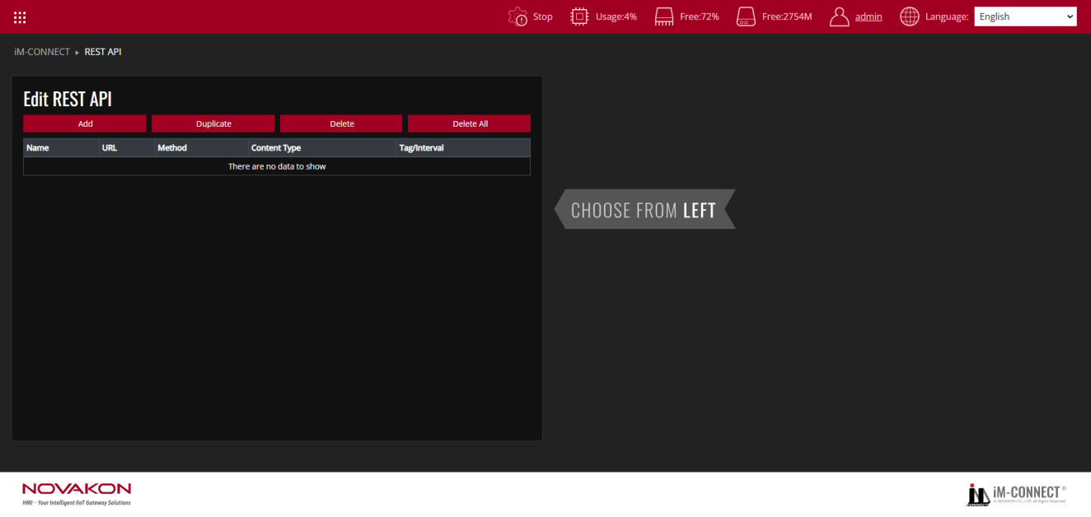

|  |  |
| --- | --- |
| Add | Add a new set of Rest API. |
| Duplicate | Copy the Rest API settings of the selected group. |
| Delete | Delete the selected Rest API settings. |
| Delete All | Delete all Rest API events. |

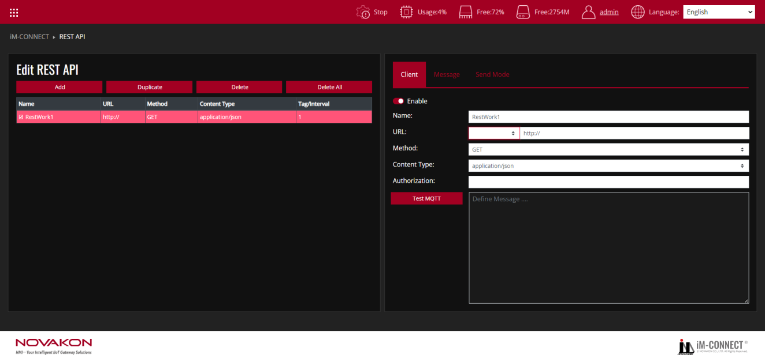

**Client**

Define a Rest API event.

|  |  |
| --- | --- |
| Enable | Check to start this Rest API project. |
| Name | Set the name of Rest API. |
| URL | Set the URL of Rest API. |
| Method | Set the GET/POST/PUT/DELETE commands of Rest API. |
| GET | The client uses the GET method to access resources at the specified URL on the server. They can quickly make GET requests and pass parameters in RESTful API requests to instruct the server to filter data before sending it. |
| POST | The client uses POST to send data to the server. It contains a representation of the data in the request. A common result of sending the same POST request multiple times is to create the same resource multiple times. |
| PUT | The client uses PUT to update existing resources on the server. Unlike POST, transmitting the same PUT request multiple times in a RESTful web service will produce the same result. |
| DELETE | The client uses DELETE to request deletion of the resource. DELETE requests a change to the server state. However, if the user does not have proper authentication, the request will fail. |
| Content Type | Set the type of Rest API. Can be divided into [text/plain], [application/json], [application/x-www-form-urlencoded]. |
| text/plain | Used to indicate that the body of the request or response is plain text data. |
| application/json | Used to indicate that the body of the request or response is data in JSON format. |
| application/x-www-form-urlencoded | Usually used for HTML form submission default Content-Type, encoding form data into key-value pairs. |
| Authorization | Set the authorization of Rest API. Ensure that only authenticated and authorized consumers can access resources using the REST API. When using Line's REST api function, you need to add [Bearer] before authorization. |
| Test API | Displays the content of the response message after the Rest API is sent. |

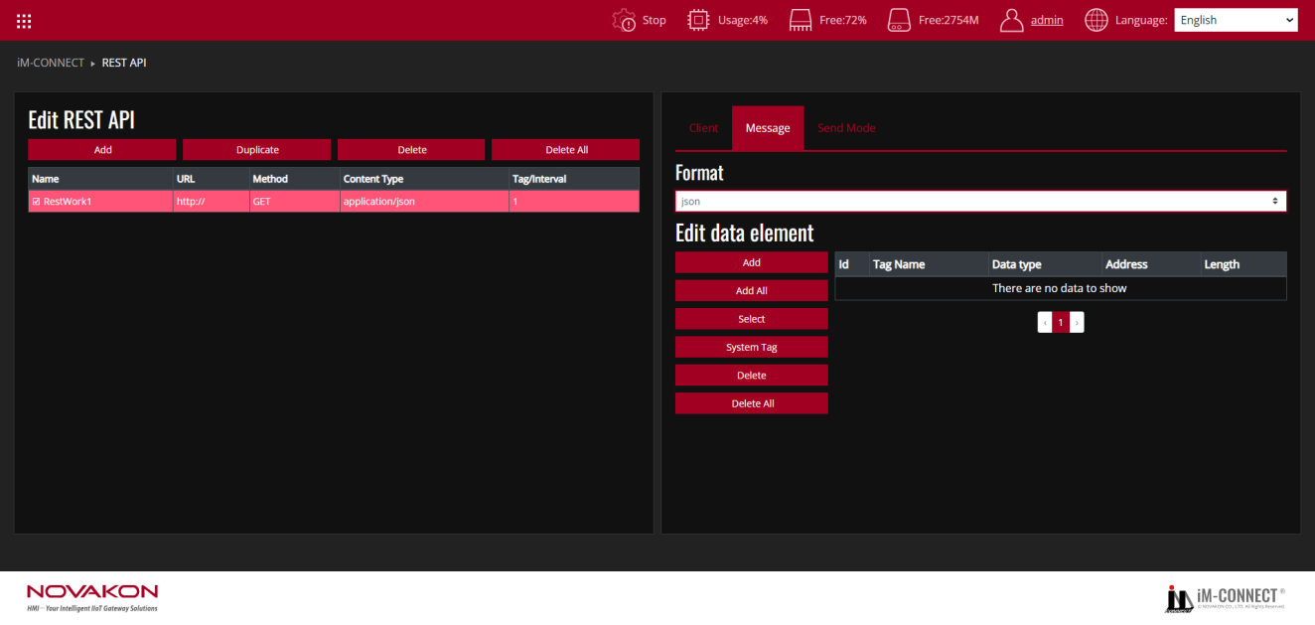

**Message**

|  |  |
| --- | --- |
| Format | You can set the [JSON]/[Customer] format. The default is [JSON]. |
| JSON | JSON is a lightweight data exchange format that is easy for humans to read and write, and easy for machines to parse and generate. In REST APIs, JSON is the most common data format used to represent request and response bodies. |
| Add | Add tags used by Rest API. |
| Add All | Add all tags to Rest API. |
| Select | Select the tag used by Rest API. |
| System Tag | Obtain the system time and other information of the gateway through the system label. |
| Delete | Delete the selected tag. |
| Delete All | Delete all tags. |

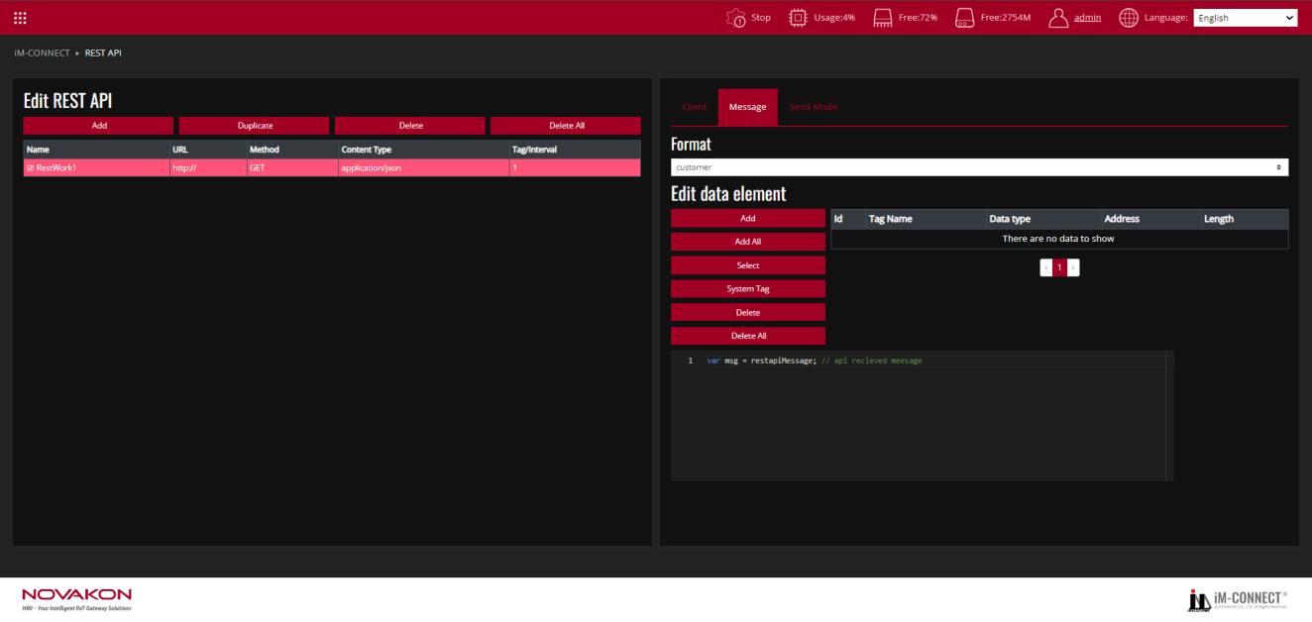

If the data format is selected as [Customer] format, the user must write the specified data into the specified tag in accordance with the RESTAPI Server definition.

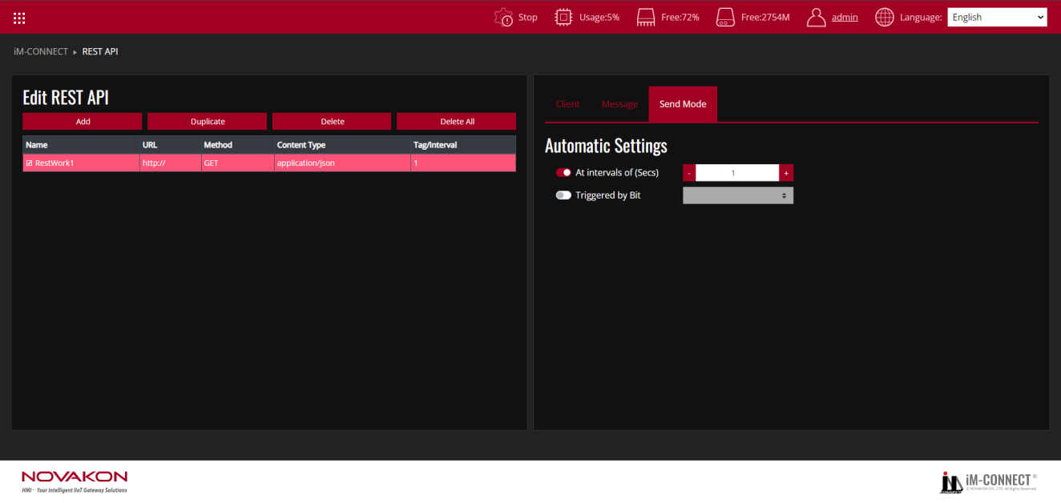

**Send Mode**

|  |  |
| --- | --- |
| At intervals of (Secs) | Set to send Rest API messages at fixed intervals of seconds. The default is 1 second. |
| Triggered by Bit | Set to send a Rest API message when the status of the trigger bit changes from OFF to ON. |

Test Procedure: (Reference files:RESTAPI.dat)

1. In the Menu, choose REST API.
2. Press "Add": Create a new REST API event by clicking "Add".
3. Enable the RESTAPI: Go to the Client Tab and click "Enable" to activate the RESTAPI Client.
4. Enter RESTAPI Name: Enter RESTAPI name: Provide a name for the RESTAPI in the Name field.
5. Set REST API URL: Input the URL for the REST API.
6. Configure REST API Method: Set the appropriate GET / POST / PUT / DELETE method based on your API requirements.
7. Set REST API Content Type: Define the content type, such as application/json, text/plain, or application/x-www-form-urlencoded.
8. Optional: Enter REST API Authorization: If needed, input the authorization details (e.g., Bearer token).
9. Switch to Message Tab: Select the format for the REST API and add the required Tag or System Tag.
10. Switch to Send Mode Tab: Choose the appropriate Send Mode, with the default being to send the REST API message at a fixed interval (every 1 second).
11. Save and Compile: Go to the Menu, select PROJECT SETTING, and execute "Save and Compile" to compile the project.
12. Start the Project: Click "Start Project" to run the project.
13. Monitor the execution: Go back to the Menu, select ONLINE MONITOR, and choose the Tags you are using to monitor the Macro’s execution results.