Part1 r10521516 土木所廖浚評

使用Python , OpenCV 完成

1. (b)

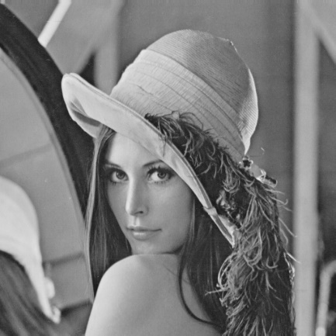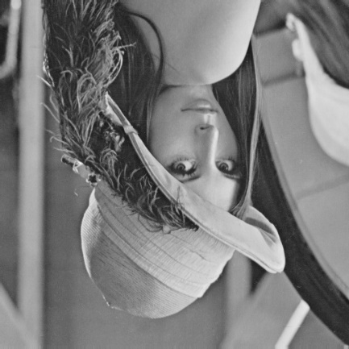

(c)

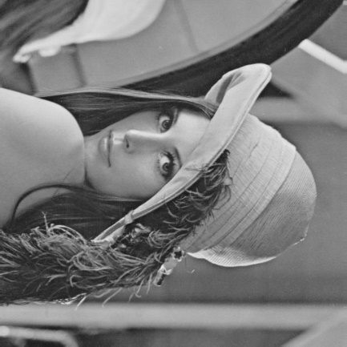

Part2

利用線上軟體photopea完成(https://www.photopea.com/)

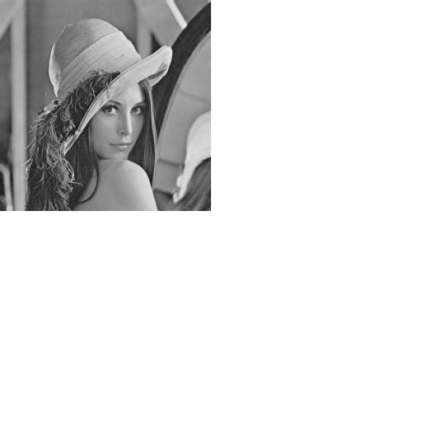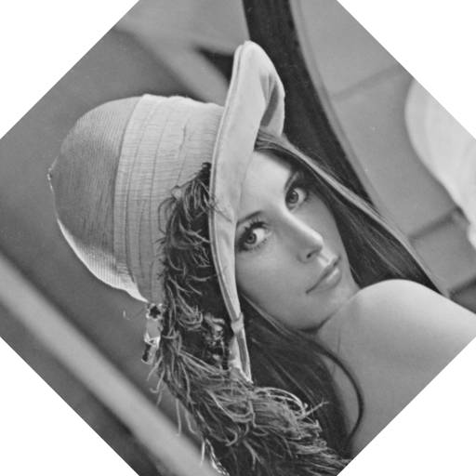(d) (e)

(f)

(a)

import cv2

img = cv2.imread('lena.bmp')

image = cv2.imread('lena.bmp')

row,col,typ = img.shape

for i in range(0,row):

for j in range(0,col):

image[i][j] = img[row-i-1][j]

cv2.imshow('vetical', image)

cv2.imwrite('vetical.jpg', image)

cv2.waitKey(0)

cv2.destroyAllWindows()

(b)

import cv2

img = cv2.imread('lena.bmp')

image = cv2.imread('lena.bmp')

row,col,typ = img.shape

for i in range(0,row):

for j in range(0 , col):

image[i][j] = img[i][col-j-1]

cv2.imshow('horizontal', image)

cv2.imwrite('horizontal.jpg', image)

cv2.waitKey(0)

cv2.destroyAllWindows()

(c)

import cv2

img = cv2.imread('lena.bmp')

image = cv2.imread('lena.bmp')

row,col,typ = img.shape

for i in range(0,row):

for j in range(0 , col):

image[i][j] = img[col-j-1][row-i-1]

cv2.imshow('diagonal flip', image)

cv2.imwrite('diagonal flip.jpg', image)

cv2.waitKey(0)

cv2.destroyAllWindows()