R10521516廖浚評 CV HW10

Use python3.8, OpenCV

用跟作業9一樣的捲積做運算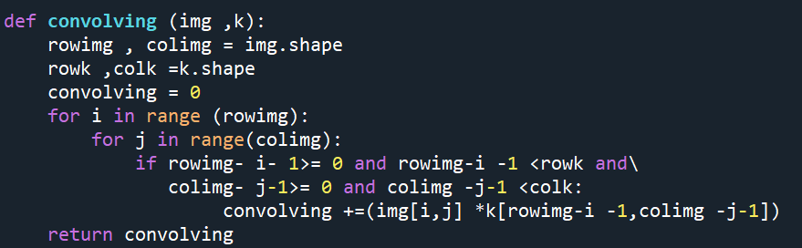

Laplace Mask1 (0, 1, 0, 1, -4, 1, 0, 1, 0): threshold = 15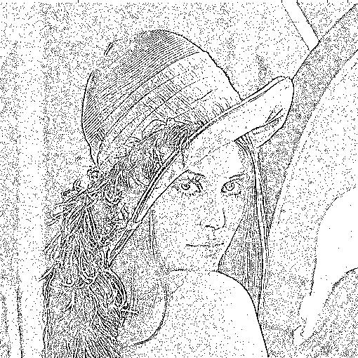

Laplace Mask2 (1, 1, 1, 1, -8, 1, 1, 1, 1):threshold = 15

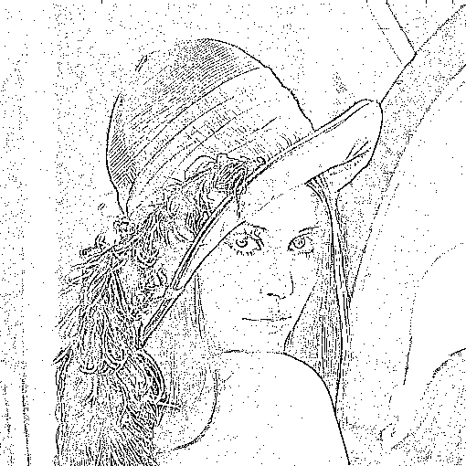

Minimum variance Laplacian: threshold = 20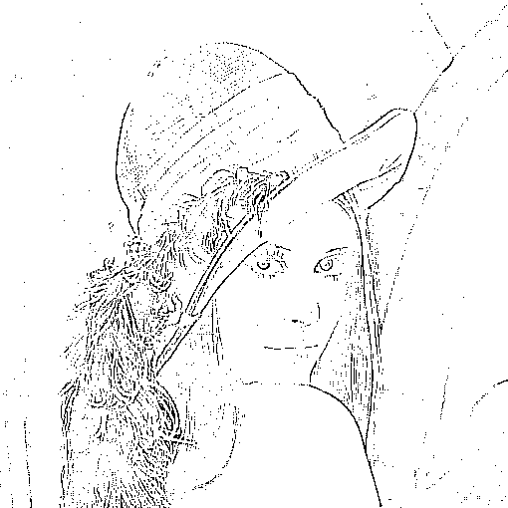

Laplace of Gaussian: threshold = 3000

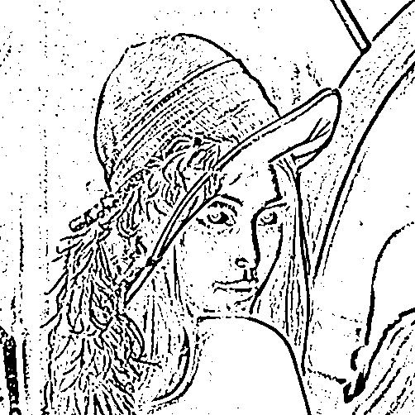

Difference of Gaussian: threshold = 1

