廖浚評 r10521516

Binarize

將lena.bmp用灰階讀進來後，對每一個位置檢查其值，若大於等於128就設成255，反之則將小於128的設為0。

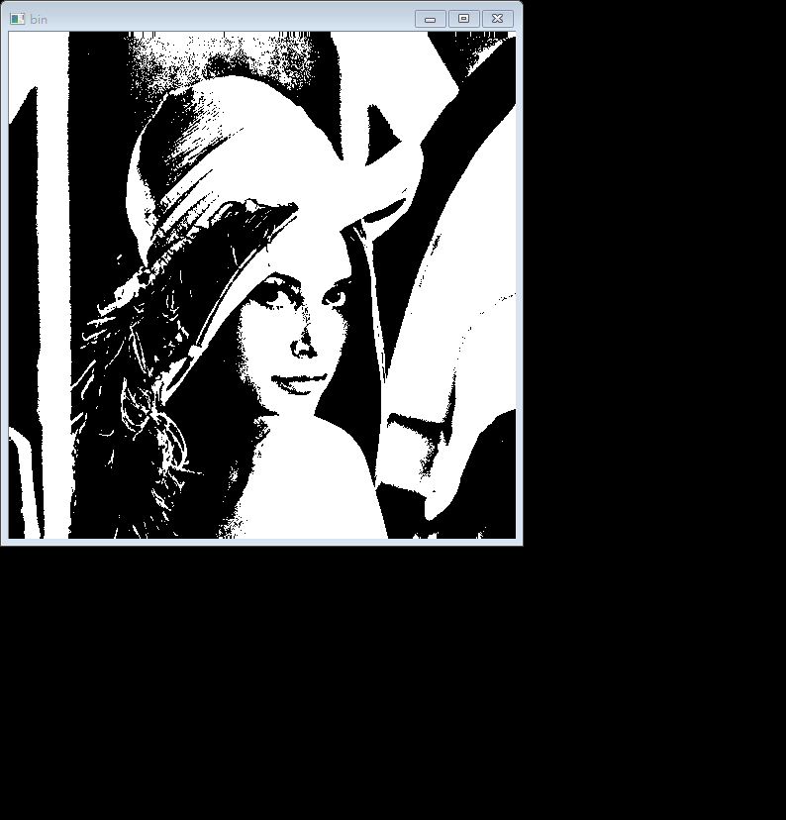

Histogram

將lena.bmp讀進來後，用上面的binarize轉成灰階，檢查每一格pixel的值，每檢查到一個值就將它加一到對應的位置去(一個起始值為0的xaxies[256]的array中)，最後將array中的值用matplotlib(plt.bar)畫成一個圖表。

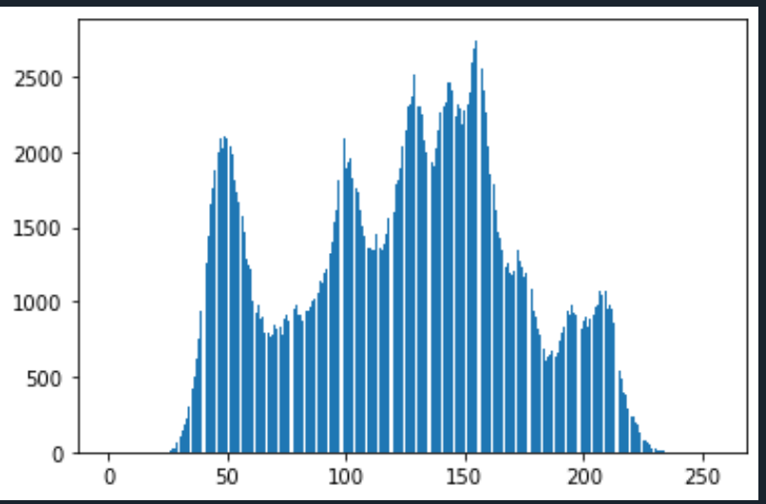

import numpy as np

import matplotlib.pyplot as plt

import cv2

def img_binarize(img_in ):

#(a)a binary image (threshold at 128)

shape = img_in.shape

binimg = np.zeros(shape )

for i in range(shape[0]):

for j in range(shape[1]):

for k in range(2):

if img_in[i][j][k] >= 128:

binimg[i][j] =255

else:

binimg[i][j] = 0

return binimg

def img_histogram(img_in):

# (b) a histogram

xaxies = np.zeros(256 ,dtype = int)

shape = img_in.shape

for i in range(shape[0]):

for j in range(shape[1]):

xaxies[img_in[i][j]] +=1

return xaxies

colorimg = cv2.imread('lena.bmp')

shape = colorimg.shape

binimg = img_binarize(colorimg )

cv2.imshow('bin ', binimg)

hist = img_histogram(colorimg)

plt.bar(range(0, 256), hist)

plt.savefig('histogram.png')

plt.show()

cv2.waitKey(0)

cv2.destroyAllWindows()